Season One of Music Makes a City Now,
New Original Web Video Series,
Available Online at PBS.org Starting August 26, 2015

Follow the dynamic, young Teddy Abrams of the Louisville Orchestra as he breaks down boundaries between musical genres and communities

(SAN FRANCISCO) – Music Makes a City Now, a new independent original web series that explores present-day stories of musical visionaries who build communities through great music and civic engagement, launches its first season on PBS.org and Music Makes a City Now YouTube channel beginning August 26, 2015 at Noon PT / 3:00 p.m. ET. Inspired by the award-winning PBS documentary, Music Makes a City: A Louisville Orchestra Story, which chronicled the historic rise of the Louisville Orchestra in the mid-twentieth century, Music Makes a City Now picks up the story in present day Louisville and beyond.
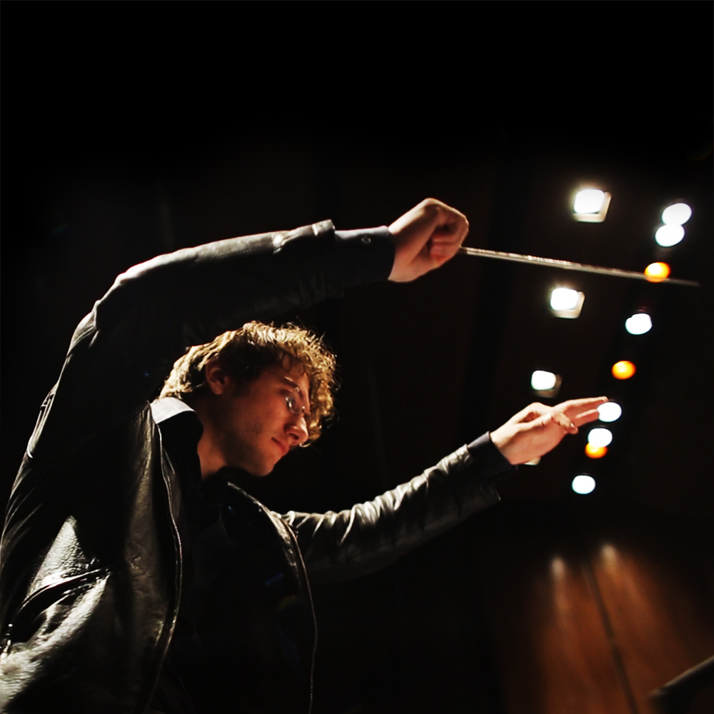

The series begins with the arrival of a rising star, 27-year-old conductor and composer Teddy Abrams, as he moves to Louisville, Kentucky, to become the youngest music director of a major American orchestra. Bursting with energy and ideas, Abrams embarks on an ambitious plan to usher in a modern renaissance for the orchestra and the city. Not afraid to embrace genres not usually found within the orchestral realm — including country, hip-hop and folk — his enthusiasm is infectious.

Through a series of twelve short episodes (5-7 minutes each), the series follow Abrams’ whirlwind debut season in 2014-15 with the orchestra, from his chaotic move-in day at his newly purchased downtown fixer-upper to the opening night of the symphony and his embrace of the city’s vibrant local music scene. Charming and unpretentious, Abrams demystifies the world of classical music as he shows what it takes to keep personal and civic artistry alive in the 21st century.

"I’m so excited to be part of Music Makes a City Now because it has allowed us to show the importance of an orchestra for a city, to tell stories of how performance and music education can open minds,” says Abrams, “and to prove that people from all walks of life can come together through creativity to learn something from one another about how we want our communities to be into the future.”

“Teddy was a match made in heaven for our musical adventure story,” says Anne Flatté, director and producer of the series. “He has a winning, charismatic personality that breaks down walls and provides a fresh perspective into what is often perceived as the stuffy world of classical music.”

Throughout the episodes, a colorful array of guest artists join Abrams for a variety of performances and deep conversations including folk music favorite Aoife O’Donovan, icon Bonnie “Prince” Billy, local Louisville hip-hop artist “1200,” and world famous virtuoso Joshua Bell. Together, they bring down traditional barriers and highlight the universal meaning of music across all genres and audiences. Additional special features to come in September include conversations with Abrams’ mentor, the renowned conductor Michael Tilson Thomas, and former schoolmate and piano superstar Yuja Wang, filmed backstage during rehearsal for Thomas's 70th birthday celebration.

Audiences can view the series on http://www.pbs.org/program/music-makes-city-now/ and subscribe to the series through the Music Makes a City Now YouTube Channel, where they will also find compelling additional content, such as Special Features and #TEDDYTalks videos highlighting Teddy’s thoughts on music and life.

Music Makes a City also enjoys a growing and engaged social media community on Facebook, Twitter, and YouTube. Follow Music Makes a City Now on Twitter @MusicMakesACity and Facebook facebook.com/musicmakesacity.

For more information, visit http://www.musicmakesacity.com.

Music Makes a City Now Episodes

1: Moving to Louisville
27-year-old conductor Teddy Abrams moves to Louisville, Kentucky, to become the youngest Music Director of a major American orchestra.

2: Opening Night
The intensity builds as Teddy Abrams and the Louisville Orchestra rehearse and perform their Opening Night concert.

3: Teddy Meets the Town
Teddy Abrams plays music around Louisville to spread the word about the orchestra.

4: Carmina Burana in Louisville
Teddy Abrams, the Louisville Orchestra, and a community cast of hundreds come together to create a powerhouse performance of Carl Orff's Carmina Burana.

5: Big Fiddle
Teddy brings composer and violinist Jeremy Kittel and his original work “Big Fiddle" to the Louisville Orchestra along with crossover cellist Ben Sollee.

6: All Together Now
Teddy and a unique mix of Louisville musicians come together to create #MMAC14, a landmark community concert at Tim Faulkner Gallery, featuring Bonnie Prince Billy and other top local groups.

7: Sixth Floor Trio
Teddy and old friends light up Louisville with their genre-blending side project, the Sixth Floor Trio.

8: Music Is Alive
Teddy gathers world-class musicians, including ethereal folk singer Aoife O’Donovan, classical musicians, bluegrass artists and a maraca virtuoso for an experimental festival at Fairchild Garden in Miami.

9: First Symphony
The Louisville Orchestra takes a risk by commissioning new work from Sebastian Chang, and the young composer delivers a full length “Classical Symphony.”

10. New World Symphony
Teddy Abrams takes a trip back to Michael Tilson Thomas’s state of the art orchestral academy in Miami, where the young conductor spent three years honing his skills.

11: Joshua Bell in Rehearsal
Violin virtuoso Joshua Bell plays Bruch’s Scottish Fantasy in his first rehearsal with Teddy Abrams at New World Symphony in Miami.

12: Season Finale
Teddy and the Louisville Orchestra’s first season comes to a high-energy close with a triumphant Day of Music and Block Party Concert. Featuring Beethoven’s Symphony No. 5 and musical mash-ups from guest artists Time for Three.

CREDITS

Series Producer/Director: Anne Flatté
Series Producer: Philip Wilder
Co-Director/DP: Stephen Kertis
Executive Producer: Owsley Brown III
Production Company: Owsley Brown Presents

About Teddy Abrams
An unusually versatile musician, Teddy Abrams is a widely acclaimed conductor, as well as an established pianist, clarinetist, and composer. The 2014 season marked the beginning of his tenure as Music Director of the Louisville Orchestra and Music Director and Conductor of the Britt Classical Festival. He also serves as Resident Conductor of the MAV Symphony Orchestra in Budapest, which he first conducted in 2011. Teddy recently concluded his appointment as Assistant Conductor of the Detroit Symphony. Active as a guest conductor, he has worked with a variety of organizations, including New Mexico Philharmonics, Kitchener-Waterloo Symphony, Indianapolis Symphony, New World Symphony, Los Angeles Philharmonic, Florida Orchestra, Jacksonville Symphony, and San Francisco Symphony. An accomplished pianist and clarinetist, Abrams has appeared as a soloist with a number of orchestras and festivals—including Jacksonville Symphony, St. Petersburg String Quartet, Olympic Music Festival, Cleveland Orchestra, Philadelphia Orchestra, and at Carnegie Hall. Abrams studied conducting with Michael Tilson Thomas, Otto-Werner Mueller, Ford Lallerstedt, and David Zinman. An award-winning composer and a passionate educator, Teddy was a proud member of the San Francisco Symphony Youth Orchestra for seven seasons, and graduated from the San Francisco Conservatory of Music with a Bachelor of Music, having studied piano with Paul Hersh. Abrams grew up in the San Francisco Bay Area. https://www.louisvilleorchestra.org/about/conductors/teddy-abrams-music-director/

About the Filmmakers

Anne Flatté (Director/Producer) has worked on critically acclaimed and award-winning documentary films and television programs since 1995. She co-produced and edited the film Music Makes a City and produced the made-for-TV version for PBS broadcast. She edited Monumental, What Do You Believe?, Daughters and Sons, and Devil’s Teeth. She earned her MA in documentary film and video from Stanford University in 1995.

Owsley Brown III (Executive Producer) was born and raised in Louisville, Kentucky. He is a documentary filmmaker whose directorial debut, Night Waltz: The Music of Paul Bowles, about the American writer and composer, won the Independent Spirit Award in 2000. His critically acclaimed second film, Music Makes A City, chronicling the landmark commissioning project of the Louisville Orchestra in the 1950s, won a Gramophone award in 2012 and had its U.S. television broadcast premiere in 2014 on PBS. Owsley’s third feature film is a seven-year documentary effort to chronicle the story of Haiti’s most important classical music school (for children), located in the heart of Port-au-Prince. He is a graduate of the University of Virginia in 1993 with a Bachelor of Arts in Cultural Anthropology.
Stephen Kertis (Co-Director/Director of Photography) began his career at PBS, working as a producer and editor on documentary projects, including winning an Emmy for Joe Downing: Poet of Color and Light. His dramatic cinematography and visual style was honed by years of commercial and creative projects, including Everybody’s Hugging, an ongoing collaborative music, film, and photography project that pairs musicians with cinematographers in unique locations. In 2008, he started Kertis Creative, an answer to our rapidly changing media world. Stephen lives, works and adventures in the south.
About Owsley Brown Presents
Owsley Brown Presents (OBP) is a San Francisco-based independent motion picture production company that produces original contemporary media works with an emphasis on artistic and creative exploration.
www.owsleybrownpresents.com

###

Additional information and downloadable images available at:
http://www.musicmakesacity.com/media-kit/

Contact:
CaraMar, Inc.
Mary Lugo, 770-623-8190; lugo@negia.net
Cara White, 843-881-1480; cara.white@mac.com
Abbe Harris, 908-244-5516; abbe@caramar.net

