MY WILD AFFAIR to Premiere July 16, 2014 on PBS
Four-Part Series Airs Wednesdays, July 16 to August 6,
8:00-9:00 p.m. ET on PBS

– Program Joins PBS’ “Think Wednesday” Lineup and Evokes the Extraordinary Stories of the Bonds Between Humans and Their Animal Companions –

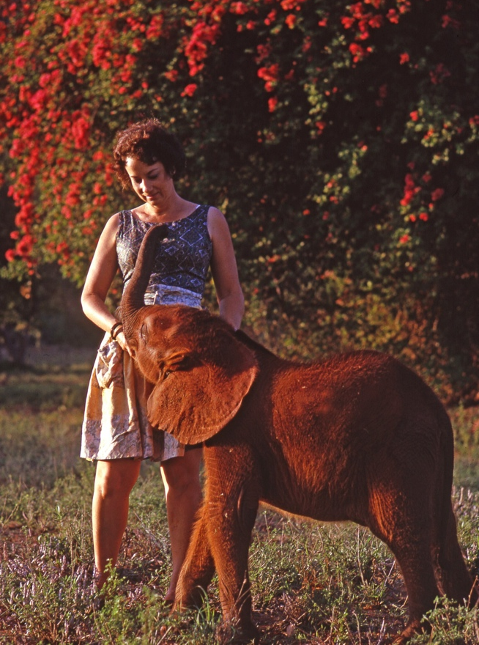
Daphne with Schmetty (Credit: The Sheldrick family)
Witness the special connection between animals and humans in MY WILD AFFAIR, a four-part series premiering July 16, 2014 on PBS that will air as part of the network’s “Think Wednesday” lineup of science and nature programming. Paired with unique access to home movies, film and television archives spanning the 1950s to 1980s, humans share their individual experiences with animals in what is a profoundly moving journey. These rare relationships cross the divide between species and give viewers a glimpse into the inner life of the creatures who share our world. Each animal anecdote provides an insightful lesson about the incredible nature of the species.

MY WILD AFFAIR begins with “The Elephant Who Found a Mom” on July 16. Focusing on the intense bond between Aisha, a baby elephant orphan, and Daphne Sheldrick, the woman who became her human foster parent, a crisis arrives when Daphne leaves Aisha with a babysitter for a few days to attend her daughter’s wedding. Aisha refuses to eat, leading to her death. Heartbroken, Daphne uses the lessons learned from Aisha’s short life to help her save more than 150 orphans over the next 40 years.

On July 23, “The Ape Who Went to College” is the incredible story of Chantek, the orangutan raised as a human child on an American university campus during the 70s and 80s. Taught to speak in sign language, he is now living among his own kind at Zoo Atlanta, although he describes himself as an “orangutan person.”

The third episode, “The Rhino Who Joined the Family,” airs on July 30. Rescued from flooding caused by the damming of the Zambezi River, Rupert, an orphaned black rhinoceros, was brought up in the suburban family home of wildlife veterinarian Dr. John Condy. Rupert captured the hearts of the vet’s four young children before his eventual release into the wild. Fifty years later, the children are searching for clues to their childhood friend’s fate.

In the final episode, “The Seal Who Came Home” on August 6, witness the true story of Andre, a two-day-old wild harbor seal who, in 1961, was rescued from certain death by Harry Goodridge, an arborist from Rockport, Maine. Over the next 25 years, Andre and Harry established a friendship that brought Andre into the world of humans without Andre’s ever having to sacrifice his wildness.

About Blink Films
The series is produced by Blink Films and New Road Media. Blink Films is the producer of The Lion Cub from Harrods, the documentary that inspired this series, telling the story of Christian, the lion cub whose reunion with the two men who raised him became a You Tube sensation.

About PBS
PBS, with its over 350 member stations, offers all Americans the opportunity to explore new ideas and new worlds through television and online content. Each month, PBS reaches nearly 109 million people through television and over 28 million people online, inviting them to experience the worlds of science, history, nature and public affairs; to hear diverse viewpoints; and to take front row seats to world-class drama and performances. PBS’ broad array of programs has been consistently honored by the industry’s most coveted award competitions. Teachers of children from pre-K through 12th grade turn to PBS for digital content and services that help bring classroom lessons to life. PBS’ premier children’s TV programming and its website, pbskids.org, are parents’ and teachers’ most trusted partners in inspiring and nurturing curiosity and love of learning in children. More information about PBS is available at www.pbs.org, one of the leading dot-org websites on the Internet, or by following PBS on Twitter, Facebook or through our apps for mobile devices. Specific program information and updates for press are available at pbs.org/pressroom or by following PBS PressRoom on Twitter.

About “Think Wednesday”
MY WILD AFFAIR airs as part of PBS’ “Think Wednesday” programming lineup of science, nature and technology programming that includes the acclaimed series NATURE and NOVA, offering new perspectives on life in the universe to keep viewers both curious and wanting more. Also airing alongside MY WILD AFFAIR are SEX IN THE WILD and OPERATION MANEATER. For more information on “Think Wednesday,” visit www.pbs.org/thinkwednesday.

– PBS –

CONTACTS: Jessie Yuhaniak, PBS, 703-739-5364; jayuhaniak@pbs.org
Maryellen Mooney/Nisa Kiang, Goodman Media for PBS Programming, 212-576-2700; PBSProgramming@goodmanmedia.com

For images and additional up-to-date information on this and other PBS programs, visit PBS PressRoom at pbs.org/pressroom.

