SHERLOCK

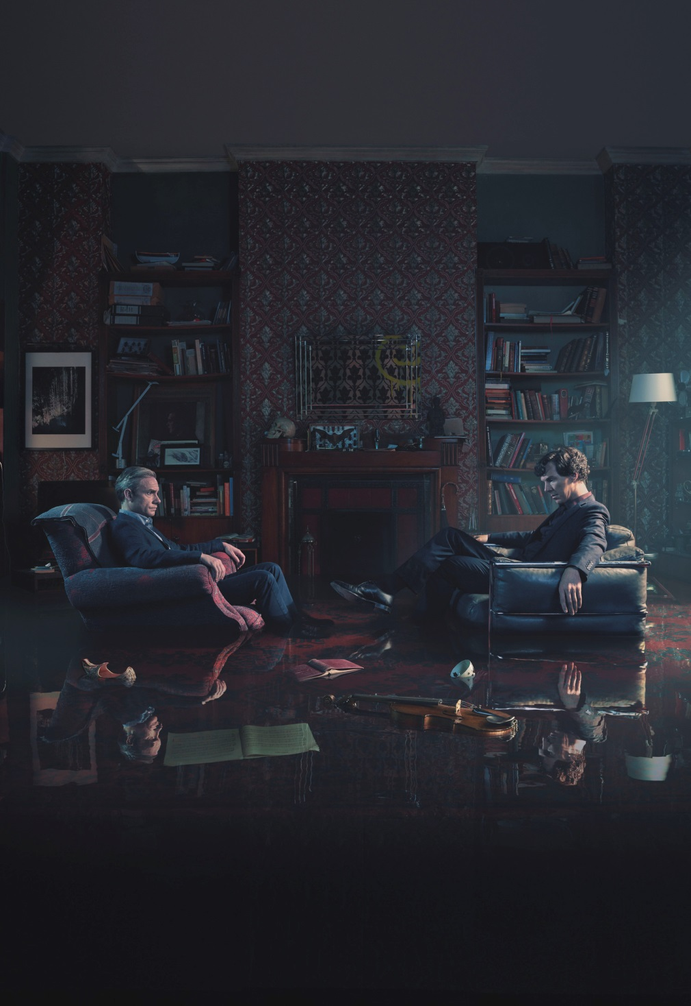

PRESS PACK
Contents
Interview with Benedict Cumberbatch – Page 3
Interview with Martin Freeman - Page 5
Interview with Steven Moffat – Page 9
Interview with Mark Gatiss – Page 10
Interview with Amanda Abbington – Page 12
Interview with Rupert Graves – Page 14
Interview with Louise Brealey – Page 16

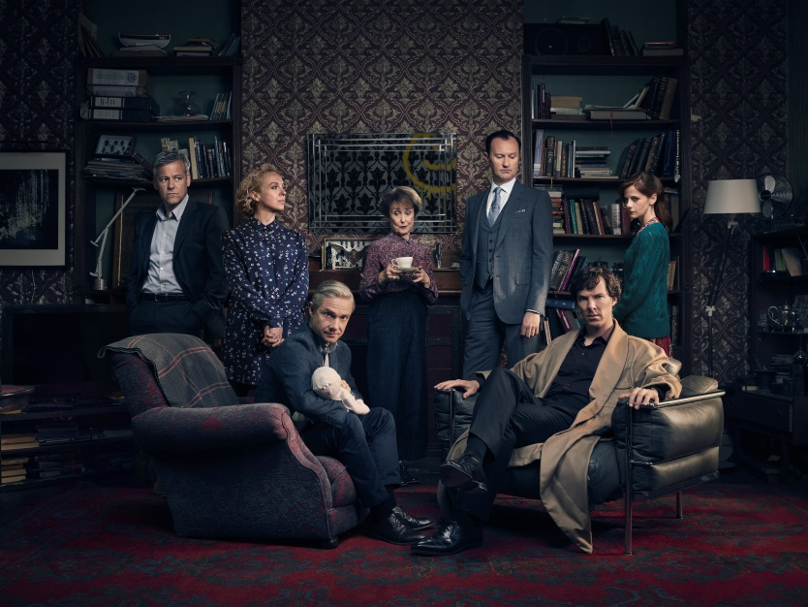
Interview with Benedict Cumberbatch (Sherlock Holmes)
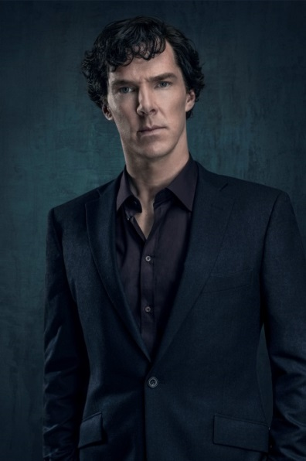
How does it feel to put Sherlock’s famous coat back on after being in Victorian costume?
Its lovely putting the famed coat back on again, as opposed to the starched collar and the morning suit, but at the same time, we were filming in the middle of summer so it was quite hot every time I put on the coat! It’s part of who he is, part of his kit and his armour.
How do we find Sherlock, John and Mary at the start of series four?
There are a lot of new things going on, for example there’s a baby! So parenting responsibilities have kicked in for the super sleuths! Childcare is never easy but it gets even more complicated when crime’s involved.
John and Mary are new parents, how does Sherlock feel about that?
I think Sherlock feels very protective towards them as a family, but he’s not a natural or a figure of authority when it comes to a new-born. I hope my skills and interaction with my own are a little bit more engaged than his are! He’s seemingly indifferent which is comic at times but it’s all underpinned with a deep love and he’s a guardian angel really.
How did you go about creating your version of Sherlock Holmes?
Sherlock isn’t just Sherlock, he was a baby, then a child, then an adolescent, then a young adult, and then the 30 year old that you met in Series One Episode One. We know he’s got a brother called Mycroft and parents but what the hell was his childhood really like? I wanted to know all that information very early on because you’re playing the most adapted and greatest fictional detective of all time. You need to have a back story to work off as an actor because what are you doing other than emulating certain airs and graces and mannerisms. What I try to do is underpin all those decisions with an informed understanding of who my character is.
What is so appealing about playing the character of Sherlock?
Whatever scale I’m working on as an actor it’s about telling interesting stories and just losing myself in an experience. There’s a degree of comfort in coming back to something you know, it’s nice getting the band back together and playing certain aspects of him. I don’t return to roles very much, even this has only been twelve episodes and one special so far, we haven’t made that many.
The scale of Sherlock is always, in ambition, as big as anything on any other kind of format. The final rendering of what we produce is very filmic and very high quality and that’s saying something because it’s not only low budget when it comes to what designers in every department have to work with in comparison to a big film but it’s also the amount of time we have to perfect it in.
They say never work with children or animals, in series four you work with both, how did you find it?
We had an interesting dog in the first episode. He was very sweet but was a bit afraid of being in the centre of town, afraid of too many people and not great on hard surfaces. We were in Borough Market, with lots of people around, on concrete and tarmac. Cut to Amanda literally pulling a bloodhound around London who was supposed to pull her around London. That was fun.
The babies have been pretty amazing, I’m a father and I know how difficult it is to get anything in tune with a baby’s schedule. It keeps you in the moment and it stops you being precious about your work. I love those elements that make it more difficult.
How much of Sherlock’s temperament is driven by the apparent inadequacies of others rather than his own desire for perfection?
Oddly, I think Sherlock’s temperament is more shaped by the fact that he is human and trying to be superhuman. The amount of stuff that we call polite civilisation is a huge distraction to this man who has to think on an unparalled level of complexities. It’s not really that the world is stupid it’s just that for him to be clever he has to really drown out a lot of noise and what he permanently gets surprised by, and what I think is his real weakness, is sometimes not seeing what’s right in front of him. His blind spot is the very thing that he purposely turns his head from in order to be as good as he is as a sleuth. So it’s a complex relationship he has with the world. He needs it to be that way in order to conquer it but at the same time the way he engages with it often blinds him to the most obvious. That’s great from a story point of view because people don’t see things because he doesn’t see them. His stupidity is also the world’s brilliance which is why there are things, people, and events, which overtake him. He’s not unhuman, he is human and he is fallible.

Interview with Martin Freeman (Doctor John Watson)
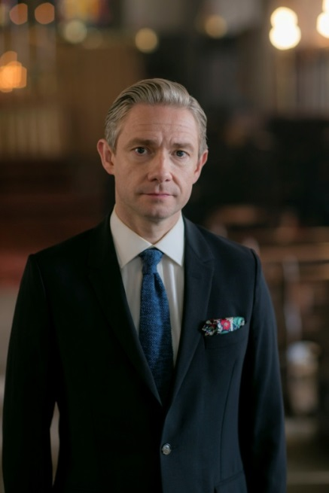
Watson is back without the moustache, how does that feel?
I thought it was a good look for the Christmas Special because it’s Victorian and its very Watsonesque - it’s a classic look but I’m not a huge fan of false moustaches. It doesn’t make your face feel very free and an actor’s face has to be free to express itself so if you’re afraid of this big walrus on your upper lip falling off then that’s not a great feeling! I’m very glad to be naked of that moustache.
John is looking very suave with his new hairdo, was it your idea?
Yes I just thought people change their hair in real life and with this show it’s always a fine balance between honouring what we have but also moving it on incrementally in tiny ways. John had different hair in the Christmas special and in the second episode of the first series he had kind of shaggy hair, so there have been little shifts. Ben isn’t quite as lucky as he has the iconic silhouette but there’s a little bit more leeway with John.
The Watsons are preparing for parenthood, how do they feel about it?
John and Mary are very excited about it - it’s their new life together. They’re married and now they’re going to start a family which is what people often do. They’re in a good place, they’re a loving married couple and it’s exciting.
Does playing new parents bring back memories of your own parenting experiences?
I think we’re reminded of certain things that you forget as parents, you forget what being in charge of a baby is like. Some of it is in the dim and distant recess of your memory and you remember things you did every day for what seemed like for ever, but it was a long time ago and so your mind moves on. So when you’re on a changing table or you’re doing nappy stuff or feeding stuff, it’s certainly like a bolt back to years ago. So yes that’s been a fun shared memory for us I think.
How does John and Mary’s relationship develop in this series?
The stakes gets higher because you get to know them more and every day their relationship grows. But Mary still seems a nice, fresh addition to the show even though it’s been a while now. You have to make that relationship grow without taking away from the central friendship of John and Sherlock. John and Mary are very happy together and they’ve been through stuff in series three that would test any couple, but they’re right through the other side of it and it makes them stronger.
Does John’s domestic life interfere with his and Sherlock’s crime solving life?
John is very happy to have a loving relationship, very happy to be a father and a husband but he would miss the adventures like crazy. There’s a subconscious reason he fell in with a mad bloke who goes around killing a lot, why he’s ended up as his flat mate and not a librarian’s flatmate. I love being at home but I would miss acting if I didn’t do it for more than a month and I do start to get edgy and I think John would be like that without crime fighting.
Do you think John has come to terms with Mary’s hidden past?
The John that we see as an audience, on the face of it, has let go of those revelations and I think he’s made peace with them but who knows. Even I don’t fully know what’s rumbling underneath there because when you find out something about someone you love that is a complete surprise that can take a while to digest. But I think what overshadows all of it is that he really loves her and wants to make it work and he does truly forgive her for not being honest and he knows that she’s got the same disease that he has which is that she needs the thrill as much as he does. She’s never going to be a stay at home Mum - she’s not cut out to be one of those people.
What changes will there be between John and Sherlock?
The fact John is with Mary and ensconced in that life and not living at Baker Street anymore changes something in the relationship between John and Sherlock. It wouldn’t be much of a show if it changed it to the extent there was just that domestic life and all we were doing were feeding babies and changing nappies and then Sherlock is off fighting crime on his own. It still has to be the same show so there has to be a bit of give and take. Obviously when you get married and have a baby that trumps everything else in real life but for this show John and Sherlock’s friendship has to stay central so it will still be very John and Sherlock centric but the reality is that John has moved on as he did in Conan Doyle’s books - he moved out and had his own life slightly away from that.
How would John’s life differ if he hadn’t met Sherlock?
John would have ended up in a bedsit on his own when he came back from Afghanistan - trying to become a Doctor, trying to get his own practice and becoming a GP I suppose. As we know, John likes excitement and the thrill of the adventure. For as much he thinks that war is hell and he’s lived through it. As many service personnel do there’s a feeling that something is missing when they come back to peace time.
They say never work with children or animals, in this series you do both, how did you find that?
I would go along with that - the babies were pretty easy actually. The dog not so much. I love dogs, I love animals and I love children but that adage comes about for a reason. Every time I read any script with loads of kids and animals I think we’ll remember that saying it is there for a reason. When it works it’s joyous but getting it to work can be tricky.
Describe John in 3 words.
Strong, loyal and funny.

Interview with Steven Moffat (Co-creator and Writer)
What do you mean when you say ghosts of the past are coming back?
By ghosts of the past we mean consequences. There are consequences to the kind of mad cap ‘in-the-moment’ fun lives that Sherlock and John and Mary lead. There are things that have happened, there are enemies that they have made, there is damage that has been done and some of that is coming back to visit them. There will be surprises and when some of those surprises happen you’ll think “ah I should have seen that coming”.
How have the main characters developed in this series?
That’s the whole story of this series, so I’m not talking about that! Events get out of their control for a while and we see them in their darkest hours and in their highest moments.
How does Sherlock feel about John and Mary’s new addition?
The thing about Sherlock Holmes is that he is a grown-up. We always like to pretend he’s an absolute lunatic but he does things well and he straightforwardly adores John and Mary, they’re his best friends. So he behaves probably better than most young men behave when their best mates are having babies. He’s pretty good at all that.
How strong is John and Sherlock’s relationship?
It’s a very powerful friendship. Now they don’t so much need each other as hugely enjoy spending time with each other. They are best buddies and they’re having the best time solving crimes together, they love it. At the beginning of series one they were two wounded beasts supporting each other, now at the beginning of series four they are at their best and the best of friends.
How has Mary affected their relationship?
Mary hasn’t affected the relationship with John and Sherlock at all. Mary and Sherlock like each other, I think Sherlock might have initially worried that he was losing his best pal but now he’s got two of them. She is a very smart lady so she knows that you don’t come between two best friends and allows and encourages that friendship to keep going. She herself adores Sherlock and those two actually have a quite separate friendship from Sherlock and Watson, so she hasn’t affected it at all, she’s enhanced it if she’s done anything.

Interview with Mark Gatiss (Co-creator, Writer and Mycroft Holmes)
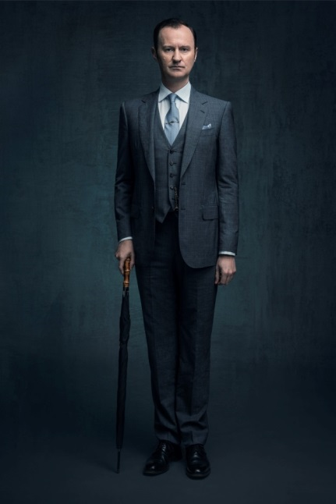
What can we expect from episode one of series four?
Traditionally we start with a lot of laughs. It’s been a considerable amount of time since the third series and a year since the special and you feel the need to reacquaint yourself with the gang, so we’ve introduced some fun stuff. That always seems to happen when we have to do the housekeeping to get out of last year’s cliff-hanger. So we have a bit of fun just enjoying Sherlock and John being back in Baker Street with Mary and the new arrival. Then essentially the ghosts of the past come back and the episode and the series get darker.
You wrote episode one, what was the inspiration behind it?
As ever we take our inspiration from Sir Arthur Conan Doyle’s stories to a greater or lesser extent. The story I’ve wanted to do for ages is The Red-Headed League and I thought this might be the one where I’d do it and I did have a little go at that, but it soon became apparent that the story this suited was The Six Napoleons, which is another favourite. It’s called The Six Thatchers now, but that book was the main inspiration, although really it’s the bare bones of the story.
How do the main characters develop in series four?
It’s very tough to say without giving anything away. They develop in various ways! There’s an ongoing humanisation of Sherlock, as Conan Doyle did in his books. He is a very different man from the first story to the last story. But he never becomes quite like us and nor should he. Doctor Watson trains him to be more like everybody else. He’s certainly more compassionate, he does know that he has friends who care for him and he goes through a massive emotional ringer this year, they all do for various reasons which I can’t explain. It’s a cliché to say it’s the darkest season, but it is. It’s the darkest but also the most meaty, with the most proper dramatic incident we could possibly throw at them all.
Is the Sherlock story about to reach its climax?
A lot of things we’ve been planning for a long time come to fruition, hopefully in a very satisfactory way. It doesn’t mean that it’s the final climax necessarily but it might do, who knows?
What can we expect from Mycroft this series?
Secrets and lies! The relationship develops with Sherlock again; it’s much spikier and more combative than in Conan Doyle’s stories. In this series we find out an awful lot more about why their relationship is like it is and where it gets to is interesting!

Interview with Amanda Abbington (Mary Watson)
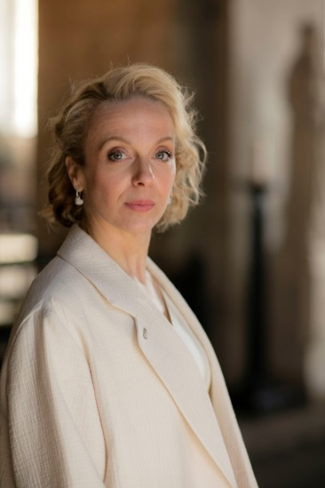
How did it feel to return to the Sherlock set?
It was brilliant being back on set, I love Sherlock and I love being a part of it and this series is particularly exciting and dramatic. It was great to be back with everybody, with loads of old faces and some new ones as well.
What makes working on Sherlock so special?
The thing about working on Sherlock that makes it so special is the fact that it’s so loved by people, so we do really feel that we’re making something that people are excited about seeing. That always gives us an added impetus to really make it the best that we can. It’s also great to be back with the old gang, I’ve been in it now for two series and the special, so it is like coming home to a family. Everyone does really get on and we have a lovely time so I love it.
Were you ever worried about the fans accepting Mary?
I was slightly anxious about the fans accepting Mary because she can be quite a divisive character. I mean, she shot Sherlock! She’s quite independent, she’s feisty and she doesn’t stand for any nonsense.
How is Mary feeling about impending motherhood?
They know it’s a girl so they’re very excited about that. When I was pregnant it was incredibly nerve wrecking and terrifying and exciting at the same time and I think that’s how she will be feeling. It doesn’t get in the way of her having adventures but it’s certainly the bump that stops her running after stuff. The impending baby is something that they’re both looking forward to a lot and Sherlock too actually, despite what he says.
Is there an element of Mary that still pines for her life as a secret agent?
I think Mary lives in both camps. On the one hand she yearns for the adventure part of her old life but there is still that excitement there with John and Sherlock. She also likes the domesticity of being with somebody who she loves and who loves her back. She’s never allowed that to happen to her before, so being with John makes her feel complete.
What impact has Mary had on John and Sherlock’s friendship?
The key thing that holds John and Sherlock’s friendship together is their love for each other, they are best friends. I think of my three best friends and how much I love them and how I can’t really be without them and that’s what those two have. They have this bond that can’t be broken, and Mary doesn’t get too involved with that. In the third series she was very keen to make sure they still had that friendship and she maintains that this series. She wants them both to be happy and to have their adventures together.
How would you describe Mary’s relationship with Sherlock?
Mary’s relationship with Sherlock is interesting, fiery and turbulent. He really likes her and she really likes him. They’re cut from the same cloth in terms of their need for excitement and adventure and they both have a mutual respect for each other.
How do the female characters affect Sherlock’s mind-set?
He respects Mrs Hudson, he respects Molly and he respects Mary. We’ve seen him grow throughout the four series and become more open.
It’s wonderful that Mark and Steven write very interesting, flawed and strong female characters. That’s great to watch and fantastic to play. All the women in the show love our characters, flaws and all.

Interview with Rupert Graves (Inspector Lestrade)
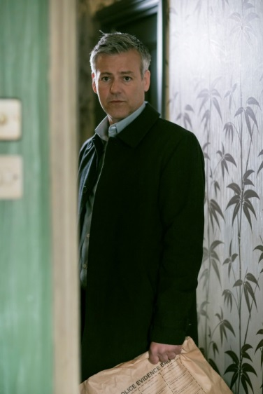
What can we expect from Lestrade in series 4?
I think this might be my favourite series! It sees Lestrade become more of a procedural copper. I don’t understand anything about what’s going to happen but it is mind blowing. Lestrade in his own lovely little way is struggling to understand what’s happening.
Do you think that Lestrade’s presence makes Sherlock show off more?
I can imagine that Sherlock probably couldn’t resist, the thing about Lestrade is that it’s quite easy to shine in his presence. I don’t think someone’s of Sherlock’s capacity needs to strain too many mental muscles to preen in front of Lestrade.
Does Lestrade wish he was more like Sherlock?
Lestrade has a double reaction to Sherlock. He’s obviously phenomenally impressed and marvels at his super brain, and at the same time jealous that Sherlock is infinitely better at his job than he is.
How different was it playing a Victorian version of Lestrade?
It was fun doing the Victorian Sherlock because I had to reconfigure the character of Lestrade. I enjoyed making the choices about what he wears in the modern incarnation but what would be the Victorian equivalent? That was fun, doing that. What was most interesting was the fact Lestrade and all the characters were projection - it was like looking through the prism of Sherlock’s mind, reinvented not only in a time difference but also through somebody else’s eyes. Lestrade only existed through Sherlock’s eyes, that’s kind of fun to do.
How is Sherlock different to working on other shows?
We’ve done four seasons and a special - it’s not very often that you do a job - a play or a film or even a TV series that you finish but to keep coming back and see the same people, same art department, same productions, same actors that’s the big difference for me.

Interview with Louise Brealey (Molly Hooper)
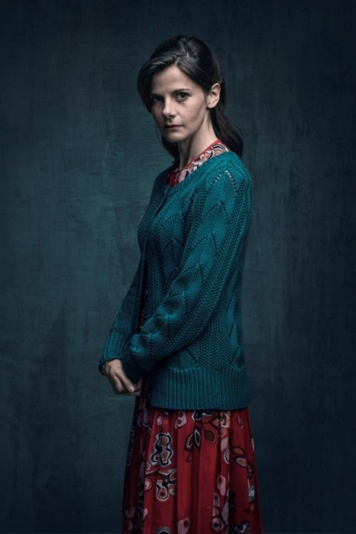
How was it being back on set?
I was just really glad to be back in the fold and part of the show again. It’s an amazing series and I think in terms of Molly it’s hard to say much without giving things away but there are some really beautiful moments which I’m really excited about.
What was it like being back after such a long break?
It’s weird because when you start after a couple of years gap you turn up at the first scene and some years I’ve come back and gone “oh god…, who am I who is she, who is she”? This year we had a big group scene on my first scene back - I didn’t even give her a thought – I just opened my mouth and though I haven’t thought about the character at all you don’t have to after all these years. She’s just there somewhere loafing about with the bone saw.
How would you describe series four?
Sad. Really sad. But I’m also really excited about series four and I think it might be the best one. There are some nasty creatures in series four and some of the magic that made you fall in love with the show right at the start.

