A FREDERICK WISEMAN FILM

NATIONAL GALLERY

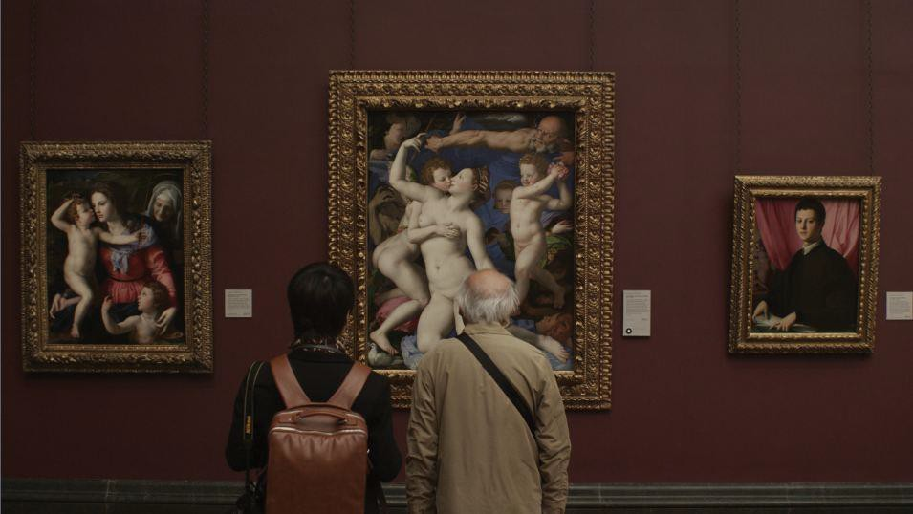

A Zipporah Films Release

2014, USA/FRANCE, 181 MINS, DCP

Synopsis

National Gallery takes the audience behind the scenes of a London institution, on a journey to the heart of a museum inhabited by masterpieces of Western art from the Middle Ages to the
19th century. National Gallery is the portrait of a place, its way of working and relations with the world, its staff and public, and its paintings. In a perpetual and dizzying game of mirrors, film watches painting watches film.

Frederick Wiseman Biography

Frederick Wiseman has made 39 documentaries and 2 fiction films. Among his documentaries are TITICUT FOLLIES, WELFARE, PUBLIC HOUSING, NEAR DEATH, LA COMÉDIE FRANÇAISE OU L'AMOUR JOUÉ, LA DANSE—LE BALLET DE L'OPÉRA DE PARIS, and AT BERKELEY. His documentaries are dramatic, narrative films that seek to portray the joy, sadness, comedy and tragedy of ordinary experience. He has won numerous awards including four Emmys, a MacArthur Prize Fellowship and a Guggenheim Fellowship. His films have played in theatres and been broadcast on television in many countries. He is also a theatre
director and has directed THE LAST LETTER, based on a chapter of Vasily Grossman's

novel LIFE AND FATE, and Samuel Beckett’s HAPPY DAYS at the Comédie Française. He is an Honorary Member of the American Academy of Arts and Letters and a Fellow of the American Academy of Arts and Sciences.

Credits

Director, Editor, Sound
Frederick Wiseman

Photography
John Davey

Sound Mix
Emmanuel Croset

Color Grading
Gilles Granier

Producers Frederick Wiseman Pierre-Olivier Bardet

Produced by
Gallery Film LLC and Idéale Audience

With the participation of
Canal + Planete + Le Fresnoy

With the support of:
Centre National de la Cinématographie (CNC), Public Broadcasting Service (PBS), Independent Television Service (ITVS), Pershing Square Foundation, LEF, Moving Image Fund, and Utah Film Center

Interview with FREDERICK WISEMAN
by Arnaud Hée Paris, April 12, 2014

Before At Berkeley, it may have seemed curious that you had never filmed a university. The same could be said of a museum before National Gallery.
Both films are projects that I have nurtured for some time, but I can’t be everywhere at once! I
thought of making a film about a museum at least 30 years ago, but other projects intervened in between times. And for this type of location, permission to shoot can be difficult to obtain.

There are many “reproductions” of paintings in the film. Were there any specific issues linked to the right to film the artworks?
No, to the extent that the museum’s permission to film includes the art. And the particularity of this
collection is that is begins in the 13th century and ends in the 19th century, so there is no problem of copyright.

What is your personal relationship to painting and museums?
That of an enlightened amateur. I took some art courses at university and I always visit museums on my travels.

Of the many museums that might fit the bill, had you set your heart on the National Gallery? Yes, I had decided to approach the National Gallery because its collection is one of the best in the world and covers a significant part of the history of painting, with its 2,400 works. Also, with regard to other museums of similar quality, it is quite small compared to the Louvre in Paris, the Metropolitan in New York or the Prado in Madrid. And even if it’s relatively small-scale, it’s fascinating to explore all that goes on there, besides the interaction with the art. Moreover, It amuses me greatly that the foundations for the collection were laid by a major auction of the Duke of Orléans’ collection after the French Revolution, which is an aspect that I slip into the film.

You apply similar methods from one film to the next, but were you faced here with the need to devise an approach to filming the paintings?
How to film paintings? It’s an exceedingly complex issue, especially bearing in mind the large
number of artworks. The guiding principle was to break the frame— the framing and hanging of the paintings—in order to step into the picture. To do so, I used an approach similar to making a film, alternating between wide shots and close-ups, and then working on the depth of field in the paintings. On film, the painting comes to life if you don’t see the wall, frame, or card to one side
with the artist’s name, title, date and technical details. Then, the painting becomes an object. My aim
was to suggest that the painting is alive and tells a story all of its own.

The question of power and hierarchy in the functioning of the museum features in the film, but there is no sense that it was your principal concern.
Hardly! We film the meeting of the executive committee. But, to my mind, the paintings were much
more interesting than internal conflicts or politicking. There is not a single human experience that is not covered by the artworks, and in greater depth than any exposé of power struggles within the institution could achieve. The paintings contain something of everything. From cruelty to tenderness, it’s all there! There is also a field of tension with the “outside world”: budgetary issues, the word “marketing” that keeps cropping up, PR, private sponsorship, especially of a sports event... Of
course, the outside world is present. I aim to show all I can, and definitely not dodge any of those aspects.

Is it possible to see this film as part of a cycle in your filmography encompassing La danse, Le Ballet de l’Opéra de Paris (2009), Crazy Horse (2011), At Berkeley (2013) and National Gallery? Each, in its own specific way, raises the issue of culture and heritage, and how they can be passed on to others, as well as how places of culture and knowledge adapt to the world. I am primarily guided by circumstance. I want to film in the largest number of places possible, to capture contemporary life, in the time that is given to me to work and live. In National Gallery, contemporary life is strongly linked to the past. But I don’t think in terms of cycles, because the order in which I shoot my films is determined by chance and possibilities that arise. For example, I always wanted to film at La Comedie Française. The idea occurred to me fifteen years before it happened. One day, a friend called me to say that she thought now was a good time. After that, I directed plays at La Comedie Française and, in so doing, met people from the Opera. That led me to La Danse. Reflecting on ballet and choreography gave me the idea for Crazy Horse. Meantime,
Boxing Gym was conceived in terms of the relationship between ballet and boxing. It’s accumulated
experiences that take me toward places or institutions. From film to film, I bring the experience of all the others. If we take another step back, the first film I directed that concerns dance was Basic Training (1971), a film about a military battalion in training, with scenes that I edited in an abstract way, but with a precise sense of choreography in mind. Those are the links between my films.

How long did you shoot for?
Around twelve weeks, from mid-January to mid-March 2012, on an almost daily basis—I think I only took two weekends off in all that time. It’s no coincidence that I often choose places that are open seven days a week. And my daily rhythm is intense, around twelve hours a day, because it’s interesting to observe events before the museum opens and then late at night also. When you start, you’re always worried you’ll miss something if you’re not there, even though you’re bound to miss things.

A few years ago, you said that your filmography was a single film running 80 hours...
Yes, but I never updated the counter! I’ll have to one day, but it must be around 90 hours now.

In terms of the sound, which you recorded on this and most of your previous films, did you decide on a particular approach?
For me, the logic is the same as for the photography— it’s instinctive and guided by the desire to
have material to edit and, perhaps, to play around with in mixing. I don’t ask major theoretical or

metaphysical questions of myself when I’m shooting.

It is fascinating, the way you frequently get the artworks to tell a story by fragmenting them, deconstructing the unit of time and space of the painting. Is this the fruit of a lot of research and testing different techniques?
The aim of the shoot for me is to give myself as many options as possible in editing. From the start, I
knew that this was a particularly complex subject, so I tried to cover my back and have everything I might need. In editing, I proceed by trial-and-error because I’m incapable of working in an abstract manner. I have to do something to see if it works. I try to find associations and those associations lead to others, and so on.

Fairly logically, an important theme of the film is the eye—the viewpoint of the public, the audience and even the paintings. How did you approach that?
Very simply. The eye is a central issue in cinema. National Gallery is therefore, through painting,
constantly concerned by cinematic issues.

Without trying to be ironic or contrarian, and without comparing a museum’s public to that of
a zoo, another of your films that focuses on this question is Zoo (1993)...
(Laughs) Indeed. Because the animals look at the people and vice-versa. But I don’t wish to distort this relationship between points of view in National Gallery, nor put it onto a similar level as in Zoo. I think that you can’t do that without irony. But the whole concept of the eye is inherent to film, and perhaps even more so to documentaries.

Unlike in Zoo, in National Gallery, we don’t see the public recording what is before their eyes with various devices rather than experiencing it with the naked eye...
Simply because it is forbidden to use such devices in the National Gallery.

The spoken word is another central theme of the film. You take a close interest in the connection between image and verbalization of the images, and in the articulation of these representations. Questions of script and narrative frequently recur.
That is precisely one of the main topics of the film, and that is what the audience experiences. If I
could explain it in 25 words, why make a film? It’s an extremely complex question, and I hope the
film raises the issue through the manner in which I edited it.

The language and register change constantly, adjusting to the listener.
Yes, and what this phenomenon suggests is fascinating. It resolves nothing but raises a lot of questions.

It’s an interpretation, but facing an audience that one presumes to be underprivileged, and mostly made up students of African origin, the guide mentions slavery. Did you intend to flag this adjustment in discourse?
What the guide says is true! Part of the collection was bought with profits from the slave trade. It
adds to the complexity of the question, but there is no predetermined significance in this scene, although it is important to think about what the guide says.

But it is perhaps the scene where the adjustment in register is clearest, or most significant in
terms of the background of the guide’s audience.
I don’t know the guide who said that. Perhaps she does emphasize the point because of the makeup of the group, but I am sure that it’s an integral part of her own political outlook. I presume that the she also mentions it when the group is mainly white.

This question of discourse involves complex editing between picture and sound.
I played on associations, sometimes literal ones. For example, with Rubens’ Samson and Delilah, when the guide talks about the light, I illustrate it with motifs from the painting. In this case, I want the audience to see what is being talked about. In other situations, such as the piano recital amid the paintings, the way the scene works is much more abstract and implicit: paintings are all around, interacting with the concert audience, and the editing attempts to find something essentially rhythmical and evocative, perhaps to say something more that may have nothing to do with music.

In a general way, throughout the film, we are watching a constant mise en abyme of painting and film.
Exactly. It could be for that reason that the film transcends, in its content, the daily events occurring
in the museum.

One of those mises en abyme resides in the relationship between film and exhibition. Juxtaposing images, linking them, provoking a connection between them— the process is the same in a museum or an editing suite. Do you have a sense of making a film about film, and perhaps about your personal approach as a filmmaker?
It’s a question that fascinates me, and it’s not the first time I’ve addressed the issue, but it’s one way
of watching the films, not the only one. I realize that what I tried to deal with here is of great
complexity. It’s almost certainly my most abstract film.

The curator of the Leonardo da Vinci exhibition talks about the installation of the exhibition in
terms of a “mosaic,” which is a term you use yourself to describe the editing of your films? For At Berkeley, I had 250 hours of footage, and 170 hours for National Gallery... I always shoot a huge amount, so my films are always mosaics! It involves selection—making subjective choices— based on the experience of a shoot where I accumulated a lot of material. The aim in editing is to find a structure and rhythm, about which I have no preconceived ideas. My films are always a
journey of discovery, unlike films of fiction that, without caricaturing the process, are shot according to stipulations in the script. It’s the same with the themes of my films. They come out of what I find. It’s all based on surprise.

Do you put yourself in a position to discover things as if for the first time?
Yes, and I try to convey that surprise—transmit or suggest it to the audience—along with all that I
also learned.

It’s a troubling moment when we hear that Nicolas Poussin painted in the knowledge that he would be hung next to Mantegna, and took this into account in his chromatic choices. That is also, in some way, a form of editing.
Yes, you could say that.

Setting out with 170 hours of footage, what were the different stages of the editing enterprise? Firstly, when I get home after the shoot, I watch everything, which takes 7-8 weeks. I often joke that I apply the Michelin Guide system: three, two, one or no stars. Usually, about half the footage
survives, and I then edit it into sequences I think I can use— both in terms of picture and sound. This phase takes about 6-8 months. And when I have edited up all these “potential” scenes, I put together
a rough cut. That can be pretty quick, and in that phase I play with order, rhythm and associations. The resultant cut comes in around three-quarters of an hour over the eventual running time. At the same time, I review all my footage to be sure I haven’t left anything out that might be important with regard to the structure I have found. Or there may be a shot that strengthens the rhythm or a transition.

The final ballet—machine set to William Byrd’s Miserere mei—has the effect of a painting that begins to move, that comes alive.
It was a museum event. Wayne MacGregor, whom I met when making La Danse, choreographed a
piece in response to the exhibition Metamorphosis: Titian, articulated around the desire to make bodies dance in dialogue with the paintings. When I heard about that, I asked if I could film it. These interconnections between art forms greatly interest me. They are also a common thread in my films.

