THE VOICE Season 14 Finalist SPENSHA BAKER JOINS ALL-STAR LINE-UP FOR PBS’ NATIONAL MEMORIAL DAY CONCERT
AN AMERICAN TRADITION HONORING OUR HEROES

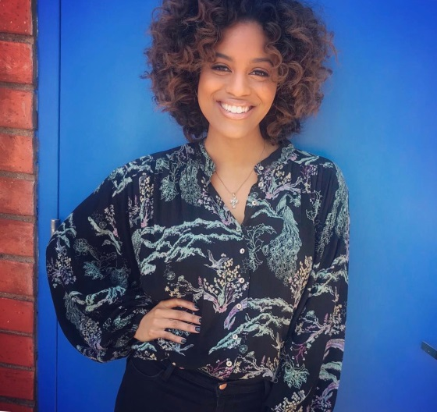
Spensha Baker, THE VOICE finalist
On the 150th anniversary of Memorial Day, PBS’ multi award-winning NATIONAL MEMORIAL DAY CONCERT welcomes THE VOICE Season 14 finalist Spensha Baker, to open the show with a special performance of the “National Anthem,” honoring the service and sacrifice of all our men and women in uniform, their families at home and those who have made the ultimate sacrifice for our country. A 29-year tradition unlike anything else on television, America’s national night of remembrance takes us back to the real meaning of the holiday through personal stories interwoven with musical performances.

“For me the ‘National Anthem’ is as symbolic as it gets when it comes to America,” said Baker. “The fact that my parents served and defended this great nation instilled into me the love and national pride for America, our military and their families. The ‘National Anthem’ gives me the opportunity to show my unwavering love to those who served in our great military and for those who are sacrificing and serving today. The ‘National Anthem’ invokes pride, patriotism and honor within me. It’s an iconic symbol of this nation that can be shared with everyone, no matter what your background is. The ‘National Anthem’ is America....The ‘National Anthem’ is me. I love this country!!”

The 29th annual broadcast of the NATIONAL MEMORIAL DAY CONCERT will recognize our Korean War veterans; mark the 50th anniversary of the Battle of Khe Sanh, one of the fiercest battles of the Vietnam War; and pay tribute to the contributions of women in our military throughout history. The concert airs live on PBS from the West Lawn of the U.S. Capitol on Sunday, May 27, 2018 from 8:00 to 9:30 p.m. ET before an on-site audience of hundreds of thousands, millions more at home, as well as to our troops serving around the world on the American Forces Network.

Hosted by Tony Award-winner Joe Mantegna and Emmy Award-winner Gary Sinise, the all-star line-up includes: distinguished American leader General Colin L. Powell USA (Ret.); Academy Award, Golden Globe and Emmy Award winning actress Allison Janney (I, Tonya, “Mom,” “The West Wing”); Academy Award-nominated actor Graham Greene (Dances With Wolves, Wind River); Emmy, Golden Globe and SAG Award-nominated actor John Corbett (My Big Fat Greek Wedding); star of “Chicago Med” Brian Tee; Tony-nominated actress and star of TV’s “Falling Water,” “The West Wing” and “Loaded,” Mary McCormack; actor and country singer Charles Esten (“Nashville”); Tony, Grammy and Emmy Award-winning actress and singer Cynthia Erivo (The Color Purple); three-time Grammy Award-nominee singer/songwriter Leona Lewis; Tony-nominee and star of NBC’s hit TV show “Smash,” Broadway and TV’s Megan Hilty; acclaimed tenor and Broadway star Alfie Boe (Les Misérables); and Gary Sinise & The Lt. Dan Band, marking 15 years and over 400 concerts entertaining our troops, veterans and military families; in performance with the National Symphony Orchestra under the direction of top pops conductor Jack Everly.

The concert will also be live-streamed on PBS, You Tube, Facebook and www.pbs.org/national-memorial-day-concert and available as Video on Demand, May 28 to June 10, 2018.

Underwriters
The NATIONAL MEMORIAL DAY CONCERT is made possible by grants from the Lockheed Martin Corporation, the National Park Service, the Corporation for Public Broadcasting, the Department of the Army, General Dynamics, PBS and public television stations nationwide.

– PBS –

CONTACT:
Kristina Hallman: (202) 537-5199; khallman@starpower.net
Carol Marshall: (818) 385-1396; carol@cmarshallpr.com

For images and additional information, visit PBS Pressroom at www.pbs.org/pressroom

Visit the program website at http://www.pbs.org/national-memorial-day-concert/home/

Connect with us on:
http://www.facebook.com/memorialdayconcert
twitter.com/MemorialDayPBS (#MemDayPBS)
instagram.com/memdayPBS

