

Anchor and Correspondent Bios

JEFF GREENFIELD, Anchor, NEED TO KNOW

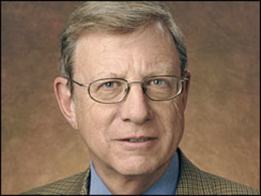
Jeff Greenfield, a veteran political, media and culture reporter and analyst, has spent more than 30 years on network television. He most recently served as CBS Senior Political Correspondent.

Prior to his return to CBS News, Greenfield had been senior analyst for CNN since 1998. During that time, he served as lead analyst for its coverage of the primaries, conventions, presidential debates and election nights, as well as presidential funerals and Supreme Court confirmation hearings. Greenfield also has reported on the media, culture and trends for the cable network.

Though the five-time Emmy winner’s reporting has taken him to locales around the world, from South Africa to Japan to Europe, he is principally known for his coverage of domestic politics and media. He has served as a floor reporter or anchor booth analyst for every national convention since 1988. He has twice been named to TV Guide’s All-Star team as best political commentator and was cited by the Washington Journalism Review as "the best in the business" for his media analysis.

Before joining CNN, Greenfield was a political and media analyst for ABC News (1983-97), appearing primarily on "Nightline" and delivering weekly commentaries for "World News" Sunday.

Previously, he was the media commentator for CBS News (1979-83). Greenfield has also has appeared on William F. Buckley's FIRING LINE and PBS' WE INTERRUPT THIS WEEK. He was the anchor of PBS' CEO EXCHANGE, a limited-run series, for five seasons.

Greenfield, a native of New York City, graduated with honors from the University of Wisconsin, where he was editor-in-chief of The Daily Cardinal. He is an honors graduate of the Yale Law School, where he was a Note and Comment Editor of the Yale Law Journal.

Following law school, Greenfield worked as a speechwriter in the Senate office and in the 1968 presidential campaign of Robert F. Kennedy. He then worked as chief speechwriter for New York mayor John Lindsay.

Greenfield spent seven years with famed political consultant David Garth, and wrote books and magazine articles as well.

His work has appeared in many publications, including The New York Times Magazine, Harper's and National Lampoon. Greenfield is the author or co-author of 12 books. His first novel, The People's Choice (1995), was a national best-seller and was named by The New York Times Book Review as one of the notable books of the year. Oh, Waiter, One Order of Crow (2001), is an insider's account of the contested 2000 presidential election. His most recent book Then Everything Changed; Stunning Alternate Histories of American Politics was published in March 2011.

Ray Suarez, Anchor, NEED TO KNOW

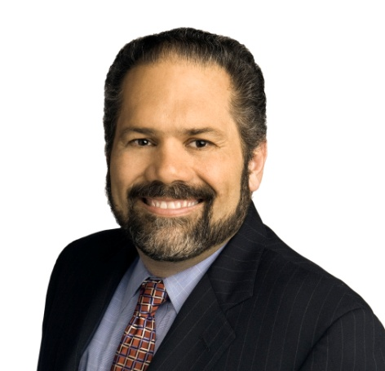
Ray Suarez joined THE PBS NEWSHOUR in October 1999 as a Washington-based senior correspondent.

Suarez has more than 30 years of varied experience in the news business. He came to THE NEWSHOUR from National Public Radio, where he had been host of the nationwide, call-in news program "Talk of the Nation" since 1993. Prior to that, he spent seven years covering local, national and international stories for the NBC-owned station WMAQ-TV in Chicago.

He is currently writing the companion volume to an upcoming PBS documentary series on the history of Latinos in America. His 2006 book, The Holy Vote: The Politics of Faith in America, examines the tightening relationship between religion and politics in the United States. Suarez also wrote The Old Neighborhood: What We Lost in the Great Suburban Migration (Free Press), and has contributed to several other books, including What We See (New Village Press, 2010), How I Learned English (National Geographic, 2007), Brooklyn: A State of Mind (Workman, 2001), Local Heroes (Norton, 2000), Saving America's Treasures (National Geographic, 2000) and Las Christmas (Knopf, 1998).

Earlier in his career, Suarez was a Los Angeles correspondent for CNN, a producer for the ABC Radio Network in New York, a reporter for CBS Radio in Rome and a reporter for various American and British news services in London. Over the years, he has narrated, anchored or reported many documentaries for public radio and television, including the nationally broadcast ANATOMY OF A PANDEMIC (PBS, 2009) and JERUSALEM: THE CENTER OF THE WORLD (PBS, 2009), a weekly series, FOLLOW THE MONEY (PBS, 1997) and programs including YESTERDAY (WETA, 2006), WHO SPEAKS FOR ISLAM? (LinkTV, 2005, 2009), BY THE PEOPLE (PBS, 2004-07), THE JOURNEY HOME (WETA, 2004), THE EXECUTION TAPES (Public Radio, 2001) and THROUGH OUR OWN EYES (KQED, 2000).

Suarez was a co-recipient of NPR's 1993-94 and 1994-95 duPont-Columbia Silver Baton Awards for on-site coverage of the first all-race elections in South Africa and the first 100 days of the 104th Congress, respectively. He was honored with the 1996 Ruben Salazar Award from the National Council of La Raza and the 2005 Distinguished Policy Leadership Award from UCLA's School of Public Policy. The Holy Vote won a 2007 Latino Book Award for Best Religion Book

Suarez holds a B.A. in African History from New York University and an M.A. in the Social Sciences from the University of Chicago. He has been awarded honorary doctorates by many colleges and universities, most recently by the State University of New York at Plattsburgh. He is a winner of the Benton Fellowship in Broadcast Journalism at the University of Chicago. He has also been honored with a Distinguished Alumnus Award from NYU and a Professional Achievement Award from the University of Chicago.

Inducted into the National Association of Hispanic Journalists’ Hall of Fame in 2010, Suarez was a founding member of the Chicago Association of Hispanic Journalists. A native of Brooklyn, New York, he lives in Washington, DC, with his wife and three children.

Scott Simon, Anchor, NEED TO KNOW

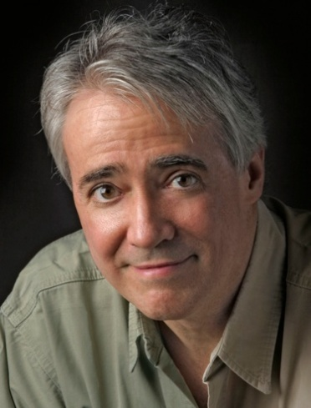
Scott Simon is one of America’s most admired writers and broadcasters. He has reported from all 50 states, five continents and 10 wars, from El Salvador to Sarajevo to Afghanistan and Iraq. His books have chronicled character and characters, in war and peace, sports and art, tragedy and comedy.

His radio show, NPR’s “Weekend Edition with Scott Simon,” has been called by the Washington Post “the most literate, witty, moving, and just plain interesting news show on any dial,” and by Brett Martin of Time-Out New York “the most eclectic, intelligent two hours of broadcasting on the airwaves.” Simon has won every major award in broadcasting, including the Peabody, the Emmy, the duPont-Columbia, the Ohio State Award, the Robert F. Kennedy Journalism Award and the Sidney Hillman Award. He received the Presidential End Hunger Award for his coverage of the Ethiopian civil war and famine, and a special citation from the Peabody Awards for his weekly essays, which were cited as “consistently thoughtful, graceful, and challenging.” He has also received the Barry M. Goldwater Award from the Human Rights Fund. Recently, he was awarded the Studs Terkel Award.

He has hosted many television specials, including PBS’ STATE OF MIND and VOICES OF VISION. THE PATERSON PROJECT won a national Emmy, as did his two-hour special from the Rio earth summit meeting. He co-anchored PBS’ Millennium 2000 coverage in concert with the BBC, and has co-hosted the televised duPont-Columbia Awards. He also became familiar to viewers in Great Britain as host of the continuing BBC series, “Eyewitness,” and a special on the White House press corps. He has appeared as a guest and commentator on all major networks, including BBC, NBC, CNN and ESPN.

Simon has contributed articles to the New York Times, the Los Angeles Times, the New York Times Book Review, The Wall Street Journal, the Sunday Times of London, The Guardian and Gourmet, among other publications, and won a James Beard Award for his story, “Conflict Cuisine” in Gourmet. He has received numerous honorary degrees.

Sports Illustrated called his personal memoir Home and Away, “extraordinary … uniformly superb … a memoir of such breadth and reach that it compares favorably with Fredrick Exley’s A Fan’s Notes.” It was at the top of several non-fiction best-seller lists. His book, Jackie Robinson and the Integration of Baseball, was Barnes and Nobles’ Sports Book of the Year. His novel, Pretty Birds, the story of two teenage girls in Sarajevo during the siege, received rave reviews, Scott Turow calling it, “the most auspicious fiction debut by a journalist of note since Tom Wolfe’s … always gripping, always tender, and often painfully funny. It is a marvel of technical finesse, close observation, and a perfectly pitched heart.” Windy City, his second novel, is a political comedy set in the Chicago City Council. Baby, We Were Meant for Each Other, an essay about the joys of adoption, was published in August 2010.

Simon is a native of Chicago and the son of comedian Ernie Simon and Patricia Lyons Simon. His hobbies are books, theater, ballet, British comedy, Mexican cooking and “bleeding for the Chicago Cubs.” Simon appeared as Mother Ginger in the Ballet Austin production of The Nutcracker. He is married to Caroline Richard, a fan of the Yankees and the French national soccer team. They have two daughters, Elise and Lina.

Maria Hinojosa, Correspondent, NEED TO KNOW

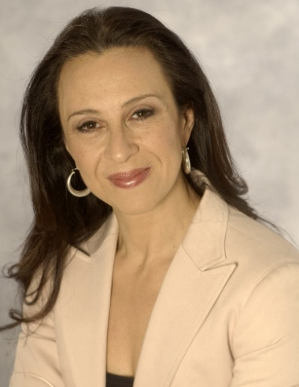
For 25 years, Maria Hinojosa has helped tell America’s untold stories and brought to light unsung heroes in America and abroad. In April 2010, Hinojosa launched The Futuro Media Group with the mission to produce multi-platform, community-based journalism that respects and celebrates the cultural richness of the American experience. She is currently reporting for Frontline on Immigration.

As the anchor and managing editor of her own long-running weekly NPR show, “Latino USA,” and anchor of the Emmy Award-winning talk show “Maria Hinojosa: One-on-One” from WGBH/ La Plaza, Hinojosa has informed millions of Americans about the fastest growing group in our country. Previously a senior correspondent for NOW on PBS and currently a contributing correspondent for NEED TO KNOW, Hinojosa has reported hundreds of important stories — from the immigrant work camps in NOLA after Katrina to female teen victims of sexual harassment on the job to Emmy Award-winning stories of the poor in Alabama. Her investigative journalism presses the powerful for the truth while giving voice to lives and stories that illuminate our world. Hinojosa has won top honors in American journalism including two Emmys, the Robert F. Kennedy Award for Reporting on the Disadvantaged, and the Edward R. Murrow Award from the Overseas Press Club for best documentary for her groundbreaking “Child Brides: Stolen Lives.” In 2009, Hinojosa was honored with an AWRT Gracie Award for Individual Achievement as Best TV correspondent. In 2010 she was awarded an honorary degree, Doctor of Humane Letters, by DePaul University in Chicago, as well as the Sidney Hillman Prize honoring her social and economic justice reporting.

Throughout her career, she has helped define the conversation about our times and our society with one of the most authentic voices in broadcast. As a reporter for NPR, Hinojosa told groundbreaking stories about youth and violence and immigrant communities. During her eight years as a CNN correspondent, Hinojosa took viewers into communities that had never been shown on television. Three times over the past decade, Hinojosa has been named one of the 100 Most Influential Latinos in the United States by Hispanic Business magazine. She has received the Ruben Salazar Communications Award from the National Council of La Raza and was inducted into the “She Made It” Hall of Fame at the Paley Center/Museum of Television and Radio in a program that honors women trail blazers in the media.

Hinojosa writes a weekly syndicated column for King Features/Hearst and is author of two books, including a motherhood memoir, Raising Raul: Adventures Raising Myself and My Son. Born in Mexico City and raised in Chicago, she received her BA from Barnard College. She is married to the artist German Perez. They live with their son and daughter in Harlem, New York City.

Jon Meacham, Contributor/Essayist, NEED TO KNOW

Jon Meacham is a Pulitzer Prize-winning biographer and the former editor of Newsweek. He arrived at the magazine as a writer in 1995, became national affairs editor that year, was named managing editor in 1998 and was appointed to his most recent position in 2006.

His book American Lion: Andrew Jackson in the White House was published by Random House in November 2008. It debuted at #2 on The New York Times best-seller list and became a Times Notable Book. On April 20, 2009, American Lion was awarded the Pulitzer Prize.

Meacham is also the author of two other New York Times best-sellers—American Gospel: God, the Founding Fathers, and the Making of a Nation and Franklin and Winston: An Intimate Portrait of an Epic Friendship, about the wartime relationship between Roosevelt and Churchill. In 2009, Meacham was elected to the Society of American Historians and serves on its executive board.

He has written for The New York Times Book Review, The Washington Post, Slate and The Los Angeles Times Book Review. In 2001, he edited Voices in Our Blood: America’s Best on the Civil Rights Movement (Random House), a collection of distinguished nonfiction about the mid-century struggle against Jim Crow. He has served as a judge for the Robert F. Kennedy Book Award and was awarded the Hubert H. Humphrey First Amendment Freedoms Prize by the Anti-Defamation League.

A member of the Council on Foreign Relations, he received an honorary Doctor of Humane Letters degree from the Berkeley Divinity School at Yale University in 2005 and holds three other honorary doctorates.

