New PBS Performing Arts Series, NEXT AT THE KENNEDY CENTER “Ballet Hispánico’s Doña Perón,” Features Exploration of Eva Perón’s Life and Diverging Legacies

Emotional Ballet Hispánico Performance of Eva’s “Rags-to-Riches” Journey Premieres on PBS, Friday, April 14, 10-11:30 p.m. ET

Screener and Images Available on PBS PressRoom
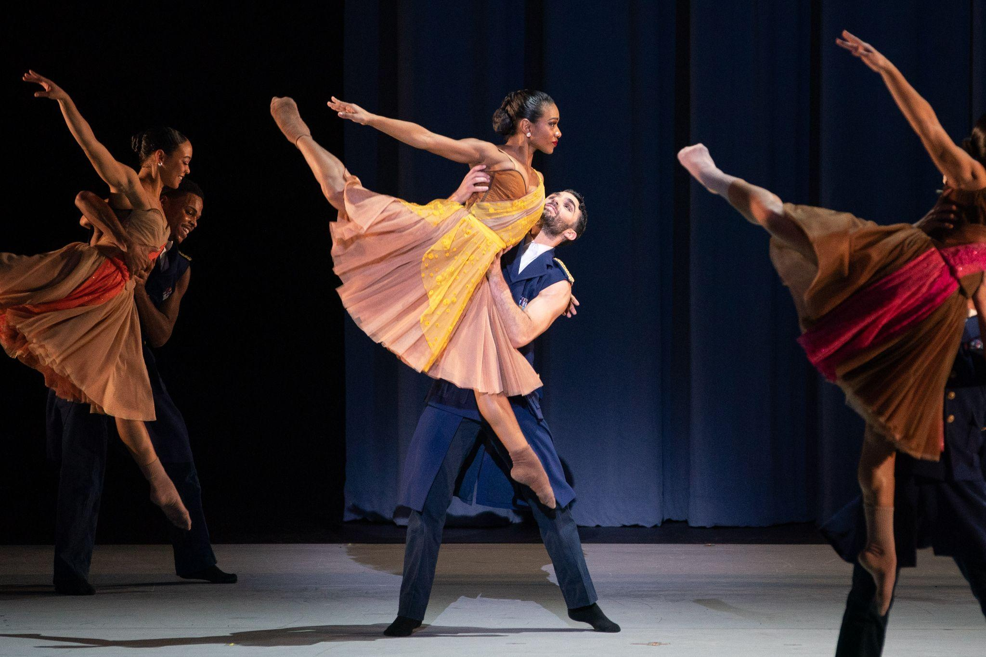
ARLINGTON, Va. – March XX, 2023 – PBS today announced that the next installment of NEXT AT THE KENNEDY CENTER, a series from the pubcaster’s multi-year collaboration with the John F. Kennedy Center for the Performing Arts, will feature Ballet Hispánico’s explosive portrait of Eva “Evita” Perón – one of the most captivating and controversial women in Argentinian history. Anchored by a riveting Ballet Hispánico performance – choreographed by the highly sought-after and award-winning Annabelle Lopez Ochoa and set to music by composer Peter Salem at the Kennedy Center’s Concert Hall – the special explores Eva’s rags-to-riches journey from illegitimate daughter to dancehall performer, acclaimed radio personality to Argentina’s First Lady, and her untimely death in her early thirties. NEXT AT THE KENNEDY CENTER “Ballet Hispánico’s Doña Perón” premieres Friday, April 14 at 10-11:30 p.m. ET (check local listings) on PBS, PBS.org, and the PBS app.

Ballet Hispánico’s Dandara Veiga (Eva “Evita” Perón), Chris Bloom (Juan Perón), and the company’s ensemble bring Doña Perón’s inner conflict and the extremes of power and powerlessness in life to light. Loved by Juan Peron but rejected by the aristocracy, Eva was dedicated to justice yet part of a regime with fascist tendencies. Her work as an activist and advocate for Argentina's women and working class raised skepticism as she indulged in the opulence of a high-class life. Was she a voice for the people, or a deceitful actress?

Through interviews with performers and Ballet Hispanico’s creative team, NEXT AT THE KENNEDY CENTER “Ballet Hispánico’s Doña Perón” explores the significance of Doña Perón and the process behind its conception and creation. A story most widely known to be associated with Andrew Lloyd Webber’s Broadway musical, Ballet Hispánico – led by Artistic Director and CEO Eduardo Vilaro – forged a partnership with Lopez Ochoa to provide the opportunity for creative leaders with Latin heritage to reclaim the story’s narrative and present its own interpretation of the historical icon.

For over fifty years Ballet Hispánico has provided a place of honor for the omitted, overlooked, and othered. Founded in 1970 by National Medal of Arts recipient Tina Ramirez, Ballet Hispánico is now headed by Vilaro, who was recruited as a dancer by Ramirez in 1985. Vilaro, who emigrated from Cuba when he was five years old, carries on Ramirez’s legacy to create a home that celebrates Hispanic diasporas. It’s no surprise the themes in Doña Perón mirror the lives lived by the artists who created and performed this powerful piece. Uprooted from their childhood homes, forced to learn a new language and a new culture, members of the company tell their stories of resilience as they come to terms with where they came from and who they are today. Each, like Eva, has to face the duality within us all in our search for achievement and inner peace. Through these lived experiences and with their dedication to the highest levels of dance, the company is able to effectively capture the essence of these ideas ever-present in her story.

The work’s music, composed by Salem, carries an emotional line of storytelling. Traditional Argentine music from the era is felt throughout, with consistent motifs and thematic melodies relating to characters and events throughout the story. The visual setting, including use of shadows and silhouettes are felt as extensions of the choreography – embodying her inner-struggle and journey into proverbial sainthood. The dancers, music, and thematic elements come together in stunning fashion as we are taken through this emotional journey and Eva’s everlasting quest for acceptance.

NEXT AT THE KENNEDY CENTER, a new series of primetime performance specials, shines a spotlight on the Kennedy Center’s contemporary culture program, bringing the best of the nation’s stage to viewers across the country. Captured to match the unique style of the artists, each episode weaves together performances filmed live at the Kennedy Center with intimate off-stage moments and first-person commentary.

Previous installments of NEXT AT THE KENNEDY CENTER “Let My Children Hear Mingus,” “A Joni Mitchell Songbook” and “The Roots Residency” are currently available for streaming on PBS Passport. Upcoming episodes premiering on PBS (check local listings) include “Ballet Hispánico’s Doña Perón” (April 14 at 10 p.m. ET) and “Continuum: Jason Moran & Christian McBride” (April 21 at 10 p.m. ET).

NEXT AT THE KENNEDY CENTER is a production of the John F. Kennedy Center for the Performing Arts. Matthew Winer and Steve Holtzman serve as executive producers for the Kennedy Center. Kristin Fosdick directs the series with her team in the Kennedy Center’s multimedia department.

NEXT AT THE KENNEDY CENTER was made possible, in part, by The Rosalind P. Walter Foundation and by contributions from public television viewers.

About Ballet Hispánico
Ballet Hispánico is the largest Latinx/Latine/Hispanic cultural organization in the United States and one of America's Cultural Treasures. Ballet Hispánico's three main programs, the Company, School of Dance, and Community Arts Partnerships bring communities together to celebrate the multifaceted Hispanic diasporas. Ballet Hispánico's New York City headquarters provide the physical home and cultural heart for Latinx dance in the United States. It is a space that initiates new inclusive cultural conversations and explores the intersectionality of Latine cultures. The Ballet Hispánico mission opens a platform for new social dialogue, and nurtures and sees a community in its fullness. Through its exemplary artistry, distinguished training program, and deep-rooted community engagement, Ballet Hispánico champions and amplifies Latine voices in the field. For over fifty years Ballet Hispánico has provided a place of honor for the omitted, overlooked, and othered. As it looks to the future, Ballet Hispánico is pushing the culture forward on issues of dance and Latine creative expression.

About the Kennedy Center
The John F. Kennedy Center for the Performing Arts is America’s living memorial to President John F. Kennedy, attracting millions of visitors each year to more than 2,000 performances, events, and exhibits. With its artistic affiliates, the National Symphony Orchestra and Washington National Opera, the Center is one of the nation’s busiest performing arts centers dedicated to providing world-class art, powerful education, and outstanding memorial experiences to the broadest possible constituency. Across all its offerings, the Kennedy Center is committed to increasing accessible, inclusive opportunities for all people to participate in, and learn through the arts, including more than 400 free performances each year and a variety of specially priced ticket programs for students, seniors, persons with disabilities, and others. On Sept. 7, 2019, the Kennedy Center inaugurated the REACH, its first-ever major expansion. Designed by Steven Holl Associates, the REACH provides visitors with new opportunities to interact and engage with the Center as the nation’s premier nexus of arts, learning, and culture. On Sept. 8, 2022, the Kennedy Center unveiled Art and Ideals: President John F. Kennedy, a new 7,500-square-foot permanent exhibit exploring Kennedy’s presidency and his commitment to the arts.

About PBS
PBS, with more than 330 member stations, offers all Americans the opportunity to explore new ideas and new worlds through television and digital content. Each month, PBS reaches over 120 million people through television and 26 million people online, inviting them to experience the worlds of science, history, nature, and public affairs; to hear diverse viewpoints, and to take front-row seats to world-class drama and performances. PBS’s broad array of programs has been consistently honored by the industry’s most coveted award competitions. Teachers of children from pre-K through 12th grade turn to PBS for digital content and services that help bring classroom lessons to life. Decades of research confirm that PBS’s premier children’s media service, PBS KIDS, helps children build critical literacy, math, and social-emotional skills, enabling them to find success in school and life. Delivered through member stations, PBS KIDS offers high-quality educational content on TV – including a 24/7 channel, online at pbskids.org, via an array of mobile apps, and in communities across America. More information about PBS is available at pbs.org, one of the leading dot-org websites on the internet, or by following PBS on Twitter, Facebook, or through our apps for mobile and connected devices. Specific program information and updates for press are available at pbs.org/pressroom or by following PBS Communications on Twitter.

– PBS –

PHOTO CAPTION: Dandara Veiga, Chris Bloom and the ensemble - NEXT AT THE KENNEDY CENTER "Ballet Hispánico’s Doña Perón" – Photo Credit: Courtesy of Teresa Wood

EDITORIAL NOTE: For images and additional up-to-date information about the NEXT AT KENNEDY CENTER and other PBS programs, visit PBS PressRoom at pbs.org/pressroom. Executives and talent from PBS, John F. Kennedy Center for the Performing Arts, and Ballet Hispánico are also available for interviews upon request.

MEDIA CONTACTS:

PBS
Meredith Wohl, mawohl@pbs.org
Brandii Toby-Leon, brandii.leon@bullseyecomm.com

The John F. Kennedy Center for the Performing Arts
Brendan Padgett, bepadgett@kennedy-center.org

Ballet Hispánico
Michelle Tabnick, michelle@michelletabnickpr.com
Liane Ramirez, BHPR@goodmanmedia.com

