NO PASSPORT REQUIRED
Season 2
Marcus Samuelsson
Host and Executive Producer

Marcus Samuelsson is the acclaimed chef behind many restaurants worldwide including Red Rooster Harlem, Marcus’ Bermuda and Marcus B&P in Newark, New Jersey. Samuelsson was the youngest person to ever receive a three-star review from The New York Times and has won multiple James Beard Foundation Awards including Best Chef: New York City.
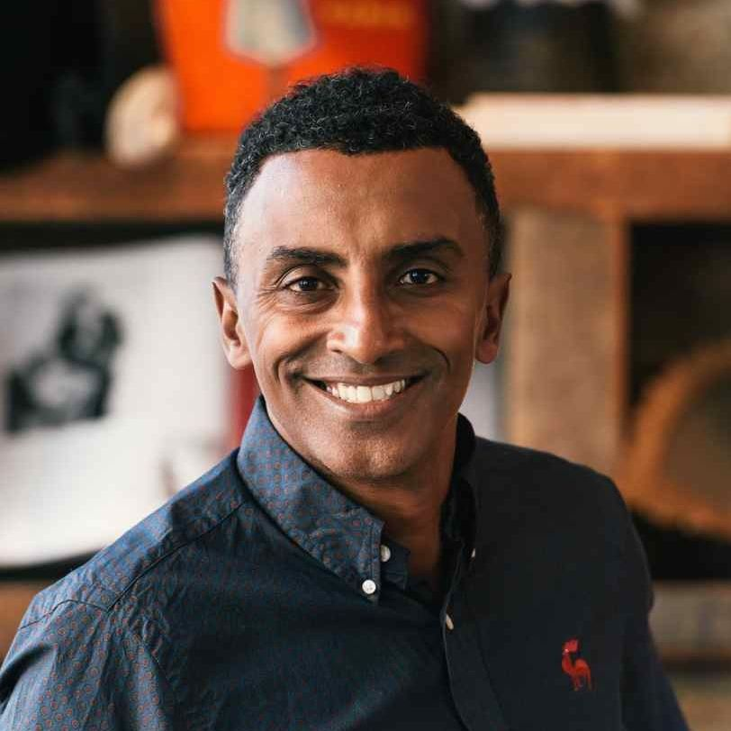

He was tasked with planning and executing the Obama administration’s first state dinner honoring Indian Prime Minister Manmohan Singh. Samuelsson was also crowned champion of television shows “Top Chef Masters” and “Chopped All Stars,” and was the winning mentor on ABC’s “The Taste.” Samuelsson recently won the 2019 James Beard Award for Outstanding TV Personality for NO PASSPORT REQUIRED and is an executive producer of Viceland’s show “Hustle.” He currently serves as Executive Chef-in-Residence of Buzzfeed Tasty’s newly launched talent program. His exciting new audio project with Audible, titled Our Harlem, was just released.

A committed philanthropist, Samuelsson is co-chair of Careers through Culinary Arts Program (C-CAP), which focuses on underserved youth. Samuelsson also co-produces the annual week-long festival Harlem EatUp!, which celebrated the food, art and culture of Harlem for the fifth year this past May. He is the recipient of the 2019 Vilcek Foundation Prize in Culinary Arts, awarded to immigrants who have made lasting contributions to American society. He is the author of multiple books including The New York Times bestselling memoir Yes, Chef and, most recently, The Red Rooster Cookbook: The Story of Food and Hustle in Harlem.

Recent restaurant openings include Red Rooster Shoreditch in East London, Norda Oslo in Norway and Streetbird Express at the world-famous Madison Square Garden. His newest restaurant, MARCUS, just opened at the Four Seasons Montreal. Marcus is also the founder of the Marcus Samuelsson Group (MSG), which works to maintain Samuelsson's culinary and cultural pillars, creating outstanding experiences that celebrate food, music, culture and art in all its endeavors, from high-end restaurants and fast-casual cafes to media and experiential events. Follow him on Instagram, Facebook and Twitter @MarcusCooks.

