A Production of HHMI Tangled Bank Studios and Passion Planet in association with Sandbox Films,
Thirteen Productions LLC, and WNET

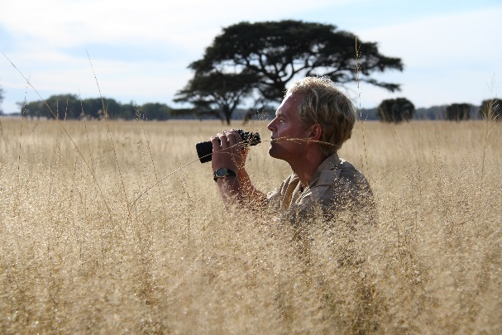
NATURE: THE SERENGETI RULES

PBS NATURE BROADCAST PREMIERE ON OCTOBER 9th

Based on the book THE SERENGETI RULES by Sean B. Carroll

Narrator: Campbell Scott
Directed by: Nicolas Brown
Producers: David Allen and Gaby Bastyra
Edit Director: Alex West
Executive Producers: David Elisco and Jared Lipworth
Story Producers: Catherine Watling, Joe Loncraine and David John
Line Producers: Christian Holland and Heather Forbes
Editor: Benedict Jackson
Director of Photography: Tim Cragg

Synopsis: Academy Award-winning Passion Pictures and HHMI Tangled Bank Studios present one of the most important but untold science stories of our time—a tale with profound implications for the fate of life on our planet. Beginning in the 1960s, a small band of young scientists headed out into the wilderness, driven by an insatiable curiosity about how nature works. Immersed in some of the most remote and spectacular places on Earth—from the majestic Serengeti to the Amazon jungle; from the Arctic Ocean to Pacific tide pools—they discovered a single set of rules that govern all life. Now in the twilight of their eminent careers, these five unsung heroes of modern ecology share the stories of their adventures, reveal how their pioneering work flipped our view of nature on its head, and give us a chance to reimagine the world as it could and should be.

Websites: pbs.org/nature, https://www.theserengetirules.com/
Facebook: facebook.com/PBSNature
Twitter: @PBSNature
Instagram: instagram.com/pbsnature
YouTube: youtube.com/naturepbs
Hashtag: #NaturePBS

For additional press information please contact:

PMK*BNC - NY
Lee Meltzer – Lee.Meltzer@pmkbnc.com – 212.373.6142
Susan Engel – Susan.Engel@pmkbnc.com – 212.373.0114

For Nature:
Chelsey Saatkamp – saatkampc@wnet.org – 212.560.4905

