Press Contacts: Chelsey Saatkamp, The WNET Group, 513-266-1748 saatkampc@wnet.org,
Press Materials: pbs.org/pressroom or thirteen.org/pressroom

Websites:
pbs.org/nature, facebook.com/PBSNature, @PBSNature, instagram.com/pbsnature, youtube.com/naturepbs, tiktok.com/@pbsnature, #NaturePBS

Dogs in the Wild, A Nature Miniseries
Talent Biographies


Fred Kaufman
Executive Producer, Nature
@kaufman_fred
For more than 40 years, Fred Kaufman has been a leader in the natural history genre and one of the longest tenured executive producers in PBS history. As the executive producer of the acclaimed PBS series Nature, Kaufman has won eight Emmys and two Peabody Awards. He has worked on Nature since its beginning in 1982 and has overseen it since 1991. During his tenure, Nature has been honored with hundreds of industry awards. In 2012, Kaufman was named the recipient of the International Wildlife Film Festival’s Lifetime Achievement Award for Media. In 2010, Nature earned the Outstanding Achievement Award from the prestigious Wildscreen Festival in Bristol, England. It was the first time in the 20-year history of the festival that the award was presented to an American wildlife series. Kaufman is a board member of the Jackson Hole Wildlife Film Festival and the Bronx Children’s Museum.


Jo Shinner
Executive Producer, BBC Natural History Unit
Jo Shinner has worked in the BBC Natural History Unit since 2011. With Nature, she has co-executive produced Animals with Cameras, Life From Above, Animal Babies: First Year on Earth, Natural Born Rebels and Koko: The Gorilla Who Talks to People.
Prior to joining the NHU, Shinner worked at Tigress Productions, producing the wildlife investigative drama reconstruction documentary series Nature Shock (National Geographic/Channel 5) and an original series for National Geographic Wild Channel, Wild Case Files. Shinner has also produced various features and documentaries across a wide range of subjects for BBC One, Two, Three, Four and Channel 5 over 30 years in TV.

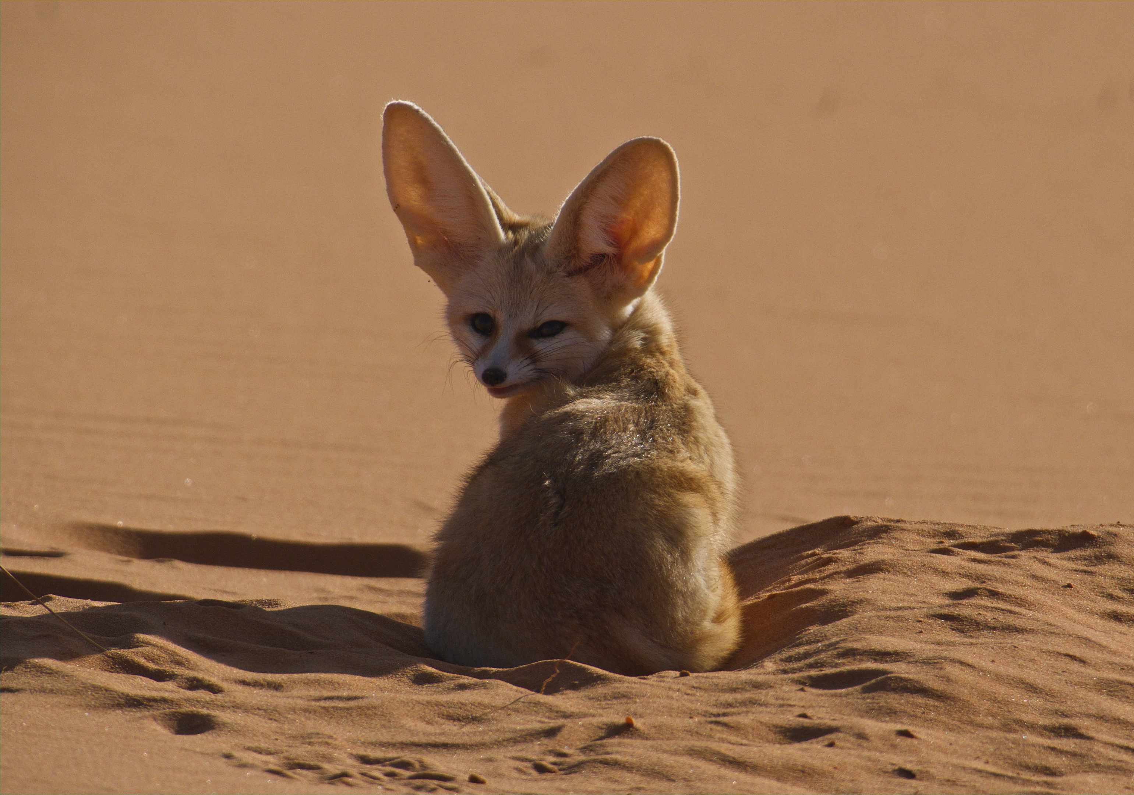
Fennec Fox
A small fox native to the deserts of North Africa, fennec foxes are the smallest of the canid family. Fennec foxes are perhaps best known for their enormous ears, which are typically 4-6 inches long and serve multiple purposes. Their ears help to dissipate excess body heat on hot days and to hear prey in the desert sands. Fennec foxes are nocturnal to avoid the desert heat, and their specifically adapted kidneys allow them to go for long periods without water. Fennec foxes mate for life. They dwell in family groups of up to 10 individuals, and multiple family groups may share a complex den.

The greatest threats to fennec fox populations are habitat loss and hunting. In North Africa, fennec foxes are illegally trapped for exhibition or sale to tourists. As human populations expand, they are at higher risk of being hit by cars. Fennec foxes are legally protected in Morocco, Algeria, Tunisia and Egypt.

