PBS Presents Earth Day Themed Programming This April

– POV “Bill Nye: Science Guy” Premieres Wednesday, April 18, 2018 –

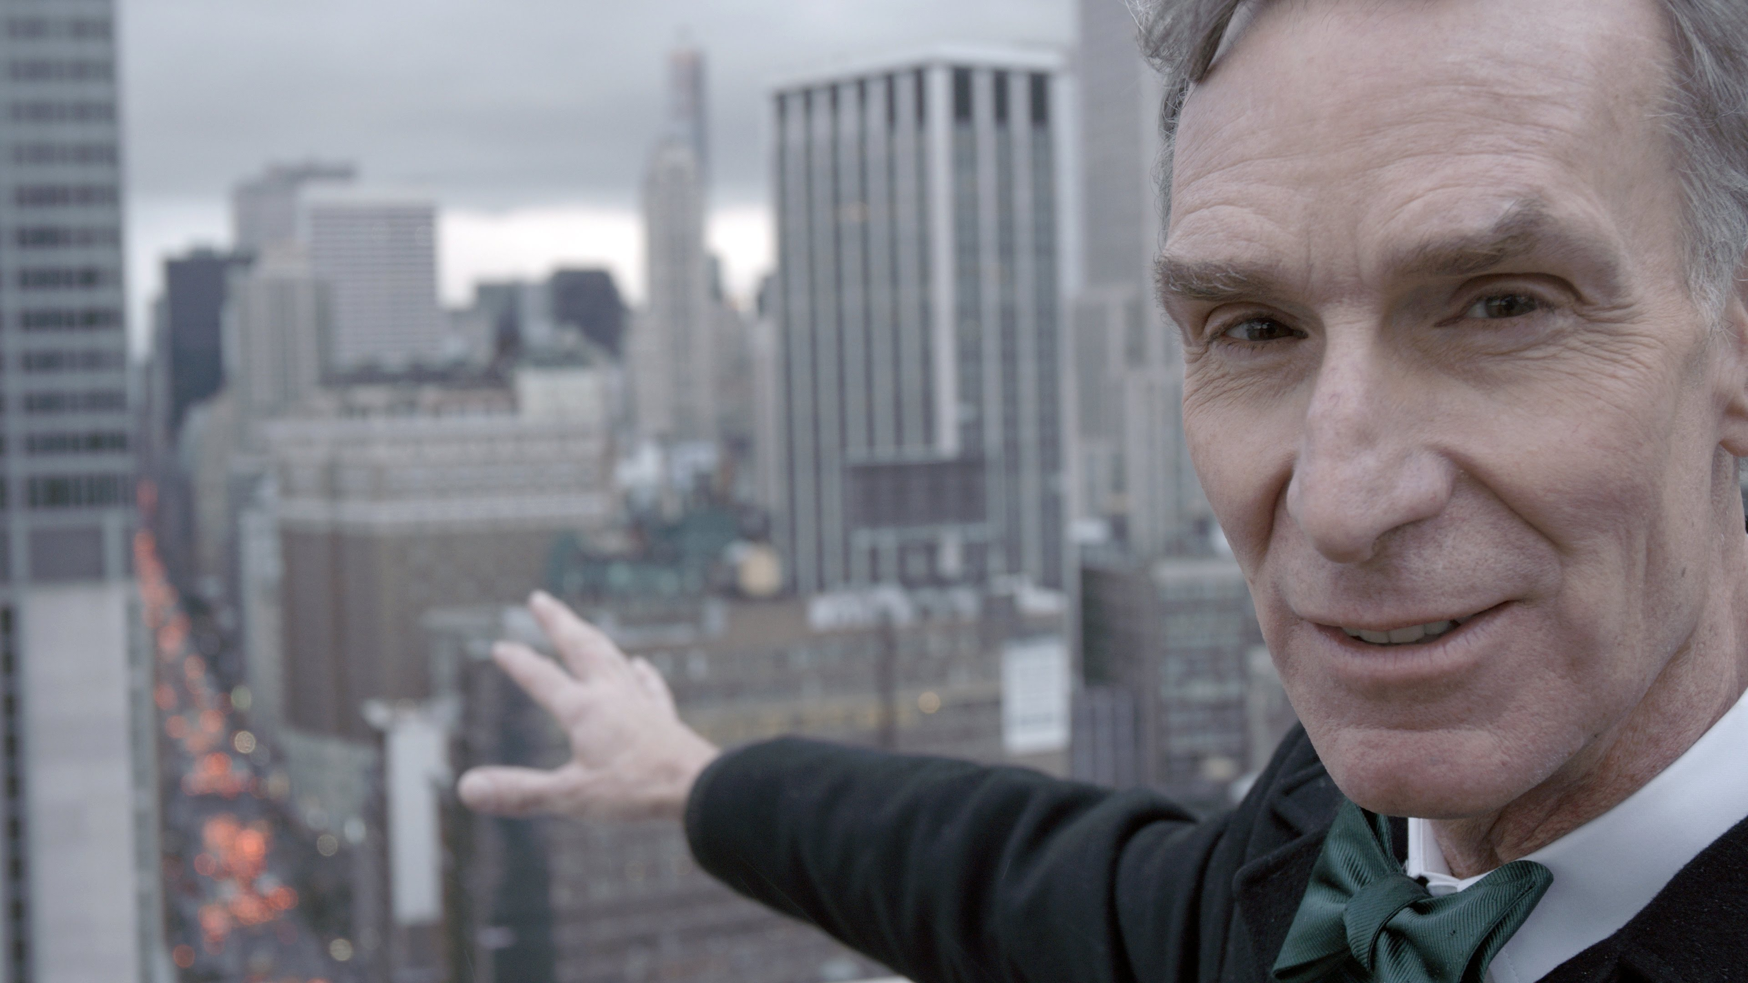
Bill Nye in POV “Bill Nye: Science Guy”
Credit: Courtesy of David Alvarado/Structure Films
ARLINGTON, VA; MARCH 12, 2018 – In conjunction with Earth Day on April 22, PBS stations will offer a selection of themed programming with topics ranging from agriculture to meteorology to climate change. Kicking off on Monday, April 16, at 10:00 p.m. ET, INDEPENDENT LENS investigates the disturbing chemical spill in West Virginia that left hundreds of thousands without drinking water in “What Lies Upstream.”

On Wednesday, April 18, at 10:00 p.m. ET, POV follows popular scientist Bill Nye, a champion of climate science, on his mission to protect the planet in “Bill Nye: Science Guy.” The behind-the-scenes portrait offers intimate and exclusive access into Nye’s life as he advocates for the scientific community and its findings.

Also premiering on April 18 at 8:00 p.m. is the two-hour NOVA “Decoding the Weather Machine.” Join scientists around the globe as they cut through the confusion to better understand climate change and help define the way forward.

Primetime Programming:

INDEPENDENT LENS “What Lies Upstream”
Monday, April 16, 2018, 10:00-11:30 p.m. ET
Travel to West Virginia with investigative filmmaker Cullen Hoback in this detective story that uncovers the troubling truth behind a massive chemical spill that left 300,000 people without drinking water for months.

NOVA “Decoding the Weather Machine”
Wednesday, April 18, 2018, 8:00-10:00 p.m. ET
Join scientists on a quest to better understand the weather and climate machine we call Earth. Why do scientists overwhelmingly agree that our climate is changing, and how can we be resilient—even thrive—in the face of enormous change?

POV “Bill Nye: Science Guy”
Wednesday, April 18, 2018, 10:00-11:30 p.m. ET
Follow Bill Nye, once the host of the popular kids show, as he seeks to change the world through science. He’s shedding the “Science Guy” costume with the goal of creating a more scientifically literate world.

INDEPENDENT LENS “Look & See: Wendell Berry's Kentucky”
Monday, April 23, 2018, 10:00-11:00 p.m. ET
Experience the changing landscapes and shifting values of rural America in the era of industrial agriculture, as seen through the mind’s eye of award-winning writer and farmer Wendell Berry, back home in his native Henry County, Kentucky.

PBS KIDS Programming:

CYBERCHASE
Monday, April 16-Friday, April 20, 2018
Explore the intersection of math and the environment with the CyberSquad through new adventures involving green roofs, invasive species, renewable resources, citizen science, water conservation, data collection, measurement, estimation and more.

PBS KIDS Explore the Outdoors
Monday, April 23-Friday, April 27, 2018
PBS KIDS celebrates Earth Month with a week featuring new episodes from SPLASH AND BUBBLES, NATURE CAT, and WILD KRATTS.

New SPLASH AND BUBBLES, NATURE CAT, WILD KRATTS, and CYBERCHASE episodes will also be available to stream for free on pbskids.org and the PBS KIDS Video App, which is accessible on a variety of mobile devices and platforms such as Roku, Apple TV, Amazon Fire TV, Android TV and Chromecast.

Full episodes of PBS primetime programming will stream for free following broadcast and be available for two weeks on all station-branded PBS platforms, including PBS.org and PBS apps for iOS, Android, Roku, Apple TV, Amazon Fire TV and Chromecast. Following the two weeks, PBS station members can view episodes via Passport, a benefit for station donors, offering extended access to a rich library of public television programming (contact your local PBS station for details).

About PBS
PBS, with nearly 350 member stations, offers all Americans the opportunity to explore new ideas and new worlds through television and digital content. Each month, PBS reaches nearly 100 million people through television and nearly 28 million people online, inviting them to experience the worlds of science, history, nature and public affairs; to hear diverse viewpoints; and to take front row seats to world-class drama and performances. PBS’ broad array of programs has been consistently honored by the industry’s most coveted award competitions. Teachers of children from pre-K through 12th grade turn to PBS for digital content and services that help bring classroom lessons to life. Decades of research confirms that PBS’ premier children’s media service, PBS KIDS, helps children build critical literacy, math and social-emotional skills, enabling them to find success in school and life. Delivered through member stations, PBS KIDS offers high-quality educational content on TV – including a new 24/7 channel, online at pbskids.org, via an array of mobile apps and in communities across America. More information about PBS is available at www.pbs.org, one of the leading dot-org websites on the internet, or by following PBS on Twitter, Facebook or through our apps for mobile and connected devices. Specific program information and updates for press are available at pbs.org/pressroom or by following PBS Pressroom on Twitter.

– PBS –

CONTACTS:
Carrie Johnson, PBS, cjohnson@pbs.org; 703-739-5129

For images and additional up-to-date information on this and other PBS programs, visit PBS PressRoom at pbs.org/pressroom.

