NOVA “Human Nature”
Summer 2020 PBS Press Tour
Panel Bios

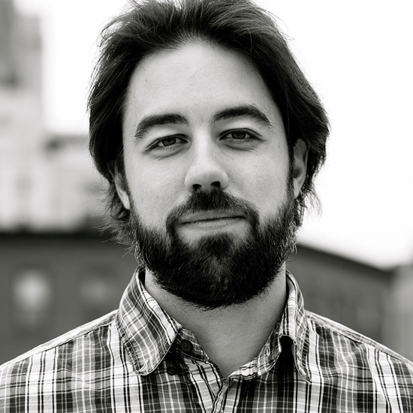
Adam Bolt, Director, Producer and Screenwriter, “Human Nature”

Adam Bolt edited and co-wrote the Oscar-winning documentary Inside Job, about the 2008 financial crisis, and won an Emmy for his work as senior producer of the Showtime docuseries “Years of Living Dangerously.” His other credits include “Park Avenue: Money, Power & The American Dream,” which premiered on PBS’s INDEPENDENT LENS and went on to win a Peabody Award in 2013; “Page One: Inside the New York Times,” which was nominated for two Emmys in 2012; and the HBO documentary "The Recruiter," which won a duPont-Columbia University Award for excellence in broadcast journalism in 2010. Most recently, he directed “Human Nature” — about the scientific breakthrough known as CRISPR — which will premiere on PBS’s NOVA in September.


Alta Charo, Bioethicist, University of Wisconsin at Madison

R. Alta Charo (BA biology, Harvard 1979; JD, Columbia 1982) is the Warren P. Knowles Professor of Law and Bioethics at the University of Wisconsin. In government, she served as a legal analyst for the former congressional Office of Technology Assessment, focusing on new reproductive technologies, and as a policy analyst for the U.S. Agency for International Development, focusing on family planning in Latin America and Francophone Africa. Alta has served as a senior policy advisor in the FDA’s Office of the Commissioner, working on drug safety, personalized medicine and bioengineered foods. She was a member of President Clinton’s National Bioethics Advisory Commission, helping to draft reports and recommendations on ethical approaches to research. Alta also served on the Obama transition team, focusing on NIH and FDA. A member of the National Academy of Medicine, she has co-chaired the National Academies’ committees that wrote guidelines for embryonic stem cell research and recommendations for U.S. policy and global principles regarding human genome editing, was a member of the organizing committee for the international summit on genome editing, and is a member of the standing committee on emerging science technology and law. At present, Alta is a member of the Nuclear Threat Initiative’s Biosecurity Innovation and Risk Reduction project, and of the World Health Organization’s committee on global governance of genome editing.

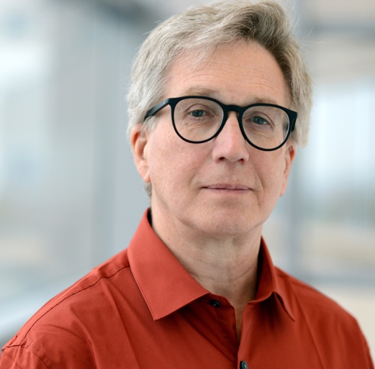
Chris Schmidt, Co-Executive Producer, NOVA

Chris Schmidt is an award-winning producer and director of documentaries and factual television series. Primarily focused on long-form films, Chris oversees NOVA’s development team in creating new multi-hour projects in collaboration with U.S. filmmakers and international co-producers. Since joining NOVA in 2012, he has developed and contributed to more than 100 ground-breaking films and series, including The Planets, Black Hole Apocalypse, Great Math Mystery, Einstein’s Quantum Riddle Eclipse Over America, Making North America, Hunting the Elements, Making Stuff and Cyberwar Threat. Prior to working full-time at NOVA, Chris was an independent filmmaker and executive producer making programs for factual networks including Discovery, National Geographic, History, Animal Planet and PBS. In love with stories of human ingenuity and discovery, Chris’ curiosity and persistence have led him up Chinese construction cranes and into the Sahara desert in search of whale skeletons; catapulted him off of an aircraft carrier; and made it possible to hang out with some of the world’s most dedicated scientists, mathematicians and engineers. His work has received the prestigious Alfred I. duPont-Columbia University Award, the AAAS Gold Kavli Science Journalism Award, the Cine Golden Eagle and many nominations for the News and Documentary Emmy Award. A graduate of Northwestern University and University of Chicago, Chris currently lives in Concord, Massachusetts.

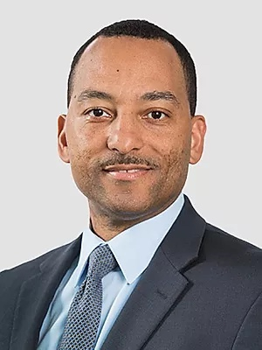
Tshaka Cunningham, Molecular Biologist, co-founder of TruGenomix, and Baptist Deacon

Tshaka Cunningham, Ph.D. is a co-founder and Chief Scientific Officer of Trugenomix Inc., an emerging precision genomics biotechnology company that is harnessing the power of genomics to improve risk prediction and diagnosis of PTSD. He previously served as the Scientific Program Manager for the Aging and Neurodegenerative Diseases Rehabilitation Research Program at the U.S. Department of Veterans Affairs, where he also served as a subject matter expert for VA’s Genomic Medicine Implementation Program (GMIP) and convened the Million Veteran Program (MVP) Diversity Working Group to maximize the participation of minority Veterans in the project. He completed a BA degree in molecular biology from Princeton University in New Jersey, and earned his doctoral degree in the same discipline, with focus on virology and immunology, from Rockefeller University in New York. His postdoctoral training in immunology and tumor immunotherapy occurred at the Pasteur Institute in Paris, France, and at the National Institutes of Health in Bethesda, MD. In addition to his work at Trugenomix Inc., Dr. Cunningham serves as the Executive Director of the Faith Based Genetic Research Institute, a non-profit organization committed to educating and engaging minority communities to democratize their access to genomics research, precision medicine, and genetic therapies. He is also a member of the advisory board of LunaDNA, a public benefit corporation that is the first health and DNA discovery platform owned by its community of data contributors.


David Sanchez, Rising high school senior with sickle cell disease

