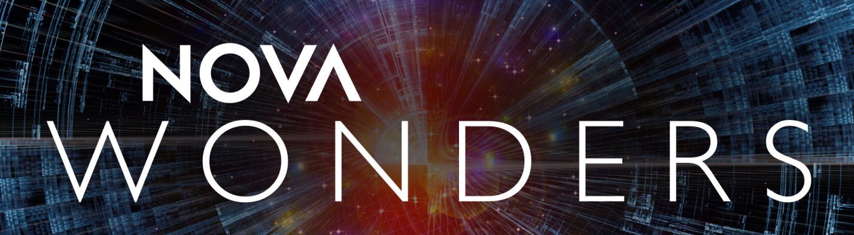

HOST BIOS

pbs.org/NOVAWonders

#NOVAWondersPBS

Dr. André Fenton, Ph.D.
Co-Host, NOVA Wonders; Professor, Center for Neural Science, NYU
André is a Professor of Neural Science at New York University. His research focus is molecular, neural, behavioral, and computational aspects of memory. He studies how brains store experiences as memories, and how the expression of knowledge activates information that is relevant without activating what is irrelevant. In an effort to integrate investigations and understanding across levels of biological organization, the Fenton laboratory uses genetic, molecular, electrophysiological, imaging, behavioral, engineering, and theoretical methods to investigate these fundamental and interrelated issues in neuroscience. André and colleagues identified PKMzeta as the first molecule that maintains the persistence of memories in the brain, a discovery recognized by Science Magazine as one of the 10 most important breakthroughs in all of science and technology published in 2006. André founded Bio-Signal Group Corp., which developed and commercialized an FDA-approved portable, wireless, and easy to use platform for obtaining medical quality EEGs anywhere, anytime, and for everyone.

DR. RANA EL KALIOUBY, Ph.D.
Co-Host, NOVA Wonders; Co-Founder and CEO, Affectiva
What if our high-tech devices could decipher and respond to our emotions? Rana el Kaliouby, Ph.D., is on a mission to humanize technology with artificial emotional intelligence, or what she calls “Emotion AI.” She envisions and works to create a world where devices and technologies that once separated us will bring us together. It’s the next frontier in artificial intelligence, with commercial applications across industries—and it’s closer than we think. Computer scientist, technologist, entrepreneur and business leader, Dr. el Kaliouby believes that “humanizing technology gives us a golden opportunity to re-imagine how we connect with machines, and, therefore, how we connect with each other.” Co-founder and CEO of Affectiva, the pioneer of Emotion AI, she invented the company’s award-winning emotion recognition technology. The Emotion AI platform combines facial expression and tone of voice to infer how a person is feeling, using deep learning and the world’s largest emotion data repository of more than five million faces, analyzed from 75 countries. Teaching machines to measure and interpret human emotions has the potential to dramatically improve lives, with such powerful applications as assisting doctors and nurses in delivering better care, engaging students and personalizing their learning experience, and increasing road safety by making “emotionally aware” vehicles. It also promises to forever change the rules of consumer engagement by providing real-time insight into viewers’ emotional responses to brands, ads and other digital content. As her popular TED talk made apparent, Dr. el Kaliouby has the ability to simplify and translate complex science and make it accessible to any

audience. A founder of her own technology company, accomplished inventor, and one of few women to have successfully transitioned from academia to business, Dr. el Kaliouby—and her work—receive considerable recognition. To name just a few: WIRED named her one of 25 Geniuses Who Are Creating the Future of Business, Entrepreneur honored her as one of The 7 Most Powerful Women to Watch and MIT Technology Review featured her among the Top 35 Innovators Under 35. Recently inducted into the Women in Engineering Hall of Fame, Dr. el Kaliouby also was selected as a World Economic Forum (WEF) Young Global Leader and serves on WEF’s Global Future Council on AI and Robotics. She’s often cited in and interviewed by top business and mainstream outlets, including The New Yorker, Wired, Forbes, Fast Company, The Wall Street Journal, The New York Times, TIME Magazine, Fortune, CNN, CBS and Reddit.

Prior to founding Affectiva, Dr. el Kaliouby was a research scientist at the MIT Media Lab where she spearheaded applications for facial coding to benefit mental health, autism and other research areas. Born and raised in Cairo, she received Bachelor of Science and Master of Science degrees in computer science from the American University in Cairo and a Ph.D. from the computer laboratory, University of Cambridge.

DR. TALITHIA WILLIAMS, Ph.D.
Co-Host, NOVA Wonders; Associate Dean for Research and Experiential Learning and Associate Professor of Mathematics, Harvey Mudd College
Dr. Talithia Williams takes sophisticated numerical concepts and makes them understandable to a wide audience. Renowned for her popular TED Talk, "Own Your Body's Data", she demystifies the mathematical process in amusing and insightful ways, using statistics as a way of seeing the world in a new light and transforming our future through the bold new possibilities inherent in the STEM fields. Dr. Williams has delivered speeches nationally and internationally on the value of statistics in quantifying personal health information. She has made it her life's work to get students, parents, educators and community members more excited about the possibilities inherent in a STEM education. In 2015, she won the Mathematical Association of America’s Henry L. Alder Award for Distinguished Teaching by a Beginning College or University Mathematics Faculty Member, which honors faculty members whose teaching is effective and extraordinary, and extends its influence beyond the classroom.

Dr. Williams is Associate Dean for Research and Experiential Learning and an Associate Professor of Mathematics at Harvey Mudd College. She earned her bachelor’s degree in Mathematics from Spelman College, a master’s degree in Mathematics from Howard University and her Ph.D. in Statistics from Rice University. Her professional experiences include research appointments at NASA’s Jet Propulsion Laboratory, NASA’s Johnson Space Center, and the National Security Agency. Dr. Williams develops statistical models which emphasize the spatial and temporal structure of data and has partnered with the World Health Organization in developing a cataract model used to predict the cataract surgical rate for countries in Africa. Through her research and work in the community at large, she is helping change the collective mindset regarding STEM in general and math in particular—rebranding the field of mathematics as anything but dry, technical or male-dominated but instead a logical, productive career path that is crucial to the future of the country. She is active in her faith community and serves with her husband as a Christian marriage mentor couple, all while being the mom of three amazing boys.

###

PR Contacts:
Eileen Campion Jennifer Welsh
Roslan & Campion PR NOVA/WGBH
212.966.4600 617.300.4382
eileen@rc-pr.com jennifer_welsh@wgbh.org

Eddie Ward
Roslan & Campion PR
212.966.4600
eddie@rc-pr.com

www.pbs.org
PBS PressRoom: www.pbs.org/pressroom PBS Facebook Fan Page: www.facebook.com/pbs
PBS YouTube Channel: www.youtube.com/pbs PBS on Twitter: www.twitter.com/pbspressroom

© 2018 WGBH EDUCATIONAL FOUNDATION

