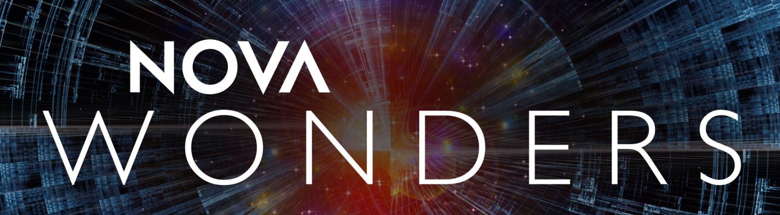

PRODUCER BIOS

pbs.org/NOVAWonders

#NOVAWondersPBS

Julia Cort
Deputy Executive Producer, NOVA and Executive Producer, NOVA Wonders
Julia Cort has more than 25 years of broadcast experience as a producer, writer and director. Since joining the WGBH Science Unit in 1991, she has contributed to more than 80 films, including Making North America, The Fabric of the Cosmos, Smartest Machine on Earth and Chasing Pluto. She played a key role in developing NOVA’s award-winning sister series, NOVA scienceNOW, currently serving as executive producer. In the pursuit of a story, Cort has traveled deep underground to investigate the hunt for dark matter, been blindfolded and led to secret diamond-making factories, waded into leech-infested swamps, and attempted to re-create the technological feats of ancient Egyptian engineers. She is a recipient of the George Foster Peabody Award, the National Academies Keck Communication Award, the AAAS Science Journalism Award, the American Institute of Physics Science Writing Award, the National Association of Science Writers Science in Society Award and the News & Documentary Emmy.

Michael Bicks
Series Producer, NOVA Wonders
Producer/Director/Writer, NOVA Wonders “What Are Animals Saying?” and NOVA Wonders “Can We Build a Brain?”
Michael Bicks is the founder of Little Bay Pictures in Durham, New Hampshire. A director with over twenty-five years of experience, he has earned the reputation as both a serious journalist and an innovative visual storyteller. Most recently he has been working for PBS’s NOVA where he has directed numerous films including Smartest Machine on Earth, the story of Watson the IBM computer that competed on Jeopardy!, which was the recipient of the National Academy of Sciences Keck Award for excellence in science reporting.

Bicks got his start at ABC News as Peter Jennings’s researcher for the 1984 election. Continuing at ABC, he worked as a breaking news producer, covering the 1988 and 1992 elections, the coup in the Soviet Union and both gulf wars. In 1993, he went to work for the ABC magazine unit where he produced over 100 stories on a wide range of topics.

From 1999 through 2010 he was an Executive Producer and Producer for the documentary unit at ABC News. In that capacity, he created numerous series and specials including the critically acclaimed In the Jury Room, Nascar in Primetime and the television graphic novel, Earth 2100. The recipient of dozens of awards, including an Emmy for investigative reporting and an Alfred I. DuPont Award.

Anna Lee Strachan
Series Producer, NOVA Wonders
Producer/Director/Writer, NOVA Wonders “What Are Animals Saying?” and NOVA Wonders “Can We Build a Brain?”
Anna Lee Strachan is a filmmaker who specializes in bringing some of the most complex scientific topics to life. She has produced and directed several hours for PBS’s NOVA series including the critically-acclaimed The Fabric of the Cosmos: Universe or Multiverse?, a one-hour film in NOVA’s four-part miniseries hosted by physicist Brian Greene. The series was nominated for an Emmy in outstanding science programming.

Strachan has a degree in cognitive neuroscience from Harvard University and an M.S. in science writing from MIT. Her first job was as a writer for NASA’s Ask an Astrobiologist web forum before she joined NPR’s Talk of the Nation: Science Friday. At Science Friday she produced dozens of feature radio segments including an hour called “Skepticism and Belief” about pseudoscience.

She got her start in television as an associate producer for PBS’s NOVA series where she helped create over twenty original programs including the George Foster Peabody Award-winning two-hour special, Judgment Day: Intelligent Design on Trial. Since 2007, she has been a producer, writer, and director on several NOVA films, notably Is There Life on Mars?, What Are Animals Thinking?, and Making Stuff Colder. She has been a fellowship recipient of the Council for the Advancement of Science Writing and currently serves on the Harvard Radcliff Mentor Program and the NASA Academy admission committee.

###

PR Contacts:
Eileen Campion Jennifer Welsh
Roslan & Campion PR NOVA/WGBH
212.966.4600 617.300.4382
eileen@rc-pr.com jennifer_welsh@wgbh.org

Eddie Ward
Roslan & Campion PR
212.966.4600
eddie@rc-pr.com

www.pbs.org
PBS PressRoom: www.pbs.org/pressroom PBS Facebook Fan Page: www.facebook.com/pbs
PBS YouTube Channel: www.youtube.com/pbs PBS on Twitter: www.twitter.com/pbspressroom

© 2018 WGBH EDUCATIONAL FOUNDATION

