ON TWO FRONTS: LATINOS & VIETNAM

POWERFUL NEW PBS FILM EXAMINES THE LATINO EXPERIENCE AT HOME AND OVERSEAS DURING THE VIETNAM WAR AND THE CONFLICT’S IMPACT ON VETERANS AND FAMILIES

Film Airs During Hispanic Heritage Month
− Tuesday, September 22, 2015, 10:00-11:30 pm ET on PBS –

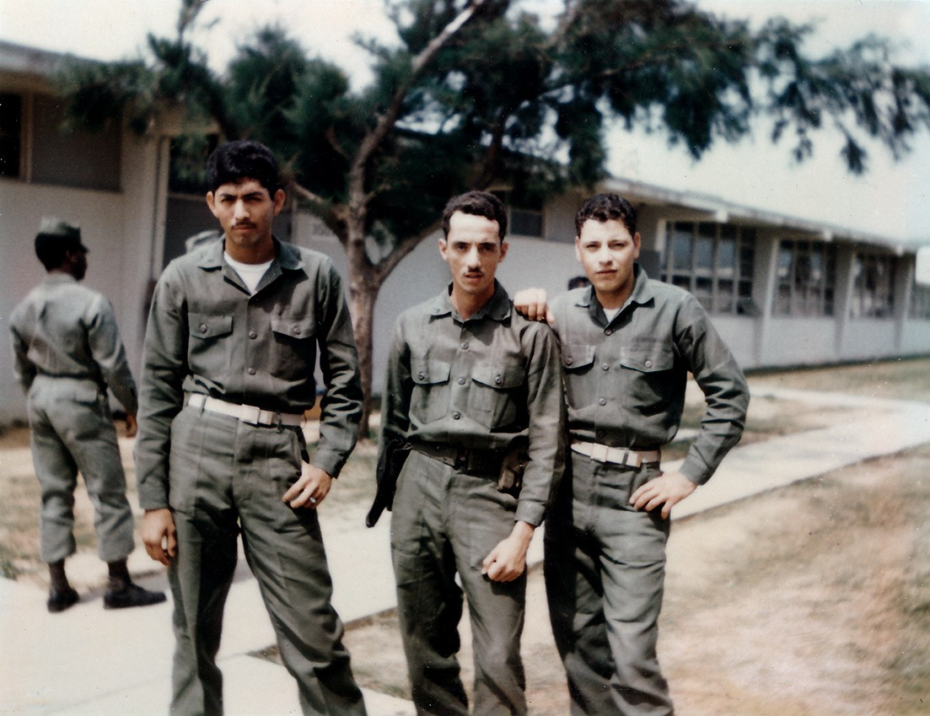
Arlington, VA; June 29, 2015 -- ON TWO FRONTS: LATINOS & VIETNAM, premiering on PBS during Hispanic Heritage Month, captures a complex aspect of the Vietnam War: the legacy of Latino veterans and their families during the conflict. Airing Tuesday, September 22, 2015, 10:00-11:30 p.m. ET, the program examines the Latino experience during a war that placed its heaviest burden on working-class youth and deeply affected Latino communities. The documentary is part of PBS Stories of Service — providing compelling stories of those who have served and a deeper understanding of our nation’s military history.

ON TWO FRONTS producer Mylène Moreno takes a comprehensive look at pivotal events on both the homefront and the battlefront, painting a vivid portrait of Latino Americans during a tumultuous time. Through compelling stories and candid interviews, the film conveys the rich heritage of military service, a deeply rooted part of Latino cultural identity in the U.S., and looks at the contributions made by Latino veterans and their families during the Vietnam era. The film also explores the controversy and changing attitudes amid the growing Chicano anti-war movement and within a community reeling over disproportionate losses and divided over participation in the war.

“This absorbing new film gives viewers a fresh new perspective on the significant role played by Latino Americans during a defining moment in our nation’s history, and offers extraordinary insights into how this diverse group helped shape events during that turbulent time,” said Dave Davis of Oregon Public Broadcasting, the film’s presenter.

Filmed in the Southwest and in Vietnam, ON TWO FRONTS: LATINOS & VIETNAM includes firsthand accounts from dozens of Latino veterans and their families and commentary from historians, social activists and other experts. To evoke the dramatic events unfolding at home and overseas, the documentary combines lush photography with home movies, archival footage, graphic newsreels and personal photographs.

Latinos began questioning the cost of war and the price of citizenship for the first time during the Vietnam conflict. In communities where there were few alternatives to service, the war exacted a heavy toll among Latinos.

“With this film, we wanted to look back, five decades later, with the benefit of hindsight, at the Vietnam War — at its costs and consequences — and ask some difficult questions about the price of war and citizenship,” said producer Moreno of Souvenir Pictures, Inc.

At home, the Latino anti-Vietnam war movement gained momentum —a radical departure from past wars, when Latino civil rights activists used high rates of military participation to prove their worth as good citizens. This time, activists pointed to similarly high rates of participation — and mortality — and argued that Latinos were being exploited. Latinos organized antiwar events to address both the war and conditions at home, culminating in unprecedented protest rallies for Chicanos.

Overseas, Latino soldiers were presented with both opportunities and challenges. Alongside Anglo-American and African-American soldiers, many discovered their differences faded away during combat. Others describe racial tensions and stereotypes that persisted in Vietnam or upon returning home.

For many, the price of service was too high. Latino veterans still suffer post-traumatic stress disorder in higher percentages than black and white American veterans. Many of the Latinos who went to war returned ill prepared for college and to the same limited career options they had before leaving home. If one reason Latinos fought for their country was to trade service for career benefits, then Vietnam’s legacy did not always fulfill that promise.

Produced by Souvenir Pictures, Inc., ON TWO FRONTS: LATINOS & VIETNAM is a presentation of Oregon Public Broadcasting in association with Latino Public Broadcasting, with major funding provided by the Corporation for Public Broadcasting. For more information, visit www.ontwofrontsmovie.com. To join the conversation, go to Facebook (Facebook.com/LatinosVietnam), Twitter, (@LatinosVietnam) or Instagram (instagram.com/LatinosVietnam/).

# # #

About Mylène Moreno
Los Angeles-based filmmaker Mylène Moreno makes documentaries that reflect her diverse cultural interests. She has followed Mexican fútbol fanáticos in Los Angeles and profiled notable Arab Americans in all walks of life. Recalling Orange County was a personal look at immigrant rights and education in California’s Orange County. True-Hearted Vixens featured female jocks pursuing dreams of professional athletic greatness in a startup tackle football league. She produced the first episode of the landmark PBS series, ¡CHICANO! History of the Mexican American Civil Rights Movement. Moreno is a graduate of Stanford University’s documentary film program.

About OPB
OPB is the largest cultural and education institution in Oregon and southern Washington, delivering excellence in public broadcasting to 1.5 million people each week through television, radio and the Internet. Widely recognized as a national leader in the public broadcasting arena, OPB is a major contributor to the program schedule that serves the entire country. OPB is one of the most-used and most-supported public broadcasting services in the country and is generously supported by its members.

About PBS Stories of Service
As America’s storyteller, PBS is bringing together multi-platform content and powerful conversations around U.S. military veterans under the banner of Stories of Service. The national programming content features compelling stories of those who have served and provides a deeper understanding of our nation’s military history. Through public television on air and on PBS.org, PBS member stations will create their own local content and provide community resources for returning veterans and their families. The initiative will educate the civilian population about our military history and highlight the contributions from the veteran community. The Stories of Service initiative was announced in May 2014, along with a community engagement campaign for select PBS member stations and their local veterans and funded by the Corporation for Public Broadcasting (CPB), called Veterans Coming Home. The PBS programming under Stories of Service, many with funding support from CPB, includes, in 2014: COMING BACK WITH WES MOORE (May 13); NATIONAL MEMORIAL DAY CONCERT (May 25); DEATH AND THE CIVIL WAR: AMERICAN EXPERIENCE (May 26); D-DAY 360 (May 27); NOVA “D-Day’s Sunken Secrets” (May 28); CRAFT IN AMERICA “Service” (November 2); MAKERS “Women in War” (November 4); in 2015: THE DRAFT (April 27); LAST DAYS IN VIETNAM: AMERICAN EXPERIENCE (April 28); HOMEFRONT (May 25); THIS OLD HOUSE – THE VETERANS SPECIAL HOUSE PROJECT various episodes (May 14-30); ON TWO FRONTS, LATINOS & VIETNAM (Fall 2015); and in 2017, Ken Burns and Lynn Novick’s THE VIETNAM WAR (w.t.).

About PBS
PBS, with over 350 member stations, offers all Americans the opportunity to explore new ideas
and new worlds through television and online content. Each month, PBS reaches more than 103
million people through television and over 33 million people online, inviting them to experience
the worlds of science, history, nature and public affairs; to hear diverse viewpoints; and to take
front row seats to world-class drama and performances. PBS’ broad array of programs has been
consistently honored by the industry’s most coveted award competitions. Teachers of children
from pre-K through 12th grade turn to PBS for digital content and services that help bring
classroom lessons to life. PBS’ premier children’s TV programming and its website, pbskids.org, are parents’ and teachers’ most trusted partners in inspiring and nurturing curiosity and love of
learning in children. More information about PBS is available at www.pbs.org, one of the leading dot-org websites on the Internet, or by following PBS on Twitter, Facebook or through our apps for mobile devices. Specific program information and updates for press are available at pbs.org/pressroom or by following PBS PressRoom on Twitter.

CONTACTS:
Eileen Campion, Roslan & Campion PR, 212-966-4600; eileen@rc-pr.com
Kelsey Wallace, Oregon Public Broadcasting, 503-293-1933; kwallace@opb.org
Carrie Johnson, PBS, 703-739-5129; cjohnson@pbs.org

For images and additional up-to-date information on this and other PBS programs, visit PBS PressRoom at pbs.org/pressroom.

