FOR IMMEDIATE RELEASE:

ONE VOICE: THE SONGS WE SHARE
TO BROADCAST BACK TO BACK FRIDAY, MAY 28 ON PBS STATIONS

Maestro LUKE FRAZIER and THE AMERICAN POPS ORCHESTRA present the inaugural episodes (“Broadway” and “Sacred”)

The “Broadway” episode is hosted by and stars Jessie Mueller, with additional performances by Amber Iman, Luke Hawkins, Alexis Michelle, Sam Simahk, Steven Mann and Ray Wong

The “Sacred” episode is hosted by and stars Michelle Williams, with additional performances by Justin Guarini, Maureen McKay, Adam Hyndman and Daniel Colaner

WATCH TRAILERS TO EACH BELOW:
“Broadway”: https://www.pbs.org/video/episode-1-preview-broadway-fxq2qe/
“Sacred”: https://www.pbs.org/video/episode-2-preview-sacred-gowtdd/
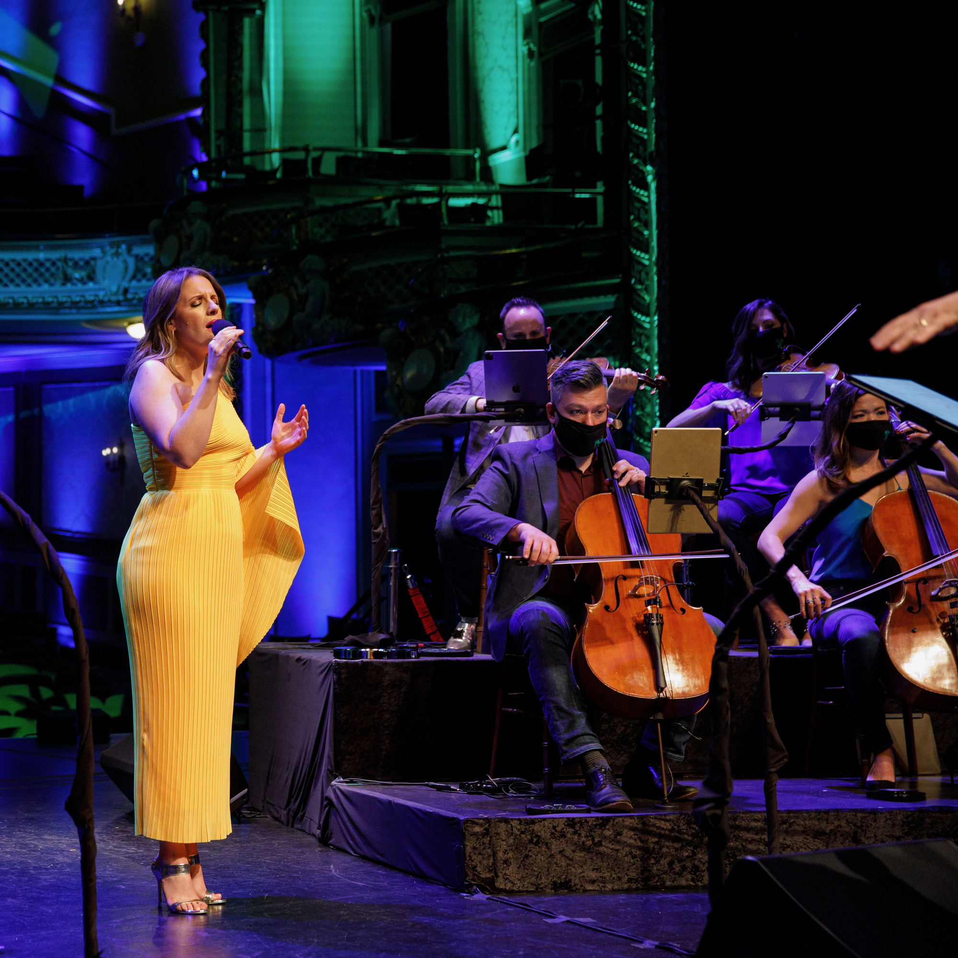
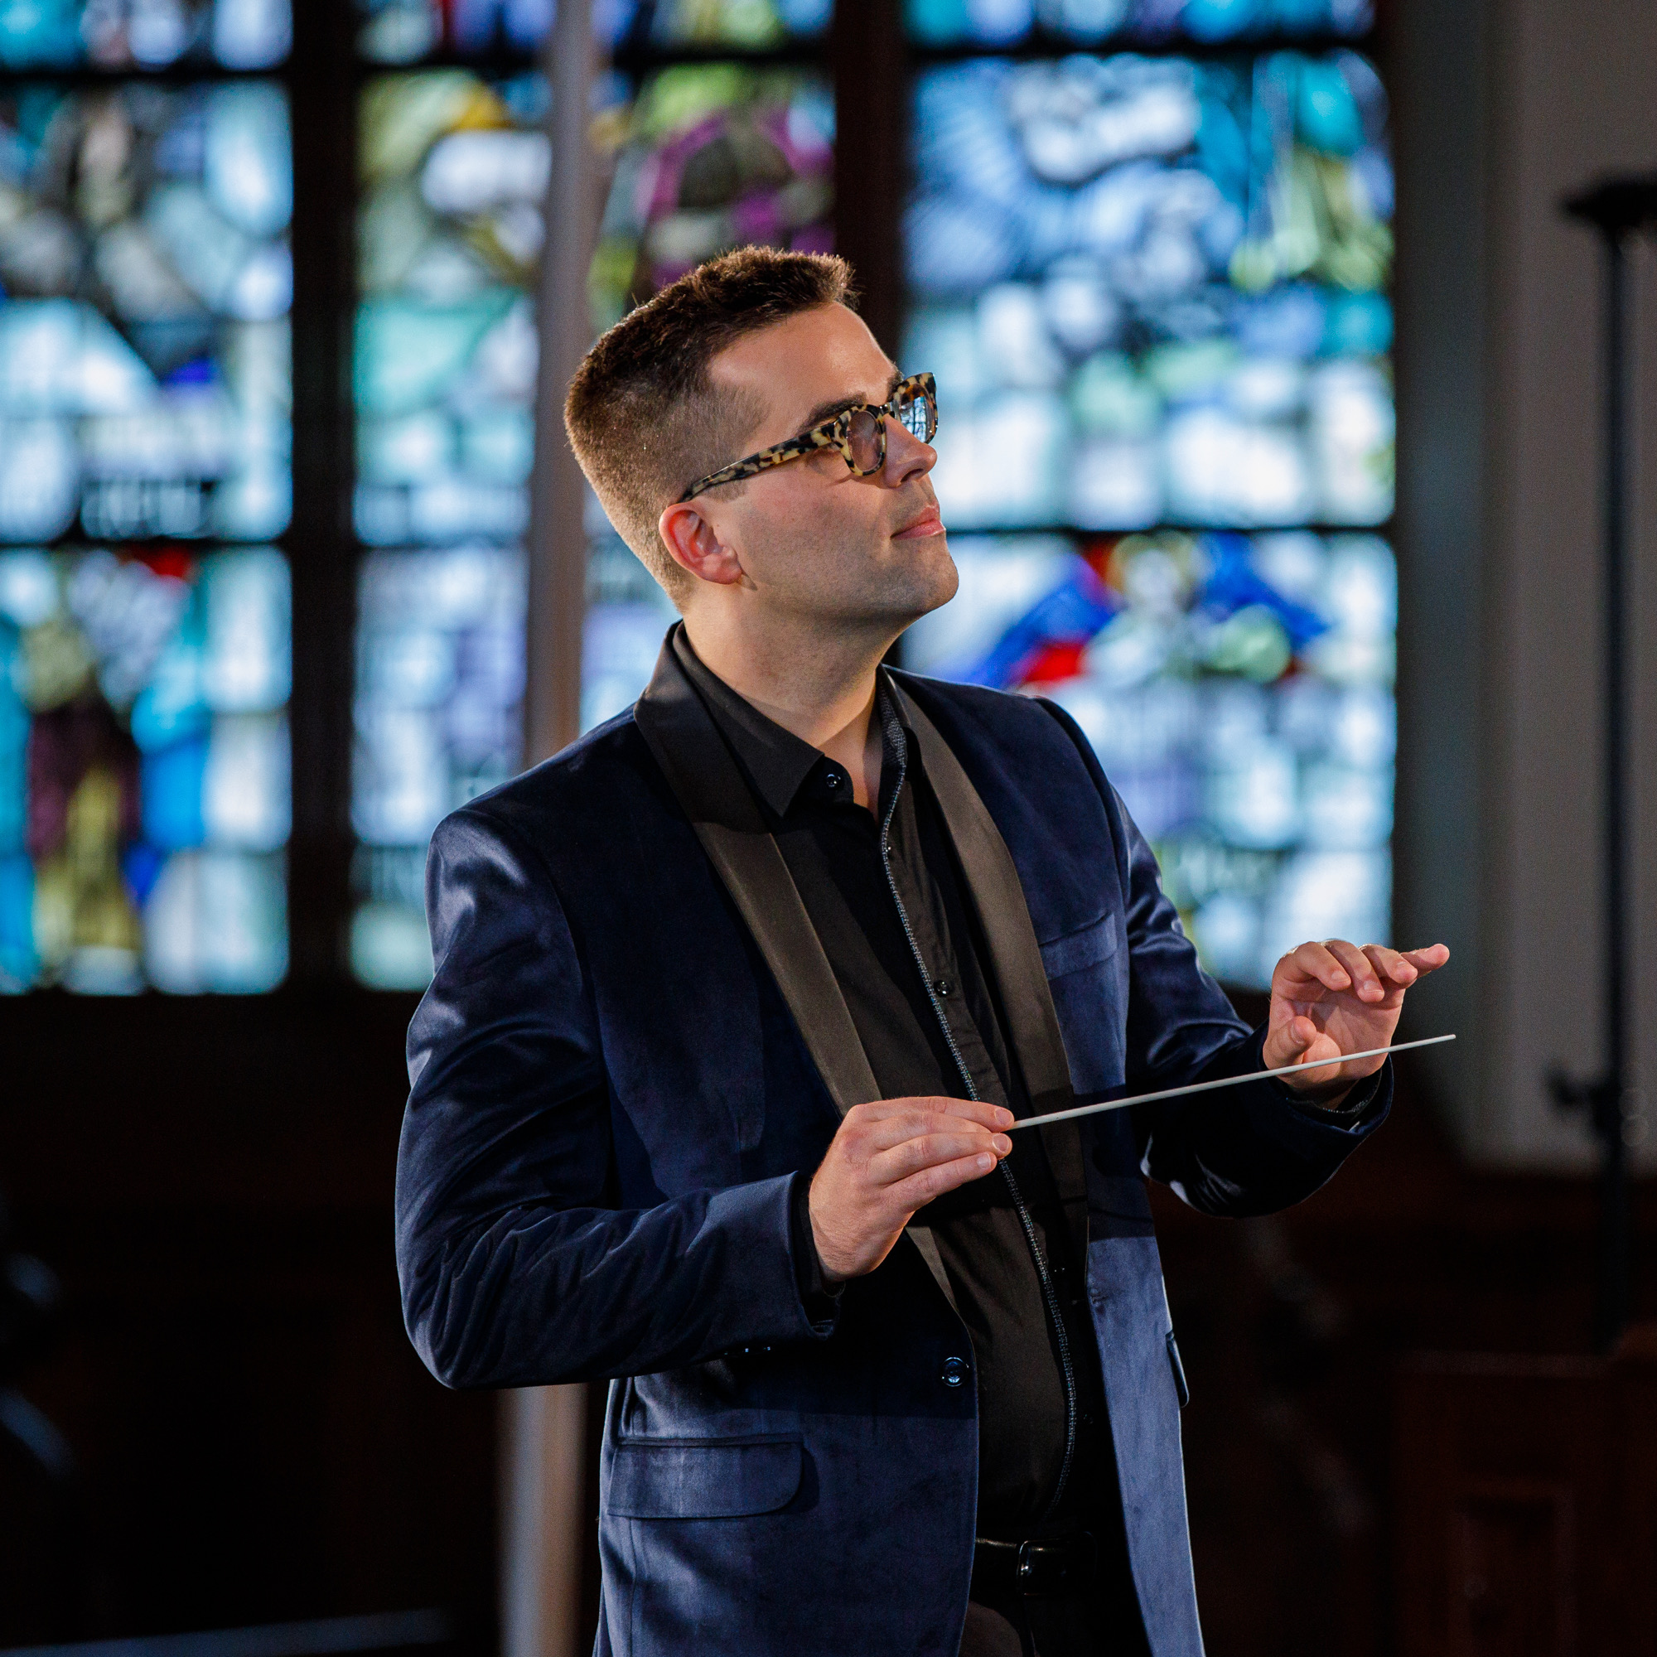
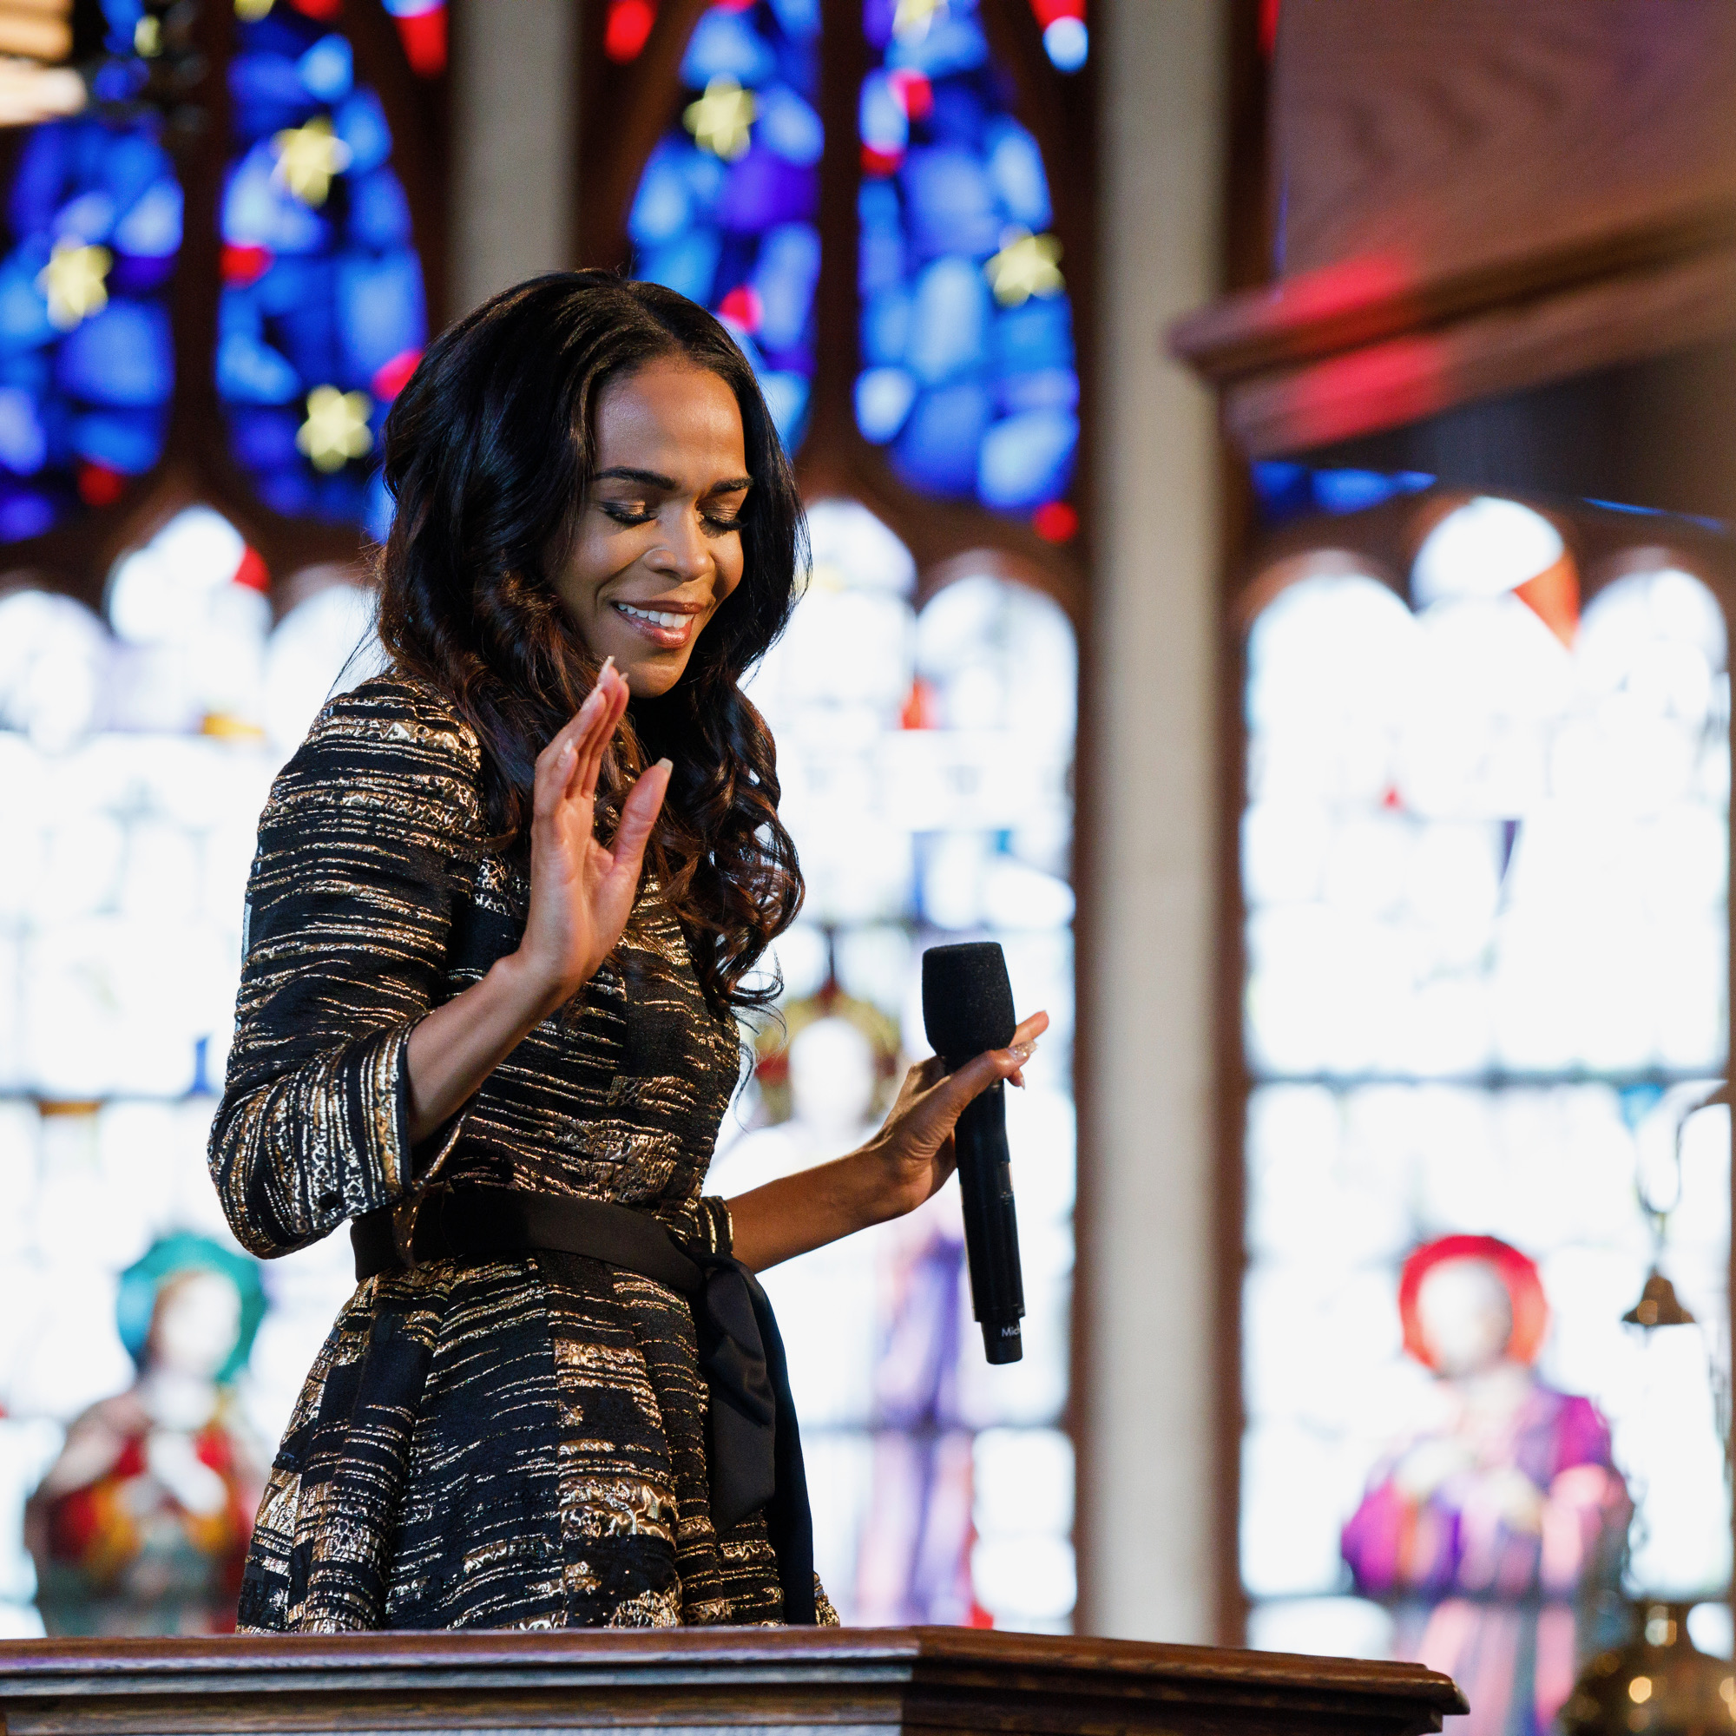

Photos by Elman Studio LLC – (from Left to Right) – JESSIE MUELLER & members of the American Pops Orchestra;
LUKE FRAZIER; MICHELLE WILLIAMS

WASHINGTON, D.C. (May 10, 2021) – The American Pops Orchestra (APO) announced today the release of a new series, entitled ONE VOICE: THE SONGS WE SHARE, as part of #PBSForTheArts. Its two inaugural episodes, “Broadway” and “Sacred,” will be broadcast back to back on Friday, May 28, 2021 (check local listings) on PBS, PBS.org and the PBS Video App.

In this new series, Maestro Luke Frazier and the American Pops Orchestra celebrate uniquely American music that has transcended its original genre to find a place in our collective culture. “Broadway” features show tunes recorded by the Rat Pack, Johnny Mathis and other chart-topping artists, as well as musical theater songs that have become anthems outside of the theater and given a broader voice to our changing society. “Sacred” includes music once only performed in church and later adapted by greats like Aretha Franklin, Elvis Presley and Johnny Cash to be shared beyond the walls of the sanctuary.

“There are so many incredible songs that contribute to the extraordinary cannon of American music. Many of the songs that you will enjoy in this series began as part of some other body of work or as part of a very specific genre of music. The pieces we will share with you have transcended their original purpose, making an indelible mark on the iconic American Songbook. ONE VOICE: THE SONGS WE SHARE brings these celebrated classics front and center, and with the American Pops Orchestra’s commitment to present them in a fresh and new way,” said Frazier.

Two additional episodes of the ONE VOICE: THE SONGS WE SHARE series are planned for release later this year, including “Country” and “American Roots.”

“Broadway”
This episode was filmed at the historic Maryland Theatre in Hagerstown, Maryland, just outside of Washington, D.C., under strict COVID-19 mitigation procedures. Hosted by and starring Tony and Grammy Award winner Jessie Mueller, “Broadway” features Amber Iman (Hamilton); Luke Hawkins (tap-sensation, Harry Connick, Jr. – A Celebration of Cole Porter); Alexis Michelle (RuPaul’s Drag Race); Sam Simahk (My Fair Lady, Carousel, The King and I, Miss Saigon); and celebrated pianists Steven Mann and Ray Wong. All performers are joined by The American Pops Orchestra under the baton of founder and music director Maestro Luke Frazier.

“Sacred”
This episode was filmed at the historic Trinity Lutheran Church in Hagerstown, Maryland, just outside of Washington, D.C., under strict COVID-19 mitigation procedures. Hosted by and starring Grammy Award-winning vocalist Michelle Williams (Destiny’s Child), “Sacred” features Justin Guarini (American Idol); Metropolitan Opera soprano Maureen McKay; Adam Hyndman (The Inheritance, Hadestown, Once on This Island, Aladdin); and 16-year-old prodigy organist Daniel Colaner. All performers are joined by The American Pops Orchestra under the baton of Maestro Luke Frazier.

#PBSFortheArts is a multiplatform campaign that celebrates the resiliency of the arts in America during the COVID-19 pandemic shutdown and reopening, and features new performing arts content filmed within the constraints of the pandemic. The collection of #PBSForTheArts programs will be available for broadcast on PBS and streaming on pbs.org/arts and the PBS Video app. Curated conversation and digital shorts will be available on PBS social media platforms using #PBSForTheArts.

About the American Pops Orchestra
APO was founded in 2015 with a mission to breathe new life into orchestral pops programming and inspire diverse audiences to discover the wealth of the material in the Great American Songbook in dynamic new ways. Seeing an opportunity to challenge the status-quo of the repertoire an orchestra performs, Founder and Music Director, Luke Frazier, created The American Pops with the intent of breaking the mold of the traditional pops orchestra. This new, distinctly “American” orchestra brings together versatile musicians and reimagined programming focused around the Great American Songbook, and presents it with an approachable, fresh spin in order to engage diverse audiences. Through non-traditional orchestral settings, APO aims to deliver popular American classics to those who already know and love them, while also introducing these timeless pieces to younger generations in approachable settings. To learn more, visit www.TheAmericanPops.org.

About Luke Frazier, Music Director and Conductor
Growing up in West Virginia and spending most of his career in New York City and Washington, D.C., Luke knows the breadth of audiences that can have their lives changed by music of all kinds. A classically trained pianist and conductor, Luke spends every day focusing not only on musical excellence but also about using music as a tool to connect people from all walks of life. Gone are the days of programming and conducting in a vacuum—the arts today are about the communities we serve and the patrons both existing ones and those yet to be reached. This philosophy has led Luke to be a pioneer in how, where, and what orchestras perform. This commitment to innovation led Luke to start The American Pops Orchestra in 2015 to serve as an artistic model of this thinking. In Luke’s shows, it’s not uncommon to hear pop singers, classical musicians and television stars all in the same program. Each concert, whether it be with his own APO or another orchestra around the country, is curated as an opportunity to highlight music, particularly American Popular Music. This music that we’ve created together can be used as a rallying point in our collective lives. Luke crafts each concert with a dramatic arc featuring both innovative and classic arrangements to keep both audiences and artists engaged at every measure.
Luke is lucky to call many of the world’s most acclaimed artists, friends and collaborators. These friendships include Renée Fleming, Brian Stokes Mitchell, Patti Labelle, Kelli O’Hara, Juanes, Wynton Marsalis, Rita Moreno, Morgan James, Joshua Bell and so many more have led to concerts all over the country both in iconic venues and to millions of viewers on television. Passionately committed to the next generation of musicians, Luke spends a significant amount of time and resources with all levels of aspiring musicians. Each year APO hosts a free national collegiate vocal competition, hosts instrumental and vocal masterclasses for collegiate musicians, creates original children’s programming of the highest caliber and spends two weeks visiting schools free of charge in some of the poorest regions of our country. Luke believes in the power of music to open new doors for children – In fact, it was an elementary school gymnasium performance which included live musicians that inspired his own career.
To get to know more about Luke, check out @fraziersedge and www.LukeFrazierMusic.com.

About PBS
PBS, with more than 330 member stations, offers all Americans the opportunity to explore new ideas and new worlds through television and digital content. Each month, PBS reaches over 120 million people through television and 26 million people online, inviting them to experience the worlds of science, history, nature and public affairs; to hear diverse viewpoints; and to take front row seats to world-class drama and performances. PBS’ broad array of programs has been consistently honored by the industry’s most coveted award competitions. Teachers of children from pre-K through 12th grade turn to PBS for digital content and services that help bring classroom lessons to life. Decades of research confirms that PBS’ premier children’s media service, PBS KIDS, helps children build critical literacy, math and social-emotional skills, enabling them to find success in school and life. Delivered through member stations, PBS KIDS offers high-quality educational content on TV – including a 24/7 channel, online at pbskids.org, via an array of mobile apps and in communities across America. More information about PBS is available at www.pbs.org, one of the leading dot-org websites on the internet, or by following PBS on Twitter, Facebook or through our apps for mobile and connected devices. Specific program information and updates for press are available at pbs.org/pressroom or by following PBS Communications on Twitter.

###
MEDIA CONTACT:
Camille Cintrón Devlin
571-317-9317
pr@camillecdevlin.com

For images and additional up-to-date information on ONE VOICE: THE SONGS WE SHARE and other PBS programs, visit PBS PressRoom at pbs.org/pressroom.

