New Series OPERATION WILD Shows How Groundbreaking Veterinary Medicine Can Save Animal Lives

– Three-Part Series Premieres July 1, 2015, 8:00-9:00 p.m. ET as part of PBS’ Robust Science Offerings This Summer –

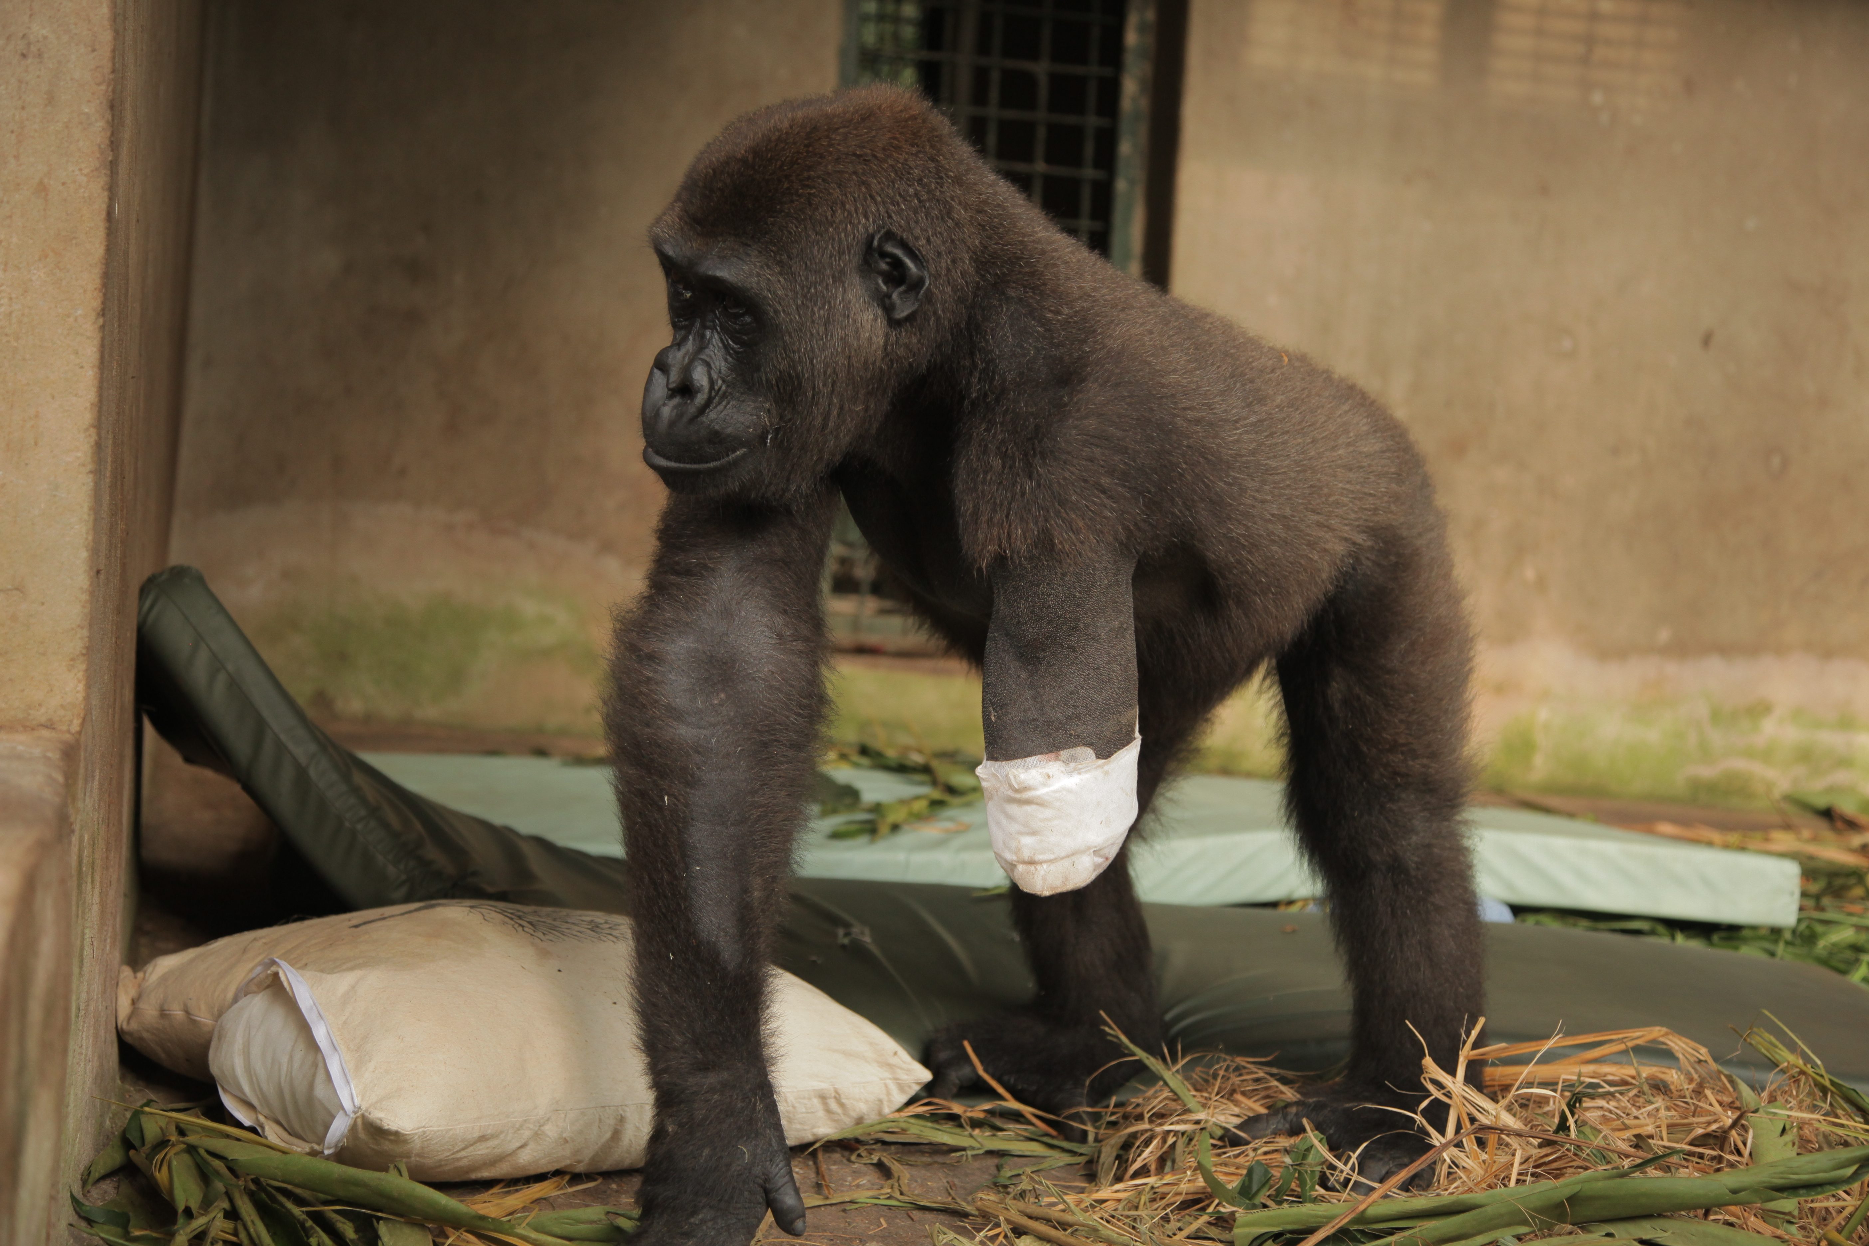
Gorilla in recovery. Courtesy of Alice Jones / BBC

ARLINGTON, VA; June 10, 2015 –In an in-depth, behind-the-scenes look at how pioneering human medicine can also transform the way to treat ailing wildlife, the three-part series OPERATION WILD (watch a clip here) premieres Wednesday, July 1, 2015, at 8:00 p.m. ET on PBS (check local listings). Filmed over 18 months in co-production with the BBC Science Department, OPERATION WILD follows veterinarian teams from around the world as they undertake groundbreaking operations to try to save, or at least improve, animals’ lives.

OPERATION WILD tells the remarkable stories of animals in need and the dedicated caregivers who push the boundaries of veterinary medicine to help them. The three episodes span the globe and take viewers on a compelling journey:

Episode One, July 1, 8:00-9:00 p.m.: In the first part of this series, the filmmakers travel to the Wolong Giant Panda Base in South West China, where vets are using high-tech animal medicine to try to save the species. In West Africa, a gorilla called Shufai is still trying to recover from being shot in the arm by poachers when he was just a baby. A vet in Japan has invented a new kind of underwater medicine designed to look after manta rays. Audiences also glimpse the largest pop-up animal ER on the planet, created when an ancient kite festival in India causes a wildlife crisis.

Episode Two, July 8, 8:00-9:00 p.m.: Part two follows a team in South Africa who are trying to help rhino Thandi with a ground-breaking skin graft operation after poachers stole her horns. A giraffe has caught his leg in a snare and must be caught and anaesthetized in order to prevent his death. Rosemary the orangutan has micro-surgery in Borneo to try to restore her sight and give her back her freedom. At Lincoln Park Zoo in Chicago, viewers learn how human heart technology is being used to help our closest animal relatives, chimpanzees, prevent heart disease.

Episode Three, July 15, 8:00-9:00 p.m.: The third episode begins in the rainforest of Laos, where vets are going to attempt groundbreaking keyhole brain surgery on Champa, an endangered moon bear. In Japan, vet and inventor Dr. Keiichi Ueda has spent the last 12 years trying to improve the life of Fuji, a dolphin with no tail. Renowned reptile specialist Dr. Doug Mader tries 21st-century surgery to save the life of a prehistoric beast, and in Poland, a team of South African vets is called in to try to remove the infected tusk of a five-ton elephant, Ninio.

OPERATION WILD is one of PBS’ robust summer science programs. Also airing this summer: LIFE ON THE REEF, a fresh look at Australia’s Great Barrier Reef; THE BOMB, revisiting the atomic bomb on its 70th anniversary; URANIUM: TWISTING THE DRAGON'S TAIL, the complex history of the most controversial rock on Earth; NOVA's “Chasing Pluto,” capturing New Horizon’s historic flyby of the far-off planet, and “Nuclear Meltdown Disaster,” recounting Japan’s nuclear energy crisis and its ongoing aftermath; and BIG BLUE LIVE, a live-as-it-happens look at the amazing sea life returning to California's Monterey Bay National Marine Sanctuary.

OPERATION WILD is a BBC production for PBS. Series producer for the BBC is Serena Davies; edit producer is Helen Quinn and executive producer is Helen Thomas. For PBS, the series has been overseen by Bill Gardner, Vice President, Programming and Development and Bill Margol, Sr. Director of Programming and Development.

About PBS
PBS, with over 350 member stations, offers all Americans the opportunity to explore new ideas and new worlds through television and online content. Each month, PBS reaches more than 103 million people through television and over 33 million people online, inviting them to experience the worlds of science, history, nature and public affairs; to hear diverse viewpoints; and to take front row seats to world-class drama and performances. PBS’ broad array of programs has been consistently honored by the industry’s most coveted award competitions. Teachers of children from pre-K through 12th grade turn to PBS for digital content and services that help bring classroom lessons to life. PBS’ premier children’s TV programming and its website, pbskids.org, are parents’ and teachers’ most trusted partners in inspiring and nurturing curiosity and love of learning in children. More information about PBS is available at www.pbs.org, one of the leading dot-org websites on the Internet, or by following PBS on Twitter, Facebook or through our apps for mobile devices. Specific program information and updates for press are available at pbs.org/pressroom or by following PBS Pressroom on Twitter.

– PBS –

CONTACTS:
Ellen Stanley Booth, PBS, 703-739-5120; esbooth@pbs.org
Chelsey Saatkamp, Goodman Media for PBS, 212-576-2700; PBSProgramming@goodmanmedia.com

For images and additional up-to-date information on this and other PBS programs, visit PBS PressRoom at pbs.org/pressroom.

