PBS AMERICAN PORTRAIT
Winter 2020 TCA Press Tour
Panel Bios

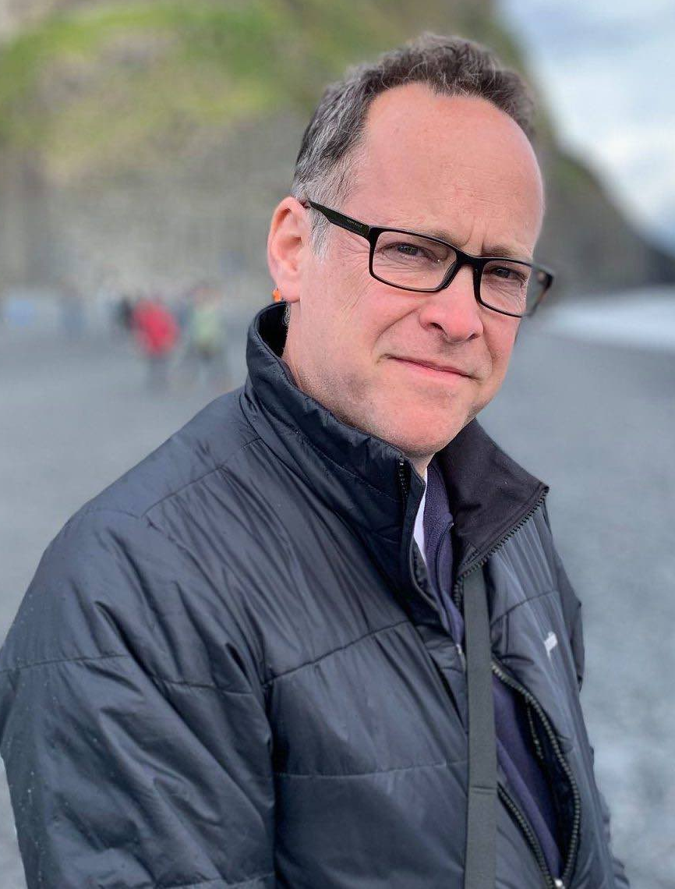
Bill Margol has spent over 30 years working in the media industry, covering the ground of writer, producer, editor, developer and executive. A graduate of Syracuse University's S.I. Newhouse School of Public Communications and Loyola University’s Masters in Emerging Media program, Bill was Executive Producer of Special Projects at Sci-Fi Channel, overseeing specials, documentaries, stunts and events from 1993-1998. He joined TNT in Atlanta as Director of Production in 1998, and in 2003 joined Travel Channel as VP of Production, where he was responsible for the launch of such groundbreaking series as “Anthony Bourdain: No Reservations.” In 2008, Bill joined National Geographic Television as VP Development, where he created the Emmy-nominated series "Brain Games.”

In 2014, Bill joined PBS as Sr. Director of Programming & Development and has overseen such programs as the Emmy-winning documentary A YEAR In SPACE, the groundbreaking series WE’LL MEET AGAIN WITH ANN CURRY, as well as programming such as 8 DAYS: TO THE MOON AND BACK, BIG BLUE LIVE, IN THEIR OWN WORDS, LIFE FROM ABOVE, BEYOND A YEAR IN SPACE, GENIUS: WITH STEPHEN HAWKING and WILD ALASKA LIVE.

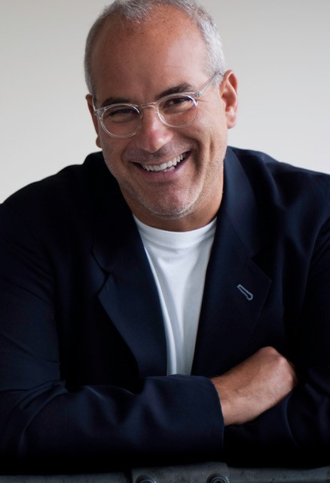
Jon Kamen, as Chairman and CEO of RadicalMedia, has created one of the world’s leading generators of premium content across all media platforms. Originally renowned for its commercial and advertising success, RadicalMedia has grown to dominate every corner of superior content creation including television, feature films, music programming, live events, graphic and interactive design. Jon continues to embrace the future and push innovation by collaborating with Radical’s community of artists, directors, producers, coders, thinkers, makers and doers.

With over 150 credits, Jon’s artistic vision has been the force behind many Oscar, Emmy, Grammy and Peabody Award-winning and nominated titles, including The Fog of War; What Happened, Miss Simone?; Paradise Lost; Concert for George; the pilot episode of AMC’s “Mad Men;” “My Next Guest Needs No Introduction with David Letterman;” and “The Fourth Estate.” RadicalMedia partnered with Bloomberg Philanthropies and National Geographic for two environmental documentary films: Paris to Pittsburgh and From the Ashes. Recent credits include Activate: A Global Citizen Movement for NatGeo, Conversations with a Killer: The Ted Bundy Tapes for Netflix and the upcoming “Grant” series for the History Channel. Harpo recently announced Kamen as part of the creative team, serving as executive producer for the upcoming Apple TV+ mental health series with Oprah Winfrey and Prince Harry.

Kamen, a recipient of the Industry Tribute at the 2018 IFP Gotham Awards, Mayor Bloomberg’s “Made in NY” Award and Smithsonian’s National Design Award, sits on the board of trustees for Rhode Island School of Design, Smithsonian Cooper Hewitt National Design Museum, The Museum of the Moving Image and Mr. Holland’s Opus Foundation.

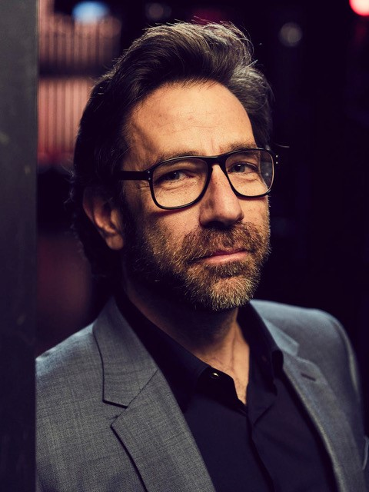
Dave Sirulnick, an award-winning executive producer and President of Entertainment at RadicalMedia, lends his extensive industry expertise toward creating and producing premium content, series, documentaries, digital, video, news programming, specials and live events.

Sirulnick has served as executive producer on several Radical projects, including “Grant,” slated to debut on History Channel in 2020; “More Than an Athlete,” featuring Lebron James, for ESPN+; “My Next Guest Needs No Introduction with David Letterman” on Netflix; Emmy-nominated documentary “The Fourth Estate” and The Family Business: Trump and Taxes on Showtime; Oh, Hello on Broadway for Netflix, “The Untold Stories of the 90s” on History Channel; Hamilton’s America on PBS; “This is A.I.” for Discovery; and IDA Documentary Award-winning series “Bobby Kennedy for President” on Netflix. Most recently, Harpo announced Sirulnick as part of the creative team, serving as executive producer for the upcoming Apple TV+ mental health series with Oprah Winfrey and Prince Harry.

Prior to joining RadicalMedia, Sirulnick served as Executive Vice President of News & Docs at MTV. During his 28-year tenure at MTV, he developed and led some of the channel’s leading and longest-running television series, including Emmy Award-winning documentary series “Made” (2000-2012), Emmy Award-winning series “True Life” (1998-2014), “Total Request Live” (1998-2008), “The Week in Rock” (1987-1997), and Peabody and Emmy Award-winning documentary series “Choose or Lose” (1992-2012), geared toward increasing the political awareness of its viewers and promoting their participation in local and national elections.

During this time, Sirulnick served as executive producer for MTV’s annual Video Music Awards, producing the pre-show and the awards show for 16 years. Sirulnick also helmed the creation of award-winning music documentaries for the network that featured the likes of superstars Miley Cyrus, Kanye West, Lady Gaga, Drake, Ed Sheeran, Nicki Minaj and Demi Lovato.

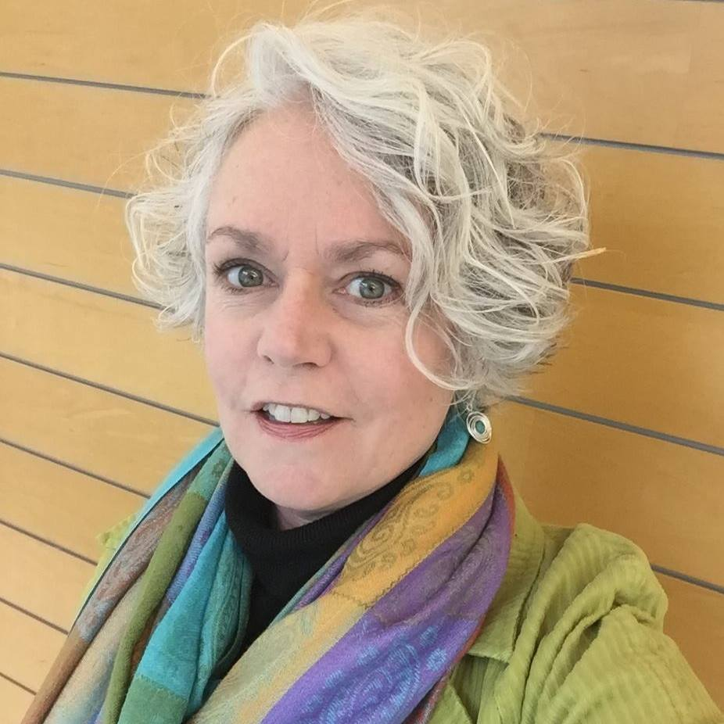
Laura Bradley has been teaching middle school students since 1988, and currently teaches English, broadcast media and design lab at Kenilworth Junior High School in Petaluma, California. She is a PBS Digital Innovator All-Star, Google Certified Innovator, National Board Certified Teacher, Bay Area Writing Project Teacher Consultant and first-place winner of the Henry Ford Teacher Innovator Award.

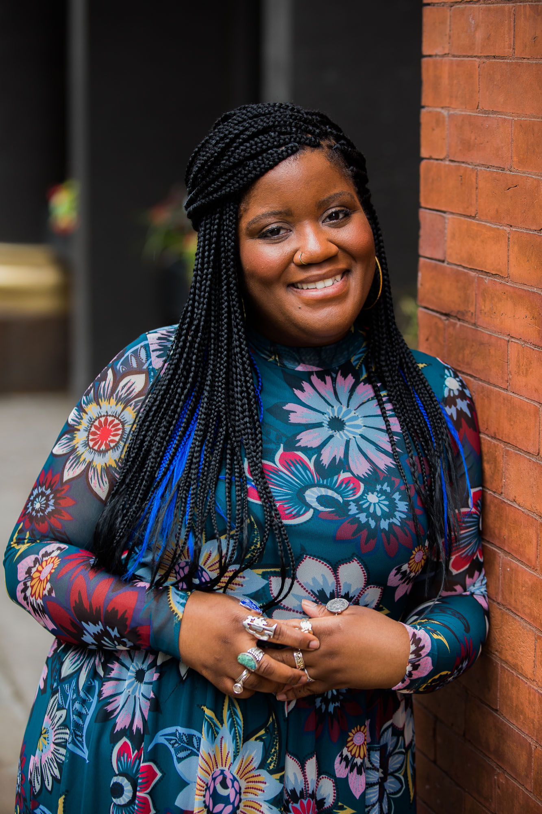
Danielle Bainbridge is an academic, writer and web series host based in Chicago. She has a PhD in African American Studies and American Studies from Yale University (2018), and a BA in English and Theatre Studies from the University of Pennsylvania (2012). In the 2018-2019 academic year, she was a postdoctoral fellow in the Department of African American Studies at Northwestern University. She is currently an Assistant Professor of Theatre, Performance Studies and African American Studies at Northwestern, where she teaches courses on history, culture and performance. She is the primary researcher, writer and host of the PBS Digital Studios web series THE ORIGIN OF EVERYTHING, which focuses on highlighting the unusual and under-told history that makes up our collective story and streams on YouTube and Facebook Watch. Her ongoing book project, Refinements of Cruelty: Enslavement, Enfreakment, and the Performance Archive, examines the lives of 19th century disabled African American sideshow and freak show performers who were enslaved.

