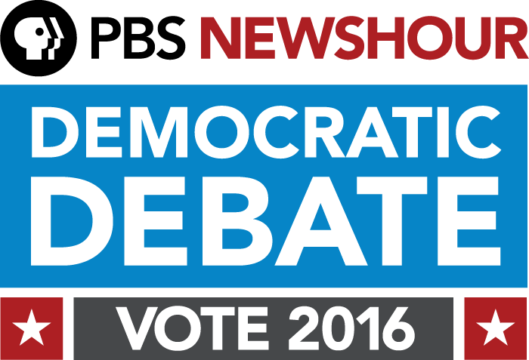

PBS NEWSHOUR AND FACEBOOK ANNOUNCE SOCIAL PARTNERSHIP
FOR FEBRUARY 11 DEMOCRATIC PRIMARY DEBATE

FOR IMMEDIATE RELEASE

February 4, 2016 (WASHINGTON, DC) — Today, PBS NewsHour announced it will host its February 11 Democratic presidential debate in partnership with Facebook. The Democratic National Committee sanctioned debate – to be moderated by NewsHour co-anchors and managing editors Gwen Ifill and Judy Woodruff – will be the first following the New Hampshire primary, and will take place at the Helen Bader Concert Hall in the Helene Zelazo Center for the Performing Arts on the main campus of the University of Wisconsin-Milwaukee. The PBS NewsHour Democratic Primary Debate, which is part of the PBS Election 2016 lineup, will be broadcast nationwide on PBS stations and stream live at www.pbs.org/newshour.

PBS NewsHour and Facebook have created a closed Facebook group of undecided voters in states soon to vote in the primaries, allowing for open discussion and soliciting questions for the February 11th debate. Participants will have the opportunity to interact around political news and issues with the NewsHour's political team including political director Lisa Desjardins, online political editor Dan Bush and correspondent and NewsHour Weekend anchor Hari Sreenivasan. During the debate, NewsHour will incorporate live Facebook data into the conversation and broadcast graphics to offer insight into how the candidates and specific issues are driving the online conversation. On February 11, NewsHour will also open up the Facebook group so people at home can follow along.

“Facebook is such an important place where many Americans turn for political news and information and share it with their friends,” said Sara Just, Executive Producer of PBS NewsHour and Senior Vice President of WETA. “We are excited to partner with Facebook at this moment and have the opportunity to incorporate new ways to harness those real time social media conversations into the debate experience as Americans are making decisions about who they want to lead the country.”

Andy Mitchell, Director, News and Global Media Partnerships at Facebook added, “From the start with PBS NewsHour, they brought a spirit of innovation to thinking about how to incorporate people on Facebook into the debate. That spirit shows through in their unique use of Facebook Groups to help foster conversation about the issues and bring Americans’ voices into the political process in a new way. We couldn’t be more excited for February 11th."

CONTACTS:

Nick Massella, Director of Audience Engagement and Communications, PBS NewsHour, nmassella@newshour.org

Kate Kelly, Senior Director of National Publicity, WETA, kkelly@weta.org

Chris Pigott, DKC News, Chris_Pigott@dkcnews.com
David Helfenbein, DKC News, David_Helfenbein@dkcnews.com

About PBS Election 2016
PBS Election 2016 is a year-long, cross-platform initiative that brings together PBS’ news, public affairs, documentary and digital programming to create a comprehensive look at the 2016 election cycle. Acclaimed series PBS NewsHour, FRONTLINE and Washington Week, as well as new and returning series and specials such as 16 FOR ’16 and America by the Numbers, will cover breaking news, provide context for political issues and explore behind-the-scenes stories of the candidates and the election process. PBS Election 2016 also includes a partnership with NPR in which the two organizations will share information across broadcast, radio and digital platforms.

About PBS
PBS, with over 350 member stations, offers all Americans the opportunity to explore new ideas and new worlds through television and online content. Each month PBS reaches more than 103 million people through television and over 33 million people online, inviting them to experience the worlds of science, history, nature and public affairs; to hear the diverse viewpoints; and to take front row seats to world-class drama and performances. PBS’ broad array of programs has been consistently honored by the industry’s most coveted award competitions. Teachers of children from pre-K through 12th grade turn to PBS for digital content and services that help bring classroom lessons to life. PBS’ premier children’s TV programming and its website, pbskids.org, are parents’ and teachers’ most trusted partners in inspiring and nurturing curiosity and love of learning in children. More information about PBS is available at www.pbs.org, one of the leading dot-org websites on the Internet, or by following PBS on Twitter, Facebook or through our apps for mobile devices. Specific program information and updates for press are available at pbs.org/pressroom or by following PBS Pressroom on Twitter.

About WETA
WETA is one of the largest producing stations of news content for public television in the United States and serves Virginia, Maryland and the District of Columbia with educational initiatives and with high-quality programming on four digital television channels. WETA productions and co-productions include PBS NewsHour, Washington Week with Gwen Ifill, America After Charleston, The Kennedy Center Mark Twain Prize, The Library of Congress Gershwin Prize for Popular Song and documentaries by filmmaker Ken Burns, including The Roosevelts: An Intimate History and the April 2016 premiere of Jackie Robinson. WETA studios and administrative offices are located in Arlington, Virginia. More information on WETA and its programs and services is available at www.weta.org.

About PBS NewsHour
PBS NewsHour is seen by over four million weekly viewers and is also available online, via public radio in select markets, and via podcast. PBS NewsHour is a production of NewsHour Productions LLC, a wholly-owned non-profit subsidiary of WETA Washington, D.C., in association with WNET in New York. Major funding for PBS NewsHour is provided by the Corporation for Public Broadcasting, PBS and public television viewers. Major corporate funding is provided by BNSF and Lincoln Financial Group, with additional support from Alfred P. Sloan Foundation, Carnegie Corporation of New York, the J. Paul Getty Trust, the S.D. Bechtel, Jr. Foundation, the John D. and Catherine T. MacArthur Foundation, the Lemelson Foundation, National Science Foundation, The Rockefeller Foundation, the William and Flora Hewlett Foundation, Ford Foundation, Skoll Foundation, Friends of the NewsHour and others. More information on PBS NewsHour is available at www.pbs.org/newshour. On social media, visit NewsHour on Facebook or follow @NewsHour on Twitter.

###

