TCA PANELIST BIOS - January 2014

RAY ROMANO
Everybody Loves Raymond
Ray Romano went to college to study accounting, but the lure of comedy wouldn’t let go. Over time, he built a solid career in stand-up, leading to an appearance on David Letterman. The set went well and the result was a development deal to create Everybody Loves Raymond. The sitcom was a nine-year mega-hit for CBS, earning Romano two Emmy awards and countless other honors. More recently, he has returned to episodic television, first in Men of a Certain Age, and more recently in Parenthood. Romano has not lost touch with his stand-up roots, performing at the Mirage in Las Vegas every year.

BOB NEWHART
The Bob Newhart Show; Newhart
In his stand-up comedy, Bob Newhart’s gentle stammer earned him three Grammys and the first comedy album to reach No. 1 on the Billboard charts. His unique brand of humor translated well to television, where he starred in two of the best-loved sitcoms of the 1970s and 1980s: The Bob Newhart Show and Newhart. He made his mark in TV drama as well, including a role on ER that earned him an Emmy nomination. With seven nominations over a 51-year stretch, Newhart finally won the award for a guest shot on Big Bang Theory last year.

JIMMIE WALKER
Good Times
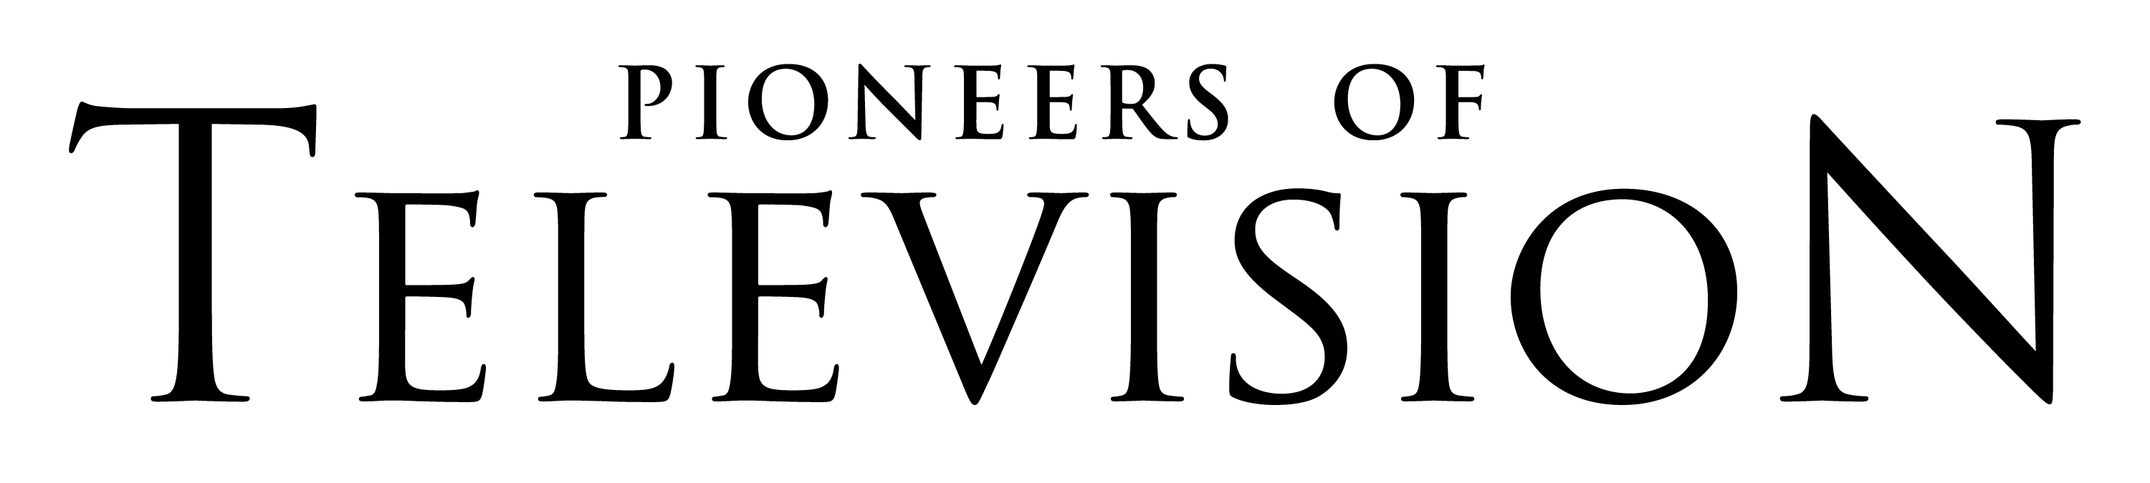
Jimmie Walker burst on to the national stage as the star of Norman Lear’s sitcom Good Times in the mid-1970s. The strutting, wisecracking J.J. Evans stole the show, and Walker’s catchphrase “Dyn-o-mite!” became part of the American lexicon overnight. During Good Time’s six-year run, Walker's fame grew. He hired writers, including two little-known comics—named David Letterman and Jay Leno. As with other great comics, television was just a diversion from Walker’s first love: stand-up. He continues to tour, doing live shows 40 weeks a year.

GEORGE TAKEI
Star Trek
George Takei spent his boyhood years in a Japanese internment camp. But he bounced back and became known worldwide for his founding role in the original Star Trek. His character, Hikaru Sulu, was the first non-stereotypical Asian American on television—and the first to speak without an accent. His resonant voice has long been in-demand—in animated films, Grammy-nominated recordings and on the Broadway stage. Today Takei is recognized as the most-influential person on Facebook, with more than five million fans, and a million followers on Twitter.

LESLIE UGGAMS
The Leslie Uggams Show
Leslie Uggams was among the first African Americans to perform regularly on primetime television—as a singer on Mitch Miller’s show. In 1970, she became the first African American woman to host a variety series, and a few years later she joined the cast of Alex Haley’s landmark series Roots. Uggams has performed on Broadway, sung at concerts around the country and won an Emmy and a Tony. She has one other distinction — appearing on the first network TV series with an African-American lead, Beulah, playing the niece of Ethel Waters.

