STAR-STUDDED FOURTH SEASON OF PIONEERS OF TELEVISION PREMIERES APRIL 15 ON PBS

– Jerry Seinfeld, Bill Cosby, Ray Romano, Roseanne Barr and Dozens More A-List TV Stars Tell
Behind-the-Scenes Tales of America’s Most Popular Shows –

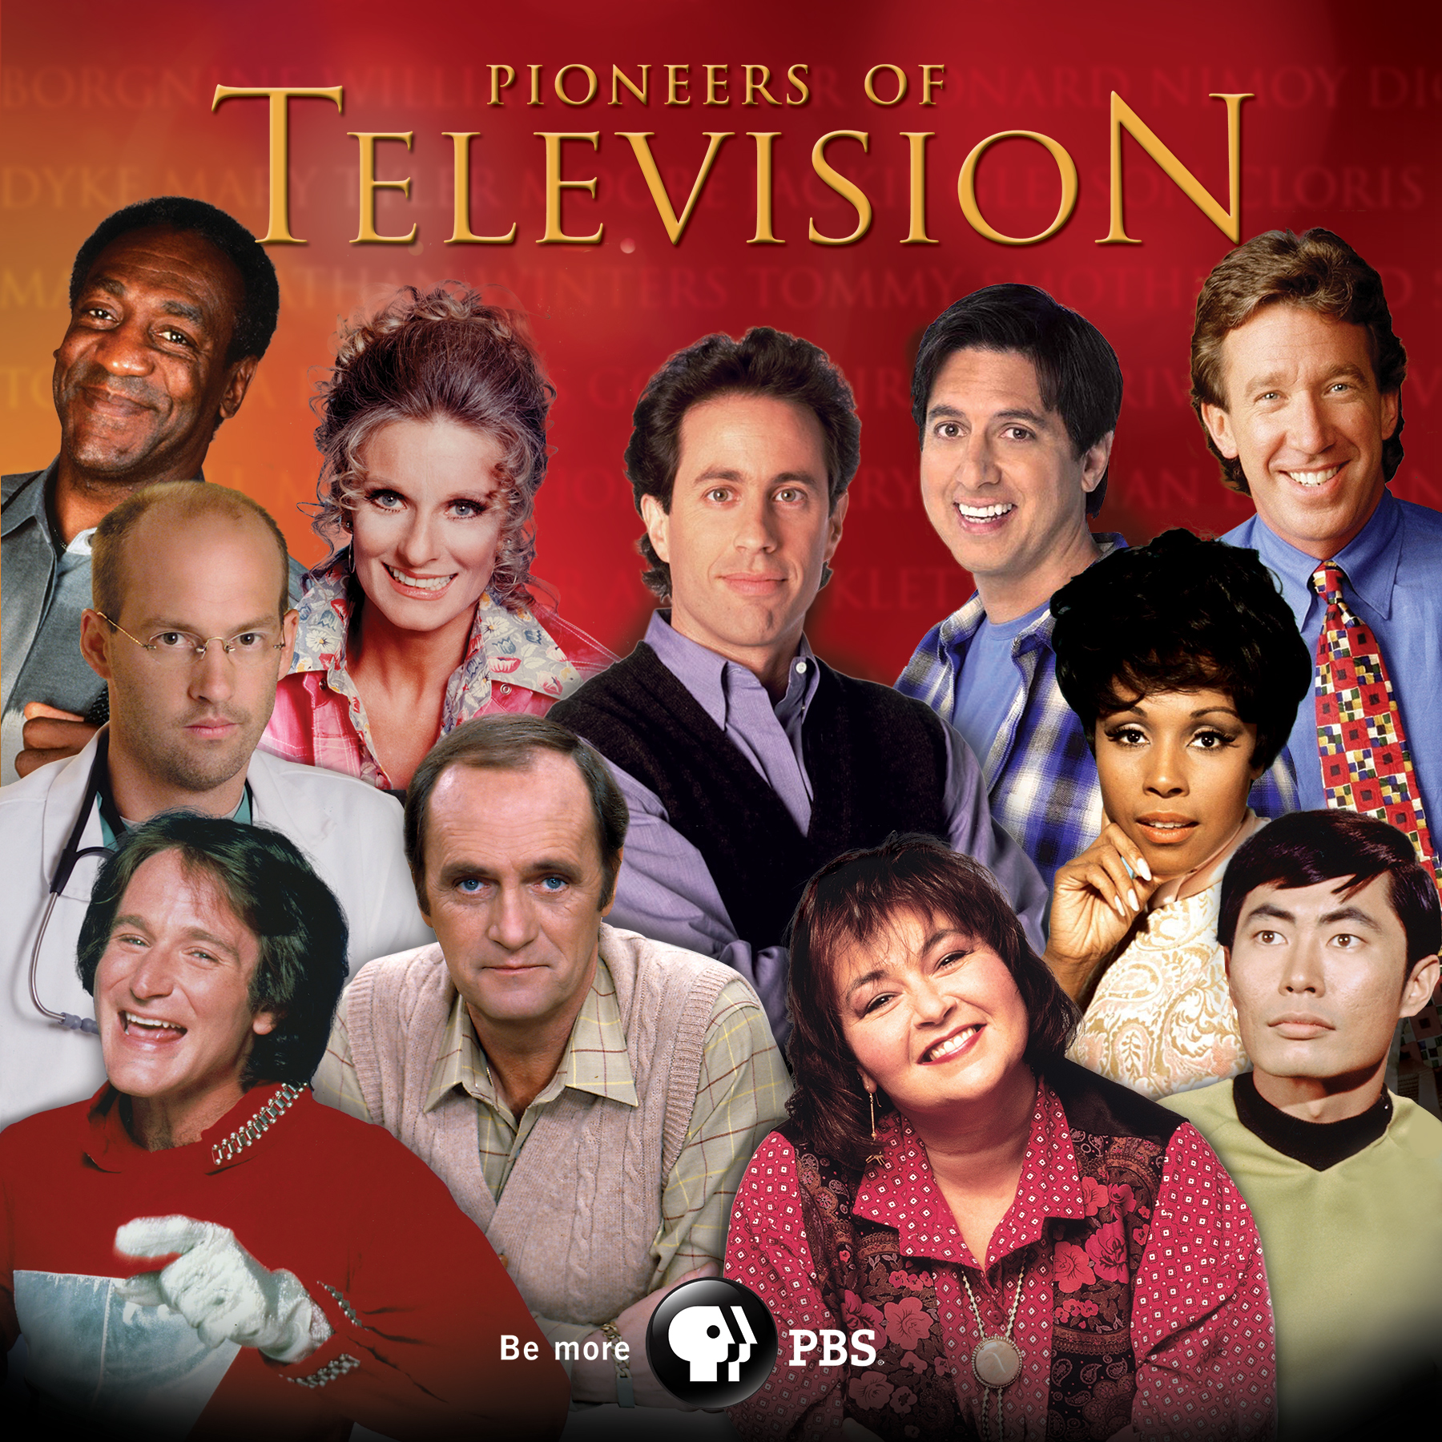
Courtesy of BT Media
ARLINGTON, VA; MARCH 21, 2014 – Explore trailblazing moments of television history when PIONEERS OF TELEVISION returns to PBS, Tuesday, April 15, 2014, featuring standup comedians who landed sitcoms, TV doctors and nurses, standout comedic actors and those who broke the color barrier on television. Offering inside stories from some of America’s most beloved television stars, the fourth season of the Emmy-nominated series reveals intriguing behind-the-scenes stories and fascinating facts about television’s best-known and influential celebrities.

The fourth season combines new interviews with legendary stars, such as Ray Romano, Bob Newhart, Robin Williams, Jimmie Walker, Tim Allen, Roseanne Barr and Dick Van Dyke, with never-before-seen images and timeless footage that continues to entertain TV viewers decades later. Pioneers of Television’s first-hand look at the medium is guided by the stories of television icons and their memories about the iconic genres they helped popularize.

“We are thrilled to bring another season of Pioneers of Television to PBS,” said executive producer Steve Boettcher, who, along with producing partner Mike Trinklein, has helmed numerous specials and series on television’s breakthrough performers. “From stars that had Americans howling with laughter in front of their television screens, to the ones who broke barriers — and maybe even some who saved lives — this season’s line-up features legends who paved the way for contemporary television.”

“The fourth season of PIONEERS OF TELEVISION continues the series’ winning formula of bringing television’s most well-known stars and their lesser-known stories to PBS,” says Donald Thoms, PBS Vice President of General Audience Programming. “The show does a masterful job of serving us the history of the medium while telling us the backstage tales of America’s favorite shows.”

This season’s four one-hour Pioneers of Television episodes include:

STANDUP TO SITCOM
Tuesday, April 15, 2014, 8:00-9:00 p.m. ET
This star-packed premiere episode features fresh interviews with Jerry Seinfeld, Roseanne Barr, Tim Allen, Ray Romano and Bob Newhart. The program reveals how America’s top standup comics made the transition from the comedy stage to the sitcom form. It includes dozens of clips from “Seinfeld,” “Home Improvement,” “Everybody Loves Raymond,” “Roseanne” and more.

DOCTORS AND NURSES
Tuesday, April 22, 2014, 8:00-9:00 p.m. ET
From George Clooney on “ER” to Richard Chamberlain on “Dr. Kildare,” television’s long love affair with doctors and nurses shows no signs of letting up. Noah Wyle, Anthony Edwards, Gloria Reuben and Eriq LaSalle open up about the secrets of “ER”; Howie Mandel, Ed Begley, Jr., Norman Lloyd and Christina Pickles revisit “St. Elsewhere.” The episode features the final interview with Chad Everett of “Medical Center” before his death in 2012.

BREAKING BARRIERS
Tuesday, April 29, 2014, 8:00-9:00 p.m. ET
This episode traces the story of people of color on American television — including the mid-1960s breakthroughs of African Americans Diahann Carroll (“Julia”) and Bill Cosby (“I Spy”). Latino landmarks range from “I Love Lucy” with Desi Arnaz to “Miami Vice” with Edward James Olmos. Also featured are Asian Americans such as George Takei (“Star Trek”), who details the childhood years he spent in a Japanese-American internment camp.

ACTING FUNNY
Tuesday, May 6, 2014, 8:00-9:00 p.m. ET
This episode peeks behind the curtain to reveal the techniques of America’s favorite comedic actors. The program features the manic improvisational style of Robin Williams and his comic predecessor, Jonathan Winters. Their style is a fascinating contrast to Tina Fey, who explains her measured, highly prepared approach. The episode also highlights the all-time #1 Emmy Award winner for comedy acting: Cloris Leachman, and the physical comedic style of Dick Van Dyke.

About PBS
PBS, with its over 350 member stations, offers all Americans the opportunity to explore new ideas and new worlds through television and online content. Each month, PBS reaches nearly 109 million people through television and over 28 million people online, inviting them to experience the worlds of science, history, nature and public affairs; to hear diverse viewpoints; and to take front row seats to world-class drama and performances. PBS’ broad array of programs has been consistently honored by the industry’s most coveted award competitions. Teachers of children from pre-K through 12th grade turn to PBS for digital content and services that help bring classroom lessons to life. PBS’ premier children’s TV programming and its website, pbskids.org, are parents’ and teachers’ most trusted partners in inspiring and nurturing curiosity and love of learning in children. More information about PBS is available at http://www.pbs.org, one of the leading dot-org websites on the Internet, or by following PBS on Twitter, Facebook or through our apps for mobile devices. Specific program information and updates for press are available at pbs.org/pressroom or by following PBS Pressroom on Twitter.

– PBS –
MEDIA CONTACTS:

Roberta Lee or John Michael Kennedy, Goodman Media International for PBS, Pioneers@goodmanmedia.com; 212-576-2700

Carrie Johnson, PBS, cjohnson@pbs.org, 703-739-5129
Michaé Godwin, PBS, mmgodwin@pbs.org, 703-739-8483

For images and additional up-to-date information on this and other PBS programs, visit PBS PressRoom at pbs.org/pressroom.

