PREHISTORIC ROAD TRIP
Premieres Wednesdays, June 17-July 1 on PBS

Join Host Emily Graslie, Chief Curiosity Correspondent at Chicago’s Field Museum and Creator of Popular YouTube Series “The Brain Scoop,”
For a Summer Road Trip Through the Heart of America’s Fossil Country

New Three-Part Series Explores Prehistoric Life Across the Western U.S.
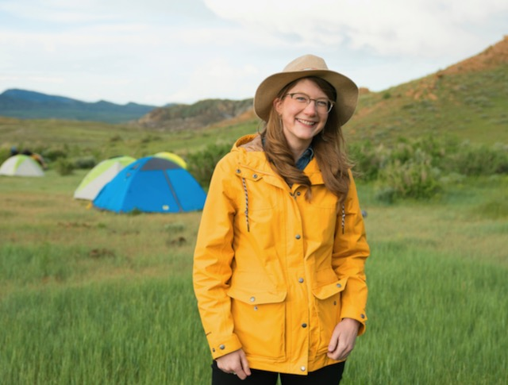
Caption: Emily Graslie, just outside Hanna, Wyoming.
Photo Credit: Julie Florio/WTTW

This summer, PREHISTORIC ROAD TRIP takes viewers on an epic adventure through dinosaur country to search for mysterious creatures and bizarre ecosystems that have shaped Earth as we know it. With the intrepid Emily Graslie as host and guide, the series travels thousands of miles to visit some of the most active and dynamic fossil sites in the world. Revealing the amazing wonders preserved beneath our feet, the three-part series combines science, culture, and history for an unforgettable expedition through hundreds of millions of years. PREHISTORIC ROAD TRIP premieres Wednesdays, June 17-July 1, 2020, 10:00-11:00 p.m. ET (check local listings) on PBS.

In the series, Emily hits the road, heading to the heart of America’s fossil country – the Northern Great Plains – for a fun and fascinating journey to explore 2.5 billion years of our planet’s history. Crossing the Dakotas, Montana, Nebraska, and Wyoming, she examines the fossils of diverse prehistoric creatures and plants and introduces some of the people who helped bring these ancient discoveries to light. Each episode turns back the pages of the past to examine different eras along Earth’s geologic timeline, focusing on the geology, ecology, and environment. On this immersive adventure, Graslie uncovers and discovers the history of North American dinosaurs and other fascinating prehistoric creatures, including ancient fishes, mammoths, and early mammals. Filmed using state-of-the-art drone technology and featuring dynamic illustration graphics, the series brings this now-extinct world to life.

“I am thrilled that I get to share my love of nature, history, paleontology, and – in general – really old, really dead stuff with the PBS audience,” said Graslie. “And this is an incredible opportunity for me to revisit my home state of South Dakota, where I grew up exploring the great outdoors as a kid.”

Episode 1: “Welcome to Fossil Country” (Wednesday, June 17)
Eager to get going, Emily embarks on a journey through billions of years of Earth history. Along the way, she meets some of the planet’s earliest life forms – from primitive bacteria to giant reptiles, and many surprising creatures in between.

Episode 2: “We Dig Dinosaurs” (Wednesday, June 24)
Emily cruises into the Cretaceous, where astonishing creatures like T. rex dominated the planet. But what happened to these tremendous animals? And how did other life forms survive an apocalyptic asteroid that crashed into Earth 66 million years ago?

Episode 3: “Tiny Teeth, Fearsome Beasts” (Wednesday, July 1)
As she drives closer to the present day, Emily discovers surprising truths written in the fossil record. Meantime, scientists studying our planet’s past are revealing clues about its future.

Audiences can dig deeper into PREHISTORIC ROAD TRIP with a companion website and social channels featuring original digital content, behind-the-scenes travel journals, an interactive road trip map, and more.

PREHISTORIC ROAD TRIP is a production of WTTW Chicago. The host, writer and executive producer is Emily Graslie. The director is Ally Gimbel. Geoffrey Baer and Ally Gimbel are executive producers for WTTW Chicago. Erin E. O’Flaherty is the Executive in Charge for PBS.

Major funding for PREHISTORIC ROAD TRIP is provided by The Negaunee Foundation. Major funding also comes from The Grainger Foundation, The Robert Thomas Bobins Foundation, PBS, and WTTW donors and members.

About Emily Graslie
Emily Graslie (host, writer, and executive producer) is a native of Rapid City, South Dakota. After moving to Missoula, Montana, to pursue an undergraduate degree in fine art painting, Emily fell in love with the campus vertebrate research collection as a place of artistic inspiration. What began as a passionate volunteering position within a small museum eventually morphed into a career as an advocate for these underappreciated repositories. As the Chief Curiosity Correspondent for Chicago’s Field Museum, Emily uses a variety of new media to communicate the importance of natural history museums with the world, including her engaging YouTube channel, The Brain Scoop, which has attracted more than a half-million subscribers. Emily’s numerous awards and recognitions include the Nancy Hanks Award for Professional Excellence from the American Alliance of Museums. She is a six-time Webby Award nominee and honoree; a member of the 2018 Forbes 30 under 30 list in Education; was named one of the Chicagoans of the Year in the Arts in 2017 by the Chicago Tribune; and has been featured on NPR, CBS News, The Washington Post, Cosmopolitan, and more. Scientists at the University of Florida recently named a new species of butterfly in her honor: Wahydra graslieae.

About WTTW
WTTW is the PBS member station in Chicago, committed to creating and presenting unique media content across distinct television and digital channels – WTTW, WTTW Prime, WTTW Create/WTTW World, WTTW PBS Kids 24/7, wttw.com, and the PBS/WTTW video app. Recognized for award-winning journalism and local productions such as Chicago Tonight, Chicago by “L,” Check, Please!, digital-first series FIRSTHAND and Urban Nature, and national productions 10 that Changed America and Nature Cat, WTTW presents the very best in public affairs, arts and culture, nature and science, history and documentary, and children’s public media content. Connect with WTTW on wttw.com, Facebook, Instagram, Twitter, and YouTube.

About the Field Museum
The Field Museum is a forward-thinking scientific leader on a mission to explore, protect, and celebrate nature and culture. For over 125 years, the Field has taken part in groundbreaking research all over the world while maintaining one of the world’s largest collections of artifacts and specimens, used to inspire discovery, spark public engagement with science, and uncover solutions for a better world. To share its scientific and educational mission, the Field welcomes 1.3 million visitors every year. For more information, visit fieldmuseum.org or follow @fieldmuseum on social media.

About PBS
PBS, with more than 330 member stations, offers all Americans the opportunity to explore new ideas and new worlds through television and digital content and to experience the worlds of science, history, nature, and public affairs; to hear diverse viewpoints; and to take front row seats to world-class drama and performances. PBS’ broad array of programs has been consistently honored by the industry’s most coveted award competitions. Teachers of children from pre-K through 12th grade turn to PBS for digital content and services that help bring classroom lessons to life. Decades of research confirms that PBS’ premier children’s media service, PBS KIDS, helps children build critical literacy, math, and social-emotional skills, enabling them to find success in school and life. Delivered through member stations, PBS KIDS offers high-quality educational content on TV – including a 24/7 channel, online at pbskids.org, via an array of mobile apps and in communities across America. More information about PBS is available at pbs.org, one of the leading dot-org websites on the internet, or by following PBS on Twitter, Facebook, or through our apps for mobile and connected devices. Specific program information and updates for press are available at pbs.org/pressroom or by following PBS Pressroom on Twitter.

About PBS TRAILBLAZERS
In the summer of 2020, PBS is celebrating the women’s vote centennial with a slate of multiplatform content honoring and commemorating U.S. women’s suffrage, the feminist movement and modern-day changemakers. AMERICAN EXPERIENCE “The Vote” tells the story of the campaign to grant women the right to vote, a transformative cultural and political movement that resulted in the largest expansion of voting rights in U.S. history. AMERICAN MASTERS “Unladylike2020” is a multimedia series featuring courageous, little-known, and diverse female trailblazers from the turn of the 20th century. “And She Could Be Next,” a POV miniseries, follows women of color as political candidates and organizers who seek to expand the electorate, asking whether democracy itself can be preserved – and made stronger – by those most marginalized. And a two-part FIRING LINE WITH MARGARET HOOVER special documents what motivated several conservative women to run for office. Two fan-favorite PBS series will salute female changemakers: AMERICAN MASTERS with “Toni Morrison: The Pieces I Am” and “Mae West: Dirty Blonde;” and GREAT PERFORMANCES with “Gloria: A Life,” about Gloria Steinem, and “Ann,” about Texas governor Ann Richards. ANTIQUES ROADSHOW spotlights outstanding contributions from female athletes, artists, activists, and more in the all-new special “Women’s Work.” The lineup also features two new miniseries: PREHISTORIC ROAD TRIP, hosted by the Field Museum’s Emily Graslie, who embarks on an epic adventure through America’s fossil country; and in the latest BBC co-production, Lucy Worsley investigates notable women and their roles in historical events in LUCY WORSLEY’S ROYAL MYTHS & SECRETS. In addition, PBS will also encore the critically acclaimed and award-winning FRONTLINE documentary “For Sama,” an intimate yet epic journey of one woman’s experience of the Syrian war.

###

CONTACT:
CaraMar, Inc.
Mary Lugo, (770) 623-8190, lugo@negia.net
Cara White, (843) 881-1480, cara.white@mac.com
Abbe Harris, (908) 244-5516, abbe.harris@caramar.net

For images and additional up-to-date information on this and other PBS programs, visit PBS PressRoom at pbs.org/pressroom.

