

Quirky Belgium Crime Drama
PROFESSOR T
Airing on PBS Stations Nationwide Beginning May 2

Click Here For a Preview of the Series

Arlington, VA – April 15, 2019 – PBS Distribution proudly announces the second international drama series from Walter’s Choice – PROFESSOR T, which will be made available for both local PBS broadcast stations and PBS Passport beginning May 2, 2019.

Bill Young, Vice President, Television Programming, KERA comments “With viewers really responding to MODUS, the first drama from Walter, they will now have the opportunity to follow it up with PROFESSOR T, continuing to solidify our on-going efforts to showcase quality international drama to our audience.”

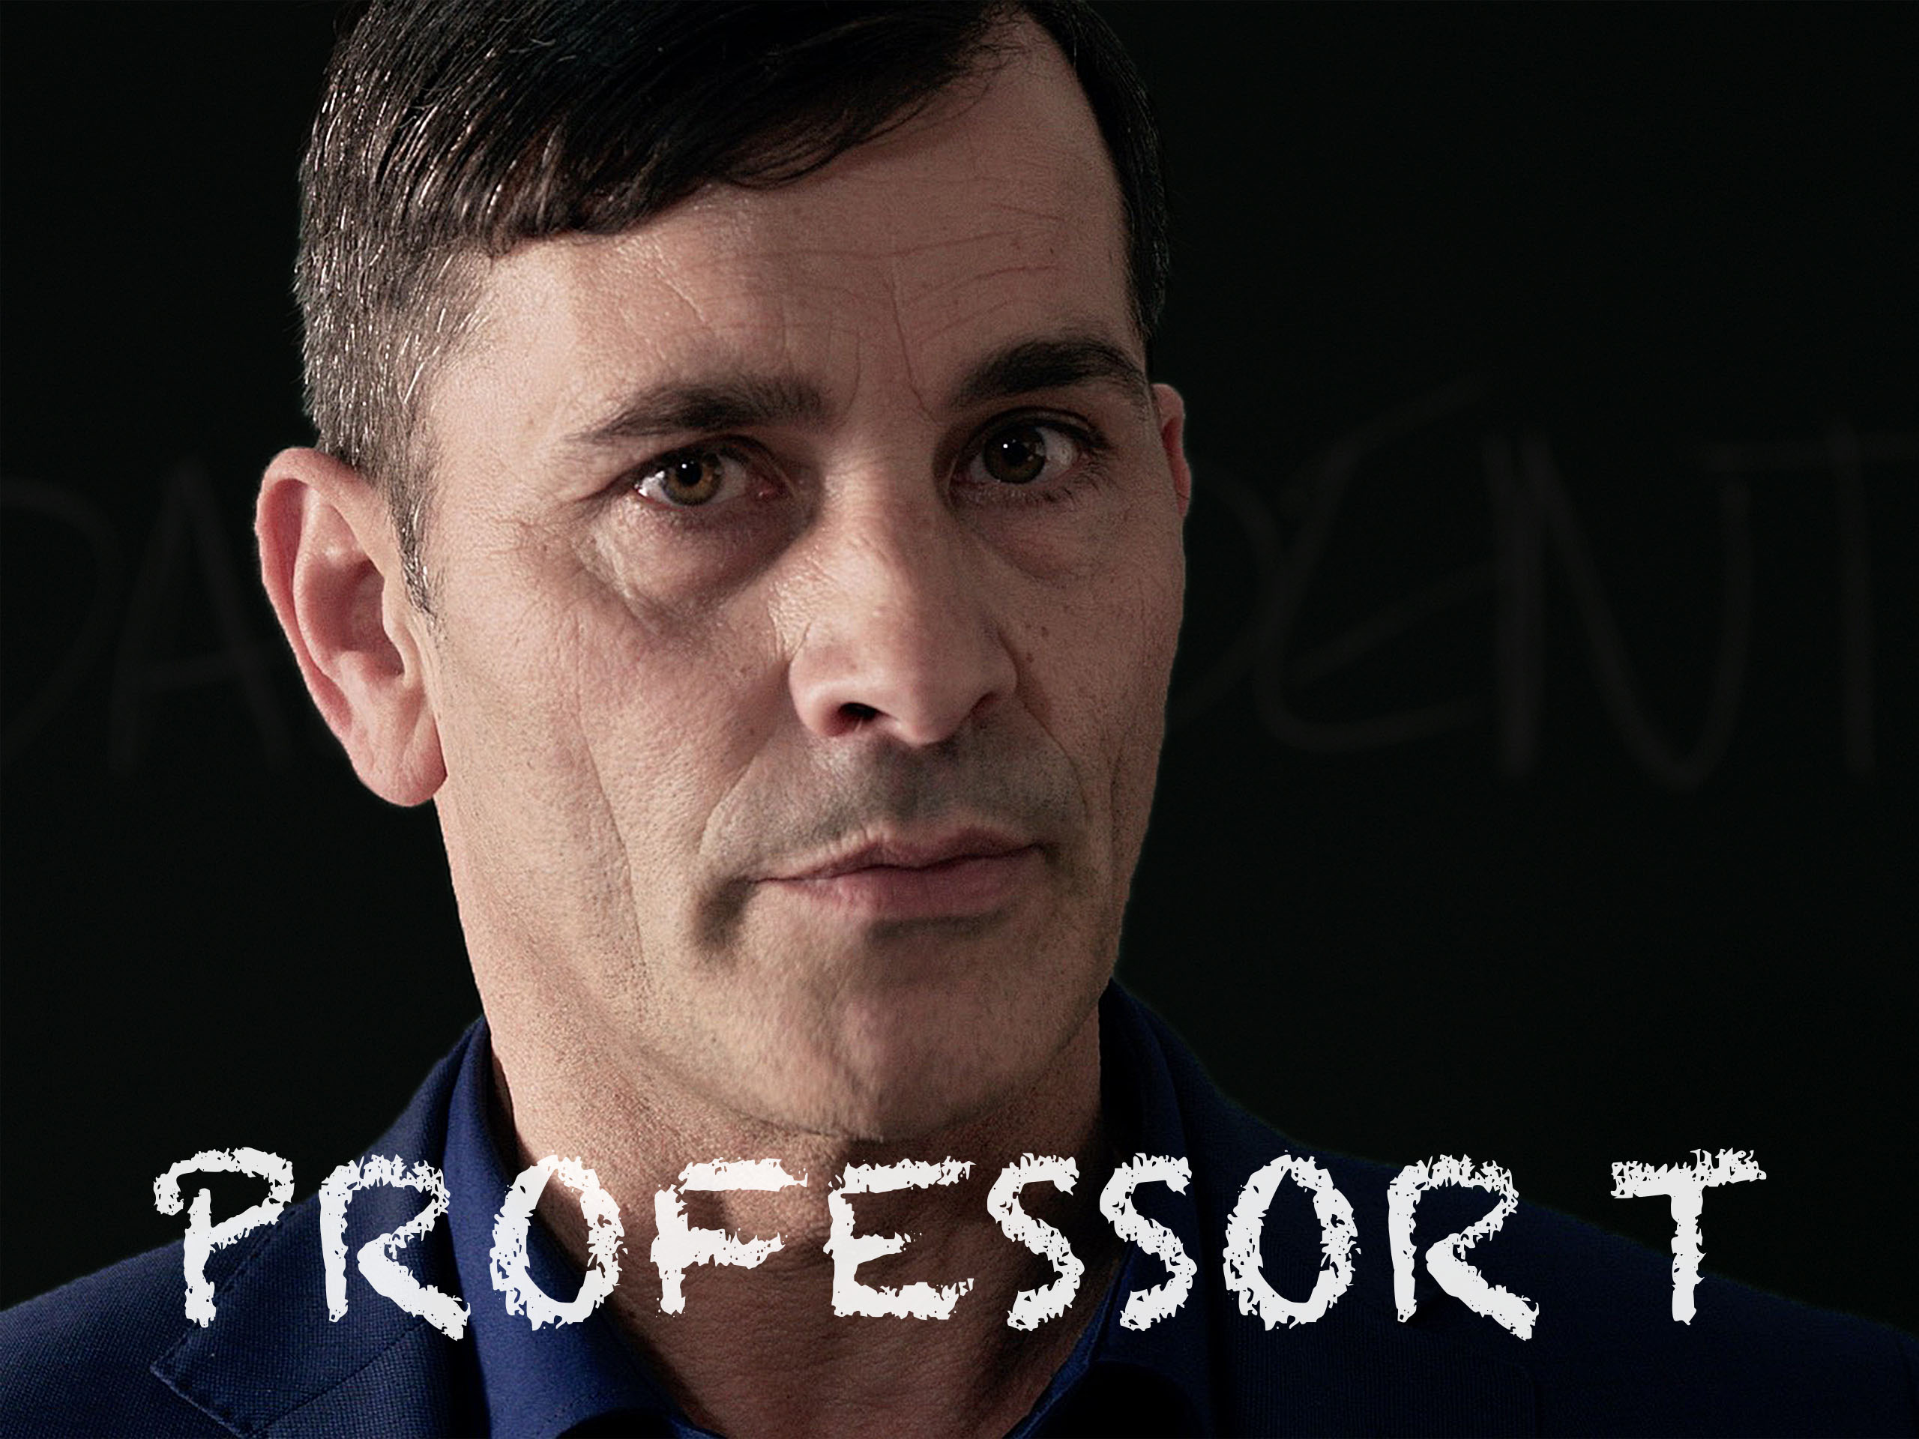
Fans of “Monk” and “House” will enjoy watching the eccentrically gifted professor, Professor T*, unravel complex criminal puzzles for the police with his brilliant mind. The show’s namesake character is an esteemed criminologist at Antwerp University. He inspires scores of students with his punchy teaching techniques. However, outside the lecture hall, he is haunted by a plethora of neuroses that hold him back from getting close to people – he quite literally protects himself from the outside world in a shroud of anti-bacterial spray and latex gloves. Despite this, the Antwerp Homicide Department relies on him and his team for expert advice.

Season 1 of the 13-episode detective drama won numerous awards including the prestigious Jury Special Prize for Foreign Fiction at the Festival de la Fiction TV, La Rochelle. The Telegraph praised Professor T, calling it “engagingly off-kilter, a mix of grim storylines and jaunty character.”

The series is also available to stream on the PBS MASTERPIECE Prime Video Channel.

Walter Iuzzolino, curator of the Walter’s Choice programming, said, “Prepare to be charmed by TV’s rudest crime fighter. Professor T is completely original and utterly brilliant - one of my all-time favorite TV crime series.”

PROFESSOR T is in Flemish with English subtitles.

About WALTER’S CHOICE
Walter’s Choice is a carefully curated series of foreign language drama selected for PBS audiences by PBS Distribution, PBS and Walter Presents.

About WALTER PRESENTS
Walter Presents launched in January 2016 in the U.K. as a video-on-demand service and is a joint venture between Channel 4 and Global Series Network, founded by Jason Thorp, Walter Iuzzolino and Jo McGrath. Dedicated to showcasing award-winning foreign language drama, the service is named after its curator, Walter Iuzzolino, a passionate drama fan. In March 2017, Walter Presents launched as an SVOD platform in the U.S., with the New York Times hailing it as a “chic TV boutique with a foreign accent.” In November 2017, Walter Presents launched in Australia through pay TV service Foxtel, and in Italy in September 2018, it launched its first roll-out in mainland Europe on Discovery’s Nove, Giallo and Dplay channels. In October 2018, Walter Presents partnered with PBS Distribution to launch over 300 hours of quality foreign language drama on the MASTERPIECE Prime Video Channel. Walter’s Choice is a selection of the Walter Presents programming that is made available for air on PBS stations.

Follow Walter Presents on Facebook and Twitter

About PBS
PBS, with nearly 350 member stations, offers all Americans the opportunity to explore new ideas and new worlds through television and digital content. Each month, PBS reaches over 90 million people through television and 30 million people online, inviting them to experience the worlds of science, history, nature and public affairs; to hear diverse viewpoints; and to take front row seats to world-class drama and performances. PBS’ broad array of programs has been consistently honored by the industry’s most coveted award competitions. Teachers of children from pre-K through 12th grade turn to PBS for digital content and services that help bring classroom lessons to life. Decades of research confirms that PBS’ premier children’s media service, PBS KIDS, helps children build critical literacy, math and social-emotional skills, enabling them to find success in school and life. Delivered through member stations, PBS KIDS offers high-quality educational content on TV – including a 24/7 channel, online at pbskids.org, via an array of mobile apps and in communities across America. More information about PBS is available at www.pbs.org, one of the leading dot-org websites on the internet, or by following PBS on Twitter, Facebook or through our apps for mobile and connected devices. Specific program information and updates for press are available at pbs.org/pressroom or by following PBS Pressroom on Twitter.
About PBS Distribution
PBS Distribution is a leading distributor of public media content around the world, reaching audiences through multiple platforms and formats including direct-to-consumer subscription video-on-demand (DTC-SVOD), transactional video-on-demand (TVOD), subscription video-on-demand (SVOD) licensing, and physical products on DVD and Blu-ray. In addition, the company operates three Prime Video Channels on Amazon—PBS MASTERPIECE, PBS KIDS, and PBS LIVING—as well as a theatrical releasing division, and educational, non-theatrical, inflight and international licensing businesses.

PBS Distribution offers consumers and educators over 4,000 programming hours of the highest quality factual, scripted and children’s programming, including films from producer Ken Burns, hit dramas from MASTERPIECE, entertaining and educational children’s series and award-winning documentaries from NOVA, FRONTLINE, AMERICAN MASTERS, NATURE, AMERICAN EXPERIENCE and many independent producers. For over 20 years, the company has extended the reach of programming beyond broadcast while generating revenue for the public television system, stations and producers.

Follow PBS Distribution on Facebook and Twitter.
For further information please contact:

Jill Goldstein
JGoldsteinPR
jill@jgoldsteinpr.com

Deana Dor
JGoldsteinPR
deana@jgoldsteinpr.com

