

Contact:
POV Communications: 212-989-7425.
Cathy Fisher, cfisher@pov.org, Amanda Nguyen, anguyen@pov.org
POV online pressroom: www.pbs.org/pov/pressroom

POV’s ‘Special Flight,’ Airing Monday, July 1, 2013 on PBS, Explores Plight

Of Undocumented Foreigners Detained in Switzerland

Fate of Immigrants Denied Asylum Exposes Contradictions Between the Country’s Compassionate Social Policies and Its Intractable Immigration Laws

Produced in Association with American Documentary | POV

“The docu’s subjects get under the skin, and their plight represents one of the major challenges to immigration policy not just in Switzerland, but in the First World as a whole.”—Jay Weissberg, Variety

MEDIA ALERT – FACT SHEET

National Dates: Fernand Melgar’s Special Flight has its national broadcast premiere on Monday, July 1, 2013 at 10 p.m., during the 26th season of POV (Point of View) on PBS. (Check local listings.) The film will stream on POV’s website, www.pbs.org/pov/specialflight, from July 2-July 31, 2013.

POV’s regular seasons continues on Mondays at 10 p.m. through Sept. 23, 2013, with specials in the fall and winter. American television’s longest-running independent documentary series, POV has been honored with a 2013 MacArthur Foundation Award for Creative and Effective Institutions.

The Film: Special Flight is a dramatic account of the plight of undocumented foreigners at the Frambois detention center in Geneva, Switzerland, and of the wardens who struggle to reconcile humane values with the harsh realities of a strict deportation system. These 25 Frambois inmates are among the thousands of asylum seekers and illegal immigrants imprisoned without charge or trial and facing deportation to their native countries, where they fear repression or even death. The film, made in Switzerland, is a heart-wrenching exposé of the contradictions between the country’s compassionate social policies and the intractability of its immigration laws.

While making his award-winning 2008 film, The Fortress, a portrait of a government institution that hosts incoming asylum seekers, filmmaker Fernand Melgar gained unprecedented access to the Frambois center for immigrants being deported. He returned to the facility for nine months to make Special Flight, keeping his camera tightly focused on a handful of detainees, guards and administrators.

Special Flight is a production of Climage in association with Radio Télévision Suisse (RTS) and ARTE G.E.I.E.

Embed a trailer, download press materials and learn more at www.pbs.org/pressroom.

Online: POV’s website for Special Flight—www.pbs.org/pov/specialflight/—offers a broad range of exclusive online content to enhance the PBS broadcast. Watch the full film online for free for a limited time following the broadcast (July 2-July 31, 2013), view a video interview with filmmaker Fernand Melgar, download a discussion guide and other viewing resources, learn more about detention policies in America and abroad and find out what happened to the detainees since the cameras stopped rolling.

Outreach: POV works with educators, public television stations and national and community groups across the country to foster dialogue around the issues presented in our films. For a list of upcoming screening events, go to www.pbs.org/pov/outreach. POV and nationally recognized media educator Dr. Faith Rogow develop discussion guides with background information to help event organizers facilitate conversations. The Special Flight discussion guide includes background information on detention in the United States and Switzerland, prompts for dialogue and a list of further educational resources. Rogow has also developed a lesson plan to accompany the film. The materials are available free of charge at www.pbs.org/pov/specialflight. Event organizers may email POV at events@pov.org to request a free loaned DVD to screen.

Filmmaker’s
Statement: “One hundred fifty thousand paperless migrants live in Switzerland,” says Fernand Melgar. “The vast majority of them work and pay taxes. They look after our elderly, care for our children and clean our flats and hospitals. Both unsuccessful asylum seekers and undocumented immigrants live with a sword of Damocles dangling over their heads: They may be arrested at any moment, imprisoned for months or years and deported from Switzerland without any form of trial.

“After obtaining the authorization to film at Frambois, I spent a lot of time with the inmates,” he continues. “Gradually, I gained their trust and they started confiding in me. Feeling rebellious and forgotten by the outside world, almost all of them agreed to participate. They knew that it was not going to change their personal situations, but it was a way for them to be heard.”

Filmmaker Bio: Fernand Melgar (Director, Producer)
Fernand Melgar, the son of Spanish unionists exiled to Tangiers, Morocco, was smuggled into Switzerland by his parents in 1963, when he was 2 years old. In the early 1980s, he cut short his business studies and co-founded Le Cabaret Orwell in Lausanne, a nightspot that became a mecca for French-speaking underground culture. Also in Lausanne, he later established the internationally renowned rock music venue La Dolce Vita.

Melgar became a self-taught freelance film director and producer, beginning with experimental films and interviews for television in 1983. In 1985 he joined the collective Climage, under whose auspices he has produced a dozen documentaries, many about immigration and identity. His documentary EXIT: The Right to Die won the prestigious 2006 EBU Golden Link Award for best European co-production and the 2006 Swiss Film Prize. In 2007, Melgar won the screenplay competition of Télévision Suisse Romande (French-speaking Switzerland’s main broadcaster). In 2008, The Fortress won a Golden Leopard at the Locarno International Film Festival. Melgar has edited several of Jacqueline Veuve’s films, including Journal de Rivesaltes 1941-1942, awarded the 1998 Swiss Film Prize.

Related Stories: “Switzerland to expand immigration quotas,” The Wall Street Journal, April 24, 2013. http://online.wsj.com/article/SB10001424127887324474004578442981776602450.html

“Latest asylum reform faces nationwide vote,” by Urs Geiser, Swiss Broadcasting Corporation, April 16, 2013. http://tinyurl.com/c6cwmo3

“Kosovan minorities struggle after repatriation,” by Veronica DeVore, Swiss Broadcasting Corporation, March 15, 2013. http://bit.ly/109g9PO

“Mass Release of Immigrants Is Tied to Impending Cuts,” by Kirk Semple, The New York Times, Feb. 26, 2013. http://nyti.ms/109kl2g

Credits: Director/Producer: Fernand Melgar
Executive Producers: Stéphane Goël, Elise Shubs
Cinematographer: Denis Jutzeler
Designer: Janka Rahm
Sound Editing and Mixing: Gabriel Hafner, François Musy
Editor: Karine Sudan
Original Music: Wandifa Njie
Running Time: 56:46

POV Series Credits:
Executive Producer: Simon Kilmurry
Co-Executive Producer: Cynthia López
VP, Production & Programming: Chris White
Coordinating Producer: Andrew Catauro

Awards/Festivals:
- Anne Dellinger Grand Jury Award and Center for Documentary Studies Filmmaker Award, 2012 Full Frame Documentary Film Festival
- Special World Feature Jury Mention, 2012 AFI-Discovery Channel Silverdocs Documentary Festival
- Best Documentary, 2012 Swiss Film Prize
- Best Film Award, 2012 One World International Human Rights Documentary Film Festival
- Prix Italia, Current Affairs, 2012
- TV Iris Award, Prix Europa, 2012
- Student Jury Prize, 2012 Paris International Film Festival on Human Rights
- Amnesty International Grand Prize, 2012 San Sebastián Human Rights Film Festival
- Ecumenical Jury Prize and Junior Jury Award, 2011 Locarno International Film Festival

Pressroom: Visit POV’s pressroom, www.pbs.org/pov/pressroom, for press releases, downloadable art, filmmaker biographies, transcripts and special features.

POV: Produced by American Documentary, Inc. and celebrating its 26th season on PBS in 2013, the award-winning POV is the longest-running showcase on American television to feature the work of today’s best independent documentary filmmakers. POV has brought more than 325 acclaimed documentaries to millions nationwide and has a Webby Award-winning online series, POV’s Borders. Since 1988, POV has pioneered the art of presentation and outreach using independent nonfiction media to build new communities in conversation about today’s most pressing social issues. Visit www.pbs.org/pov.

Major funding for POV is provided by PBS, The John D. and Catherine T. MacArthur Foundation, National Endowment for the Arts, New York State Council on the Arts, New York City Department of Cultural Affairs, the desJardins/Blachman Fund and public television viewers. Funding for POV’s Diverse Voices Project is provided by the Corporation for Public Broadcasting. Special support provided by the Academy of Motion Picture Arts and Sciences. POV is presented by a consortium of public television stations, including KQED San Francisco, WGBH Boston and THIRTEEN in association with WNET.ORG.

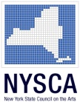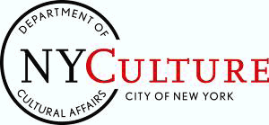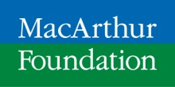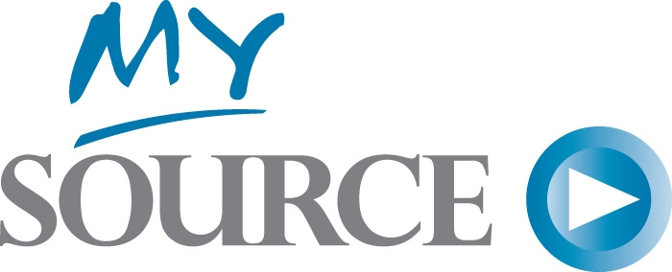
Media Sponsor:

25th Anniversary Partner:

