


POV “Koch”

TCA Biographies

Premieres Monday, September 22, 2014 on PBS

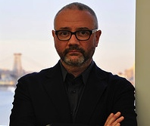
Simon Kilmurry, Executive Director, American Documentary | POV;
Executive Producer, POV

Simon Kilmurry joined American Documentary | POV in 1999 and was appointed executive director in 2006. He oversees all aspects of American Documentary’s programs and operations, including the production of POV (Point of View), PBS’ award-winning documentary film series. Since 2006, POV has been honored with a Special Emmy for Excellence in Television Documentary Filmmaking, a Primetime Emmy®, 13 News and Documentary Emmys, 57 Emmy nominations, four Academy Award® nominations, four Peabody Awards, three duPont-Columbia Journalism Awards, two International Documentary Association Awards for Best Continuing Series, a Webby Award and the National Association of Latino Independent Producers Corporate Commitment to Diversity Award.

Since joining American Documentary, Kilmurry has been involved in the production and distribution of more than 200 POV films and special presentations, including a live town-hall meeting with ABC News’ Nightline and the PBS miniseries Right Here, Right Now. He has helped lead new initiatives to increase POV’s reach, diversity and innovation, including the Diverse Voices Project, which supports emerging filmmakers, and online initiatives to use digital tools in support of documentary storytelling.

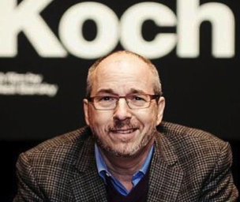
Neil Barsky, Director, “Koch”

Koch is Neil Barsky’s first documentary. He is currently the chairman and founder of The Marshall Project, the non-profit journalism enterprise dedicated to covering the U.S. criminal justice system. Barsky began his career as a newspaper reporter, covering real estate and economic development for the New York Daily News and The Wall Street Journal. He subsequently became a Wall Street analyst and hedge fund manager.

Barsky is a graduate of Oberlin College and the Columbia University Graduate School of Journalism. He sits on the board of trustees of Oberlin College and the board of directors of Youth Communication, and is chair of the Columbia Journalism Review board of overseers.

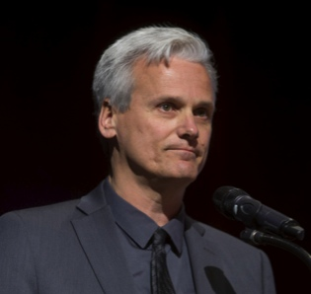
Michael Powell, Film Subject, “Koch”

Michael Powell, a native New Yorker, is the Sports of The Times columnist for The New York Times. Previously he wrote the “Gotham” column for The New York Times. He joined The New York Times as a metro reporter in February 2007. Prior to that, he served as the New York bureau chief of The Washington Post, where he had worked since 1996, writing on national politics for the style section.

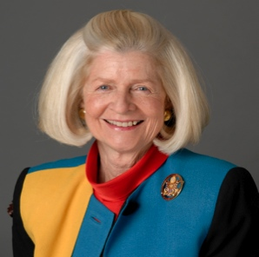
Diane M. Coffey, Film Subject, “Koch”

Diane M. Coffey is a partner and managing director responsible for media, marketing and public affairs at the Peter J. Solomon Company.

Coffey came to PJSC from the Dreyfus Corporation, where she was vice president of Corporate Communications and co-portfolio manager of the Third Century Fund, a social investing stock fund. Prior to her tenure at Dreyfus,
Coffey served as the Chief of Staff in City Hall to New York Mayor Edward I. Koch. Simultaneously, in 1987, she served as the acting commissioner of cultural affairs. She had previously been Mr. Koch’s administrative assistant in Washington with responsibility for the operations of his Capitol Hill office during his tenure as a member of Congress.

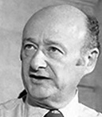
Ed Koch

Born on December 12, 1924, Edward Irving Koch was elected the 105th mayor of New York City in 1977. His parents, who were of Polish-Jewish ancestry, moved the family to Newark, New Jersey, during the Depression and later moved to Ocean Parkway, Brooklyn, when Koch was a teenager. He left City College when he was drafted into the Army, where he became a decorated combat infantryman, achieving the rank of sergeant. He received his law degree from New York University Law School in 1948. As an active member of a Manhattan reform club and the Greenwich Village Independent Democrats, Koch ran successfully for district leader in 1963 against Carmine DeSapio. Koch was re-elected in 1965 and elected to the City Council the following year.

In 1968, Koch was elected to the U.S. House of Representatives in a district that hadn’t sent a Democrat to Congress since 1934. He was re-elected four times, earning a reputation as a competent legislator and a champion of many social causes. In 1977, he sought the Democratic nomination for mayor among a crowded field of candidates. Koch won the primary and went on to defeat Liberal Party candidate Mario Cuomo in the general election. Described in the infancy of his mayoralty as a shy and retiring man, Koch used his inauguration to send New Yorkers a message of redemption: “These have been hard times. We have been drawn across the knife-edge of poverty. We have been shaken by troubles that would have destroyed any other city. But we are not any other city. We are the city of New York, and New York in adversity towers above any other city in the world.”

With New York City’s treasury near empty, Koch restored the city's credit in his first term (1978-1982) through a series of budget-cutting measures, enabling the city to enter the bond market within a few years and raise capital funds. As the city’s fiscal prognosis began to brighten, so too did the mood of New Yorkers. The characterization of Koch as low-key was soon revised after he took office, with his ebullient personality and his trademark greeting, “How’m I’m doin’?” Under Koch, the city’s annual budget doubled to $26 billion, and approximately $19 billion was spent on capital projects in the 1980s.

Koch, who vowed to be the first four-term mayor, sought re-election in 1989. However, he was confronted with a series of government corruption scandals. He also faced heated criticism for his combative dealings with other public officials and the press. He lost the Democratic primary to then Manhattan Borough President David Dinkins.

Koch remained active and popular after leaving office, practicing law in New York City, lecturing, authoring books, serving as a newspaper columnist, hosting his own radio show, serving as a judge on the popular television show The People's Court and writing movie reviews. Koch died of congestive heart failure on February 1, 2013, at the age of 88.

# # # #

