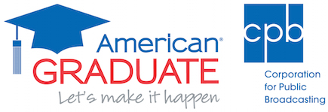



Contacts:
Cathy Fisher, cfisher@pov.org; Isaac Park, ipark@pov.org; 212-989-7425
Communications@pov.org; POV Pressroom: www.pbs.org/pov/pressroom

POV’s ‘Make All the Difference’ Engagement Campaign Is in Full Swing,
With Support from the Corporation for Public Broadcasting’s
American Graduate: Let’s Make It Happen

Campaign to Help Mobilize Students, Families, Educators, Mentors and PBS Stations to Support First-Generation Students and Young Men of Color as They Prepare for College

Tod Lending’s documentary ‘All the Difference,’ premiering Monday, Sept. 12, 2016, on POV, follows two young men from a disadvantaged neighborhood as they pursue higher education, career opportunities

New York, NY – Aug. 25, 2016 – American Documentary | POV has launched the national Make All the Difference engagement campaign for All the Difference, a documentary that spotlights the victories and struggles of young African-American men navigating their way through high school and college. The engagement campaign, featuring events in five cities, is funded by the Corporation for Public Broadcasting (CPB) as part of American Graduate: Let’s Make It Happen, a public media initiative to help keep more students on the path to graduation, college and careers.

POV’s All the Difference, premiering Monday, Sept. 12, 2016, at 10 p.m. (check local listings), kicks off SPOTLIGHT EDUCATION, a special week of primetime programming on PBS focusing on the brightest ideas and toughest challenges facing today’s students and America’s education system. The film traces the paths of two teens from the South Side of Chicago who dream of graduating from college. Statistics predict that Robert Henderson and Krishaun Branch will drop out of high school, but they have other plans. Oscar®-nominated producer/director Tod Lending’s intimate film follows the young men beginning their senior year at Urban Prep Academies through four years of hard work, sacrifice and uncertainty in college. As they discover, support from family, teachers and mentors makes all the difference in defying the odds.

The documentary was inspired by Wes Moore’s best-selling autobiographical book, The Other Wes Moore. He and his mother, media consultant Joy Thomas Moore, are the film’s executive producers.

The ‘Make All the Difference’ Campaign
In partnership with American Graduate: Let’s Make It Happen and leading organizations around the country, the POV and All the Difference teams have launched a national campaign to mobilize students, families, educators, mentors and PBS stations to support first-generation students and young men of color as they prepare for and graduate from college. This endeavor is supported by a set of strategic tools, including an interactive College-Bound Students Handbook, a Facilitator’s Guide, Discussion Guide and Family Tip Sheets. Visit www.pbs.org/pov/allthedifference/ for educational resources, a step-by-step guide to hosting screenings, a list of nationwide events and ways to get involved.

Among the national organizations partnering on the Make All the Difference campaign are Urban Prep Academies, where mentors and teachers encouraged film subjects Henderson and Branch not only to get through high school but to go to college and beyond; and City Year, which provides high-impact student, classroom and school-wide support to help students stay in school and on track to graduate from high school, ready for college and career success. After graduating from college, film subject Krishaun Branch returned to Chicago to work at Urban Prep’s Fellows Program, while the other subject, Henderson, moved to Columbia, S.C., to serve as an AmeriCorps member at City Year.

POV has awarded grants to five PBS stations to support local programming and community activities: WTTW Chicago Public Media, WHYY Philadelphia, Maryland Public Television (Owings Mills, Md.), PBS SoCal (Costa Mesa, Calif.) and Alabama Public Television (Birmingham, Ala.).

“Local engagement is an essential component to public media’s work in communities across the country through the American Graduate initiative,” said CPB President and CEO Patricia Harrison. “Make All the Difference is an important avenue for communities to explore ways to support young African-American men on a path to education and career success.”

POV will conduct satellite media tours on television and radio to maximize broadcast coverage locally and nationally. To create a national dialogue with a high-profile personality and expert in the field, POV forged a partnership with hip-hop artist Che “Rhymefest” Smith, an Oscar- and Grammy-winning songwriter (“Glory” from the 2014 motion picture Selma), activist and teacher. He recently joined the All the Difference team in Los Angeles for the Television Critics Association Press Tour and a special screening with PBS SoCal, where he performed and shared his experiences growing up and living on Chicago’s South Side. He and his wife, Donnie, founded the nonprofit youth arts program Donda’s House with Kanye West.

“Renewing the discussion of race and education that POV explored in American Promise, which followed two African-American boys from kindergarten through high school, POV is excited to continue the journey with All the Difference, a story too seldom told by the media,” said Eliza Licht, vice president of content strategy and engagement for POV. “Local PBS stations are taking the lead by working with parents and community-based and educational institutions to help students in their communities achieve their full potential, aided by invaluable resources that POV created with support from CPB.”

“POV is proud to continue our partnership with PBS and CPB and be part of the conversation about closing the black male achievement gap,” said Justine Nagan, executive director/executive producer of POV. “We’ve seen at community screenings how this film has struck a chord with young people in similar situations to those of Krishaun and Robert. Recently, a young man, with tears in his eyes, told them, ‘Your story is my story; you’ve shown me I can do it.’ This campaign would not be possible without the invaluable support of CPB’s American Graduate: Let’s Make It Happen.”

All the Difference is a co-production of Nomadic Pictures, Ethno Pictures, JWS Media Consulting, Omari Productions and American Documentary | POV. In addition to its Sept. 12 broadcast premiere on POV, the film will stream on POV’s website from Sept. 13-Oct. 13, 2016.

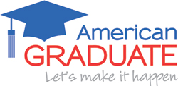
American Graduate: Let’s Make It Happen is public media’s long-term commitment to supporting community-based solutions to help young people succeed in school and life. More than 100 public television and radio stations have joined forces with over 1,700 partners across 49 states to elevate the stories of youth and the supportive adults who help them succeed.

About SPOTLIGHT EDUCATION
SPOTLIGHT EDUCATION is a special week of primetime news, public affairs and documentary programming on PBS stations Sept. 12-17 (check local listings) focusing on the brightest ideas and toughest challenges facing today’s students and America’s education system. Short-form and full episodes from the week, interactive content modules and a social hub for SPOTLIGHT EDUCATION will be available on PBS.org and Americangraduate.org. SPOTLIGHT EDUCATION also kicks off a year-long teacher support campaign—“Teach Boldly”—led by PBS and local member stations across the country. Major funding for SPOTLIGHT EDUCATION is provided by the Corporation for Public Broadcasting as part of the American Graduate: Let’s Make It Happen initiative.

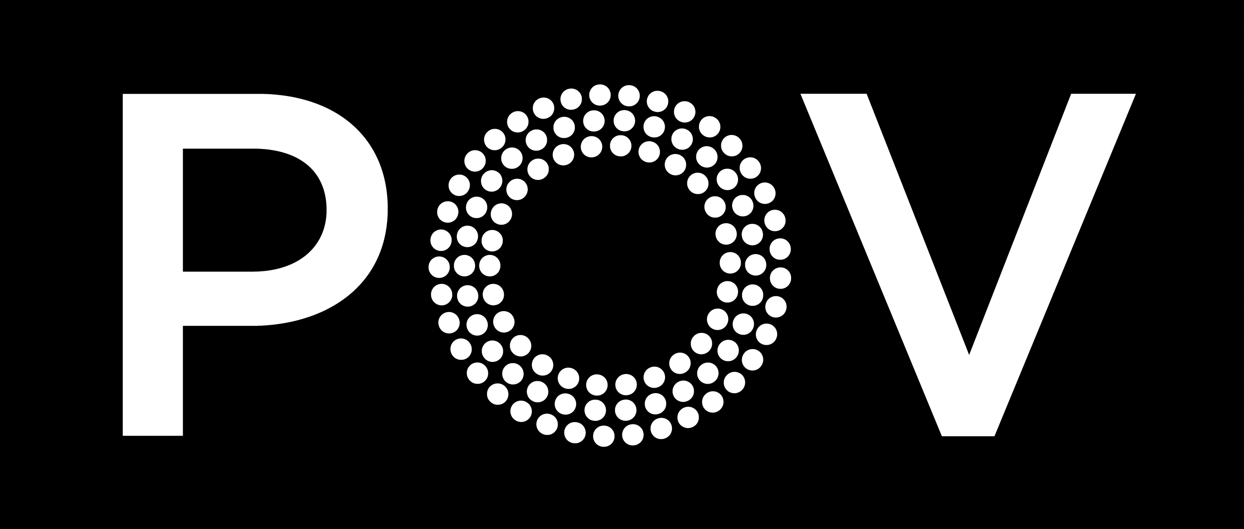
Produced by American Documentary, Inc., POV is public television’s premier showcase for nonfiction films. Since 1988, POV has been the home for the world’s boldest contemporary filmmakers, celebrating intriguing personal stories that spark conversation and inspire action. Always an innovator, POV discovers fresh new voices and creates interactive experiences that shine a light on social issues and elevate the art of storytelling. With our documentary broadcasts, original online programming and dynamic community engagement campaigns, we are committed to supporting films that capture the imagination and present diverse perspectives.

POV films have won 34 Emmy® Awards, 19 George Foster Peabody Awards, 12 Alfred I. duPont-Columbia University Awards, three Academy Awards®, the first-ever George Polk Documentary Film Award and the Prix Italia. The POV series has been honored with a Special News & Documentary Emmy Award for Excellence in Television Documentary Filmmaking, three IDA Awards for Best Curated Series and the National Association of Latino Independent Producers (NALIP) Award for Corporate Commitment to Diversity. Learn more at www.pbs.org/pov.

Major funding for POV is provided by PBS, The John D. and Catherine T. MacArthur Foundation, the
John S. and James L. Knight Foundation, Corporation for Public Broadcasting and National Endowment for the Arts. Additional funding comes from Nancy Blachman and David desJardins, Bertha Foundation, Wyncote Foundation, The Fledgling Fund, Marguerite Casey Foundation, Ettinger Foundation, New York State Council on the Arts, Ann Tenenbaum and Thomas H. Lee, and public television viewers. POV is presented by a consortium of public television stations, including KQED San Francisco, WGBH Boston and THIRTEEN in association with WNET.ORG.

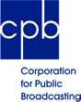
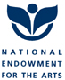
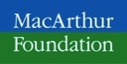
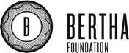

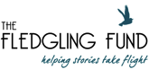
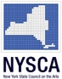
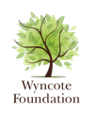
Media Sponsor:

