


Contacts
POV Communications 212-989-7425, communications@pov.org
Adam Segal adam@the2050group.com
POV Pressroom pbs.org/pov/pressroom

A Triumphant Portrait of Three Young Men with Autism—“Swim Team,” Airing October 2, 2017, on POV

A coming-of-age story that shows how sports transcend disabilities

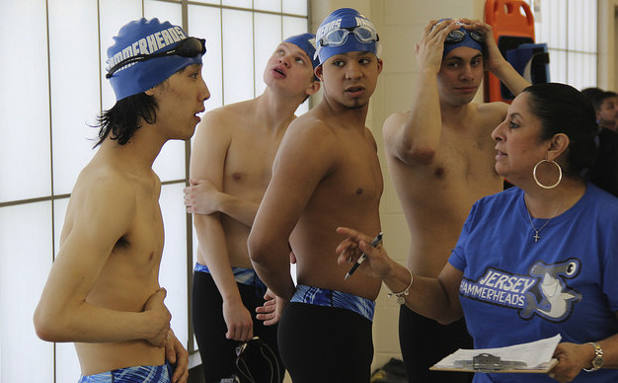
CREDIT: NICOLE CHAN

When doctors told Michael and Maria McQuay that their son with autism would never be self-sufficient, the pair responded by seeking out a series of therapies and programs for him. After discovering there was a dearth of suitable public services, they formed their own swim team for children with developmental disabilities. “So many people don’t give our kids a chance to do anything,” says Maria.

Lara Stolman’s inspiring debut documentary, Swim Team, follows three diverse young men—Michael McQuay Jr., Robert Justino and Kelvin Truong—from Perth Amboy, New Jersey, who fall on the autism spectrum. New Jersey reports the highest rate of autism in the country, with one in 26 boys on the spectrum. On the McQuays’ team, the Jersey Hammerheads, these young men find inclusion, independence and space to achieve their loftiest goals.

Swim Team premieres nationally on POV (Point of View) on Monday, October 2, 2017, 10-11:30 p.m (check local listings) on PBS. POV is American television’s longest-running independent documentary series, now in its 30th season.

At its heart, the eye-opening Swim Team chronicles the hard work and dedication the Hammerheads undertake to make life work in, and out, of the swimming pool. Justino dreams of making video games, despite predictions from his teachers that store clerking will be the only job available to him. Truong, who also has Tourette’s syndrome, struggles with controlling verbal and physical outbursts.

Compassionate and perceptive, filmmaker Stolman also manages to capture the parents’ hopes and frustrations. As Truong’s mother shows the holes that Truong has made in the walls at home, she maintains a smile, though her voice quavers at times. Stolman makes clear that the parents face financial burdens, compounded by an underfunded public school system ill-equipped to support special-needs children and young adults.

The Jersey Hammerheads rack up medals and eventually make it to the state Summer Games at the Special Olympics. One member of the team even goes on to compete in the national Special Olympics games.

The Hammerheads feel most comfortable in the pool’s fast lane. “When I’m swimming,” says Michael McQuay Jr., “I feel normal.”

“With the Hammerheads families, I found a group of parents who refused to take no for an answer,” said Stolman. “They were saying yes, and as a community it was galvanizing for them. As a mother, I was so personally inspired by what they hoped to accomplish; I knew I had to share their story. I hope my film provides inspiration for families everywhere raising children with unanticipated challenges.”

“More than just a heartening sports saga, Swim Team brings to light the systemic challenges confronting teenagers with developmental disabilities and their parents,” said Justine Nagan, executive producer/executive director of POV/American Documentary. “For too many, public resources and programs are either nonexistent or few and far between. In this film, we see how autism affects people of varied backgrounds, including those in communities of color and working-class families. Swim Team, with the stories of the Hammerheads and their parents, explores all of these issues and is a compelling, cheer-worthy sports film: a win-win for audiences all around.”

* * * *

About the Filmmaker:

Lara Stolman, Director, Producer
Lara Stolman is an award-winning director, producer and writer whose work has appeared on NBC, MSNBC, TLC, AMC, VH1 and the New York Times website. Her film Portraits of Survival, about coming to terms with the tragedy of 9/11 through art, premiered at the Hamptons International Film Festival, aired on MSNBC and was awarded a CINE Golden Eagle.

For Swim Team, her first feature documentary film, she was named an IFP Filmmaker Lab Fellow, was awarded the New York Women in Film and Television Loreen Arbus Disability Awareness grant and was provided with funding from Easterseals, the Aetna Foundation and the Karma Foundation. Swim Team has screened at more than 30 international festivals, has won more than 10 awards and was released theatrically in July 2017.

Stolman has guest lectured on documentary production at New York University, served as a juror for the News and Documentary Emmy Awards and writes for The Huffington Post. She has a B.A. in political science from Columbia College of Columbia University and a J.D. from Yeshiva University’s Benjamin Cardozo School of Law.

Credits:
Director and Producer: Lara Stolman
Co-Producer: Ann Collins
Producer: Shanna Belott
Director of Photography: Laela Kilbourn
Composer: Mark Suozzo
Executive Producers for POV: Justine Nagan, Chris White
* * * *


Produced by American Documentary, Inc., POV is public television’s premier showcase for nonfiction films. Since 1988, POV has been the home for the world’s boldest contemporary filmmakers, celebrating intriguing personal stories that spark conversation and inspire action. Always an innovator, POV discovers fresh new voices and creates interactive experiences that shine a light on social issues and elevate the art of storytelling. With our documentary broadcasts, original online programming and dynamic community engagement campaigns, we are committed to supporting films that capture the imagination and present diverse perspectives.

POV films have won 36 Emmy® Awards, 19 George Foster Peabody Awards, 12 Alfred I. duPont-Columbia University Awards, three Academy Awards®, the first-ever George Polk Documentary Film Award and the Prix Italia. The POV series has been honored with a Special News & Documentary Emmy Award for Excellence in Television Documentary Filmmaking, three IDA Awards for Best Curated Series and the National Association of Latino Independent Producers Award for Corporate Commitment to Diversity. Learn more at www.pbs.org/pov/.

POV Community Engagement and Education (www.pbs.org/pov/engage/)
POV’s Community Engagement and Education team works with educators, community organizations and PBS stations to present more than 650 free screenings every year. In addition, we distribute free discussion guides and standards-aligned lesson plans for each of our films. With our community partners, we inspire dialogue around the most important social issues of our time.

POV Digital (www.pbs.org/pov/)
Since 1994, POV Digital has driven new storytelling initiatives and interactive production for POV. The department created PBS’s first program website and its first web-based documentary (POV’s Borders) and has won major awards, including a Webby Award (and six nominations) and an Online News Association Award. POV Digital continues to explore the future of independent nonfiction media through its digital productions and the POV Hackathon lab, where media makers and technologists collaborate to reinvent storytelling forms. @povdocs on Twitter.

American Documentary, Inc. (www.amdoc.org)
American Documentary, Inc. (AmDoc) is a multimedia company dedicated to creating, identifying and presenting contemporary stories that express opinions and perspectives rarely featured in mainstream media outlets. AmDoc is a catalyst for public culture, developing collaborative strategic engagement activities around socially relevant content on television, online and in community settings. These activities are designed to trigger action, from dialogue and feedback to educational opportunities and community participation.

Major funding for POV is provided by PBS, The John D. and Catherine T. MacArthur Foundation, the John S. and James L. Knight Foundation, Corporation for Public Broadcasting and National Endowment for the Arts. Additional funding comes from Nancy Blachman and David desJardins, Bertha Foundation, Wyncote Foundation, The Fledgling Fund, Marguerite Casey Foundation, Ettinger Foundation, New York State Council on the Arts, Ann Tenenbaum and Thomas H. Lee, and public television viewers. POV is presented by a consortium of public television stations, including KQED San Francisco, WGBH Boston and THIRTEEN in association with WNET.ORG.

