


Contacts
POV Communications 212-989-7425, communications@pov.org
POV Pressroom pbs.org/pov/blog/pressroom

‘Bill Nye: Science Guy’ Fights for Science — Documentary About TV Personality and Climate Advocate Coming to POV Wednesday, April 18, 2018 in Celebration of Earth Day

Film features exclusive access and personal look at celebrity scientist,

with appearances by Neil deGrasse Tyson, Ann Druyan and other luminaries in the field

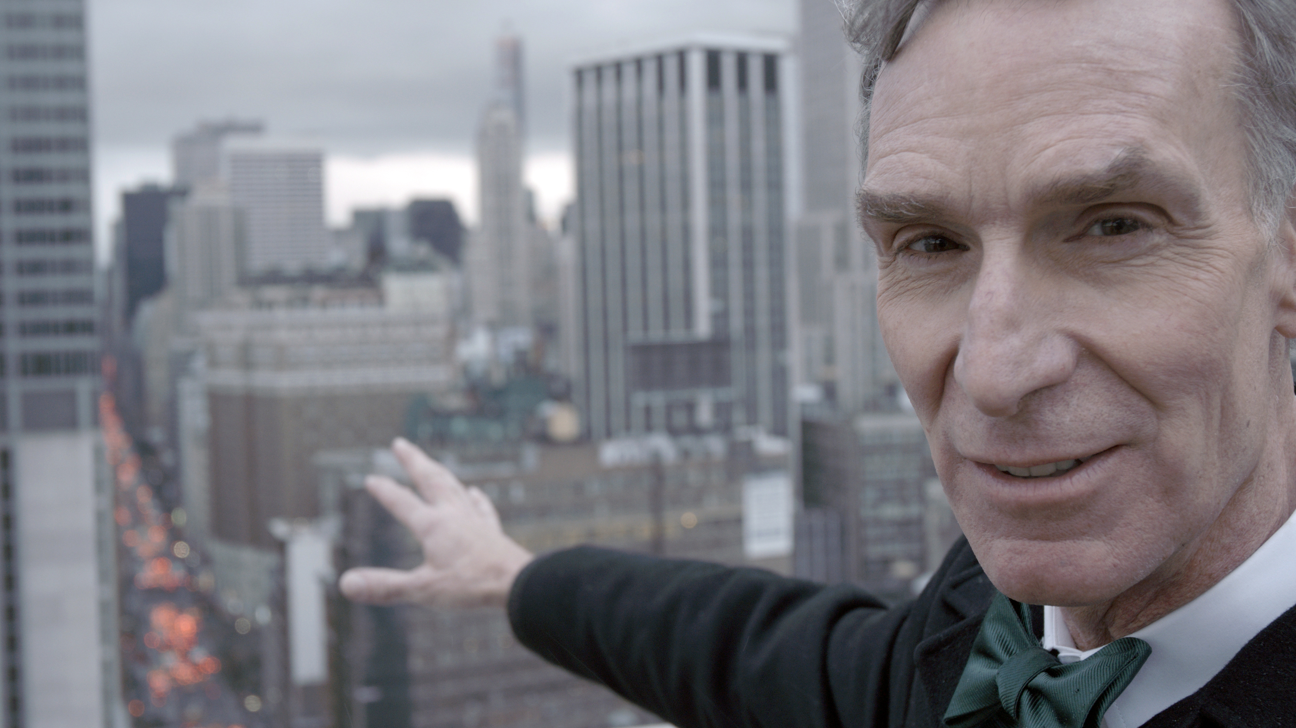
CREDIT: DAVID ALVARADO/STRUCTURE FILMS

Bill Nye is on a mission to stop the spread of anti-scientific thought and action. Once the host of a popular kids’ show and now the CEO of the Planetary Society, he’s leading a mission to launch LightSail, a satellite propelled by sunlight, while in turn fulfilling the legacy of his late professor and Planetary Society cofounder Carl Sagan.

Bill Nye: Science Guy by David Alvarado and Jason Sussberg has its national broadcast and streaming debut on the PBS documentary series POV and pov.org on Wednesday, April 18, 2018 at 10 p.m. (check local listings). The broadcast precedes Earth Day, April 22. POV is American television's longest-running independent documentary series and will begin its 31st season on television and streaming in summer 2018.

In addition to taking off his signature “Science Guy” lab coat, Nye has started taking on those who deny the importance of science, from prominent creationist Ken Ham to climate change skeptic, meteorologist and occasional Fox News commentator Joe Bastardi. Nye goes head-to-head to advocate for the scientific community and its invaluable findings.

And Nye acknowledges that he’s ready for a new challenge. “The Science Guy show is over, and I’ve got to move on to something bigger,” he says. “We have this increasing anti-science movement in the United States. It’s worse than ever. The anti-science movement is more powerful than it’s ever been.”

Accordingly, in his role as CEO of the Planetary Society, Nye and his team are working toward the first-ever successful launch and flight of a solar sailing satellite propelled by sunlight in space. “When I was in class 40 years ago, Carl Sagan talked about a solar sail mission, but it never happened. So this is realizing a 40-year-old dream of building a spacecraft that could fly in space propelled just by light. So, Professor Sagan, this one’s for you,” Nye says as the satellite is being tested for the first time.

But Nye’s focus never strays far from what initially propelled him to fame: education. “If we raise a generation of kids that can’t think critically, can’t think scientifically, we are headed for trouble,” he warns. “As a science educator, I am really more serious about it than ever. These people who are denying science, denying evolution, denying the efficacy of vaccinations and especially denying human-caused climate change—we just can’t have this. We’ve got to fight this fight. I’ve got to fight this fight.”

With intimate and exclusive access, as well as plenty of wonder and whimsy, Bill Nye: Science Guy is a behind-the-scenes portrait of the “Science Guy,” who continues to inspire millennials to participate in STEM (science, technology, engineering and mathematics). In addition to Nye, the film features Neil deGrasse Tyson, Ann Druyan and many other notable voices in the field.

Nye’s mission is driven in part by anxiety about what future generations may face. Sitting on climate change denier Joe Bastardi’s porch, Nye implores, “What if you’re wrong? What about Garrett?” Garrett is Bastardi’s college-age son, who is following in his father’s footsteps by studying meteorology and also shares his father’s skepticism about climate change.

Another flashpoint in the film comes when Nye is touring the Creation Museum founded by Christian fundamentalist Ken Ham. The museum features displays suggesting that humans lived alongside dinosaurs and that the earth is 6,000 years old. Nye finds it alarming. He points out, “Humans and ancient dinosaurs did not live at the same time. The evidence for that is overwhelming, and to suggest this to schoolchildren is irresponsible at best. It’s reprehensible at worst.”

Nonetheless, Nye is not without his own critics. Even some in the scientific community feel there have been times when Nye’s mission has taken a back seat to his ego. Some say that by agreeing to a televised debate with Ham about our evolutionary origins, Nye gave Ham undeserved media attention. “Nye’s mistake was giving credibility to Ken Ham by giving him a public platform. Everything I’ve seen about Nye is that he really misses being the Science Guy because he was much beloved and very popular. It’s hard to give up celebrity,” says evolutionary biologist Jerry Coyne.

Bill Nye: Science Guy also illuminates Nye’s private life. He remains close to his two siblings, who are struggling with a hereditary neurological disorder that Nye doesn’t have. Numerous friends, both from his childhood and from his Science Guy days, speak to his quirks and ambitions. Nye even opens up about his romantic life.

Ultimately, the Science Guy and Nye are indistinguishable from each other. “Bill has always wanted to be famous,” one of his longtime friends says. Expertly chronicling the TV character and the very real human subject behind him, Bill Nye: Science Guy presents an absorbing, charming portrait of a man and his not-so-modest mission to educate and change the world.

“Many of us grew up with Bill Nye, the Science Guy. He loved science, and he inspired a whole generation of kids to share that passion through his PBS show,” said POV executive director/executive producer Justine Nagan. “Now, as Bill Nye has focused on his role as a champion for climate science, we hope his story and this film will spark dialogue across ideological lines. We are thrilled to bring this outstanding independent film on Bill’s life and work to public media audiences.”

* * * *

About the Filmmakers:

David Alvarado, Director, Producer
David Alvarado is an award-winning documentary filmmaker with a passion for science, philosophy and human rights. After earning his B.A. in film production from the University of North Texas, he worked at Dallas PBS affiliate KERA Channel 13, then later earned his M.F.A. from Stanford University’s documentary film and video program. He now lives in New York, where he founded Structure Films, a documentary production company creating long-form nonfiction storytelling about science, health and technology. His first feature documentary with co-director Jason Sussberg was The Immortalists (2014), about two scientists who want to cheat death. The film’s world premiere screened in competition at SXSW and also screened at Hot Docs, CPH:DOX, BFI London Film Festival and others. Bill Nye: Science Guy is his latest film.

Jason Sussberg, Director, Producer
Jason Sussberg is an award-losing documentary filmmaker focusing on the art and humanity in STEM. He started his career working in sports television as a producer/editor for the San Francisco Giants and Golden State Warriors. After earning an M.F.A. from Stanford University, he founded Structure Films, a science storytelling production company, with his filmmaking partner, David Alvarado. They directed and produced The Immortalists (2014), a film about two scientists trying to find the cure for aging, and Bill Nye: Science Guy.

Credits:
Director and Producer: David Alvarado
Director, Producer, Sound: Jason Sussberg
Producer: Seth Gordon
Producer: Nick Pampenella
Producer: Kate McLean
Editor: Annukka Lilja
Executive Producers for POV: Justine Nagan, Chris White

* * * *


Produced by American Documentary, Inc., POV is public television’s premier showcase for nonfiction films. Since 1988, POV has been the home for the world’s boldest contemporary filmmakers, celebrating intriguing personal stories that spark conversation and inspire action. Always an innovator, POV discovers fresh new voices and creates interactive experiences that shine a light on social issues and elevate the art of storytelling. With our documentary broadcasts, original online programming and dynamic community engagement campaigns, we are committed to supporting films that capture the imagination and present diverse perspectives.

POV films have won 37 Emmy® Awards, 19 George Foster Peabody Awards, 12 Alfred I. duPont-Columbia University Awards, three Academy Awards®, the first-ever George Polk Documentary Film Award and the Prix Italia. The POV series has been honored with a Special News & Documentary Emmy Award for Excellence in Television Documentary Filmmaking, three IDA Awards for Best Curated Series and the National Association of Latino Independent Producers Award for Corporate Commitment to Diversity. Learn more at www.pbs.org/pov/.

POV Community Engagement and Education (www.pbs.org/pov/engage/)
POV’s Community Engagement and Education team works with educators, community organizations and PBS stations to present more than 650 free screenings every year. In addition, we distribute free discussion guides and standards-aligned lesson plans for each of our films. With our community partners, we inspire dialogue around the most important social issues of our time.

POV Digital (www.pbs.org/pov/)
Since 1994, POV Digital has driven new storytelling initiatives and interactive production for POV. The department created PBS’s first program website and its first web-based documentary (POV’s Borders) and has won major awards, including a Webby Award (and six nominations) and an Online News Association Award. POV Digital continues to explore the future of independent nonfiction media through its digital productions and the POV Hackathon lab, where media makers and technologists collaborate to reinvent storytelling forms. @povdocs on Twitter.

American Documentary, Inc. (www.amdoc.org)
American Documentary, Inc. (AmDoc) is a multimedia company dedicated to creating, identifying and presenting contemporary stories that express opinions and perspectives rarely featured in mainstream media outlets. AmDoc is a catalyst for public culture, developing collaborative strategic engagement activities around socially relevant content on television, online and in community settings. These activities are designed to trigger action, from dialogue and feedback to educational opportunities and community participation.

Major funding for POV is provided by PBS, The John D. and Catherine T. MacArthur Foundation, the John S. and James L. Knight Foundation, Corporation for Public Broadcasting and National Endowment for the Arts. Additional funding comes from Nancy Blachman and David desJardins, Bertha Foundation, Wyncote Foundation, The Fledgling Fund, Marguerite Casey Foundation, Ettinger Foundation, New York State Council on the Arts, Ann Tenenbaum and Thomas H. Lee, and public television viewers. POV is presented by a consortium of public television stations, including KQED San Francisco, WGBH Boston and THIRTEEN in association with WNET.ORG.

