

‘POV’ Details the Inspiring Story of Activists Fighting to Save A Thriving Chicago Elementary School On the Brink of Closure Due to Gentrification in
Let the Little Light Shine
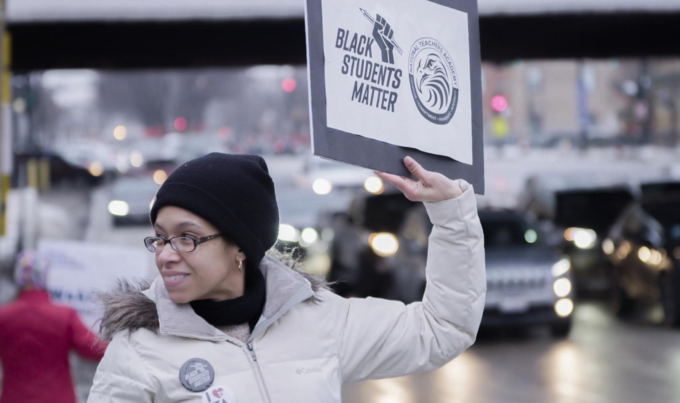
Debuts on PBS Television Nationwide Monday, December 12, 2022 and Free Streaming on PBS.org Until February 10, 2023
Trailer • Download Press Photos • #LittleLightShineFilmPBS

New York, N.Y. — November 3, 2022 — POV takes a look at the dynamic between parents, educators, and students embroiled in a battle over closing a top-ranked elementary school with a predominantly Black student population in a gentrified Chicago neighborhood in the inspiring documentary Let The Little Light Shine, directed and produced by Kevin Shaw (America To Me, The Street Stops Here), produced by Rachel Dickson (‘63 Boycott, Hard Earned) and executive produced by Academy Award® nominee Steve James (Abacus: Small Enough to Jail, Hoop Dreams). Let The Little Light Shine makes its national broadcast premiere on POV Monday, December 12, 2022 (check local listings) and will be available to stream with no PBS Passport membership necessary until February 10, 2023 at pbs.org, and the PBS Video app.

In addition to standard closed captioning for the film, POV, in partnership with audio description service DiCapta, provides real time audio interpretations for audiences with sensory disabilities. POV, currently celebrating its milestone 35th anniversary season, is America’s longest running non-fiction series.

South Side Chicago’s National Teachers Academy (NTA), a high-performing elementary school, is considered a beacon for Black children. The school has served as a safe haven for children and a community bedrock in “The South Loop,” Chicago’s fastest growing neighborhood. When NTA is threatened to be transformed into a high school favoring the needs of the community’s wealthier residents, African American parents-turned-organizers, alongside students and staff advocate to keep the school open. In Let The Little Light Shine, Shaw carefully considers race and other factors at play – class, which is intertwined with race, gentrification, power, privilege, and politics – as they collide to create discord amongst a community that wants the best possible education for their children. Shaw focuses on the stories of Elisabeth, a parent-turned activist; Isaac, the school’s steadfast principal; Taylor, an empowered student; and Audrey, a community member with long ties to the area. They are among those impacted by the discourse showcasing their unique perspectives about the situation. The film also posits the point-of-view of residents in favor of changing NTA into a high school that is sorely needed for its neighborhood.

“I made this film to understand why there was a movement in a booming Chicago neighborhood to close a high-performing, top-ranked elementary school that serviced a majority Black student population and transform that institution into a high school, potentially causing more harm than good to neighborhood families.

“‘If it ain’t broke, don’t fix it,’ the adage goes. Race, obviously and unfortunately, figured into the equation, but there were other factors at play – class, which is intertwined with race, gentrification, power, privilege, and politics all had a hand in creating discord amongst a community that wanted the same thing -- the best possible education for their children. The ways to achieve that goal were different for each set of residents, reminding us of harsh inequities and bias existing in our country. This story is not unique to Chicago; it is reflective of our American experience, one where Black and Brown communities still must fight for not only a seat at the table, but in this instance, an equitable place to learn,” said Kevin Shaw, director/producer, Let the Little Light Shine.

“I knew from working with Kevin before that he’d be the ideal filmmaker to shine a light on what’s going on in the fraught Chicago public school system. Here’s a predominantly Black grammar school that’s doing everything right by its students yet has to fight for its life against bureaucracy and gentrification. The beauty of Kevin’s film is that it is not a polemic. It’s incisive, thoughtful, and very moving, telling a story we’ve not seen before," said Steve James, executive producer, Let the Little Light Shine.

“Kevin Shaw’s Let the Little Light Shine centers the commitment that Chicago’s parents, teachers and students place on education and fighting for what’s right for their community. His balanced approach detailing many sides of the gentrification argument supports the fundamental right that children from all walks of life must have access to a quality education,” said Chris White, executive producer of POV and America ReFramed.
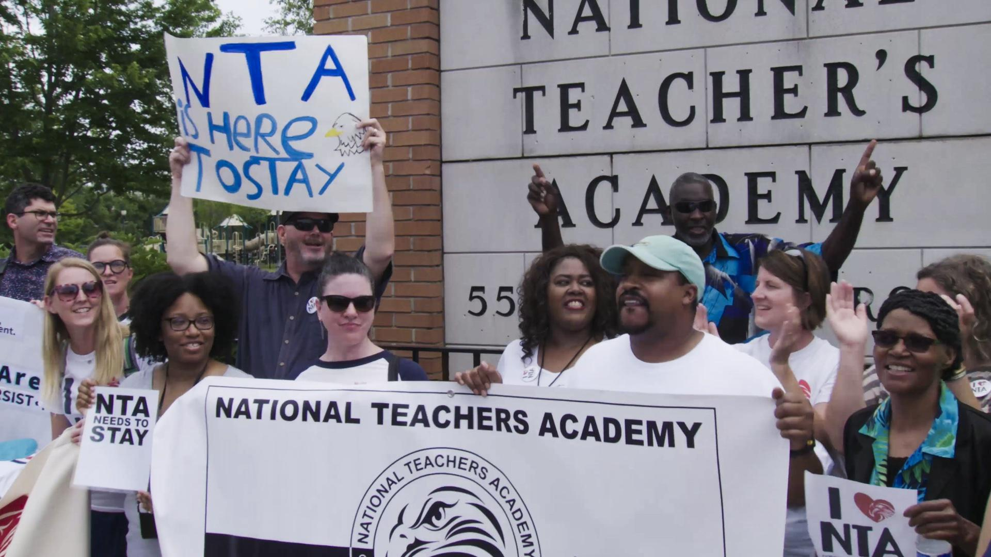
Let the Little Light Shine premiered at the 2022 True/False Festival and was an official selection of the 2022 Full Frame Festival, 2022 SXSW Edu, the 2022 Blackstar Film Festival, among others, and had a limited U.S. theatrical run in Chicago, New York, Los Angeles and other cities.

FESTIVAL PRESS

"It’s a rousing tribute to grassroots activism.”
– Michael Phillips, Chicago Tribune

“‘Let the Little Light Shine’ follows a remarkable movement: a group of people, some white and some Black, upper-middle-class and low-income, advocating for Black children’s futures. It weaves from classroom to district boardroom, a student’s kitchen to City Hall, meetings for the conversion of NTA and against. In doing so, it delves into the thorny politics of gentrification – the sanitized language of displacement, who and what is lost in the name of growth.”
– Adrian Horton, The Guardian

Let the Little Light Shine is a co-production of POV and ITVS, in association with Black Public Media. Kevin Shaw is the director/producer, Rachel Dickson is the producer and Steve James, Sally Jo Fifer, Leslie Fields Cruz, Erika Dilday and Chris White are the executive producers.
###

Credits

Director/Producer: Kevin Shaw
Producer: Rachel Dickson
Executive Producers: Steve James, Sally Jo Fifer, Leslie Fields Cruz, Erika Dilday, Chris White
Cinematographer: Kevin Shaw
Sound: Rachel Dickson
Editor: Kevin Shaw
Music By: Kahil El’Zabar

###

Photos

Download Let the Little Light Shine photos here.

About the Filmmakers

Kevin Shaw, Director/Producer, Let the Little Light Shine
As a director, producer and cinematographer, Kevin Shaw has created award-winning content for national television networks. Shaw was a segment director and cinematographer on America to Me, and additional cinematographer on City So Real, both from Oscar- nominated filmmaker Steve James. America to Me debuted to high acclaim at the 2018 Sundance Film Festival and premiered on Starz in August 2018, where it was lauded as the No. 1 television mini-series of the year by The Hollywood Reporter and The New York Times.
Shaw’s debut documentary, The Street Stops Here, aired nationally on PBS and ESPN in 2010 to rave reviews. The following year, Shaw’s Big Ten Network short documentary on a quadriplegic trying to regain the ability to walk won the Edward R. Murrow Award for Sports Reporting Excellence. His cinematography talents were recognized in 2015 with a National Sports Emmy for ESPN’s FIFA World Cup Show Opens and Teases. Later that year, Shaw produced a documentary about the relationship between megastar Shaquille O’Neal and his collegiate coach, Dale Brown. Shaq and Dale premiered on ESPN.
Shaw is a Firelight Media Documentary Lab Alum and a graduate of Kartemquin Films’ Diverse Voices in Documentary Fellowship

Rachel Dickson, Producer, Let the Little Light Shine
Rachel Dickson is an independent filmmaker based in Chicago and rural Colombia with a background in journalism and Spanish translation. She produced ‘63 Boycott with Kartemquin Films, which was named on the Academy Awards shortlist for Best Documentary Short Subject, won the Jury Award for Best Short Documentary at the Nashville Film Festival, the Audience Award at the Pan African Film Festival in Los Angeles, and was an official selection of the Museum of Modern Art Doc Fortnight and the DOC NYC Short List.
Dickson was the supervising producer of The School Project, a web series collaboratively produced by Kartemquin Films, Media Process Group, Kindling Group, Free Spirit Media, and Siskel/Jacobs Productions, in partnership with WTTW/ Channel 11, the Chicago Sun-Times, and Ebony.com, and won a Hometown Media Award. Dickson was a field producer for Hard Earned, a Kartemquin Films production which won the Alfred I. DuPont-Columbia University Award. Before that, she was a story producer for Central Standard on Education, WTTW/Channel 11’s first web series with PBS Digital. Dickson has worked as a teaching filmmaker of high school students for the University of Chicago Impact Lab of the Urban Education Institute. She attended Chicago Public Schools, and before working as a filmmaker, she worked as a journalist in Latin America for four years.

Steve James, Executive Producer, Let the Little Light Shine
Steve James’ previous work includes Hoop Dreams; Sundance award winner, Stevie; The Interrupters, which won an Emmy, Independent Spirit Award, and the DuPont Columbia Journalism Award; Emmy winner Life Itself, named best documentary by The National Board of Review, and The Producers Guild of America among many others; and Abacus: Small Enough to Jail, which earned James a second Academy Award nomination. His Starz docuseries, America to Me, premiered at Sundance and was one of the most acclaimed TV shows of 2018. His most recent docuseries, City So Real premiered to rave reviews at Sundance in 2020. His latest film, A Compassionate Spy, premiered at the 2022 Venice Film Festival.

# # #
About POV
Produced by American Documentary, POV is the longest-running independent documentary showcase on American television. Since 1988, POV has presented films on PBS that capture the full spectrum of the human experience, with a long commitment to centering women and people of color in front of, and behind, the camera. The series is known for introducing generations of viewers to groundbreaking works like Tongues Untied, American Promise and Minding The Gap and innovative filmmakers including Jonathan Demme, Laura Poitras and Nanfu Wang. In 2018, POV Shorts launched as one of the first PBS series dedicated to bold and timely short-form documentaries. All POV programs are available for streaming concurrent with broadcast on all station-branded PBS platforms, including PBS.org and the PBS Video app, available on iOS, Android, Roku streaming devices, Apple TV, Android TV, Amazon Fire TV, Samsung Smart TV, Chromecast and VIZIO. For more information about PBS Passport, visit the PBS Passport FAQ website.

POV goes “beyond the broadcast” to bring powerful nonfiction storytelling to viewers wherever they are. Free educational resources accompany every film and a community network of thousands of partners nationwide work with POV to spark dialogue around today’s most pressing issues. POV continues to explore the future of documentary through innovative productions with partners such as The New York Times and The National Film Board of Canada and on platforms including Snapchat and Instagram.

POV films and projects have won 46 Emmy Awards, 27 George Foster Peabody Awards, 15 Alfred I. duPont-Columbia University Awards, three Academy Awards and the first-ever George Polk Documentary Film Award. Learn more at pbs.org/pov and follow @povdocs on social media.

About American Documentary, Inc.
American Documentary, Inc. (AmDoc) is a multimedia company dedicated to creating, identifying and presenting contemporary stories that express opinions and perspectives rarely featured in mainstream media outlets. AmDoc is a catalyst for public culture, developing collaborative strategic engagement activities around socially relevant content on television, online and in community settings. These activities are designed to trigger action, from dialogue and feedback to educational opportunities and community participation.

Major funding for POV is provided by PBS, the Open Society Foundations, The John D. and Catherine T. MacArthur Foundation, the Wyncote Foundation, Reva & David Logan Foundation, Park Foundation, and Perspective Fund. Additional funding comes from the National Endowment for the Arts, New York State Council on the Arts, public funds from the New York City Department of Cultural Affairs in partnership with the City Council, Sage Foundation, Nancy Blachman and David desJardins, Chris and Nancy Plaut, Abby Pucker, Ann Tenenbaum and Thomas H. Lee and public television viewers. POV is presented by a consortium of public television stations, including KQED San Francisco, WGBH Boston and THIRTEEN in association with WNET.ORG.

###

