

“American Promise” TCA Biographies

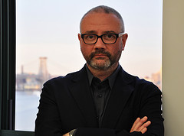Simon Kilmurry, Executive Director, American Documentary | POV; Executive Producer, POV
Simon Kilmurry joined American Documentary | POV in 1999 and was appointed executive director in 2006. He oversees all aspects of American Documentary’s programs and operations, including the production of POV (Point of View), PBS’ award-winning documentary film series. Since 2006, POV has been honored with a Special Emmy for Excellence in Television Documentary Filmmaking, a Primetime Emmy®, 13 News and Documentary Emmys, 57 Emmy nominations, four Academy Award® nominations, four Peabody Awards, three duPont-Columbia Journalism Awards, two International Documentary Association Awards for Best Continuing Series, a Webby Award and the National Association of Latino Independent Producers Corporate Commitment to Diversity Award.

Since joining American Documentary, Kilmurry has been involved in the production and distribution of more than 200 POV films and special presentations, including a live town-hall meeting with ABC News’ Nightline and the PBS miniseries Right Here, Right Now. He has helped lead new initiatives to increase POV’s reach, diversity and innovation, including the Diverse Voices Project, which supports emerging filmmakers, and online initiatives to use digital tools in support of documentary storytelling.

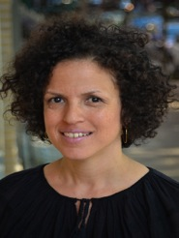Michèle Stephenson, Producer and Director, “American Promise”
Michèle Stephenson is the co-producer and co-director of “American Promise.” A graduate of McGill University and Columbia Law School, Stephenson uses her background in critical studies, race, and human rights to inform her documentary work. Her Panamanian and Haitian heritage has also fueled her passion to tackle stories on communities of color and human rights. An early pioneer in the Web 2.0 revolution, Stephenson used video and the Internet to structure human rights campaigns and train people from around the globe in video Internet advocacy. Her work has appeared on PBS, Showtime, MTV and other outlets. Stephenson’s honors include the Silverdocs Diversity Award and the Henry Hampton Award for Excellence in Film and Digital Media.

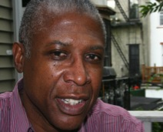Joe Brewster, Producer and Director, “American Promise”
Joe Brewster is the co-producer and co-director of “American Promise.” He and his partner, Michèle Stephenson, have produced and directed award-winning feature documentaries and narrative films. Brewster is a Harvard- and Stanford-educated psychiatrist who specializes in organizational analysis, the use of psychoanalytical principals to understand and improve organizations. He moved to New York City in 1985 to pursue media studies in the service of social change. In 1992, Brewster sold his first screenplay to the Jackson/McHenry group under the Warner Bros. imprint. In 1996, he wrote and directed The Keeper, which was an official selection in the dramatic narrative competition section of the Sundance Film Festival and garnered numerous national and international awards, including an Independent Spirit Award nomination.

Idris Brewster, Film Subject, “American Promise”
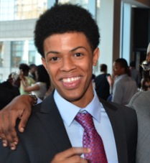Idris Brewster is a featured subject in “American Promise.” He is currently a freshman at Occidental College in Los Angeles, and attended the Dalton School in New York City. He is an avid skateboarder and enjoys a game of basketball every now and then. He was born and raised in Brooklyn, New York.

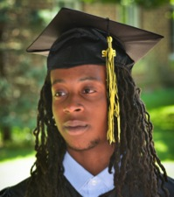Oluwaseun (Seun) Summers, Film Subject, “American Promise”
Seun Summers is a featured subject in “American Promise.” He is currently a freshman at the State University of New York, Fredonia, and attended Benjamin Banneker Academy High School. He is a black belt in karate and enjoys drawing. He was born and raised in Brooklyn, New York.

Rada Film Group
The Rada Film Group began as a partnership between Joe Brewster and Michèle Stephenson with a mission to create compelling visual stories that provoke thought about our complex multicultural world. Their current documentary film, “American Promise,” was conceived in 1999 as a vehicle to celebrate the importance of diversity and acknowledge the work of British director Michael Apted. Through their work with “American Promise,” Brewster and Stephenson have been Sundance Documentary Fund fellows, Tribeca All Access fellows, and BAVC Producers Institute fellows. They have received support from the Ford Foundation, the MacArthur Foundation, the Open Society Foundations Campaign for Black Male Achievement, the Kellogg Foundation, the Fledgling Fund, the New York State Council on the Arts, the National Black Programming Consortium, ITVS and the POV Diverse Voices Project. Brewster and Stephenson are also recipients of a 2011 San Francisco Film Society Documentary Film Fund grant, a Jerome Foundation film grant, a Gucci Tribeca Documentary Fund grant and a 2012 Tribeca Film Institute New Media Fund grant.

* * * *

Contacts:

POV Communications: communications@pov.org, 212-989-7425

Cathy Fisher, cfisher@pov.org; Amanda Nguyen, anguyen@pov.org
POV online pressroom: http://www.pbs.org/pressroom

