


POV “The Feeling of Being Watched” Panelist Biographies
Premieres Monday, October 14 at 10:00 p.m. ET on PBS

 | Assia Boundaoui, Director, Producer, The Feeling of Being Watched  Assia Boundaoui is an Algerian American filmmaker and journalist. She has reported for PRI, BBC, Al Jazeera, VICE and CNN, among others. Her debut short film about hijabi hair salons for HBO Documentary Films premiered at the 2018 Sundance Film Festival. Her award-winning feature-length directorial debut, The Feeling of Being Watched, a documentary investigating a decade of FBI surveillance in Assia's Muslim American community, had its world premiere at the 2018 Tribeca Film Festival. Assia was named one of Filmmaker Magazine's 2018 "25 New Faces of Independent Film,” and is currently a New America National Fellow and a fellow with the Co-Creation Studio at the MIT Open Documentary Lab, where she is iterating a co-created AI fueled sequel to her film: the Inverse Surveillance Project. She has an M.A. in journalism from New York University and is an Algiers-born, Arabic-speaking Chicago native, currently based in Southern California.
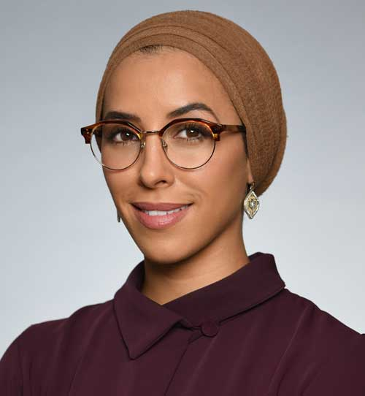  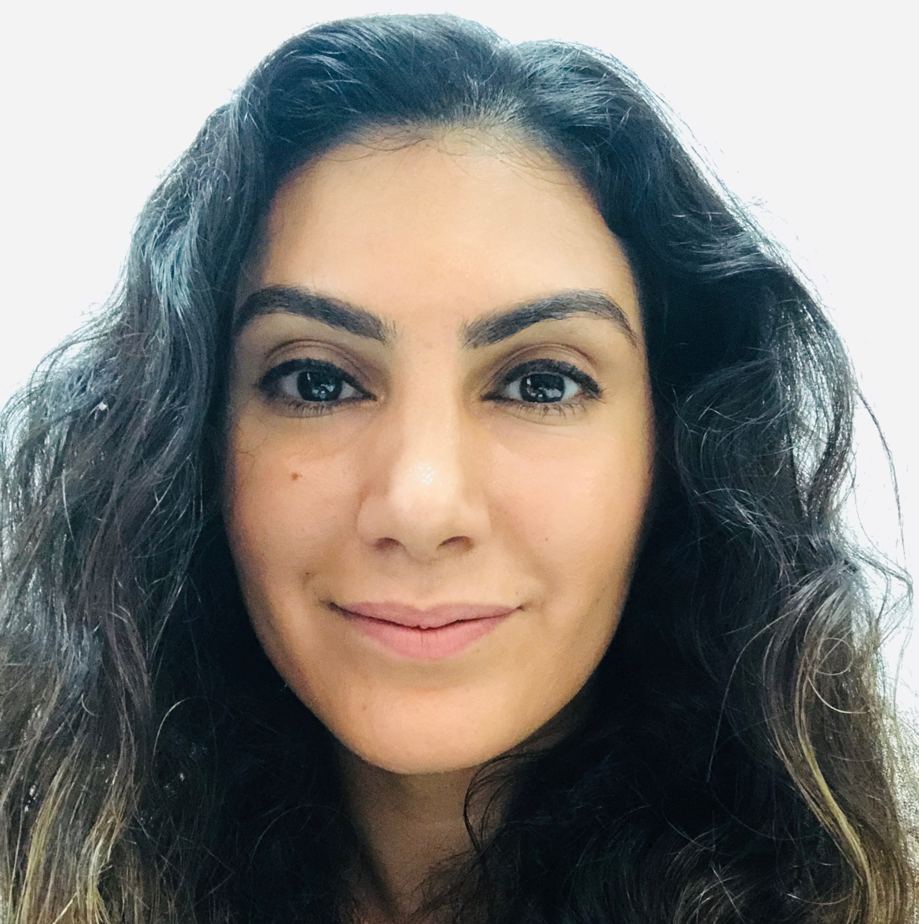   | Iman Boundaoui, Civil Rights Attorney, Film Subject, The Feeling of Being Watched  Iman Boundaoui is a civil rights attorney and human rights advocate based in Chicago. She represents victims of unfair labor practices, private and state-sponsored discrimination, abusive corporate structures, and other varieties of civil rights, employment and constitutional law. In 2017, Iman was named a “Chicagoan of the Year” by Chicago Magazine for playing a key role in the on-the-ground legal response to the Trump administration's anti-Muslim travel ban at Chicago’s O’Hare port of entry, as well as her role in launching and streamlining the "Travelers Assistance Project," a long-term assistance model for addressing ongoing human and civil rights abuses at the border. Iman is also a coach-in-training at the Coaches Training Institute (CTI), on the path to becoming a certified professional life coach and community healer. Following certification, she aims to launch a holistic coaching practice with a focus in the areas of somatic coaching and trauma healing and transformation.  Christina Abraham, Attorney, Film Subject and Co-Executive Producer, The Feeling of Being Watched  Christina Abraham is co-executive producer of The Feeling of Being Watched and works on Assia Boundaoui's legal team, handling the FOIA litigation. Christina is an attorney practicing in immigration, employment and civil rights law. She also consults local, national and international organizations in human rights and humanitarian law, program development and fundraising strategies. Christina previously was the International Research Fellow at the International Institute of Higher Studies in Criminal Science (now the Siracusa International Institute), where she conducted research, published materials and coordinated educational programs related to international criminal law, rule of law and human rights. There, she co-edited the Siracusa Guidelines for International, Regional and National Fact-finding Bodies. Prior to that, Christina served as chief of staff to the Bahrain Independent Commission of Inquiry, a human rights investigative body. She also served as the first civil rights director at CAIR-Chicago, where she represented thousands of Muslims affected by discrimination, harassment and hate crimes. Christina obtained her J.D. from DePaul University and M.A. from the University of Chicago.  Justine Nagan, Executive Producer/Executive Director, POV/American Documentary  Justine Nagan is the executive director of American Documentary (AmDoc), and an executive producer on its two signature series, POV (PBS) and America Reframed (World Channel in partnership with WGBH). POV is the longest-running independent documentary series on television. She is a strong believer in the important role of public media in a democracy, diversity and independent voices in popular culture, and of documentary as a tool for civic dialogue, new thinking and social change.  Prior to coming to AmDoc, Justine led Kartemquin Films (KTQ) as executive director for seven years, as well as being an Emmy Award-winning Executive Producer on KTQ films including Abacus, Life Itself and The Interrupters by Steve James; Minding the Gap by Bing Liu; and The Trials of Muhammad Ali by Bill Siegel. Justine successfully transitioned to the ED role in a historic founder-led organization, and under her leadership, the organization significantly expanded its programs to assist documentary filmmakers and saw unprecedented levels of production and financial growth. During her tenure, over 20 projects had world premieres, including the ambitious duPont Award-winning six-hour series Hard Earned for Al Jazeera America. She left the organization with a robust production pipeline and a strong financial footing.  With Kartemquin, she also directed Typeface, an award-winning documentary on American typography and graphic design, which aired on PBS and internationally on the Sundance Channel, and the doc short Sacred Transformations.  Nagan has a certificate in nonprofit management from Harvard Business School and a master’s degree from the University of Chicago in the humanities/cinema and media studies. She is a member of the Academy of Motion Picture Arts and Sciences, is active in the media community and was one of the founding board members of Good Pitch Chicago. She lives in Brooklyn, New York, with her husband and two young sons.
# # #

POV: communications@pov.org, 212-989-7425
Keisha Salmon, director, ksalmon@pov.org, 917-512-5629
POV online pressroom: http://www.pbs.org/pressroom

