


POV “When I Walk”

Premieres Summer 2014 on PBS

TCA Biographies

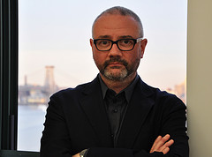
Simon Kilmurry, Executive Director, American Documentary | POV; Executive Producer, POV

Simon Kilmurry joined American Documentary | POV in 1999 and was appointed executive director in 2006. He oversees all aspects of American Documentary’s programs and operations, including the production of POV (Point of View), PBS’ award-winning documentary film series. Since 2006, POV has been honored with a Special Emmy for Excellence in Television Documentary Filmmaking, a Primetime Emmy®, 13 News and Documentary Emmys, 57 Emmy nominations, four Academy Award® nominations, four Peabody Awards, three duPont-Columbia Journalism Awards, two International Documentary Association Awards for Best Continuing Series, a Webby Award and the National Association of Latino Independent Producers Corporate Commitment to Diversity Award.

Since joining American Documentary, Kilmurry has been involved in the production and distribution of more than 200POV films and special presentations, including a live town-hall meeting with ABC News’ Nightline and the PBS miniseriesRight Here, Right Now. He has helped lead new initiatives to increase POV’s reach, diversity and innovation, including the Diverse Voices Project, which supports emerging filmmakers, and online initiatives to use digital tools in support of documentary storytelling.

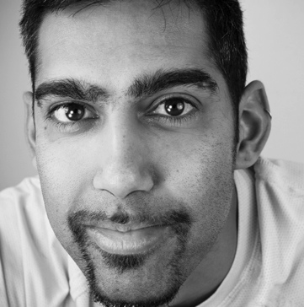
Jason DaSilva, Director/Producer, “When I Walk”

Jason DaSilva has been a prolific filmmaker for the past 10 years, directing four short films (Olivia’s Puzzle, A Song for Daniel, Twins of Mankala and First Steps) and two feature-length documentaries (Lest We Forget and When I Walk). Many of his films have won awards; Olivia’s Puzzle premiered at the 2003 Sundance Film Festival and qualified for an Academy Award®. Three of his films have been broadcast nationally on PBS, HBO and CBC. He also produced Shocking and Awful, a film installation on the movement against the Iraq War, exhibited at the 2006 Whitney Biennial.

In 2006, DaSilva took a short break from filmmaking to earn his master’s degree in applied media arts from Emily Carr University. He produced and directed an op-doc (opinion documentary) for The New York Times entitled The Long Wait, published in January 2013. He and his wife, Alice Cook, live and work in Brooklyn, New York.


Alice Cook, Director/Producer/Editor, “When I Walk”

Alice Cook is a documentary filmmaker and producer living in Brooklyn, New York. When I Walk is her first production. She also produced and directed the New York Times op-doc The Long Wait, published in January 2013. She has produced the digital media project AXS Map, which was funded by charitable giving from Google and other organizations. Cook received her bachelor’s and master’s degrees in engineering and science from Stanford University.

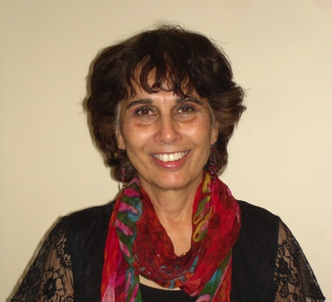
Marianne D'Souza, Film Subject, “When I Walk”

Marianne D’Souza was born in Nairobi, Kenya, where she lived until the age of 20. She moved to the United States to study as an international student and has a degree in English and a master’s in social work from New York University. D’Souza’s many careers include child and youth counsellor, psychiatric social worker and educator (kindergarten through high school, and adult education). She lives near Vancouver, Canada, where she is a teacher in the public school system.

D’Souza is a mother of three sons. Her pastimes include hiking in the mountains, sustainable gardening, volunteering at cultural and arts events, and visiting senior citizens. She has been an active supporter of her son Jason DaSilva’s art and film career from the beginning, and has always been involved. She continues to be a strong advocate for AXS Map and has attended Mapping Days in several cities, including Toronto, Vancouver and San Diego.

* * * *

Contacts:

POV Communications: communications@pov.org, 212-989-7425. Emergency contact: 206-790-8697.

Cathy Fisher, cfisher@pov.org; Amanda Nguyen, anguyen@pov.org
POV online pressroom: http://www.pbs.org/pressroom

