

Royal Family’s Rarely Visited Spaces Uncovered in New Documentary:
THE QUEEN’S GARDEN

– Specials Open Doors to Royal Life, From Medieval to Modern Times
Sunday, December 21 and Sunday, January 11 –

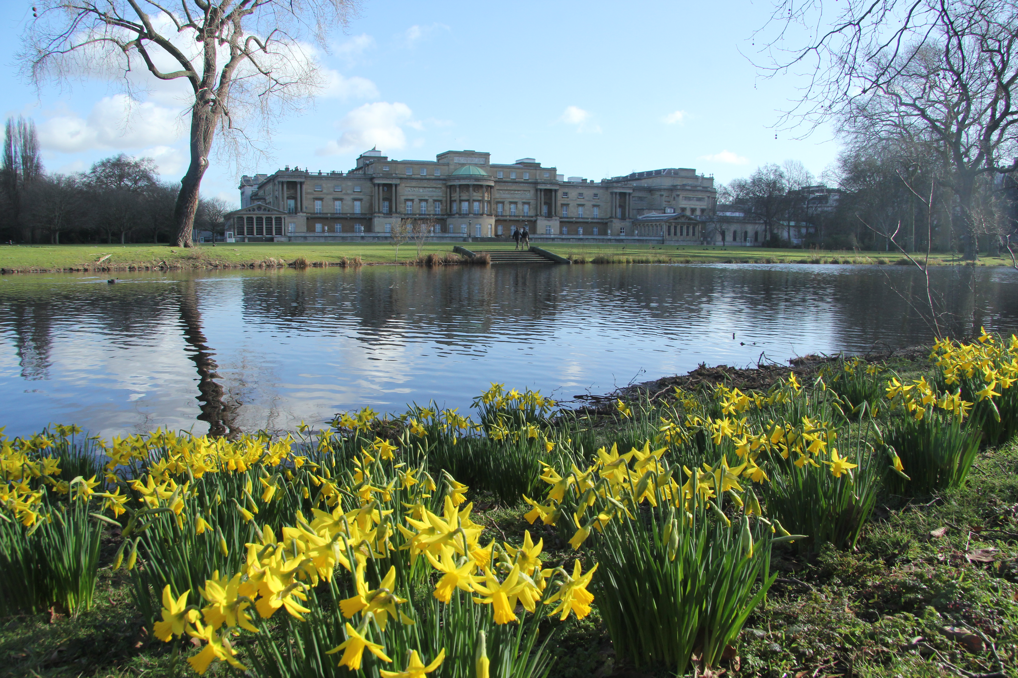
Buckingham Palace. Photo: Courtesy
of Will Benson ©Oxfordscientificfilms
ARLINGTON, VA; December 2, 2014 (updated Dec. 22, 2014) – From bedchambers to flower beds, two new one-hour specials on PBS reveal the secluded spaces of British royal families. TALES FROM THE ROYAL BEDCHAMBER premiered Sunday, December 21, 2014, 8:00-9:00 p.m. ET (watch now on video.pbs.org,) and THE QUEEN’S GARDEN premieres January 11, 2015, 10:00-11:00 p.m. ET on PBS (check local listings). The programs underscore the importance of both locations in the lives of the royal household, with insightful interviews and unprecedented public access to these most intimate spaces.

Following episode two of “Downton Abbey, Season 5” on MASTERPIECE, the documentary THE QUEEN’S GARDEN recounts a year in the Buckingham Palace Garden, exploring the history and natural history of this remarkable 39-acre oasis hidden in the heart of London (watch a clip here). With permission from Her Majesty the Queen, the filmmakers explore this urban oasis with a five-century history — a “living museum” where almost every plant (and some of the animals) have royal stories to tell.

Viewers see the garden’s transformation across four seasons, with a chance to marvel at rare flowers bred specially for the queen, extraordinary wildlife captured with hidden cameras, a vast lake with an island in the middle where royal bees make honey that has been gifted to the pope, and a 15-foot marble urn that once belonged to Napoleon. The wildest corners of THE QUEEN’S GARDEN function as an important wildlife haven in London, as well as serve as a backdrop for the annual 8,000-attendee Royal Garden Party.

In TALES FROM THE ROYAL BEDCHAMBER, host Dr. Lucy Worsley, Chief Curator at Historic Royal Palaces, snuggles up with Britain’s monarchs to uncover the fascinating secrets of the royal bedchamber (watch a clip here). From Hampton Court to Hever Castle to the great English country manors, Worsley shows the opulence of Royal State bedrooms and explains how these private spaces were once very public hubs of English politics and policy. It was in these rooms that royal marriage ceremonies were held, royal births were observed by crowds eager to verify the baby’s sex. Even the process of creating royal babies took place in a semi-public context, Worsley says, because everyone had a stake in its outcome.

The eventual creation of private chambers evolved as a reaction to the overwhelmingly public nature of royal bedrooms, and affairs of state eventually were relegated to offices and the Houses of Parliament. But TALES FROM THE ROYAL BEDCHAMBER gives viewers access to the regal pomp and detailed work of these inner chambers – detailing the lavish designs of royal state beds and “pulling back the covers” on the political intrigue that occurred behind closed doors.

TALES FROM THE ROYAL BEDCHAMBER and THE QUEEN’S GARDEN will be available to stream through PBS stations’ video sites each morning after broadcast, including video.pbs.org, PBS station-branded digital platforms, such as ROKU, Apple TV and Xbox, and on PBS iPad and iPhone apps.

Credits:
THE QUEEN’S GARDEN: Writer and director Martin Williams. Executive producers: Alice Keens-Soper and Jeremy Bradshaw. An Oxford Scientific Films Production in association with PBS for ITV.
TALES FROM THE ROYAL BEDCHAMBER: Producer and director: Nick Gillam-Smith. Executive producer: Lionel Mill. Host: Dr. Lucy Worsley. A Tiger Aspect Productions, an Endemol company, for BBC.
About PBS
PBS, with its over 350 member stations, offers all Americans the opportunity to explore new ideas and new worlds through television and online content. Each month, PBS reaches nearly 109 million people through television and over 28 million people online, inviting them to experience the worlds of science, history, nature and public affairs; to hear diverse viewpoints; and to take front row seats to world-class drama and performances. PBS’ broad array of programs has been consistently honored by the industry’s most coveted award competitions. Teachers of children from pre-K through 12th grade turn to PBS for digital content and services that help bring classroom lessons to life. PBS’ premier children’s TV programming and its website, pbskids.org, are parents’ and teachers’ most trusted partners in inspiring and nurturing curiosity and love of learning in children. More information about PBS is available at www.pbs.org, one of the leading dot-org websites on the Internet, or by following PBS on Twitter, Facebook or through our apps for mobile devices. Specific program information and updates for press are available at pbs.org/pressroom or by following PBS PressRoom on Twitter.
– PBS –
For additional information, photos, interviews and more, contact Goodman Media or PBS:

Roberta Lee/ Chelsey Saatkamp, Goodman Media International for PBS, 212-576-2700; PBSProgramming@goodmanmedia.com

Colleen Flanagan, PBS: 703-739-8130; crflanagan@pbs.org

For images and additional up-to-date information on this and other PBS programs, visit PBS PressRoom at pbs.org/pressroom.

