“A RAISIN IN THE SUN REVISITED: THE RAISIN CYCLE AT CENTER STAGE”
PREMIERES OCTOBER 25 AS PART OF PBS ARTS FALL FESTIVAL

– Explores Legacy and Impact of Lorraine Hansberry’s Groundbreaking Play –

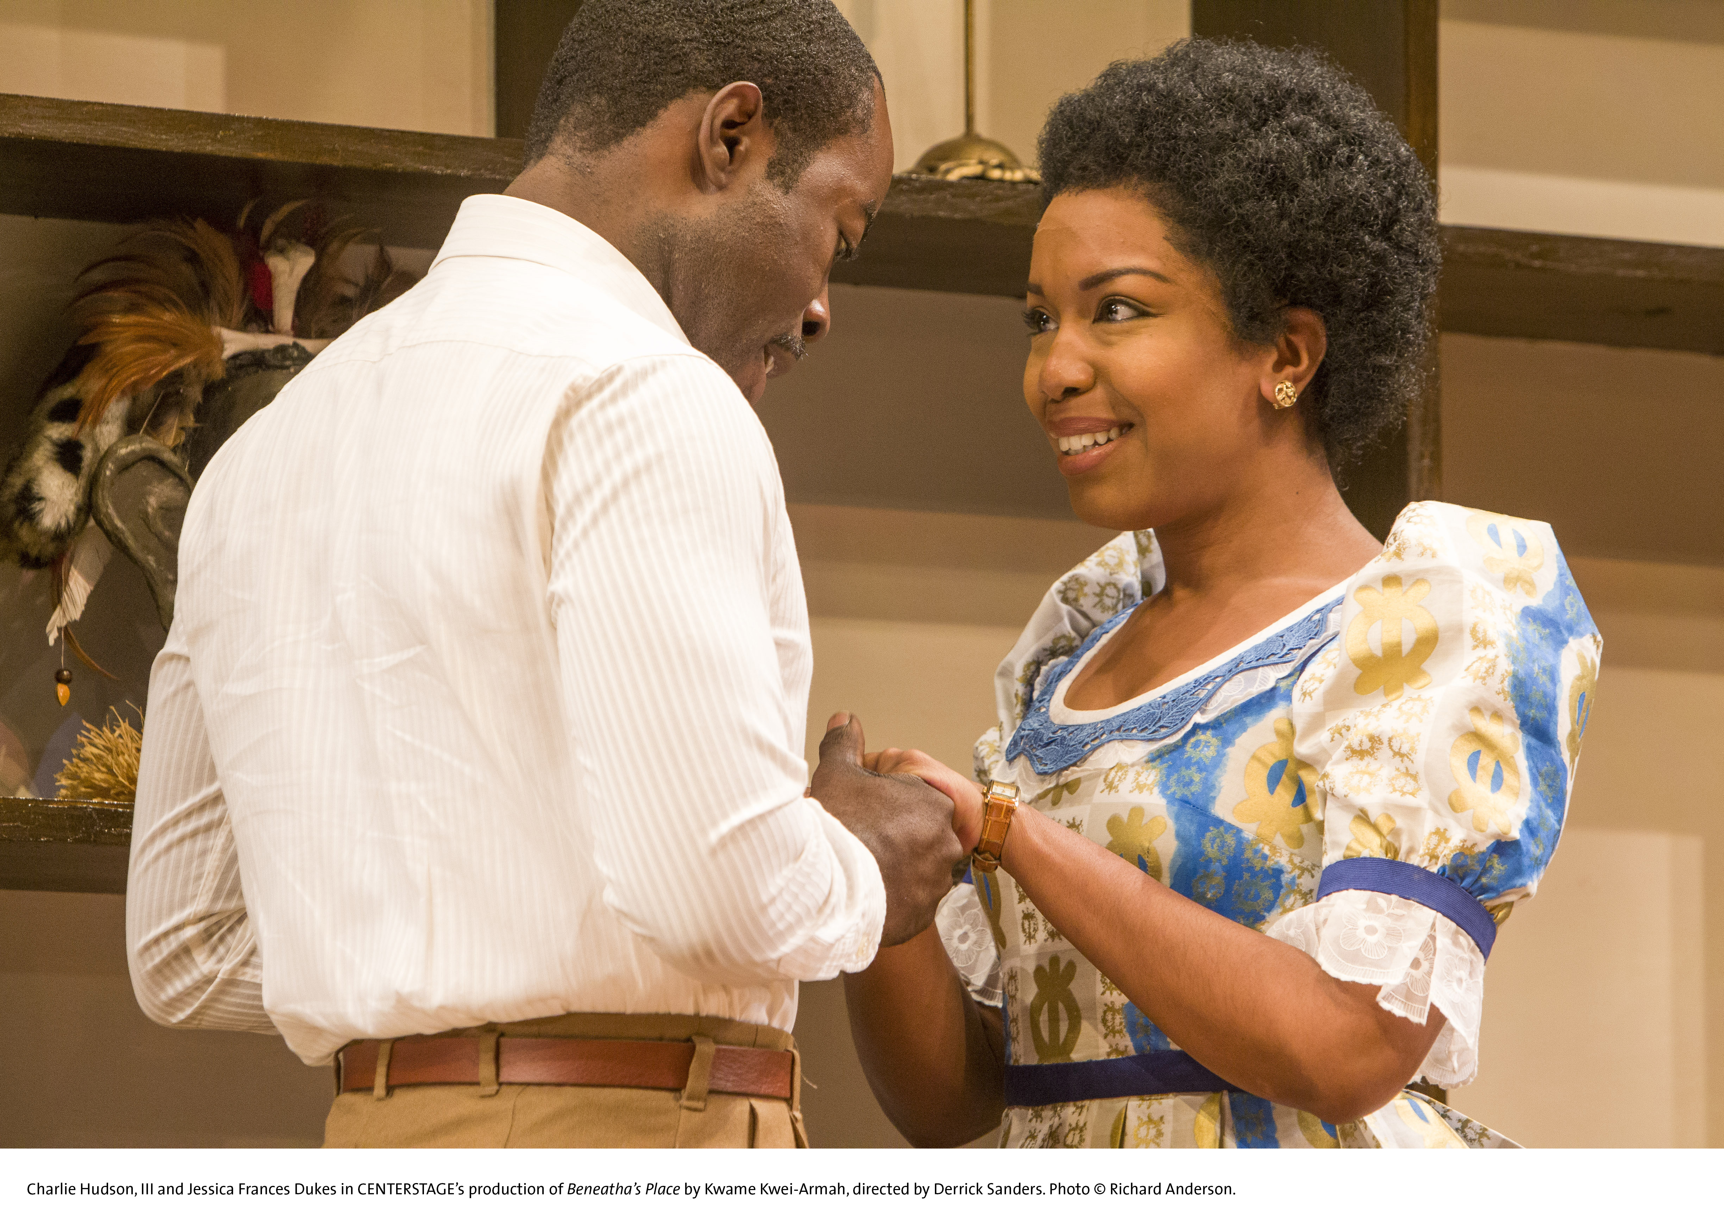
ARLINGTON, VA; October 3, 2013 –PBS’ new performance documentary A RAISIN IN THE SUN REVISITED: THE RAISIN CYCLE AT CENTER STAGE explores the history and legacy of Lorraine Hansberry’s groundbreaking 1959 play through the lens of a culturally significant milestone: the staging of two contemporary, issues-oriented plays that Raisin inspired: Bruce Norris’s Tony Award-winning Clybourne Park and Beneatha’s Place by Kwame Kwei-Armah, artistic director of the State Theater of Maryland, Baltimore’s Center Stage. The program premieres Friday, October 25 at 9:00 p.m. ET on PBS (check local listings) as part of the PBS ARTS FALL FESTIVAL, which highlights artists and performances from around the country and invites every American into the worlds of music, theater, opera and cultural history.
Charlie Hudson III and Jessica Frances Dukes in Center Stage’s production of “Beneatha's Place.” Photo © Richard Anderson

A Raisin in the Sun was the first Broadway play to depict the strength and humanity of an African-American family striving for a piece of the American dream by buying a house in a white working-class neighborhood in Chicago. More than 50 years later, playwright Bruce Norris created Clybourne Park, a sardonic Pulitzer Prize-winning prequel/sequel that takes place in the same Chicago house and revisits the questions of race, real estate and gentrification in America. Inspired by Hansberry’s original and Norris’ follow-up, Kwame Kwei-Armah penned Beneatha’s Place, which follows two of the Raisin characters to Nigeria and its post-colonial struggles.

Baltimore’s acclaimed regional theater Center Stage mounted Clybourne Park and Beneatha’s Place in repertory as The Raisin Cycle, in celebration of the theater’s 50th anniversary season. The 60-minute documentary reflects the legacy of Hansberry’s original work and underscores the considerable backstage work that goes into making a performance pairing of this caliber. With two opening nights looming, actors, creative team members, and Center Stage producers talk candidly about their work and the challenges of an unusually demanding rehearsal process. Rehearsals, meetings and costume fittings are paired with footage of Center Stage’s performances, the 1961 film and insights from theater historians.

“These contemporary plays, inspired by A Raisin in the Sun and produced by Center Stage, are perfect examples of the thought-provoking, culturally significant work being done at American theater companies today,” said Donald Thoms, PBS Vice President of Programming and Talent Management. “This special documentary both salutes the pioneering original and gives insight into the development of the new -- with significant glimpses of all three. This film is a tremendous addition to this year’s PBS Arts Fall Festival.”

A RAISIN IN THE SUN REVISITED: THE RAISIN CYCLE AT CENTER STAGE is produced by James Arntz and John Paulson of Third Rail Productions, in collaboration with Maryland Public Television.

“Lorraine Hansberry’s original play continues to inspire artists and audiences more than 50 years later,” said Kwame Kwei-Armah. “The issues raised by the original work, as well as by Clybourne Park and Beneatha’s Place are vital to the national conversation on race and class, and our hope through staging the two plays simultaneously was to engage the audience and encourage them to consider these issues in their own lives. We’re proud to bring this performance documentary to PBS with the same goal in mind, raising the civic discussion from a local to a national level.”

“The relevance of A Raisin in the Sun is undeniable. We are thrilled to have worked with Center Stage, as well as with James Arntz and John Paulson, to bring the story of the original and the ambitious stage productions of ‘The Raisin Cycle’ to PBS audiences across the U.S.,” said Steven J. Schupak, Chief Content Officer, Maryland Public Television.

James Arntz and John Paulson have produced a number of award-winning PBS arts specials over the years, including HOMECOMING: The Kansas City Symphony Presents Joyce DiDonato for the 2012 PBS Arts Summer Festival, AMERICAN MASTERS "Les Paul – Chasing Sound," and "Piano Grand! A Smithsonian Celebration" with the Smithsonian Institution and Maryland Public Television.

The full PBS ARTS FALL FESTIVAL schedule follows. Details at pbs.org/pressroom.

- GREAT PERFORMANCES “40th Anniversary Celebration,” October 18, 2013, 9:00 p.m. ET
- A RAISIN IN THE SUN REVISITED: The Raisin Cycle at Center Stage, October 25, 2013, 9:00 p.m. ET
- GREAT PERFORMANCES “Moby-Dick from San Francisco Opera,” November 1, 2013, 9:00 p.m. ET
- GREAT PERFORMANCES “Stephen Sondheim’s Company with the New York Philharmonic,” November 8, 2013, 9:00 p.m. ET
- GREAT PERFORMANCES “Rodgers & Hammerstein’s Oklahoma!,” November 15, 2013, 9:00 p.m. ET
- NASHVILLE 2.0: The Rise of Americana, November 22, 2013, 9:00 p.m. ET
- GREAT PERFORMANCES “Barbra Streisand: Back to Brooklyn,” November 29, 2013, 9:00 p.m. ET

National funding for the PBS Arts Fall Festival is provided by a generous grant from Anne Ray Charitable Trust.

A Raisin in the Sun Revisited is made possible by The Eddie C. Brown Family Foundation and Brown Capital Management with additional support from The Charlesmead Foundation, Ellen and Ed Bernard, and the Estate of Katherine Vaughns.

About the PBS Arts Fall Festival
As part of its commitment to increase every American’s access to and participation in the arts, PBS premieres its 2013 PBS Arts Fall Festival on Friday, October 18, 2013, hosted by award-winning television, film and stage star Anna Deavere Smith. Anchored by broadcasts every Friday night and a range of related online content, the Fall Festival features artists and performances from across the country, comprised of full-length performances, behind-the-scenes interviews, and artist and performer profiles.

About Center Stage
Under the leadership of playwright, actor, and director Kwame Kwei-Armah OBE (Artistic Director) and national arts leader Stephen Richard (Managing Director), Center Stage is an artistically driven institution committed to engaging, entertaining, and enriching audiences of today and tomorrow through joyous and bold performance. The professional, nonprofit theater company is dedicated to the creation and presentation of a dynamic and diverse array of new and classic work, and each year hosts an audience of more than 100,000 in its historic home in Baltimore’s Mount Vernon neighborhood. With its signature focus on civic and community engagement, Center Stage, The State Theater of Maryland, enters its second 50 years with a commitment to exploring how art and entertainment communicate in the 21st century, and to igniting conversation in Baltimore and beyond.
Center Stage is supported by a grant from the Maryland State Arts Council (MSAC), an agency dedicated to cultivating a vibrant cultural community where the arts thrive. An agency of the Department of Business & Economic Development, the MSAC provides financial support and technical assistance to nonprofit organizations, units of government, colleges, and universities for arts activities. Funding for the MSAC is also provided by the National Endowment for the Arts, a federal agency. Maryland Public Television is a Media Partner for Center Stage's 2013-14 Season.

About Maryland Public Television
Launched in 1969 and headquartered in Owings Mills, MD, Maryland Public Television is a nonprofit, state-licensed public television network and member of the Public Broadcasting Service (PBS). MPT’s six transmitters cover Maryland plus portions of contiguous states and the District of Columbia. Frequent winner of regional Emmy® awards, MPT creates local, regional, and national television shows. Beyond broadcast, MPT’s commitment to professional educators, parents, caregivers, and learners of all ages is manifest in its year-round instructional events and super-website Thinkport which garners in excess of 1.4 million visits annually.

About PBS
PBS, with its over 350 member stations, offers all Americans the opportunity to explore new ideas and new worlds through television and online content. Each month, PBS reaches nearly 120 million people through television and over 29 million people online, inviting them to experience the worlds of science, history, nature and public affairs; to hear diverse viewpoints; and to take front row seats to world-class drama and performances. PBS’ broad array of programs has been consistently honored by the industry’s most coveted award competitions. Teachers of children from pre-K through 12th grade turn to PBS for digital content and services that help bring classroom lessons to life. PBS’ premier children’s TV programming and its website, pbskids.org, are parents’ and teachers’ most trusted partners in inspiring and nurturing curiosity and love of learning in children. More information about PBS is available at www.pbs.org, one of the leading dot-org websites on the Internet, or by following PBS on Twitter, Facebook or through our apps for mobile devices. Specific program information and updates for press are available at pbs.org/pressroom or by following PBS Pressroom on Twitter.

– PBS –

For additional information, photos, interviews and more, contact Goodman Media or PBS:

John Michael Kennedy/Meghan Newton Carrie Johnson / Michae Godwin
Goodman Media International for PBS PBS
212-576-2700 cjohnson@pbs.org; 703-739-5129
PBSProgramming@goodmanmedia.com mmgodwin@pbs.org; 703-739-8483

For full episode descriptions, images, videos and additional up-to-date information on this and other PBS programs, visit PBS PressRoom at pbs.org/pressroom.

