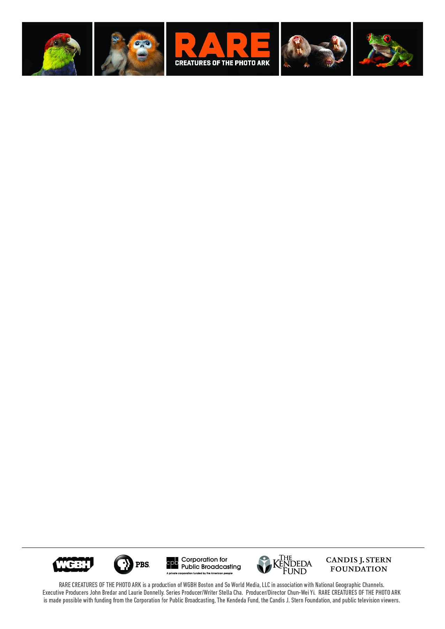

Renowned Photographer Joel Sartore Travels the Globe to Create the Photo Ark

Documenting Every Species in the World’s Zoos and Wildlife Sanctuaries

RARE — Creatures of the Photo Ark

Three-Part Series Premieres July 18, July 25 and August 1 at 9 pm ET/8c on PBS

BOSTON, MA [June 28, 2017] – Renowned National Geographic photographer Joel Sartore is a natural-born storyteller. His Photo Ark project is a digital “collection” of the world’s mammals, fish, amphibians, birds, reptiles and insects, and the focus of RARE—Creatures of the Photo Ark. This captivating new three-part series, produced by WGBH Boston and premiering on PBS in Summer 2017, follows Sartore as he documents threatened species at zoos, in nature preserves, and more. Throughout RARE, scientists and naturalists reveal surprising and important information about why ensuring the future of these animals is so critical. Follow Sartore’s adventures at #RarePBS.

RARE—Creatures of the Photo Ark premieres on consecutive Tuesdays—on July 18, July 25 and August 1—at 9 pm ET/8c on PBS.

Author, conservationist and National Geographic Fellow, Sartore has traveled to nearly 40 countries to photograph 6,395 species for the Photo Ark to date, including 576 amphibians, 1,839 birds, 716 fish, 1,123 invertebrates, 896 mammals, and 1,245 reptiles in captivity. When complete the Photo Ark will be one of the most comprehensive records of the world’s biodiversity. Through RARE, audiences can journey with Sartore across the globe—to Africa, Asia, Europe, North America, and Oceania—to chronicle his experiences.

“Viewers will see the spectacular variety and beauty of these animals, large and small, whose lives are intertwined with ours,” said John Bredar, executive producer of RARE and VP of National Programming for WGBH. “The loss of biodiversity exacts a toll on all our lives.”

In the premiere episode of RARE, prankish semi-habituated lemurs playfully crawl over Sartore at Madagascar’s Lemur Island rehab center, during one of his easiest photography shoots. Others are more challenging: as no amount of tasty, tempting raw carrots can persuade a 500-pound, 150-year-old giant tortoise to stand on his mark or get ready for his close-up. Likewise, in Florida, a photo of an elusive bunny taking refuge near an active U.S. Navy airstrip has taken four years to procure for the Photo Ark. It’s all in a day’s work….

Sartore knows he is in a race against time. Sometimes he is able to photograph 30 to 40 species in a few days. Others are disappearing before he can get to them. RARE looks at factors driving extinction, including deforestation, rising sea levels, invasive species, pollution and human development, all impacting creatures essential to the world’s ecosystems.

“RARE provides audiences the opportunity to follow in the footsteps of an exceptional photographer with an extraordinary mission. We share Joel's goal that through his photography and these films, people will be inspired to care while there is time,” says Laurie Donnelly, executive producer of RARE and director of Lifestyle Programming at WGBH, where she has overseen series such as I’ll Have What Phil’s Having and Sacred Journeys with Bruce Feiler.

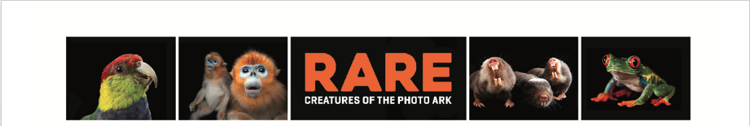

In the second hour, Sartore travels around the globe in pursuit of some of the rarest and most vulnerable creatures on earth—trying to capture these species for the Photo Ark before they go extinct. In China, he goes in search of the Yangtze giant softshell turtle, with just three left on the planet, and the South China tiger, which has not been seen in the wild for more than 30 years. In Spain, he photographs one of the rarest small cats, the Iberian lynx, whose numbers fell to fewer than a hundred 15 years ago, then he heads to Africa to the mountain rainforest of Cameroon to accompany scientists working on the frontlines to save the cross river gorilla, the rarest gorilla on earth.

In RARE’s final episode, Sartore treks up a mountain in New Zealand to photograph the rowi kiwi, accompanying a naturalist to rescue its egg successfully. Without this intervention, there is only a five percent chance of survivability for this rare flightless bird.

But there are also losses: at the Dvur Kralove Zoo near Prague, in one of RARE’s most emotional moments, Sartore’s camera records a northern white rhino—a very old female and, at the time, one of only five left in the world. Now, only three remain.

Sartore likes photographing the smallest creatures for the Photo Ark because they’re often more important to the health of an ecosystem than the big ones, like the naked mole rat: blind, buck-toothed and hairless, it is also cancer-resistant—and scientists are researching why. And he has seen how photos can lead to change. His images of parrots in South America and koalas in Australia prompted local governments to protect them. In the U.S., coverage of the Photo Ark has helped to save the Florida grasshopper sparrow and the Salt Creek tiger beetle.

“Fifty percent of all animals are threatened with extinction, and it’s folly to think we can drive half of everything else to extinction but that people will be just fine,” says Sartore. “That’s why I created what’s now called the National Geographic Photo Ark. I hope seeing the images fills people with wonder and inspires them to want to protect these species.”

RARE is premiering in conjunction with an ongoing initiative by National Geographic, which is showcasing the Photo Ark project throughout 2017 on multiple platforms, including exhibitions around the world, two new books and digital features. Learn more at NatGeoPhotoArk.org.

RARE—Creatures of the Photo Ark is a production of WGBH Boston and So World Media, LLC in association with National Geographic Channels. Executive producers are John Bredar and Laurie Donnelly. Series producer/writer: Stella Cha. Producer/director: Chun-Wei Yi. RARE is made possible with funding from the Corporation for Public Broadcasting, The Kendeda Fund, the Candis J. Stern Foundation and public television viewers.

RARE – Creatures of the Photo Ark is part of “PBS Summer of Adventure,” taking viewers and their families on an adventure around the world this season. The lineup of history, science and natural history programming includes the six-part series THE STORY OF CHINA, an exploration of China’s 4,000-year history featuring Michael Wood beginning June 20. The five-part program BIG PACIFIC, starting June 21, reveals the Pacific Ocean’s most guarded secrets. Following BIG PACIFIC on June 21, GREAT YELLOWSTONE THAW is a three-part series showcasing the stories of different animal families as they attempt to survive the toughest spring on Earth. On July 12, the three-part NATURE’S GREAT RACE explores the most astounding migrations on earth. WEEKEND IN HAVANA is a one-hour walking tour through Cuba on July 18. In WILD ALASKA LIVE, airing live over three nights beginning July 23, witness a must-see natural spectacle as thousands of the world’s wildest animals gather to take part in Alaska’s amazing summer feast. On August 2, IRELAND’S WILD COAST takes viewers on a one-hour journey along the island’s rugged Atlantic coast. Summer of Adventure will also include PBS KIDS programming, featuring three new one-hour specials: NATURE CAT: OCEAN COMMOTION (premieres June 19), WILD KRATTS ALASKA: HERO’S JOURNEY (premieres Monday, July 24.) and READY JET GO!: BACK TO BORTRON 7 (premieres August 14).
###

About WGBH
WGBH Boston is America’s preeminent public broadcaster and the largest producer of PBS content for TV and the Web, including Frontline, NOVA, American Experience, Masterpiece and Antiques Roadshow, as well as lifestyle and children’s series. WGBH also is a major supplier of programming for public radio, and a leader in educational multimedia for the classroom, supplying content to PBS LearningMedia. WGBH is a pioneer in technologies and services that make media accessible to those with hearing or visual impairments. More info at www.wgbh.org/.

About PBS
PBS, with nearly 350 member stations, offers all Americans the opportunity to explore new ideas and new worlds through television and digital content. Each month, PBS reaches nearly 100 million people through television and nearly 28 million people online, inviting them to experience the worlds of science, history, nature and public affairs; to hear diverse viewpoints; and to take front row seats to world-class drama and performances. PBS’ broad array of programs has been consistently honored by the industry’s most coveted award competitions. Teachers of children from pre-K through 12th grade turn to PBS for digital content and services that help bring classroom lessons to life. Decades of research confirms that PBS’ premier children’s media service, PBS KIDS, helps children build critical literacy, math and social-emotional skills, enabling them to find success in school and life. Delivered through member stations, PBS KIDS offers high-quality educational content on TV – including a new 24/7 channel, online at pbskids.org, via an array of mobile apps and in communities across America. More information about PBS is available at www.pbs.org, one of the leading dot-org websites on the internet, or by following PBS on Twitter, Facebook or through our apps for mobile and connected devices. Specific program information and updates for press are available at pbs.org/pressroom or by following PBS Pressroom on Twitter.

PR Contacts:
Eddie Ward Bara Levin
Roslan & Campion PR WGBH
212.966.4600 617.300.5391
eddie@rc-pr.com bara_levin@wgbh.org

© 2017 WGBH EDUCATIONAL FOUNDATION. ALL RIGHTS RESERVED.

