RENÉE FLEMING – CHRISTMAS IN NEW YORK
Premieres Thursday, December 4, 2014 (check local listings) on PBS

– The Celebrated Soprano Is Joined By Special Guests Kurt Elling, Kelli O’Hara,
Gregory Porter and Rufus Wainwright –

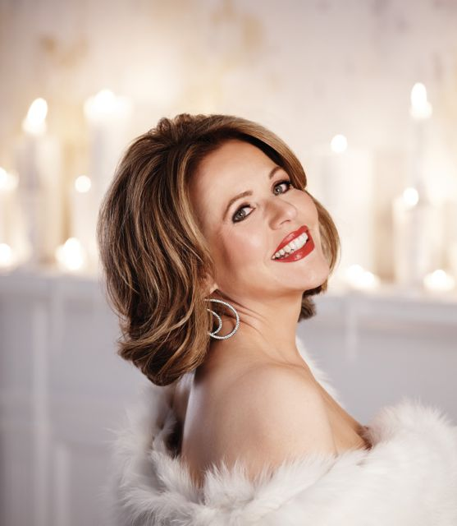
Renée Fleming
Credit: © Timothy White/Decca
American soprano Renée Fleming and special guests bring the magic of Christmas in New York to homes across America. The essence of the city during this most wonderful time of year is captured in a series of intimate and unique musical performances in a beautiful setting decorated for the holidays. Fleming performs popular seasonal favorites with Kurt Elling, Kelli O’Hara, Gregory Porter and Rufus Wainwright, and is joined by her daughters and sister to sing heartwarming Christmas carols. Guests discuss family, food, traditions and more, and scenes filmed around the city during the holidays make this an unforgettable musical experience. RENÉE FLEMING – CHRISTMAS IN NEW YORK premieres Thursday, December 4, 2014, 9:00-10:00 p.m. ET (check local listings) on PBS.

Backed by a who’s who of New York musicians, Renée and her guests perform beloved holiday songs, as well as “Central Park Serenade,” a new song from Diane Warren.

RENÉE FLEMING – CHRISTMAS IN NEW YORK features these selections:

- “The Christmas Waltz”
- “Still, Still, Still” (with Kurt Elling)
- “Winter Wonderland”
- “Silver Bells,” (with Kelli O’Hara)
- “Central Park Serenade” (with Gregory Porter)
- “In the Bleak Midwinter” (with Rufus Wainwright)
- “Have Yourself a Merry Little Christmas” (with Gregory Porter)
- Traditional holiday carols, featuring Renée’s sister and daughters

PBS special programming invites viewers to experience the worlds of science, history, nature and public affairs; hear diverse viewpoints; and take front-row seats to world-class drama and performances. Viewer contributions are an important source of funding, making PBS programs possible. PBS and public television stations offer all Americans from every walk of life the opportunity to explore new ideas and new worlds through television and online content.

Underwriters: Public Television Viewers and PBS
Producer: Universal Music Classics
Format: CC Stereo HD

- PBS –

CONTACT: O lga Makrias, Universal Music Classics, 212-333-1485; olga.makrias@umusic.com

For images and additional up-to-date information on this and other PBS programs, visit PBS PressRoom at pbs.org/pressroom.

