RETRO REPORT ON PBS
Premieres Monday-Tuesday, October 7 and 8, 2019

TCA Panelists

Celeste Headlee (Host) is an award-winning journalist who has appeared on NPR, PBS World, PRI, CNN, BBC and other international networks. In her 20-year career in public radio, she has been the Executive Producer of On Second Thought at Georgia Public Radio and anchored programs including Tell Me More, Talk of the Nation, All Things Considered and Weekend Edition. She also served as co-host of the national morning news show, The Takeaway, from PRI and WNYC, and anchored presidential coverage in 2012 for PBS World Channel.
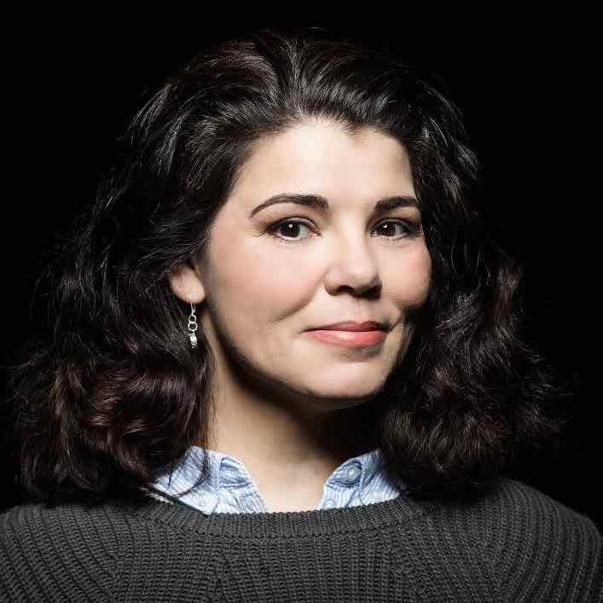

Celeste is the author of Heard Mentality and We Need To Talk: How To Have Conversations That Matter. She is also a professional speaker and her TEDx Talk, “Sharing 10 Ways to Have a Better Conversation,” has over 21 million total views to date. She co-hosted the Scene on Radio podcast – MEN. Her work and insights have been featured on TODAY, Psychology Today, Inc., NPR, Time, Essence, Elle, BuzzFeed, Salon, Parade and many more. For many years, Celeste has been a mentor and managing editor for NPR’s Next Generation Radio Project, training young reporters and editors in broadcasting.

Masud Olufani (Host) is an Atlanta-based multidisciplinary artist and actor. He is a graduate of Arts High School in Newark, New Jersey, Morehouse College and The Savannah College of Art and Design, where he earned an M.F.A. in sculpture in 2013. Masud has exhibited his work in group and solo shows in Atlanta; New Orleans; Chicago; Richmond; Lacoste, France; and Hong Kong. He has completed residencies at The Vermont Studio Center, SCAD Alumni Artist in Residence Program, The Hambidge Center for Arts and Sciences in Rabun, Georgia, and Creative Currents in Portobello, Panama. He is a 2017 Southern Arts Prize State Fellow for Georgia; a recipient of 2018 and 2015 Idea Capital Grants; a Southwest Airlines Art and Social Engagement grant; and a 2015-16 MOCA GA Working Artist Project Grant, and is a member of the 2014-15 class of the Walthall Fellows. He is the lead designer of Blocked at Five Points, a site-specific installation created to memorialize the enslaved Africans bought and sold at the Crawford Frazier Auction House, which once stood on the grounds of Atlanta’s Five Points MARTA station.
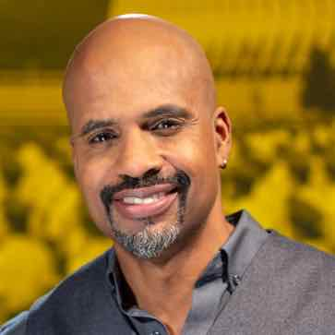

Andy Borowitz (Contributor) is a New York Times best-selling author and a comedian who has written for The New Yorker since 1998. In 2001, he created the Borowitz Report, a satirical news column that has millions of readers around the world, for which he won the first-ever National Press Club Award for Humor. The Borowitz Report was acquired by The New Yorker in 2012. He has published two recent best-selling books: The 50 Funniest American Writers, which became the first title in the history of the Library of America to make the Times best-seller list; and a memoir, An Unexpected Twist, a No. 1 best-seller, which Amazon named the Best Kindle Single of 2012. As a comedian, he has performed sold-out shows around the world and has made countless television and radio appearances on National Public Radio, VH1 and Comedy Central, among other places. He has been called a “Swiftian satirist” (the Wall Street Journal), “America’s satire king” (the Daily Beast), “the funniest human on Twitter” (the Times) and “one of the funniest people in America” (CBS News’ “Sunday Morning”).
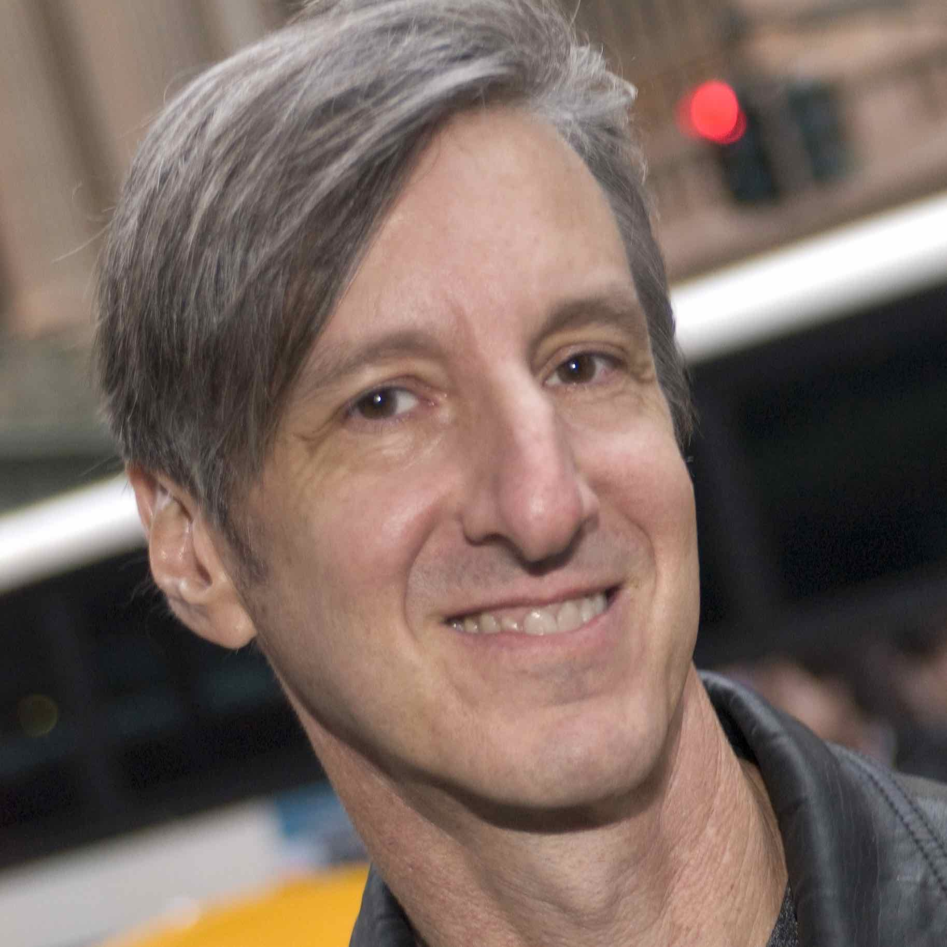

Kyra Darnton (Executive Producer) is a veteran producer from CBS News, 60 Minutes, where she produced stories covering a wide range of topics, including the Mexican drug war, counterfeit prescription drugs and the coverup in the death of U.S. Ranger Pat Tillman. Her investigative reporting and storytelling have won multiple awards, including a 2012 Peabody Award for a piece exposing fraud in cancer clinical trials. At RETRO REPORT, she has executive produced videos repeatedly recognized by the Emmy Awards, the Gerald Loeb Awards, the Edward R. Murrow Awards, the Webby awards, the Society of American Business Editors and Writers and others. Kyra has worked in journalism for 25 years.
