PBS Presents RETURN TO THE WILD, Premiering Tuesday,
November 25, 2014 at 9:00 p.m. ET

Riveting Documentary Includes New Details Behind Famous Case, Including Never-Before-Seen Letters, New Interviews with Family Members

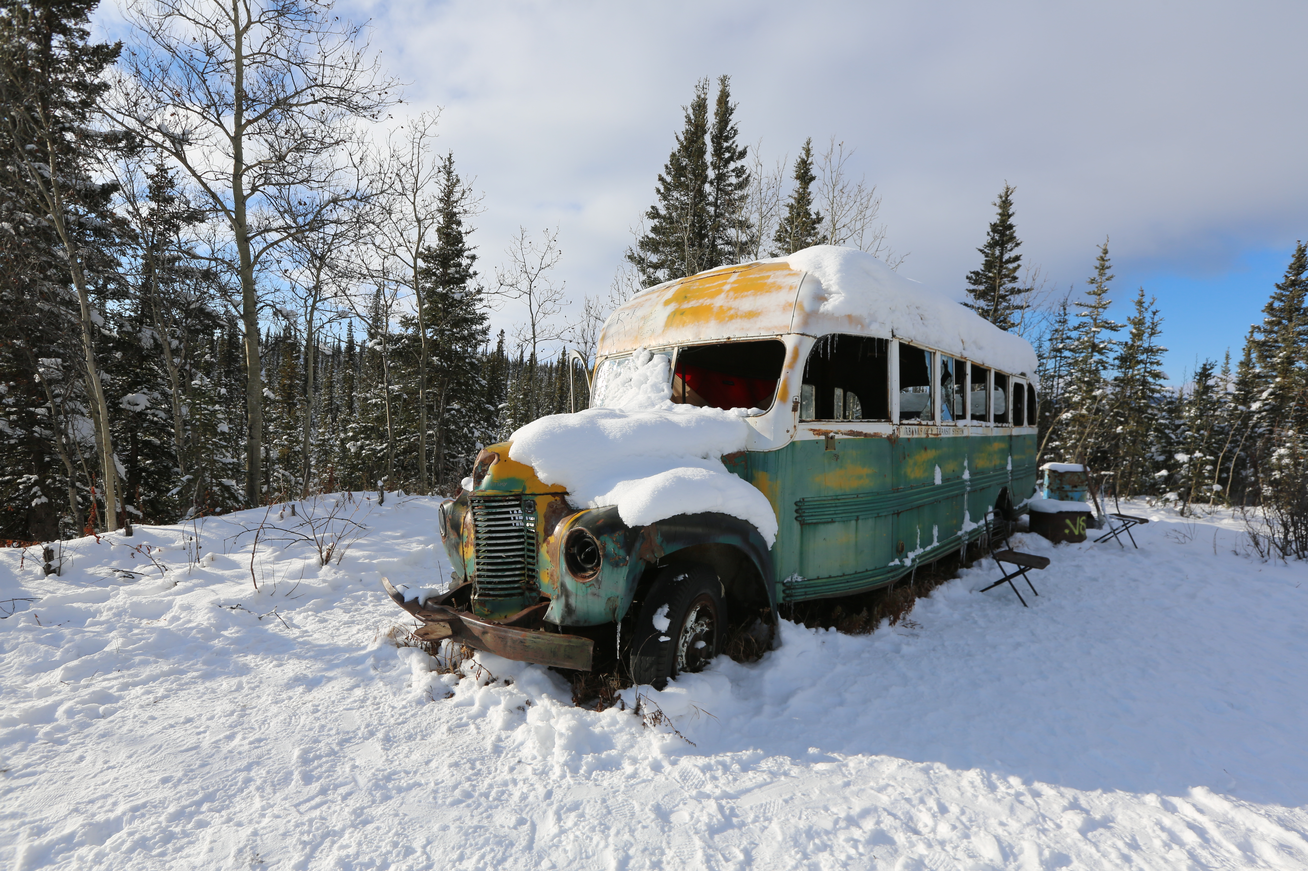
Caption: The Bus in Alaska. Credit: Andrew Wegst/Coneflower Studios

ARLINGTON, VA; November 21, 2014 – PBS presents RETURN TO THE WILD, a gripping documentary produced by Lincoln Square Productions in Association with Coneflower Studios for PBS about the life and death of a promising young man whose tragic end inspired the best-selling book and film “Into the Wild.” RETURN TO THE WILD premieres Tuesday, November 25, at 9:00 p.m. ET (check local listings). The documentary features new details about the mysterious case, including Chris McCandless’ own words in previously unreleased letters he wrote before he disappeared and died in Alaska.

Twenty years ago a young American hiker Chris McCandless, the accomplished son of successful middle-class parents, was found dead in an abandoned bus in the Alaskan wilderness. The documentary retraces McCandless’ steps, trying to understand why he severed all ties with his past, burnt or gave away all his money, changed his name, and hiked into the Denali Wilderness. McCandless’ own letters, released for the first time – plus new and surprising interviews – shed light on a private mystery that became a public obsession and continues to confound so many to this day.

“PBS is the only place for a sensitive and thoughtful revisit of this heartbreaking and forgotten mystery,” said Beth Hoppe, PBS’ Chief Programming Executive and General Manager of General Audience Programming. “RETURN TO THE WILD puts the story back the national spotlight, delivering unseen evidence and revelatory details to the forefront of a tragic story.”

Images and more information about RETURN TO THE WILD are available here.

About Lincoln Square Productions:
Lincoln Square Productions produces original content for broadcast, cable and digital distribution specializing in entertaining ways to tell fact based stories. Clients include ABC Television Group, Scripps Networks, Viacom, Discovery Communications, National Geographic Networks, and more. Lincoln Square Productions is a wholly owned subsidiary of American Broadcasting Companies, Inc. The headquarters are located in New York City.

About PBS
PBS, with its nearly 360 member stations, offers all Americans the opportunity to explore new ideas and new worlds through television and online content. Each month, PBS reaches nearly 123 million people through television and more than 21 million people online, inviting them to experience the worlds of science, history, nature and public affairs; to hear diverse viewpoints; and to take front row seats to world-class drama and performances. PBS’ broad array of programs has been consistently honored by the industry’s most coveted award competitions. Teachers of children from pre-K through 12th grade turn to PBS for digital content and services that help bring classroom lessons to life. PBS’ premier children’s TV programming and its website, pbskids.org, are parents’ and teachers’ most trusted partners in inspiring and nurturing curiosity and love of learning in children. More information about PBS is available at www.pbs.org, one of the leading dot-org websites on the Internet, or by following PBS on Twitter, Facebook or through our apps for mobile devices. Specific program information and updates for press are available at pbs.org/pressroom or by following PBS Pressroom on Twitter.

– PBS –

CONTACTS:
Jennifer Rankin Byrne, PBS, Tel.: 703-739-5487; JRByrne@pbs.org
Liane Ramirez/Roberta Lee, Goodman Media, Tel.: 212-576-2700; PBSprogramming@goodmanmedia.com

For images and additional up-to-date information on this and other PBS programs, visit PBS PressRoom at pbs.org/pressroom.

