RICKOVER: THE BIRTH OF NUCLEAR POWER
Tuesday, December 9, 2014
8:00-10:00 p.m. ET on PBS

– The Story of the Man Who Harnessed Atomic Power to Drive the First Nuclear-Powered Submarine –

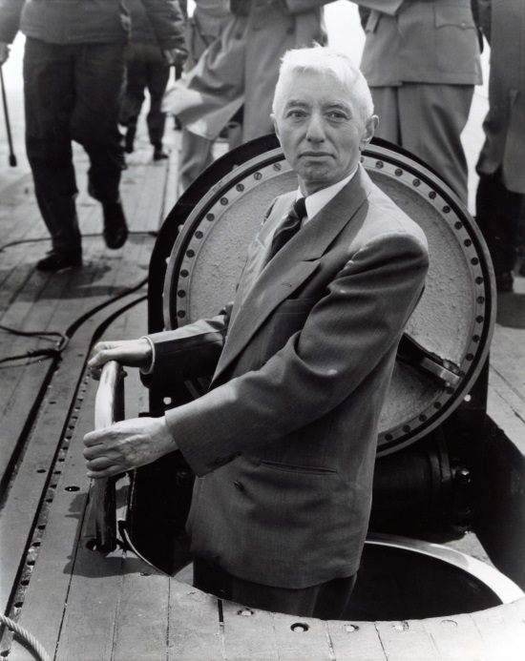
Admiral Rickover emerging from below-decks on the USS Nautilus.
Credit: Courtesy of Norman Polmar
Combative, provocative and searingly blunt, Admiral Hyman G. Rickover was a flamboyant maverick, a unique American hero. Unafraid to buck the system, he alienated Navy brass, yet inspired the men under him.

RICKOVER: THE BIRTH OF NUCLEAR POWER, a profile of the man who created the nuclear navy, as well as the civilian nuclear power industry, airs Tuesday, December 9, 2014, 8:00-10:00 p.m. ET on PBS.

When few thought it possible, then-Captain Rickover undertook a quest to harness the fearsome power of the atom to drive the first nuclear-powered submarine, the USS Nautilus, whose trip under the polar ice pack was one of the great adventure stories of the 1950s. Later, Rickover built the world’s first commercial nuclear power plant at Shippingport, Pennsylvania. Rickover’s achievements made him into a national celebrity — he appeared on the cover of Time magazine.

Many questioned Rickover’s goal of a nuclear navy, with its high price tag and unknown risks. Others questioned his methods — his arrogant, high-handed behavior and his creation of a technocratic elite, his own navy within the Navy. However, few contested that he had transformed the Navy and much of U.S. industry and changed the course of America’s technological development.

Today, questions about nuclear power have risen again, as we seek alternatives to fossil fuels and try to lower our carbon footprint. Many wonder whether America can maintain its technological pre-eminence and whether we can still build and manage large-scale projects. To understand these issues, RICKOVER: THE BIRTH OF NUCLEAR POWER considers the story of the man who created the nuclear navy, as well as the civilian nuclear power industry.

The program’s distinguished Board of Advisors includes Admiral Bruce DeMars, USN (Ret); Richard Hewlett and Richard Rhodes. The documentary is funded, in part, by Alfred P. Sloan Foundation, The Arthur Vining Davis Foundations, Bechtel Corporation and MPR Associates, Inc.

Michael Pack, producer/director, serves as president of Manifold Productions, Inc., an independent film and television production company he founded in 1977. Major television credits include GOD AND THE INNER CITY, narrated by Phylicia Rashad (2003), REDISCOVERING GEORGE WASHINGTON, hosted by Richard Brookhiser (2002), THE FALL OF NEWT GINGRICH, narrated by Blair Brown (2000) and others. All have been nationally broadcast on PBS. Pack also served as Senior Vice President for Television Programming at the Corporation for Public Broadcasting, and Director of Worldnet at the U.S. Information Agency. Pack’s most recent film Rediscovering Alexander Hamilton, hosted by Richard Brookhiser, was broadcast nationally via PBS in 2011; the Los Angeles Times called it “history with a high-octane kick” and the Washington Post praised its “surprising, relevant, and entertaining insights.” Pack also recently completed The Last 600 Meters, which tells the story of the battles of Najaf and Fallujah in Iraq in 2004. The film will be broadcast by PBS following a theatrical release.

Theodore Rockwell, executive producer, has been directly involved in nuclear power for more than 65 years. In 1949, then-Captain Hyman Rickover hired him to help develop designs, procedures and facilities for safe operation of nuclear-powered naval vessels and the world’s first commercial central station nuclear power plant. As the program’s technical director, he went out on initial sea trials of most new ships. In 1964 he left with two colleagues to set up the international engineering firm MPR Associates, Inc. He was given Distinguished Service Medals by the Navy and the US Atomic Energy Commission and the first “Lifetime Contribution Award,” henceforth known as the “Rockwell Award,” by the American Nuclear Society. He is author of The Rickover Effect: How One Man Made a Difference (Naval Institute Press, 1992) and other books and articles.

Stephen K. Bannon, executive producer, has over 20 years’ experience working with media and entertainment companies. A former Goldman Sachs investment banker, Bannon is currently the Chairman of the Board of several publicly-traded and privately-held companies, including Genius Products, Inc., one of the largest companies in the home entertainment industry. Bannon, an award-winning filmmaker, directed and co-wrote the critically acclaimed In The Face of Evil: Reagan’s War in Word, winning a 2004 Liberty Film Festival Award for Best Feature Film and Best Feature Film of the American Film Renaissance 2004 Festival. It is the only film to ever win both awards. From 1976 to 1983, Bannon served as a Surface Warfare Officer in the United States Navy and as Special Assistant to the Chief of Naval Operations in the Pentagon during President Reagan’s first term. Bannon received his MBA with honors from Harvard Business School in 1985.

Gina Cappo Pack, executive producer, serves as vice president of Manifold Productions, Inc. and has worked on a variety of Manifold projects since 1987, through fundraising, promotion and as an executive producer. Her background is in corporate management, marketing and personnel.

Dan Curl, associate producer, has worked on numerous high-profile programs such as “Wretches & Jabberers” (theatrical release), “Just Add SPICE: Parenting for Happy Healthy Kids” (PBS Kids), “20 Ways Your Home Can Save the Planet” (HGTV) and “Stories From the Road,” a web series designed to raise awareness about autism. In 2011, Curl earned his MFA in Film and Electronic Media from American University.

– PBS –

For images and additional up-to-date information on this and other PBS programs, visit PBS PressRoom at pbs.org/pressroom.

