Ride The Tiger: A Guide Through The Bipolar Brain
from Detroit Public Television
April 6, 2016 at 10 p.m. ET on PBS

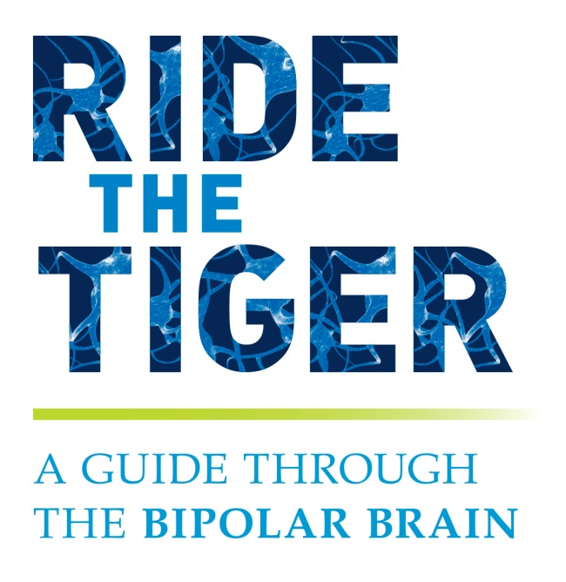
DETROIT (January 20, 2016) – The reality of bipolar disorder is hard to fathom: five and a half million Americans have been diagnosed with the disorder and yet so little is known about how the illness manifests itself in our brains. Coming April 6, 2016 from Detroit Public Television (DPTV) and airing on PBS stations nationwide is Ride the Tiger, a one-hour documentary that tells the story of highly accomplished individuals—congressmen, attorneys, pastors, authors, and stay-at-home moms, who have been diagnosed as bipolar.

Narrated by David Ogden Stiers (American Experience), co-written by National Book award-winning author, Andrew Solomon (The Noonday Demon) and directed by duPont-Columbia award-winner, Ed Moore, the documentary seeks to find out where the biological breakdowns occur and how we can possibly pre-empt, fix or rewire our brains back to recovery.

“The popular headline we keep hearing today is ‘Rewire your brain for happiness,” said Ed Moore Executive Producer, National Documentary Unit. And while it’s not that simple for those with severe mental illness, there is some truth to it—that the brain is far more malleable than we ever knew. And researchers are just now starting to understand how that works and how it could be harnessed for future treatments.”

Most importantly, Ride The Tiger is designed to subvert stereotypes about people with mood disorders by raising awareness, reducing stigmas, and improving the lives of those affected by disorders such as bipolar. The film weaves together brave and compelling stories of people with mood disorders with a new narrative of scientists and scholars on the cusp of discovery. It explores questions and connections that are spurring four scientific disciplines of mental health research: genetics, the brain, treatment, and basic science.

Among the people featured in the film are: Patrick Kennedy, former member of the U.S. House of Representatives who most notably fought the battle to end medical and societal discrimination against a variety of mental illnesses; Patty Duke – Oscar and Emmy award winning actress diagnosed with bipolar disorder in the early 1980s; Terri Cheney, former entertainment attorney in Beverly Hills who represented the likes of Michael Jackson, Quincy Jones, and major motion picture studios; and Ellen Forney talented cartoonist and award winning author. Several of her books have been New York Times bestsellers including Marbles: Mania, Depression, Michelangelo and Me. Kay Redfield Jamison – bestselling author of the groundbreaking book on bipolar disorder, An Unquiet Mind and Professor of Psychiatry at Johns Hopkins.

Experts featured in the film include:
Dr. Thomas Insel, a neuroscientist and psychiatrist best known for his leadership of the National Institute of Mental Health and prior work as the Director of the Center for Behavioral Neuroscience at Emory University in Atlanta; Dr. Paul Keck: A scientist, author, and CEO whose research is greatly focused on bipolar disorder and psychopharmacology and has led to over 500 scientific journals, various text book contributions, and numerous honors; Dr. Karl Deisseroth, a professor, researcher, and technological innovator who is both the D.H. Chen Professor of Bioengineering and of Psychiatry and Behavioral Sciences at Stanford University; and Dr. Helen Mayberg, a well-known neurologist trained at Columbia University’s Neurological Institute whose work as a neurologist led to the first ever study of deep brain stimulation. She began her DBS research at University of Toronto before moving on to Emory.

About Detroit Public Television
Detroit Public Television (DPTV) is the non-commercial, viewer-supported PBS-member station watched by more than 1.5 million people in Detroit and Southeast Michigan and another 1.2 million people throughout Canada. DPTV also manages WRCJ 90.9 FM, Detroit's classical and jazz radio station, in collaboration with the license-holder, the Detroit Public Schools. The radio station is located in the Detroit School of Arts. DPTV is licensed to the Detroit Educational Television Foundation and governed by a volunteer board of trustees from the local business, civic, and cultural communities.

About PBS
PBS, with its over 350 member stations, offers all Americans the opportunity to explore new ideas and new worlds through television and online content. Each month, PBS reaches nearly 109 million people through television and over 28 million people online, inviting them to experience the worlds of science, history, nature and public affairs; to hear diverse viewpoints; and to take front row seats to world-class drama and performances. PBS’ broad array of programs has been consistently honored by the industry’s most coveted award competitions. Teachers of children from pre-K through 12th grade turn to PBS for digital content and services that help bring classroom lessons to life. PBS’ premier children’s TV programming and its website, pbskids.org, are parents’ and teachers’ most trusted partners in inspiring and nurturing curiosity and love of learning in children. More information about PBS is available at www.pbs.org, one of the leading dot-org websites on the Internet, or by following PBS on Twitter, Facebook or through our apps for mobile devices. Specific program information and updates for press are available at pbs.org/pressroom or by following PBS PressRoom on Twitter.

– PBS –

CONTACTS: Della Cassia, Detroit Public Television, 248-305-3770 or dcassia@dptv.org

For images and additional up-to-date information on this and other PBS programs, visit PBS PressRoom at pbs.org/pressroom.

