PBS TO AIR KEN BURNS’S
“THE ROOSEVELTS: AN INTIMATE HISTORY” IN 2014

– First Documentary to Interlace the Stories of Theodore, Franklin and Eleanor Roosevelt–

– Meryl Streep, Paul Giamatti and Edward Herrmann Voice
Eleanor, Theodore and Franklin Roosevelt –

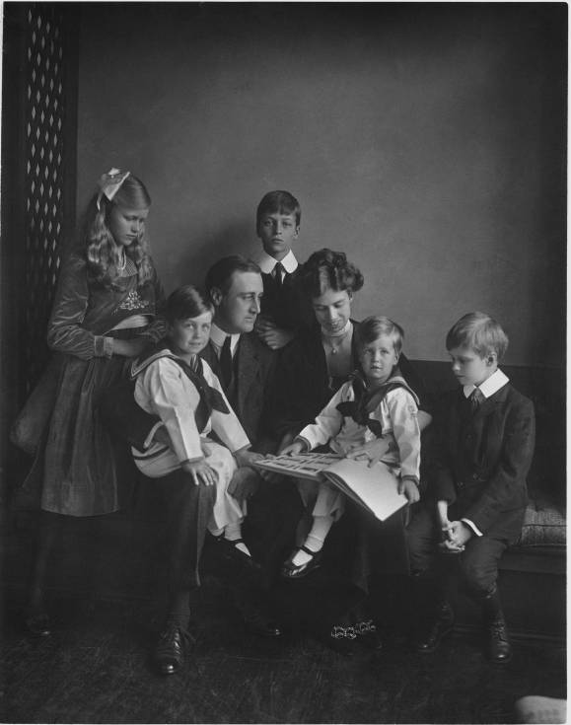
Franklin and Eleanor Roosevelt with their children in Washington, DC, June 12, 1919.
Credit: Franklin D. Roosevelt Presidential Library, Hyde Park, NY
LOS ANGELES, CA; JULY 21, 2012 -- PBS announced today that THE ROOSEVELTS: AN INTIMATE HISTORY, a new seven-part, 14-hour documentary by Ken Burns, will air in 2014 on PBS. The film weaves the stories of Theodore, Franklin and Eleanor Roosevelt, three members of one of the most prominent and influential families in American politics. The series marks the first time their individual stories have been woven into a single narrative.

“The Roosevelts have played significant roles in other stories we’ve told before, from the National Parks to World War II,” said Burns. “It’s impossible, in fact, to visit many parts of the American experience without encountering their presence. But beyond simply sharing a bloodline or political success, they each shared a passionate belief that America is at its strongest when everyone has an equal chance. And on a personal level, they each struggled to overcome their own fears while maintaining a public face of courage.”

THE ROOSEVELTS follows the family’s story for more than a century, from Theodore’s birth in 1858 to Eleanor’s death in 1962. Over the course of those years, Theodore would become the 26th president of the United States, and his beloved niece, Eleanor, would marry his fifth cousin, Franklin, who became the 32nd president. Together, they redefined the relationship Americans had with their government and with each other, and redefined, as well, the role of the United States within the wider world. The series encompasses all the history the Roosevelts helped to make — the creation of National Parks and the digging of the Panama Canal, the New Deal and the defeat of Hitler, and the postwar struggles for civil rights at home and human rights around the world in which Eleanor Roosevelt played a central role. But it is also an intimate human story about love and betrayal, family feeling and personal courage and the conquest of fear.

“In THE ROOSEVELTS, Ken delves into these three larger-than-life figures in a way that’s never been done before, exploring not only the characteristics that made them such tremendously influential and strong leaders, but also their interpersonal relationships and human, vulnerable qualities,” said Paula Kerger, president and CEO of PBS. “It’s a wonderful story and we’re very excited to present it to our viewers.”

Legendary actress Meryl Streep portrays Eleanor Roosevelt in readings from her personal letters and writings. Of her performance, Burns said, “As we’ve seen time and time again, Ms. Streep is a magician. Here, she completely transformed herself into Eleanor Roosevelt, simply through her voice. It was remarkable to witness. The entire cast delivers what I consider to be some of the finest voice-over work we’ve ever been fortunate enough to present.”

Joining Streep are Paul Giamatti as the voice of Theodore Roosevelt and Edward Herrmann, two-time Emmy Award nominee for his performance as Franklin Roosevelt, as the voice of FDR.

Rounding out the cast are Patricia Clarkson, Adam Arkin, Philip Bosco, Keith Carradine, Kevin Conway, Ed Harris, John Lithgow, Josh Lucas, Carl Lumbly, Amy Madigan, Carolyn McCormick, Pamela Reed, Billy Bob Thornton and Eli Wallach.

THE ROOSEVELTS is written by longtime Burns collaborator Geoffrey C. Ward, who is an authority on Franklin Roosevelt. The author of two biographical volumes, A First-Class Temperament and Before the Trumpet, he is also the editor of Closest Companion, which revealed for the first time Roosevelt’s close friendship with his distant cousin, Daisy Suckley. Ward’s interest in FDR grew in part from the fact that he, like FDR, is a polio survivor.

In addition to THE ROOSEVELTS, Burns’s THE DUST BOWL will air on PBS on November 18 and 19, 2012. THE CENTRAL PARK FIVE, which recently premiered at the Cannes Film Festival, will air in 2013 or 2014.

Funding is provided by Bank of America; Corporation for Public Broadcasting; Mr. Jack C. Taylor; The Arthur Vining Davis Foundations; National Endowment for the Humanities; Rosalind P. Walter; Public Broadcasting Service and members of The Better Angels Society, including Jessica & John Fullerton; The Pfeil Foundation – David, Mindy, Robert & Daniel Pfeil; Joan Wellhouse Newton; Bonnie & Tom McCloskey; and The Golkin Family.

THE ROOSEVELTS: AN INTIMATE HISTORY is a production of Florentine Films and WETA, Washington, DC. Director: Ken Burns. Writer: Geoffrey C. Ward. Producers: Ken Burns, Paul Barnes and Pam Tubridy-Baucom. Editors: Paul Barnes, Tricia Reidy and Erik Ewers. Cinematographers: Buddy Squires and Alan Moore.

About PBS
PBS, with its nearly 360 member stations, offers all Americans the opportunity to explore new ideas and new worlds through television and online content. Each month, PBS reaches nearly 123 million people through television and more than 21 million people online, inviting them to experience the worlds of science, history, nature and public affairs; to hear diverse viewpoints; and to take front row seats to world-class drama and performances. PBS’ broad array of programs has been consistently honored by the industry’s most coveted award competitions. Teachers of children from pre-K through 12th grade turn to PBS for digital content and services that help bring classroom lessons to life. PBS’ premier children’s TV programming and its website, pbskids.org, are parents’ and teachers’ most trusted partners in inspiring and nurturing curiosity and love of learning in children. More information about PBS is available at www.pbs.org, one of the leading dot-org websites on the Internet, or by following PBS on Twitter, Facebook or through our apps for mobile devices. Specific program information and updates for press are available at pbs.org/pressroom or by following PBS Pressroom on Twitter.

About WETA
WETA Washington, DC, is the third-largest producing station for public television. WETA’s other productions and co-productions include PBS NEWSHOUR, WASHINGTON WEEK WITH GWEN IFILL AND NATIONAL JOURNAL, THE KENNEDY CENTER MARK TWAIN PRIZE, IN PERFORMANCE AT THE WHITE HOUSE, THE LIBRARY OF CONGRESS GERSHWIN PRIZE FOR POPULAR SONG and documentaries by filmmaker Ken Burns, including THE CIVIL WAR, THE WAR, THE NATIONAL PARKS: AMERICA’S BEST IDEA, THE TENTH INNING and PROHIBITION. More information on WETA and its programs and services is available at www.weta.org.

– PBS –

CONTACTS:
Dave Donovan/Brian Moriarty, Dan Klores Communications (DKC), 212-685-4300; dave_donovan@dkcnews.com, brian_moriarty@dkcnews.com

For images and additional up-to-date information on this and other PBS programs, visit PBS PressRoom at pbs.org/pressroom.

