PBS Station Sites to Stream Ken Burns’s THE ROOSEVELTS in its Entirety Starting Day after Broadcast Premiere
– 14-Hour Epic of American Political Dynasty Premieres Sunday, September 14th
and Runs Seven Consecutive Nights on PBS –
– Available on all PBS Station Websites and PBS Station Branded Digital Sites after Broadcast Premiere –
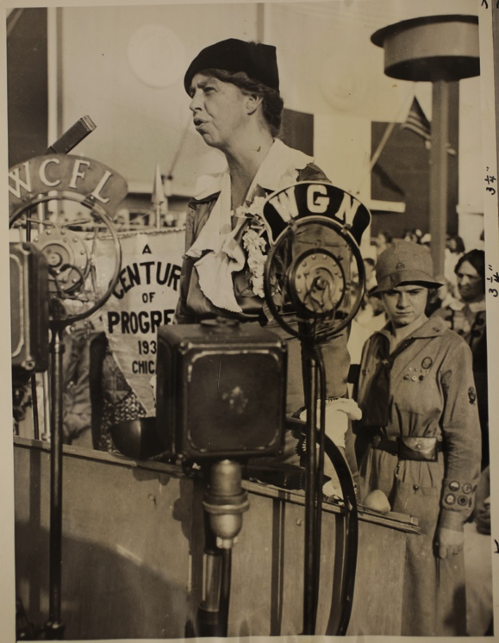
First Lady Eleanor Roosevelt speaking on Women's Day at the Chicago World's Fair, 1933 (Credit: Franklin D. Roosevelt Presidential Library, Hyde Park, NY)

BEVERLY HILLS, CA; July 22, 2014 -- Ken Burns’s upcoming film, THE ROOSEVELTS: AN INTIMATE HISTORY, marks the first time the Roosevelts’ individual stories have been woven into a single narrative, following the family’s story for more than a century, from Theodore’s birth in 1858 to Eleanor’s death in 1962. Over the course of those years, Theodore would become the 26th president of the United States and his beloved niece, Eleanor, would marry her fifth cousin, Franklin, who became the 32nd president. Together, they redefined the relationship Americans had with their government and with each other, and redefined, as well, the role of the United States within the wider world.

The first 2-hour episode will premiere on PBS stations, Sunday, September 14th (8:00 p.m. ET) and the entire series can be streamed on station websites and PBS station branded digital sites beginning the day after the broadcast premiere.

THE ROOSEVELTS is written by long-time Burns collaborator Geoffrey C. Ward, who is an authority on Franklin Roosevelt. The author of two biographical volumes, A First-Class Temperament and Before the Trumpet, he is also the editor of Closest Companion, which revealed for the first time Roosevelt’s close friendship with his distant cousin, Daisy Suckley. Ward’s interest in FDR grew in part from the fact that he, like FDR, is a polio survivor.

“THE ROOSEVELTS is Ken Burns at his best. This is a family history that is a sweeping drama, rich with stories of personal and political power, sex, love and death,” said Beth Hoppe, PBS Chief Programming Executive and General Manager, General Audience Programming. “We have worked together with PBS member stations to accommodate a wide-range of viewing and recording habits, including special opportunities for viewers who like to ‘epic binge.’ Through these efforts, we hope to connect even more viewers with the film and our PBS member stations.”

The first episode of THE ROOSEVELTS will premiere on Sunday, September 14th from 8:00 to 10:00 p.m. (ET) and run for seven consecutive nights. In addition, each episode will be repeated from 10:00 p.m. to 12:00 a.m. (ET) each night and will have a weekend, daytime marathon September 20th and 21st. An additional repeat is planned in spring 2015.

Beginning on Monday, September 15th, the entire 14 hours will be available online to stream through PBS stations’ video sites, pbs.org/theroosevelts, and PBS station branded digital platforms, including, ROKU, Apple TV and Xbox, and will be available for two weeks, through September 29th.

To support the film, WETA, the Washington, D.C. public television station that produces Burns’s films, in partnership with PBS and others, will create an ambitious educational engagement campaign that utilizes the stories of the Roosevelts to engage students — and all Americans — in better understanding some of the most critical periods of history of the 20th century.

THE ROOSEVELTS will also be available on DVD and Blu-ray September 16, 2014. The DVD and Blu-ray include special features — 13 bonus videos, making of THE ROOSEVELTS and deleted scenes with an introduction by Ken Burns. This film will also be available for digital download on iTunes, Amazon, GooglePlay, Vudu, Xbox, Target Ticket and Nook.

Funding is provided by Bank of America; Corporation for Public Broadcasting; Mr. Jack C. Taylor; The Arthur Vining Davis Foundations; National Endowment for the Humanities; Rosalind P. Walter; Public Broadcasting Service and members of The Better Angels Society, including Jessica & John Fullerton; The Pfeil Foundation – David, Mindy, Robert & Daniel Pfeil; Joan Wellhouse Newton; Bonnie & Tom McCloskey; and The Golkin Family.

THE ROOSEVELTS: AN INTIMATE HISTORY is a production of Florentine Films and WETA, Washington, DC. Director: Ken Burns. Writer: Geoffrey C. Ward. Producers: Ken Burns, Paul Barnes and Pam Tubridy-Baucom. Editors: Paul Barnes, Tricia Reidy and Erik Ewers. Cinematographers: Buddy Squires and Alan Moore.

About PBS
PBS, with its more than 350 member stations, offers all Americans the opportunity to explore new ideas and new worlds through television and online content. Each month, PBS reaches nearly 109 million people through television and more than 28 million people online, inviting them to experience the worlds of science, history, nature and public affairs; to hear diverse viewpoints; and to take front row seats to world-class drama and performances. PBS’ broad array of programs has been consistently honored by the industry’s most coveted award competitions. Teachers of children from pre-K through 12th grade turn to PBS for digital content and services that help bring classroom lessons to life. PBS’ premier children’s TV programming and its website, pbskids.org, are parents’ and teachers’ most trusted partners in inspiring and nurturing curiosity and love of learning in children. More information about PBS is available at www.pbs.org, one of the leading dot-org websites on the Internet, or by following PBS on Twitter, Facebook or through our apps for mobile devices. Specific program information and updates for press are available at pbs.org/pressroom or by following PBS Pressroom on Twitter.

About WETA
WETA Washington, DC, is the third-largest producing station for public television. WETA’s other productions and co-productions include PBS NEWSHOUR, WASHINGTON WEEK WITH GWEN IFILL, THE KENNEDY CENTER MARK TWAIN PRIZE, IN PERFORMANCE AT THE WHITE HOUSE, THE LIBRARY OF CONGRESS GERSHWIN PRIZE FOR POPULAR SONG and documentaries by filmmaker Ken Burns, including THE CIVIL WAR, THE WAR, THE NATIONAL PARKS: AMERICA’S BEST IDEA, THE TENTH INNING and PROHIBITION. More information on WETA and its programs and services is available at www.weta.org.

– PBS –
CONTACT:
Brian Moriarty, DKC Communications, 212-685-4300; brian_moriarty@dkcnews.com
Carrie Johnson, PBS, 703-739-5129; cjohnson@pbs.org

For images and additional up-to-date information on this and other PBS programs, visit PBS PressRoom at pbs.org/pressroom.

