PBS TO AIR KEN BURNS’S “THE ROOSEVELTS: AN INTIMATE HISTORY” BEGINNING SEPTEMBER 14, 2014

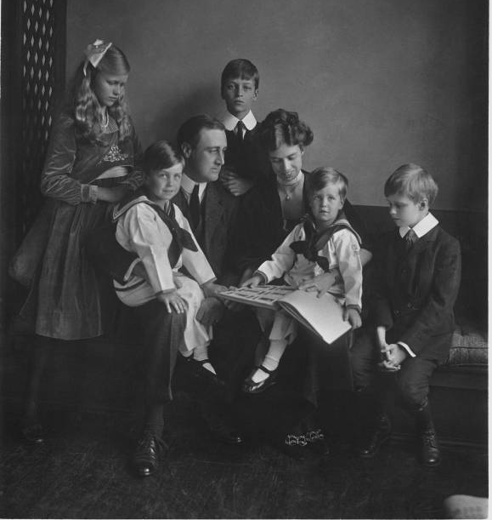
Franklin and Eleanor Roosevelt with their children in Washington, DC, June 12, 1919.
Credit: Franklin D. Roosevelt Presidential Library, Hyde Park, NY
THE ROOSEVELTS: AN INTIMATE HISTORY, a new seven-part, 14-hour documentary by Ken Burns, will air for seven consecutive nights beginning Sunday, September 14, 2014, on PBS. The film weaves the stories of Theodore, Franklin and Eleanor Roosevelt, three members of one of the most prominent and influential families in American politics. The series marks the first time their individual stories have been woven into a single narrative.

THE ROOSEVELTS follows the family’s story for more than a century, from Theodore’s birth in 1858 to Eleanor’s death in 1962. Over the course of those years, Theodore would become the 26th president of the United States, and his beloved niece, Eleanor, would marry his fifth cousin, Franklin, who became the 32nd president. Together, they redefined the relationship Americans had with their government and with each other, and redefined, as well, the role of the United States within the wider world. The series encompasses all the history the Roosevelts helped to make — the creation of National Parks and the digging of the Panama Canal, the New Deal and the defeat of Hitler, and the postwar struggles for civil rights at home and human rights around the world in which Eleanor Roosevelt played a central role. But it is also an intimate human story about love and betrayal, family feeling and personal courage and the conquest of fear.

In addition to the PBS broadcast beginning September 14, THE ROOSEVELTS will be available to viewers in its entirety on multiple digital platforms, including the PBS Video Portal, OTT devices such as Xbox, Roku and Apple TV, the PBS mobile apps for iPhone, iPhone and iPad Touch and on digital media stores such as iTunes, Amazon Instant Video, Google Play and Vudu. Episodes will be available on-demand beginning the morning after the broadcast and for the following two weeks.

Legendary actress Meryl Streep portrays Eleanor Roosevelt in readings from her personal letters and writings. Joining Streep are Paul Giamatti as the voice of Theodore Roosevelt and Edward Herrmann, two-time Emmy Award nominee for his performance as Franklin Roosevelt, as the voice of FDR. Rounding out the cast are Patricia Clarkson, Adam Arkin, Philip Bosco, Keith Carradine, Kevin Conway, Ed Harris, John Lithgow, Josh Lucas, Carl Lumbly, Amy Madigan, Carolyn McCormick, Pamela Reed, Billy Bob Thornton and the late Eli Wallach.

Follow Ken Burns on Twitter at @KenBurns. Join the conversation about the film with #RooseveltsPBS.

Funding is provided by Bank of America; Corporation for Public Broadcasting; Public Broadcasting Service; Mr. Jack C. Taylor; The Arthur Vining Davis Foundations; National Endowment for the Humanities; Rosalind P. Walter and members of The Better Angels Society, including Jessica & John Fullerton; The Pfeil Foundation; Joan Wellhouse Newton; Bonnie & Tom McCloskey; and The Golkin Family.

THE ROOSEVELTS: AN INTIMATE HISTORY is a production of Florentine Films and WETA, Washington, DC. Director: Ken Burns. Writer: Geoffrey C. Ward. Producers: Ken Burns, Paul Barnes and Pam Tubridy-Baucom. Editors: Paul Barnes, Tricia Reidy and Erik Ewers. Cinematographers: Buddy Squires and Alan Moore.

About PBS
PBS, with its more than 350 member stations, offers all Americans the opportunity to explore new ideas and new worlds through television and online content. Each month, PBS reaches nearly 109 million people through television and more than 28 million people online, inviting them to experience the worlds of science, history, nature and public affairs; to hear diverse viewpoints; and to take front row seats to world-class drama and performances. PBS’ broad array of programs has been consistently honored by the industry’s most coveted award competitions. Teachers of children from pre-K through 12th grade turn to PBS for digital content and services that help bring classroom lessons to life. PBS’ premier children’s TV programming and its website, pbskids.org, are parents’ and teachers’ most trusted partners in inspiring and nurturing curiosity and love of learning in children. More information about PBS is available at www.pbs.org, one of the leading dot-org websites on the Internet, or by following PBS on Twitter, Facebook or through our apps for mobile devices. Specific program information and updates for press are available at pbs.org/pressroom or by following PBS Pressroom on Twitter.

About WETA
WETA Washington, DC, is the third-largest producing station for public television. WETA’s other productions and co-productions include PBS NEWSHOUR, WASHINGTON WEEK WITH GWEN IFILL, THE KENNEDY CENTER MARK TWAIN PRIZE, IN PERFORMANCE AT THE WHITE HOUSE, THE LIBRARY OF CONGRESS GERSHWIN PRIZE FOR POPULAR SONG and documentaries by filmmaker Ken Burns, including THE CIVIL WAR, THE WAR, THE NATIONAL PARKS: AMERICA’S BEST IDEA, THE TENTH INNING and PROHIBITION. More information on WETA and its programs and services is available at www.weta.org.

– PBS –

CONTACT:
Dave Donovan/Brian Moriarty, Dan Klores Communications (DKC), 212-685-4300; dave_donovan@dkcnews.com/brian_moriarty@dkcnews.com

For images and additional up-to-date information on this and other PBS programs, visit PBS PressRoom at pbs.org/pressroom.

