PBS ANNOUNCES U.S. PREMIERE OF “ROYAL MEMORIES: PRINCE CHARLES’ TRIBUTE TO THE QUEEN”
September 2, 2012
8:00-9:00 p.m. ET on PBS

– Narrated by the Prince of Wales, Documentary Celebrates Queen Elizabeth’s Diamond Jubilee –

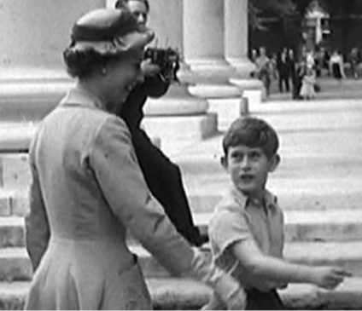
Queen Elizabeth and Prince Charles
Credit: © British Pathé
ARLINGTON, VA; JULY 26, 2012--PBS announced today that ROYAL MEMORIES: PRINCE CHARLES’ TRIBUTE TO THE QUEEN, which premiered to 10 million viewers in the UK as part of Queen Elizabeth’s Diamond Jubilee weekend, will air Sunday, September 2, 2012, 8:00-9:00 p.m. ET on PBS. In this touching, personal film, Charles, Prince of Wales reflects on Her Majesty’s 60-year reign — both as the nation’s queen and as his mother.

Providing a rare glimpse of the everyday private life of the royal family, Prince Charles narrates the documentary, adding his own insight and commentary to archival newsreels, never-before-seen home movies and previously unseen photographs from Her Majesty’s private collection. Included in the program is footage of a young Prince Charles and his sister Princess Anne on a family holiday — filmed by Queen Elizabeth herself.

“ROYAL MEMORIES: PRINCE CHARLES’ TRIBUTE TO THE QUEEN is a captivating documentary that gives viewers the extraordinary opportunity to see the royal family through the eyes of an insider,” said John Wilson, senior vice president & chief TV programming executive for PBS. “The unique commentary offered by the Prince of Wales makes this film about Queen Elizabeth unlike any other.”

ROYAL MEMORIES includes exclusive camera footage taken behind the scenes on Coronation day at Buckingham Palace, and clips of the family on board the Britannia, at the royal residence of Windsor Castle in Berkshire and on holiday at Balmoral Castle in Scotland. The result is a documentary that depicts Queen Elizabeth in her dual role as the Queen of England and as a loving mother, providing an unprecedented glimpse of the private life of the royal family throughout the monarch’s six-decade reign.

ROYAL MEMORIES continues PBS’ history of presenting acclaimed Brit-themed programs. During its “British Summer Holiday,” PBS presented the new series MICHAEL WOOD’S STORY OF ENGLAND and QUEEN AND COUNTRY, new episodes of MASTERPIECE MYSTERY!, including “Endeavour,” the back story of beloved character Inspector Morse, and “Inspector Lewis, Series V,” as well as returns of the landmark series Queen Victoria’s Empire and Monarchy: The Royal Family at Work. Beginning September 30, PBS presents the American premiere of the smash British drama Call The Midwife.

ROYAL MEMORIES: PRINCE CHARLES’ TRIBUTE TO THE QUEEN is a Crux Production for the BBC in association with Rare Day.

About PBS
PBS, with its nearly 360 member stations, offers all Americans the opportunity to explore new ideas and new worlds through television and online content. Each month, PBS reaches nearly 123 million people through television and more than 21 million people online, inviting them to experience the worlds of science, history, nature and public affairs; to hear diverse viewpoints; and to take front row seats to world-class drama and performances. PBS’ broad array of programs has been consistently honored by the industry’s most coveted award competitions. Teachers of children from pre-K through 12th grade turn to PBS for digital content and services that help bring classroom lessons to life. PBS’ premier children’s TV programming and its website, pbskids.org, are parents’ and teachers’ most trusted partners in inspiring and nurturing curiosity and love of learning in children. More information about PBS is available at www.pbs.org, one of the leading dot-org websites on the Internet, or by following PBS on Twitter, Facebook or through our apps for mobile devices. Specific program information and updates for press are available at pbs.org/pressroom or by following PBS Pressroom on Twitter.

– PBS –

CONTACTS: Jenny Brod or Lena Auerbuch, Goodman Media International for PBS
212-576-2700, pbsprogramming@goodmanmedia.com

Carrie Johnson, PBS, 703-739-5129, cjohnson@pbs.org

For images and additional up-to-date information on this and other PBS programs, visit PBS PressRoom at pbs.org/pressroom.

