Join PBS for ROYAL WEDDING WATCH, a Special Nightly Series on the Marriage of Prince Harry of Wales and American Meghan Markle

– Five-Part Series Premieres Monday-Friday, May 14-18, and Culminates With Live Broadcast of the Royal Wedding on Saturday, May 19 –

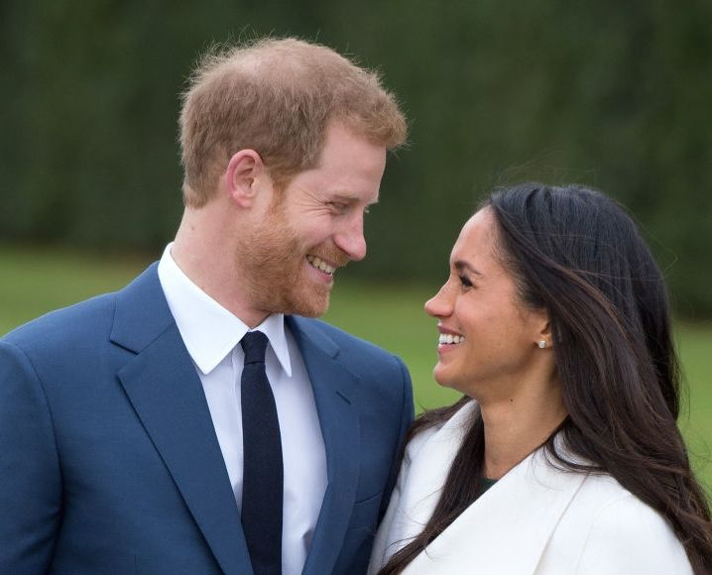
Prince Harry to wed Meghan Markle.
Credit: Anwar Hussein]/[Getty Images News]/Getty Images

ARLINGTON, VA; April 11, 2018 – Today, PBS announced ROYAL WEDDING WATCH, premiering Monday-Thursday, May 14-17, 10:00-11:00 p.m. ET and Friday, May 18, 10:30-11:30 p.m. ET (check local listings), a five-part nightly series of special programs. PBS will also broadcast THE ROYAL WEDDING: PRINCE HARRY AND MEGHAN MARKLE, live coverage from the BBC, on Saturday, May 19, 2018, 4:00 – 9:00 a.m. ET.

Produced by BBC Studios’ Topical and Live Unit and coming nightly from London, ROYAL WEDDING WATCH will be hosted by American news anchor Meredith Vieira and British television presenter Matt Baker, who will update viewers on the preparations for the much-anticipated wedding of Prince Harry and actress Meghan Markle.

During the week prior to the ceremony, which will occur in St. George’s Chapel at Windsor, the hosts will be joined in-studio by experts, commentators and special guests. BBC presenter and host Anita Rani will report live from Windsor each night, and English historian Lucy Worsley, Joint Chief Curator at Historic Royal Palaces, will delve into the pageantry, pomp and protocol surrounding Harry and Meghan’s nuptials.

“Americans find the British royals incredibly fascinating, and ROYAL WEDDING WATCH is the ultimate backgrounder leading up to this historic moment when our American beauty marries her prince,” Meredith Vieira said.

ROYAL WEDDING WATCH will also showcase Britain’s rich royal heritage and illuminate how history and tradition will influence the union of this modern couple.

“From cakes to choristers, banquets to bouquets, gowns to crowns, viewers will get a fun and informative insider’s briefing on royal etiquette, an unprecedented look at the elaborate planning, secrecy and care that goes into this royal wedding that has captured the imagination of people around the world,” said Shawn Halford, PBS’ Senior Director, Programming.

Lisa Ausden, Creative Director, BBC Studios’ Topical and Live Unit, added: “BBC Studios is thrilled to be working with PBS in this unique collaboration, giving U.S. viewers a front row seat in the build-up to the big day. We’ll capture all the excitement as Windsor becomes the focus of the world, and we’ll have unrivaled expertise in our central London studio to discuss the history and tradition of royal weddings, plus, of course, the romance which brought the Prince and his American bride together.”

About PBS
PBS, with nearly 350 member stations, offers all Americans the opportunity to explore new ideas and new worlds through television and digital content. Each month, PBS reaches nearly 100 million people through television and nearly 28 million people online, inviting them to experience the worlds of science, history, nature and public affairs; to hear diverse viewpoints; and to take front row seats to world-class drama and performances. PBS’ broad array of programs has been consistently honored by the industry’s most coveted award competitions. Teachers of children from pre-K through 12th grade turn to PBS for digital content and services that help bring classroom lessons to life. Decades of research confirms that PBS’ premier children’s media service, PBS KIDS, helps children build critical literacy, math and social-emotional skills, enabling them to find success in school and life. Delivered through member stations, PBS KIDS offers high-quality educational content on TV – including a new 24/7 channel, online at pbskids.org, via an array of mobile apps and in communities across America. More information about PBS is available at www.pbs.org, one of the leading dot-org websites on the internet, or by following PBS on Twitter, Facebook or through our apps for mobile and connected devices. Specific program information and updates for press are available at pbs.org/pressroom or by following PBS Pressroom on Twitter.

About BBC Studios
BBC Studios, a global content company with British creativity at its heart, is a commercial subsidiary of the BBC Group. Formed in April 2018 by the merger of BBC Worldwide and BBC Studios, it spans content financing, development, production, sales, branded services and ancillaries. BBC Studios’ award-winning British programmes are internationally recognised across a broad range of genres and specialisms. It has offices in 22 markets globally, including six production bases in the UK and production bases and partnerships in a further nine countries around the world. The company, which makes 2500 hours of content a year, is a champion for British creativity around the world and a committed partner for the UK’s independent sector. BBC Studios has revenue of £1.4bn, and returns around £200m to the BBC Group annually, complementing the BBC’s licence fee and enhancing programmes for UK audiences.
bbcstudios.com
twitter.com/bbcstudios

- PBS -
CONTACTS:
Carrie Johnson, PBS, 703-739-5129, cjohnson@pbs.org
Cara White, CaraMar Inc., 843-881-1480, cara.white@mac.com
Kate Toft, BBC Studios, +44 7736 481124, kate.toft@bbcstudios.com
For further information and photos visit http://www.pbs.org/pressroom.

