Witness A New Perspective on Britain’s 1936 Abdication Crisis in
ROYAL WIVES AT WAR
Sunday, September 18, 2016
8:00-9:00 p.m. ET on PBS

– Dramatization Revisits Friction Between Wallis Simpson and Queen Elizabeth that Changed the Course of Today's Monarchy –

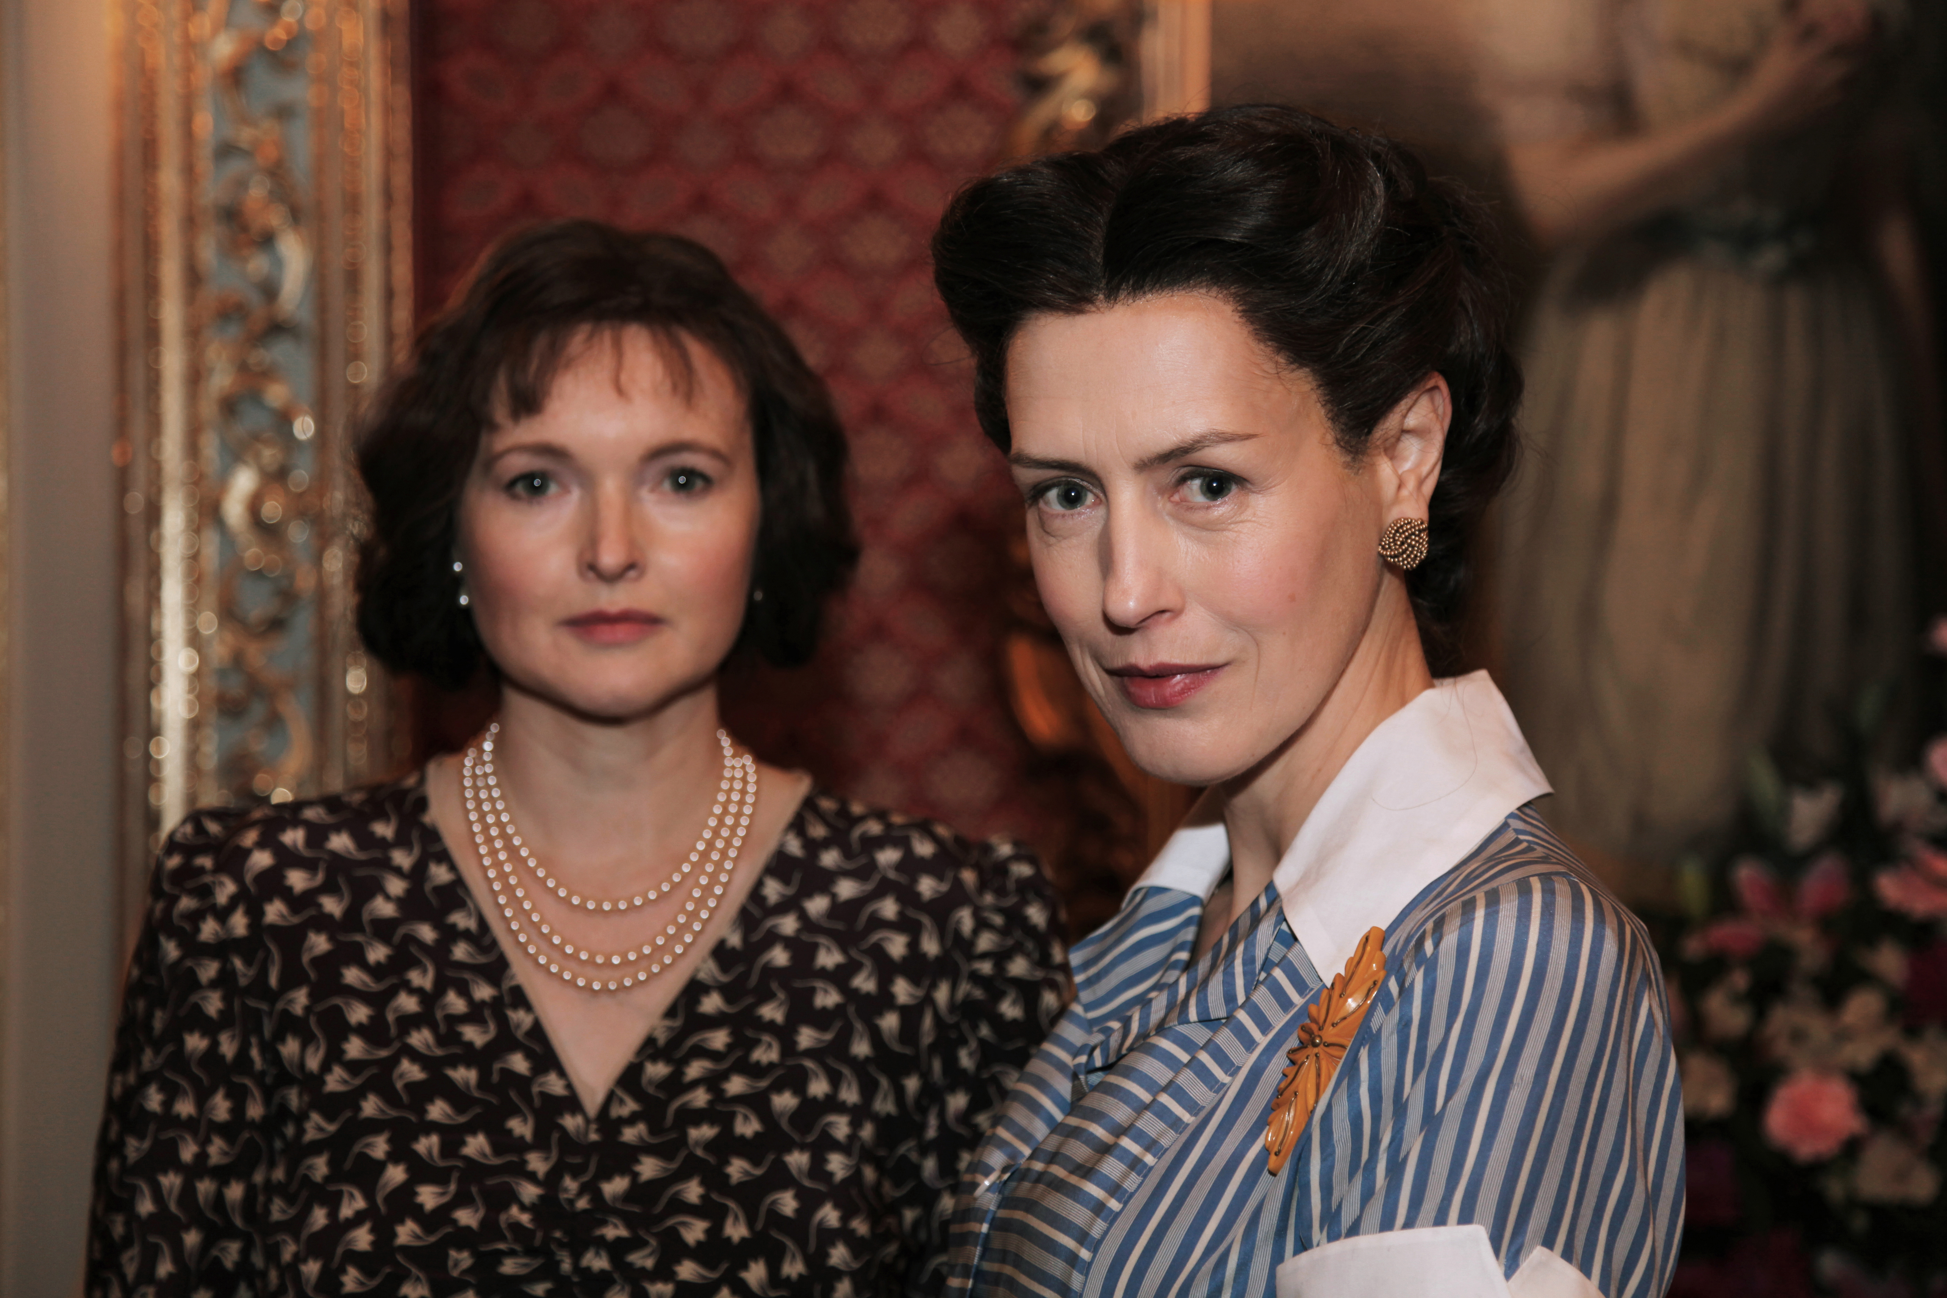
ARLINGTON, VA; August XX, 2016 – ROYAL WIVES AT WAR presents a revealing new look at England’s abdication crisis of 1936, seen through the eyes of the two women at its heart. The program (watch a clip here), co-produced by the BBC, premieres Sunday, September 18, 2016, at 8:00 p.m. ET (check local listings).

In a series of dramatized monologues set in 1967, Elizabeth the Queen Mother (Emma Davies, Emmerdale) and Wallis Simpson (Gina McKee, The Borgias) look back at events that led King Edward VIII (Nick Waring, The Merchant of Venice) to give up the throne for the woman he loved. Combining dramatic reconstructions, archives and a chorus of acquaintances and biographers, ROYAL WIVES AT WAR tells the intimate and moving story of two strong women and the friction that characterized their relationship.
Emma Davies (left) as Queen Elizabeth and Gina McKee (right) as Wallis Simpson. Credit: Courtesy of Monika Kupper / ©BBC 2016

ROYAL WIVES explores not only the scandalous love story, but also the emotional impact of the post-abdication fallout: how Wallis regretted a marriage she now couldn’t avoid and how Elizabeth, miserable at becoming Queen Consort, schemed to ostracize and exile both Edward and Wallis. Upon the outbreak of war, the British government was forced to step in, banishing the Windsors to the then-sleepy backwater of the Bahamas. Elizabeth became the power behind the throne during the war years while Wallis lashed out bitterly from afar.

“ROYAL WIVES AT WAR is a fresh new look at one of Britain’s most dramatic royal moments of the 20th century,” says Beth Hoppe, Chief Programming Executive and General Manager of General Audience Programming for PBS. “The brilliant English actresses Emma Davies and Gina McKee give us compelling new portrayals of the friction between the two wives, while also showing us the personal, emotional stakes of the abdication crisis and its aftermath.”

In addition to Davies, McKee and Waring, ROYAL WIVES AT WAR features Emma Campbell-Jones (Doctor Who) as Thelma Furness and Richard Harrington (Hinterland) as the narrator. Biographers Andrew Morton, Lady Colin Campbell and Anne Sebba also are featured in the program.

The co-production deal was brokered by Chris Cole on behalf of BBC Worldwide North America.

About PBS
PBS, with nearly 350 member stations, offers all Americans the opportunity to explore new ideas and new worlds through television and online content. Each month, PBS reaches nearly 100 million people through television and nearly 33 million people online, inviting them to experience the worlds of science, history, nature and public affairs; to hear diverse viewpoints; and to take front row seats to world-class drama and performances. PBS’ broad array of programs has been consistently honored by the industry’s most coveted award competitions. Teachers of children from pre-K through 12th grade turn to PBS for digital content and services that help bring classroom lessons to life. PBS’ premier children’s TV programming and its website, pbskids.org, are parents’ and teachers’ most trusted partners in inspiring and nurturing curiosity and love of learning in children. More information about PBS is available at www.pbs.org, one of the leading dot-org websites on the Internet, or by following PBS on Twitter, Facebook or through our apps for mobile devices. Specific program information and updates for press are available at pbs.org/pressroom or by following PBS Pressroom on Twitter.

About BBC
The BBC has an unrivalled global reputation for the factual content it produces across arts, history, documentaries and natural history, and broadcasts some 7,000 hours of high-quality, distinctive factual programs a year on television. The BBC is recognized as an industry leader in terms of innovation, consistently pushing the boundaries of its productions, delivered to our audience by the most engaging and inspirational experts.

About BBC Worldwide North America
BBC Worldwide North America is the main commercial arm and wholly-owned subsidiary of the British Broadcasting Corporation (BBC) operating in the U.S. and Canada. The company exists to maximize the value of the BBC’s assets for the benefit of the UK license payer and invests in public service programing in return for rights. The company operates four businesses in the territory - linear and digital content sales and co-productions, consumer products, BBC.com, and two studios based in Los Angeles - BBC Worldwide Productions, responsible for the smash hit Dancing with the Stars and the limited series The Night Of; and Adjacent Productions, producers of Life Below Zero and Ladies of London, among others. The company also owns a 50.1% share in cable channel BBC AMERICA through a joint venture with AMC Networks.

– PBS –

CONTACTS: Chelsey Saatkamp, Goodman Media International for PBS, 212-576-2700; PBSProgramming@goodmanmedia.com

Kayla Springer, PBS, 703-739-5357; kmspringer@pbs.org

For additional information, including media screeners, photos, interviews and more, visit PBS PressRoom at pbs.org/pressroom.

