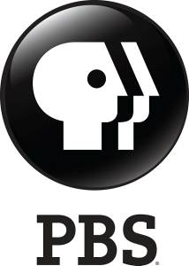

PBS Reveals More of Britain’s Secrets in Two New Documentaries:
SECRETS OF HER MAJESTY’S SECRET SERVICE and
SECRETS OF WESTMINSTER

– One-Hour Specials Disclose Little-Known Stories and History of Iconic Institutions, Sundays, August 31 and September 7 –

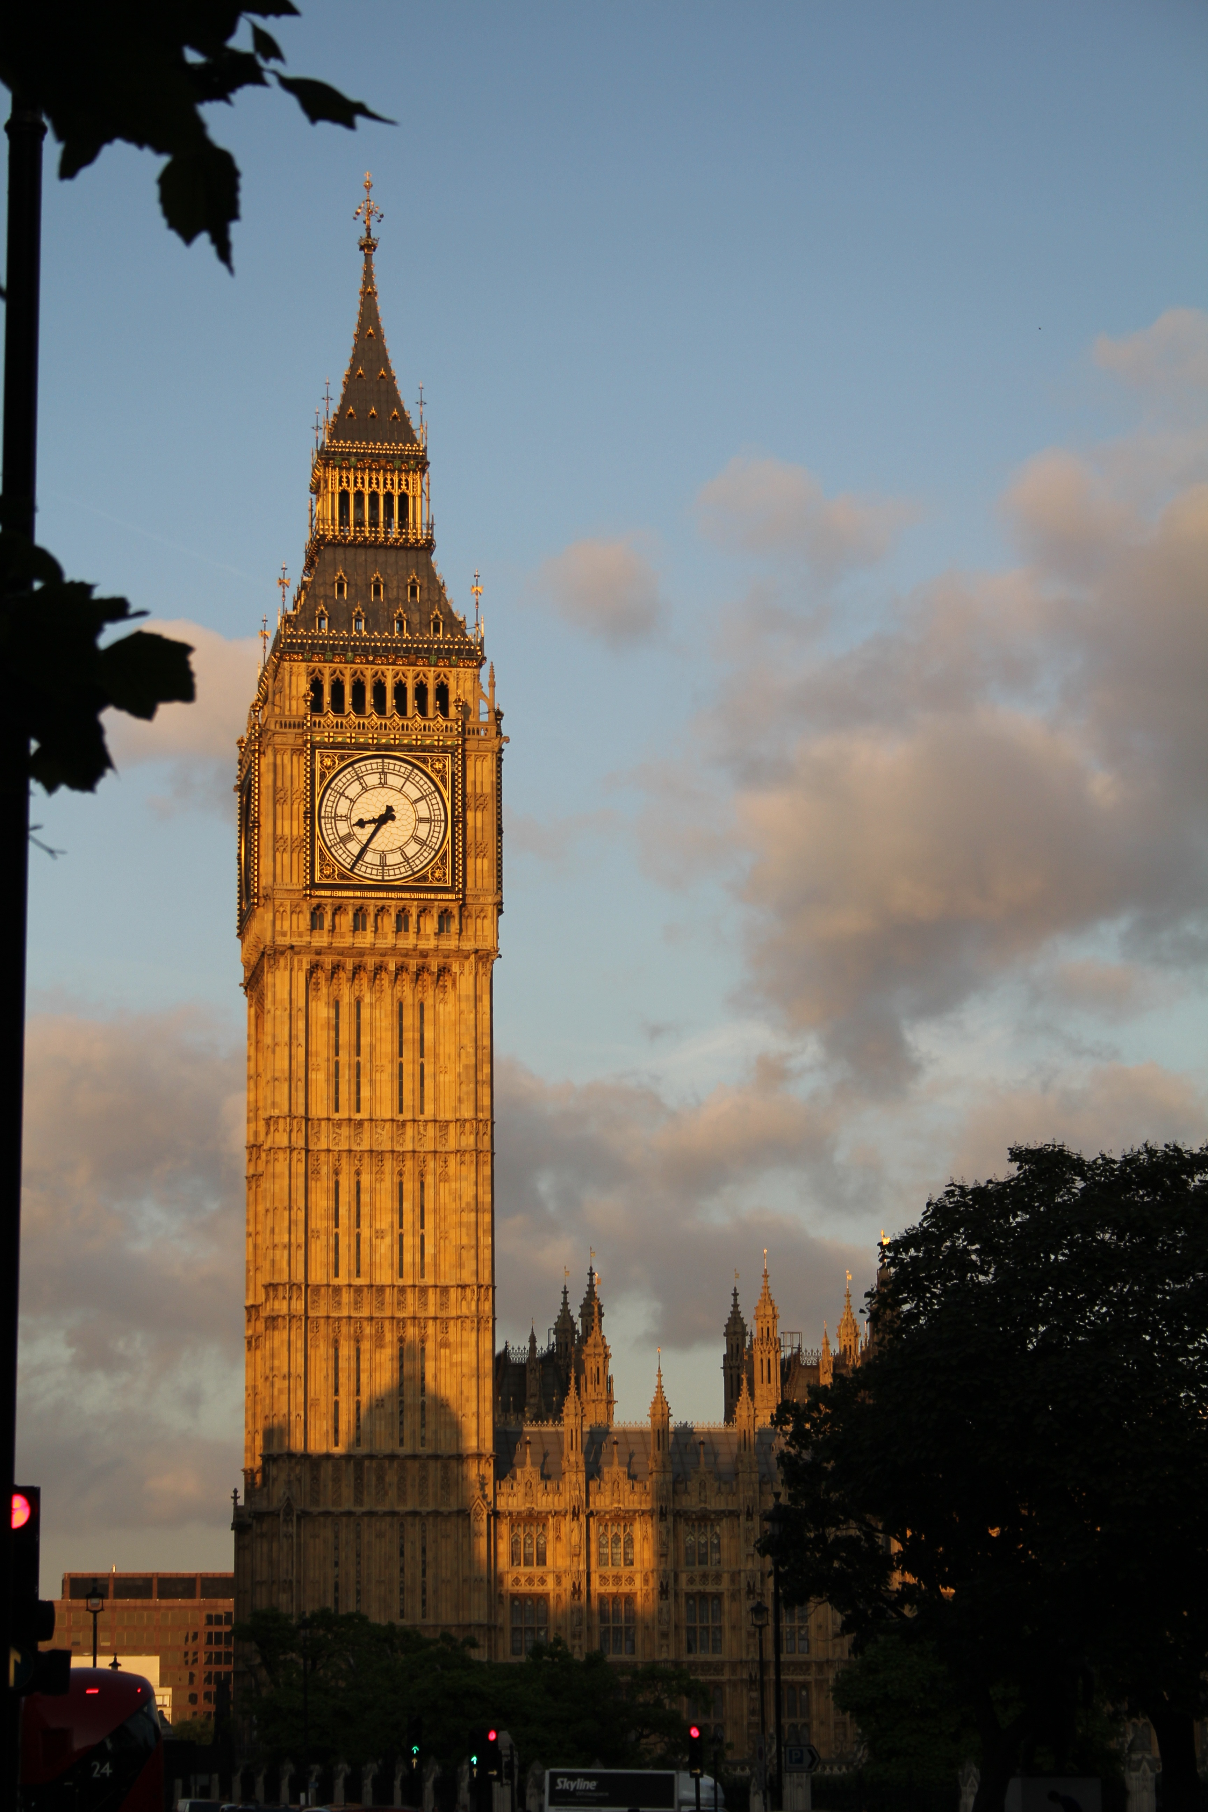
Big Ben clock tower in Westminster. Photo: Courtesy of Pioneer Productions
ARLINGTON, VA; August 5, 2014 – From royal intrigue to real-life spies, two new one-hour specials uncover elements of England’s iconic institutions in SECRETS OF HER MAJESTY’S SECRET SERVICE, premiering Sunday, August 31, 8:00-9:00 p.m. ET, and SECRETS OF WESTMINSTER, premiering September 7, 2014, 8:00-9:00 p.m. ET on PBS (check local listings). The programs highlight these emblems of British history and democracy through illuminating interviews and unprecedented access to key players with inside knowledge of some of Britain’s memorable milestones.

In SECRETS OF HER MAJESTY’S SECRET SERVICE, viewers learn about the legendary spy agency popularized by Ian Fleming’s James Bond, the urbane fictional spy who used high-tech weapons and gadgets to protect queen and country. The film lifts the veil on the shadowy culture of espionage, going back in time and behind the scenes to look at some the world’s most calculated and delicately executed operations.

Established in 1909 as the Secret Service Bureau, MI6, as it is known, initially was set up to control secret intelligence operations overseas, concentrating on Imperial Germany’s activities. In addition to outlining the exploits of Reilly “Ace of Spies” and presenting some of the “gadgets” used in intelligence gathering, the film reveals how the practice of recruiting agents from the upper classes proved damaging to the agency and threatened the “special relationship” between Britain and the United States.

SECRETS OF HER MAJESTY’S SECRET SERVICE includes exclusive interviews with the former Chief of Service of MI6; a former MI6 spy, now an author; Mavis Batey — in one of her last on-camera interviews — who decrypted codes, including Nazi Germany’s “Enigma” system, at Bletchley Park; and a Cold War-era Russian double agent who asserts, “I was playing with death every day.”

In SECRETS OF WESTMINSTER, viewers see the hidden areas of London’s House of Commons, House of Lords and Westminster Abbey. Throughout its history, Westminster has embodied stories of power struggles and tradition.

As one of the world’s most famous churches, Westminster Abbey is steeped in Anglo-Saxon myths and legends dating back to the 11th century. Viewers are privy to a behind-the-scenes tour to one of the most memorable vantage points of this architectural masterpiece, the site of the coronations of every English monarch since 1066. The film charts the brazen heist of the Stone of Destiny, part of the famous Coronation Chair, first used by Edward the Confessor in 1296. The theft, on Christmas Eve in 1950, made international headlines. Scotsman Ian Hamilton reveals how he and others planned and carried out the theft, then returned the storied stone in time for Queen Elizabeth II’s coronation.

SECRETS OF WESTMINSTER also provides access to the Houses of Parliament, both the House of Lords and the House of Commons. Here, intrigue, pageantry and customs, including why a monarch is never allowed into the House of Commons, are the order of the day. A tour of the iconic bell tower of Big Ben showcases this iconic symbol and explains the origin of its nickname and the mystery of its distinct tone. Victoria Tower holds priceless Acts of Parliament, documents that record 500 years of British history, including the Stamp Act that eventually led to colonial America’s rebellion. The film outlines the famous Gunpowder Plot, commemorated annually with bonfires and fireworks on Guy Fawkes Day; features footage of suffragette Emily Davison’s grim demise; and covers the career of Lady Astor, an American in England, who had a profound impact on Parliament.

Credits:
Producer: Pioneer Productions for PBS. Executive producer: Jeremy Dear. Senior supervising producer: Alice Harper. Producer/director: Kasia Uscinska (Secret Service); Louise Wardle (Westminster).

About Pioneer Productions
Pioneer Productions, one of the UK’s most successful independent production companies, has developed an outstanding reputation for producing innovative, high-quality and popular programs for both the UK and US markets. Pioneer has produced more than 700 hours of adventure, science and technology, docu-drama, lifestyle, current affairs and history programming for the US and international markets, with films screened in more than 80 countries. Critically acclaimed Pioneer productions have attracted high viewership as well as prestigious awards, including Emmys, BAFTAs, the Grand Award at the New York Television Festival, a UK Indie Award, Sony Award and Royal Television Society Award, to name a few, and Pioneer is the only independent company to win the coveted Best Science film at the Banff TV festival.
About PBS
PBS, with its over 350 member stations, offers all Americans the opportunity to explore new ideas and new worlds through television and online content. Each month, PBS reaches nearly 109 million people through television and over 28 million people online, inviting them to experience the worlds of science, history, nature and public affairs; to hear diverse viewpoints; and to take front row seats to world-class drama and performances. PBS’ broad array of programs has been consistently honored by the industry’s most coveted award competitions. Teachers of children from pre-K through 12th grade turn to PBS for digital content and services that help bring classroom lessons to life. PBS’ premier children’s TV programming and its website, pbskids.org, are parents’ and teachers’ most trusted partners in inspiring and nurturing curiosity and love of learning in children. More information about PBS is available at www.pbs.org, one of the leading dot-org websites on the Internet, or by following PBS on Twitter, Facebook or through our apps for mobile devices. Specific program information and updates for press are available at pbs.org/pressroom or by following PBS Pressroom on Twitter.
– PBS –
For additional information, photos, interviews and more, contact Goodman Media or PBS:

Meghan Newton / Roberta Lee, Goodman Media International for PBS, 212-576-2700; PBSProgramming@goodmanmedia.com

Lara Davidson, PBS: 703-739-5115; lkdavidson@pbs.org

For images and additional up-to-date information on this and other PBS programs, visit PBS PressRoom at pbs.org/pressroom.

