Pack Your Bags for a Rare Inside Look at the Monarchy’s
Private Trains and Planes in

SECRETS OF ROYAL TRAVEL
Premieres Sundays, November 15 and 22 on PBS

ARLINGTON, VA – The British Royal Family is the most well-traveled monarchy in history. The Queen alone has been around the world 42 times, racking up over one million air miles. SECRETS OF ROYAL TRAVEL reveals the inside story of the monarchy on the move, taking viewers inside some of the most famous and exclusive transport in the world.
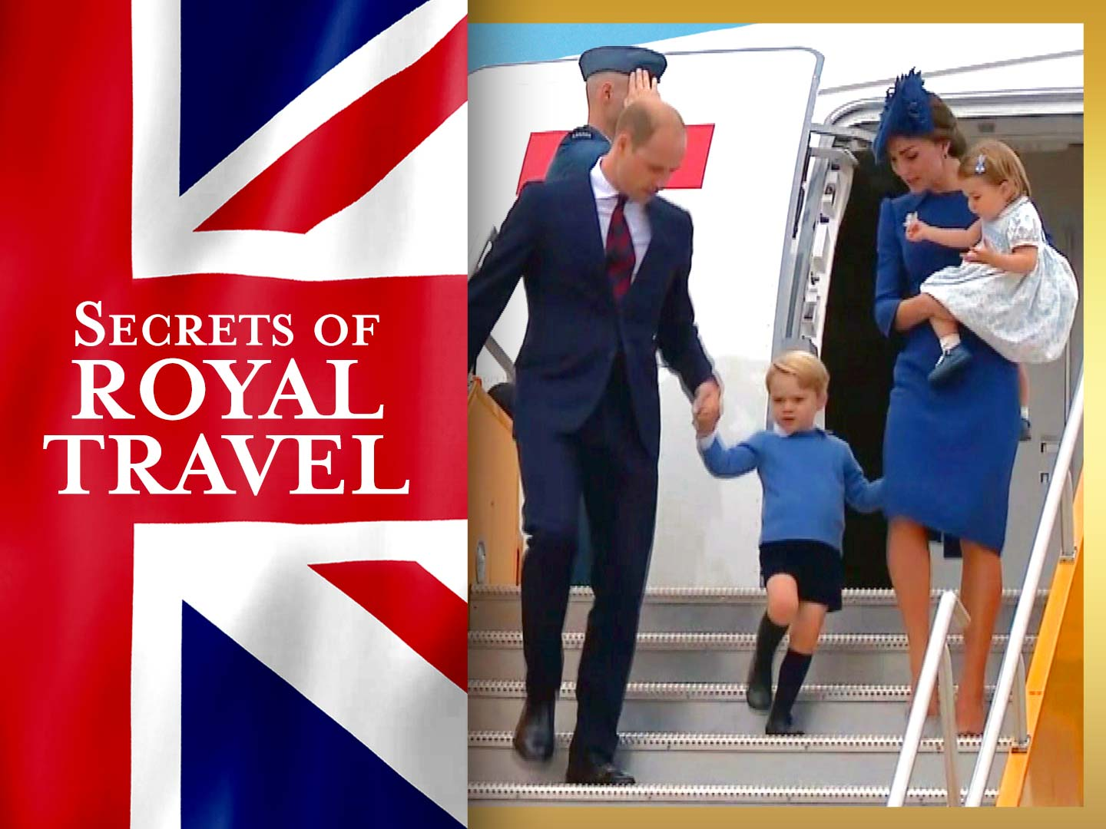

This two-part series opens the door to the private world of the Royal Train and the Royal Flight, each with its own mysterious traditions and protocols. It features a treasure trove of remarkable archival footage and interviews from the staff who drove the trains and flew the planes, as well as from those who cared for the Queen and her family in transit, offering a rare look into a world often hidden from public view. SECRETS OF ROYAL TRAVEL premieres Sundays, November 15 and 22, 10:00-11:00 p.m. ET (check local listings), on PBS, PBS.org and the PBS Video App.

“Secrets of the Royal Train” (Sunday, November 15) uncovers the inside story of the most luxurious and exclusive locomotive in the history of the British Isles, from its lavish past as the “royal express of excess” to its role today as the royal family’s mobile home away from home. For over 150 years, from Queen Victoria to Queen Elizabeth II, it has been the monarchy’s favorite way to travel. But the private world behind its veiled carriages remained a mystery to all but a privileged few — until now.

This episode looks back at the Royal Train’s history, including a glimpse inside Queen Victoria’s luxurious railway cars commissioned in 1869. Resplendent with sumptuous satins, silks and 23-karat gold paint, Victoria’s train was outfitted with the latest modern conveniences, including the first-ever onboard toilet and electric lights.

The latest incarnation of the locomotive was presented to Queen Elizabeth for her Silver Jubilee in 1977. The Royal Train team offer unique insights into the tastes of the Queen, Prince Charles and the few select people allowed on board.

“Secrets of the Royal Flight” (Sunday, November 22) lifts the curtain on five-star regal luxury at 30,000 feet and tells the story of a family who love to fly in style. From a young Queen jetting around the globe for the very first time to the next generation taking the Windsor brand worldwide, this episode uncovers how plane travel defines a family constantly on the move.
During her lifetime, Queen Elizabeth II has flown over one million air miles. “Secrets of the Royal Flight” traces her story in the air, from the dangerous beginnings of jet travel to the luxury of her own private jet. Exclusive revelations from the onboard team detail the secrets of imperial service, from wrangling corgis in the sky to preparing Her Majesty’s favorite aperitif. The episode also unveils stories, from managing the 12 tons of luggage Queen Elizabeth II took on her 44,000-mile Commonwealth tour in 1953, to landing with the body of a much-loved Princess Diana to an audience of over half a billion around the globe. In 1995, the government disbanded the Queen’s flight after investigating how much was spent on air travel. For public duties, the younger royals now travel commercially, sometimes slipping into rear seats under assumed names.

Above all, this is the story of how, once upon a time, the royal family traveled in a style truly fit for a Queen.

SECRETS OF ROYAL TRAVEL will stream simultaneously with broadcast and be available on all station-branded PBS platforms, including PBS.org and the PBS Video App, available on iOS, Android, Roku streaming devices, Apple TV, Amazon Fire TV, Android TV, Samsung Smart TV and Chromecast.

SECRETS OF ROYAL TRAVEL is a Lambent Production for Channel 5. The series producer is Rachel Ozers. Executive Producer is Ollie Tait. The editor is Tom Pierce.

About PBS
PBS, with more than 330 member stations, offers all Americans the opportunity to explore new ideas and new worlds through television and digital content. Each month, PBS reaches over 120 million people through television and 26 million people online, inviting them to experience the worlds of science, history, nature and public affairs; to hear diverse viewpoints; and to take front row seats to world-class drama and performances. PBS’s broad array of programs has been consistently honored by the industry’s most coveted award competitions. Teachers of children from pre-K through 12th grade turn to PBS for digital content and services that help bring classroom lessons to life. Decades of research confirms that PBS’s premier children’s media service, PBS KIDS, helps children build critical literacy, math and social-emotional skills, enabling them to find success in school and life. Delivered through member stations, PBS KIDS offers high-quality educational content on TV— including a 24/7 channel, online at pbskids.org, via an array of mobile apps and in communities across America. More information about PBS is available at www.pbs.org, one of the leading dot-org websites on the internet, or by following PBS on Twitter, Facebook or through our apps for mobile and connected devices. Specific program information and updates for press are available at pbs.org/pressroom or by following PBS Pressroom on Twitter.
– PBS –
CONTACTS:

Cara White / Mary Lugo, CaraMar, Inc.
cara.white@mac.com; lugo@negia.net
843-881-1480; 770-623-8190

Atiya N. Frederick, PBS
anfrederick@pbs.org; 703-739-5147

For images and additional up-to-date information on SECRETS OF ROYAL TRAVEL and other PBS programs, visit PBS PressRoom at pbs.org/pressroom.

