SOUTH BY SOMEWHERE
Vivian Howard
Host, Creator and Producer

Vivian Howard is an author, chef, restaurant owner, storyteller and host of the PBS series A CHEF’S LIFE. She returns to PBS in Winter/Spring 2020 with a new series, SOUTH BY SOMEWHERE, which will tell stories of the American South in the context of global food traditions.
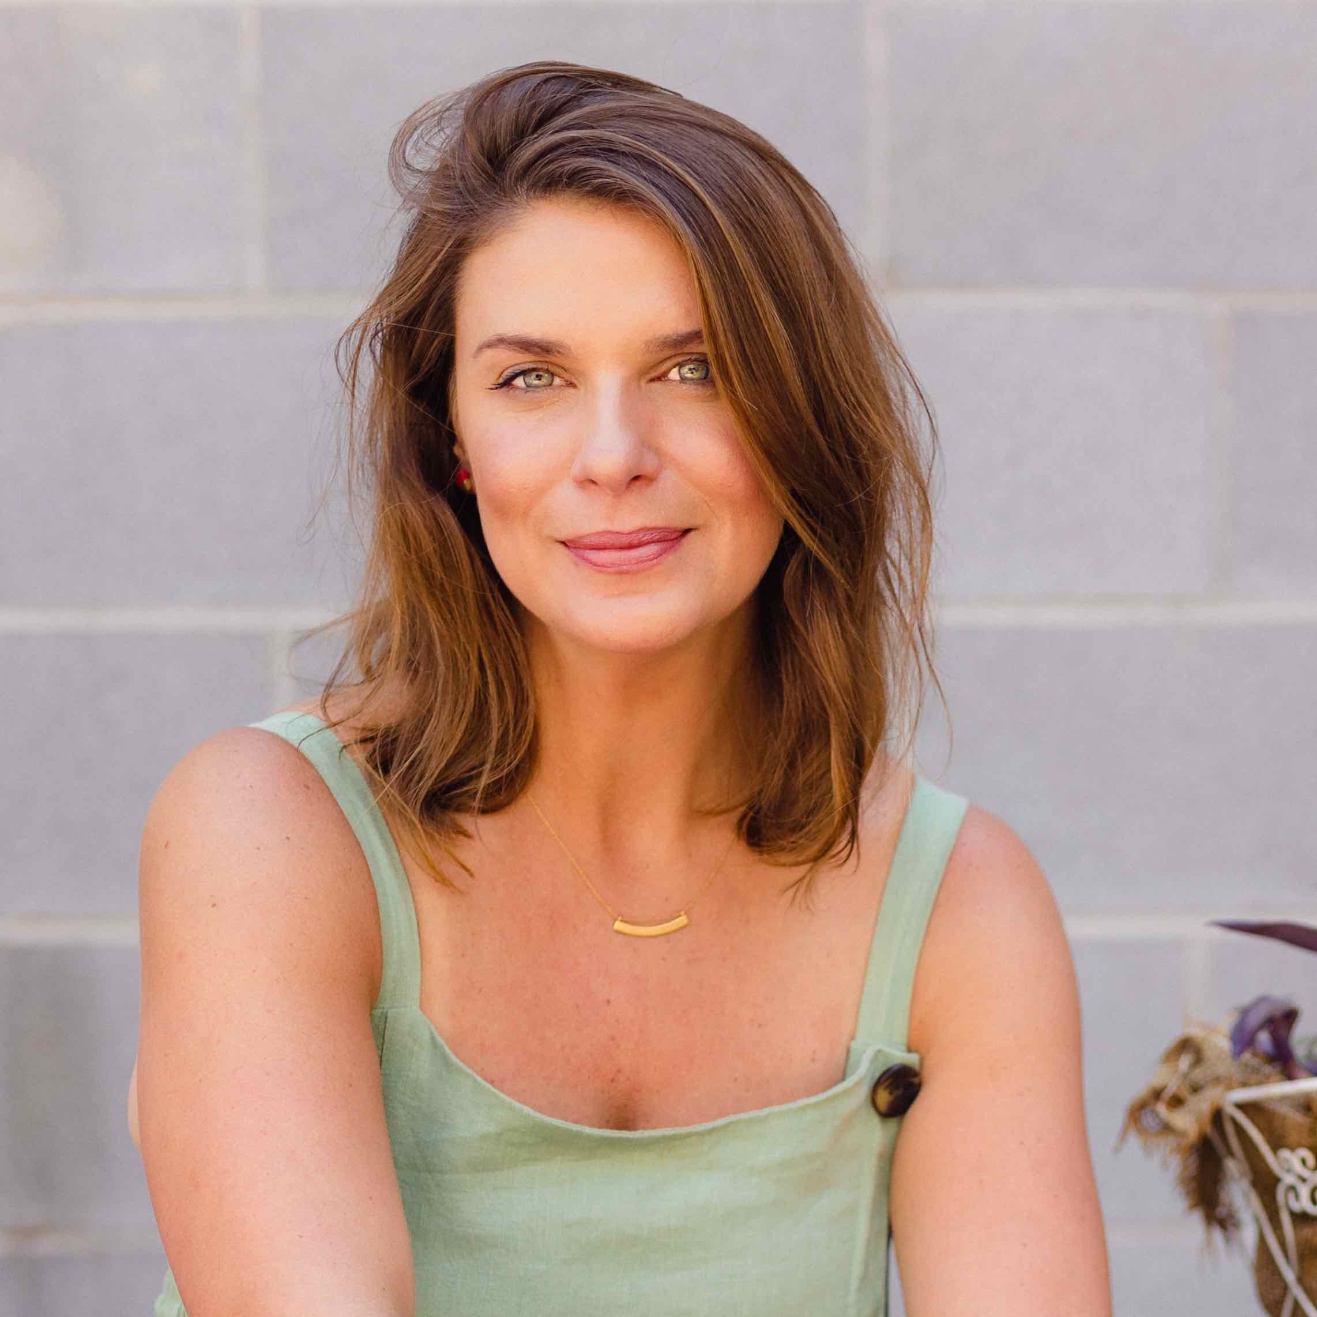
Credit: Baxter Miller

Vivian’s New York Times bestseller, Deep Run Roots: Stories & Recipes from My Corner of the South, is a landmark work of American food writing, as much a storybook as it is a cookbook, imparting the true tale of Eastern North Carolina food.

Vivian and her restaurants — Chef & the Farmer, Boiler Room Oyster Bar and Benny’s Big Time Pizzeria — have racked up numerous accolades, including her selection as a five-time James Beard semifinalist for Best Chef: Southeast. This year, she launched her newest concept, Handy & Hot, an online limited-release bakeshop.

A CHEF'S LIFE, which ran for five seasons, celebrated Eastern North Carolina food traditions. The series was awarded a Daytime Emmy, Peabody Award and James Beard Award for Outstanding Personality/Host.

