SOUTHERN STORYTELLERS
PANELIST BIOS
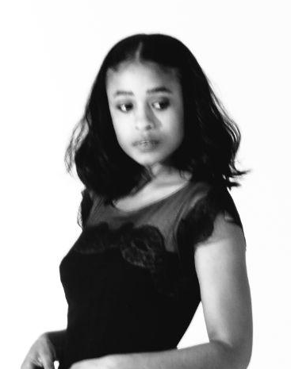

Adia Victoria— A Southern Gothic is Adia’s third album and marks the follow up to 2019’s critically acclaimed “Silences,” produced by Aaron Dessner. Around its release, The Songwriters Hall of Fame presented Adia with the Holly Prize which recognizes and supports a new "all-in songwriter.” She toured the U.S. and Europe on the "Dope Queen Tour" which included a performance on Live From Here with Chris Thile and at Brooklyn’s Prospect Park, the Newport Folk Festival, and a performance at Mass MOCA and Boston Calling. She has also appeared on The Late Show With Stephen Colbert. 2020 saw Adia participate in a panel discussion, “Black Equity in Americana: A Conversation, hosted by the Americana Music Association and moderated by Marcus K. Downling.

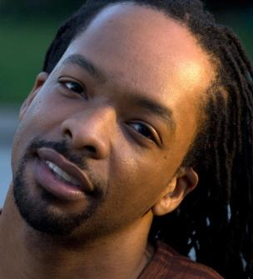
Jericho Brown is the recipient of a Whiting Writers’ Award and fellowships from The Academy of American Poets, the John Simon Guggenheim Foundation, the Radcliffe Institute for Advanced Study at Harvard University, and the National Endowment for the Arts. Brown’s first book, Please (2008), won the American Book Award. His second book, The New Testament (2014), won the Anisfield-Wolf Book Award and was named one of the best of the year by Library Journal, Coldfront, and the Academy of American Poets. He is also the author of the collection The Tradition (2019), which was a finalist for the 2019 National Book Award and the winner of the 2020 Pulitzer Prize for Poetry. His poems have appeared in Buzzfeed, The Nation, The New York Times, The New Yorker, The New Republic, TIME, and The Pushcart Prize Anthology, and several volumes of The Best American Poetry anthologies. He is the Charles Howard Candler Professor of Creative Writing and the Director of the Creative Writing Program at Emory University in Atlanta.

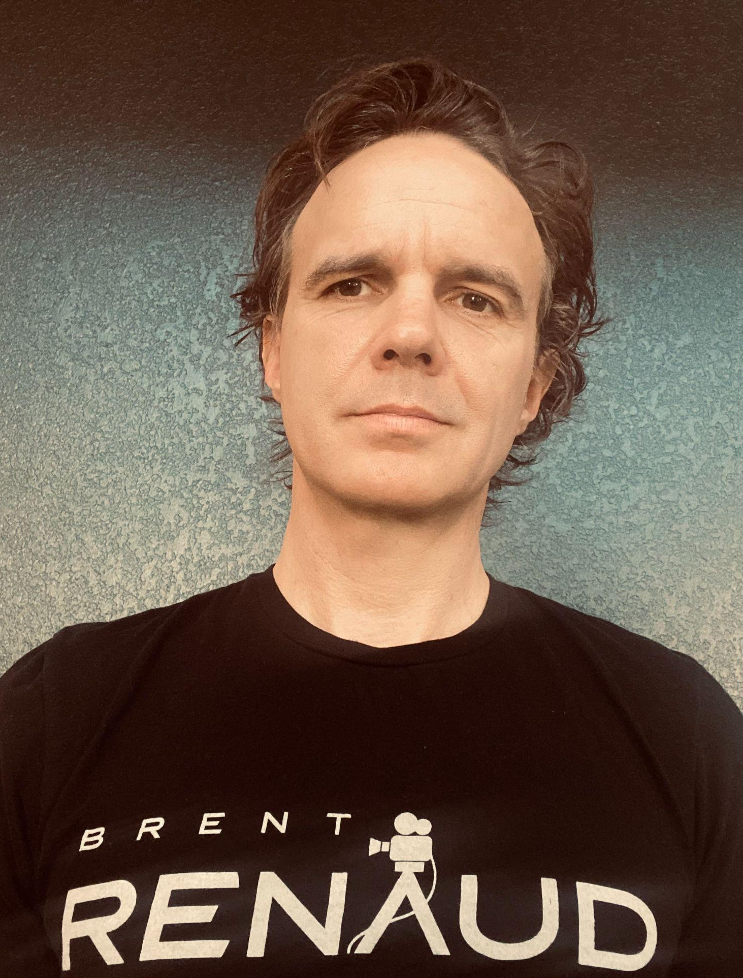
Craig Renaud— The Renaud Brothers are best known for their character driven, cinema verité documentaries like Dope Sick Love, Last Chance High, Off to War, and Meth Storm. Their work has won the film industry's most prestigious awards, including: a Peabody, Columbia DuPont (twice), Overseas Press Club (twice), an IDA, a Webby, and an Edward R Murrow. While documenting the refugee crisis in 2022, Brent Renaud was the first American journalist killed in Ukraine. Craig Renaud is currently in production on a number of film projects, including a documentary about his late brother Brent and a national PBS series called Southern Storytellers.

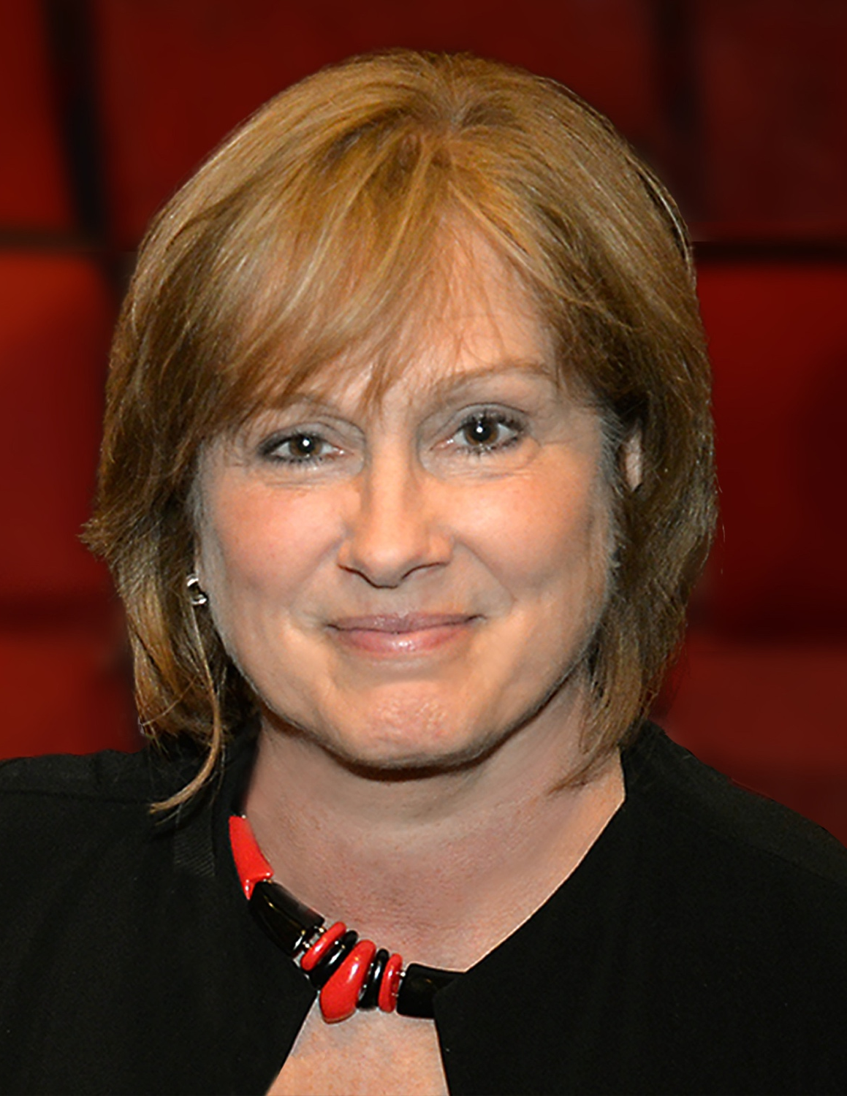
Courtney Pledger, Series Co-Creator/ Executive Producer— Courtney Pledger currently serves as CEO of statewide public broadcaster Arkansas PBS. Prior to entering public media, Pledger worked as a producer and senior film and television executive in Los Angeles and London where she shepherded or produced multiple award-winning projects. She served as executive director of Oscar-qualifying Hot Springs Documentary Film Festival and is a recipient of the Women in Film Lillian Gish Producing Award.

